Air Quality Multimeter
EET100 User Manual
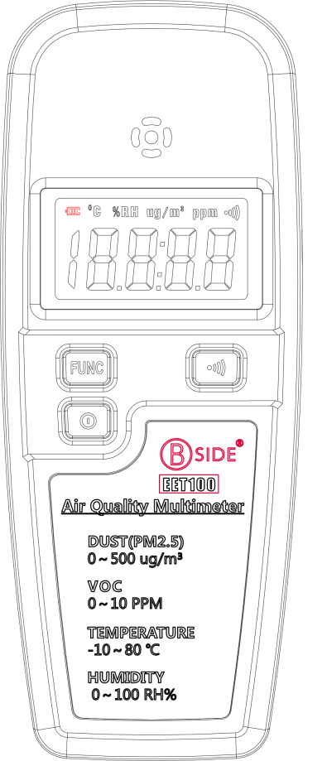
DUST(PM2.5) & VOC & Temperature & Humidity

Function
EET100 integrated high sensitivity Dust sensor, VOC sensor, and Temperature & Humidity sensors. That makes the possibility to measure PM2.5, VOC, temperature and humidity in one meter. It is multifunction, high accuracy, fast response, easy to carry, easy to use and etc. It is suitable for the air quality measurement of daily life, work and learning environment, provide the basis for air quality assessment.

Specification
Dust / PM2.5:
➢ Range: 0-500 ug/m³
➢ Accuracy: ±10%
➢ Sampling cycle: 1second
VOC:
➢ Range: 0-10 ppm
➢ Accuracy: ±10%
➢ Sampling cycle: 1Second
(The VOC sensor should be preheated for 5 minutes)
Temperature:
➢ Range: -10-80 ℃
➢ Accuracy: ±0.3 ℃
➢ Sampling cycle: 2 Second
Humidity:
➢ Range: 0-100 RH%
➢ Accuracy: ±3 RH%
➢ Sampling cycle: 2 Second
Power:
➢ 3.7V Li-Battery: BL-5C
➢ Micro USB Supply
Battery Life:
➢ DUST/PM2.5 mode: 35 Hours
➢ VOC mode: 8 Hours
➢Temperature & Humidity mode: 35 Hours

Structure
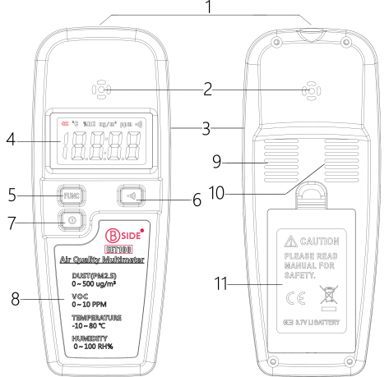

1: VOC Sensor
2: Dust sensor air hole
3: USB port for charging
4: LCD screen
5: Function button
6: Alarm enable button
7: Power On/OFF button
8: Panel
9: Buzzer
10: Temperature & Humidity sensor
11: Battery cover

Operation Instruction
Power On/Power Off:
- Press the red ON/OFF button and hold 2 seconds till the LCD screen shows on for Power ON.
- Press the red ON/OFF button and hold 2 seconds till the LCD screen shows off for Power OFF.
Mode selection:
- Press the button “” to select different mode
- If LCD shows “ug/m³” icon, that means current mode is Dust/PM2.5 measurement
- If LCD shows “ppm” icon, that means current mode is VOC measurement
- If LCD shows “℃” icon, that means current mode is Temperature measurement
- If LCD shows “RH%” icon, that means current mode is Humidity measurement
Alarm :
- Press the button “” will enable or disable alarm
- In DUST/PM2.5 mode, the alarm will be triggered if the value is over 75 ug/m³
- In VOC mode, the alarm will be triggered if the value is over 0.500 ppm
Over Range:
- The LCD will show “” if the current measure value is higher than upper the limit of this meter
- The LCD will show “” if the current measure value is lower than the lower limit of this meter
Charging:
- When the battery is running down, the battery icon will flash and show as “”, please change a full battery or use a cable to charge it through the micro USB port.

Notice
- In VOC mode, the sensor need to be heated up to 60 ℃, please keep it away from your skin in order to avoid scald.
- The VOC sensor should be heated by itself about 5 minutes, so in the first 5 minutes the reading is not accurate.
- There is a relative mode in VOC mode, press and hold the alarm button “” for 3 seconds, the LCD reading will be set to 0.000 ppm, then you can move the meter to a higher VOC environment, the LCD reading will show the differential value.
- For save power, please power it off when you don’t use it
- Please keep dry and clean.

Common sense of living environment

DUST/PM2.5 and air quality rating (24 hours average)
Class 1 0~35ug/m³ Great
Class 2 35~75ug/m³ Good
Class 3 75~115ug/m³ Slight pollution
Class 4 115~150ug/m³ Moderate pollution
Class 5 150~250ug/m³ Heavy pollution
Class 6 250~500ug/m³ Serious pollution

VOC and air quality rating (24 hours average)
Class 1 0.000~0.050ppm Great
Class 2 0.050~0.120ppm Good
Class 3 0.120~0.300ppm Slight pollution
Class 4 0.300~0.500ppm Moderate pollution
Class 5 0.500~0.800ppm Heavy pollution
Class 6 over 0.800ppm Serious pollution
Note: These are not official certification, just for reference only!

Application
- Working and Living air quality testing
- House decoration air quality testing
- Alcohol test (for drunk driving)
- Sewer Tunnels test for safety working
- Gas station leak detection
- Factory air quality testing
- Smoking test

