F218
Standalone Biometric time attendance INSTRUCTION MANUAL

CONTENT

Introduction 4
Supplied Part List 4
About 4
Hardware Specification 4
Precaution 5
Product Overview 6
F218 Illustration: 6
Product Overview 6
User Management 7
User Enrollment 7
Illustration of Correct Fingerprint Pressing 7
Wrong Pressing Method 8
Authentication & verification 8
Authentication with Fingerprint 8
Authentication with RF ID card 8
Authentication with Password 8
Delete User 9
Menu Level Structures 9
Menu 1 User / Manager 9
Menu 2 Delete User 11
Menu 3 Data Download 11
Menu 4 Time Setting 12
Menu 5 Advance Setting 12
Device Setting 13
Record Setting 14
Door Lock Out 15
Menu 6 Information 16
Device Operation for Administrator 18
Device Management 18
New User Registration / New Administrator Registration 18
Enrolled User Registration (Backup Register) 20
Password Registration 20
Card Registration 21
Delete User 22
Attendance Log and System Log Management 23
Query of Attendance Log 23
Query of System Log 24
Delete all Record 25
Advance Setting 25
Device Setting 26
Admin Quantity 26
Language 27
Voice Out 27
Volume 28
Auto Power Off 28
Screen Saver 28
RS485 Download 29
Verify 29
Default Setting 29
Record Management 30
Administrator Record (System Log) Warning 30
User Record (Attendance Log ) Warning 31
Reverify 31
Record Detail 31
Enroll Information (Storage Detail) 32
Maintenance Clean 33
Clean keyboard & LCD Screen 33
Clean Optic Lens 33
Quick Setup Guide 33
Door hardware connection diagram: 34

Introduction

Supplied Part List

- Fingerprint Terminal 1 pc
- Installation Screw Bag 1 bag
- Mounting Panel 1 pc

About
F218 biometric time attendance terminal is a flexible and reliable design to meet the market requirement for a secure and cost-effective biometric time attendance solution. It allows registering maximal 3000 fingerprints, 3000 passwords, 3000 RF ID cards (optional) and saving maximal 80,000 records.

Hardware Specification

Fingerprint Template Capacity | 3000
Password (PIN) Capacity | 3000
RF ID Card Capacity | 3000 (optional)
Record Capacity | 80,000
Verification Mode | 1:1 or 1:N
Communication | TCP/IP, RS485 & U-disk  Via U-disk it can send fingerprint data to other F218
Recognition Mode | Fingerprint or password or RF ID Card (optional)
Keyboard and Display | 2.8 inch color screen and Touch button
Power Supply | 12VDC;  standby current: 0.25A;  operating current: 0.3A  when not running electric strike lock
Identification speed | ＜=0.7 second
FRR (False Rejection Ratio) | ＜=0.01%
FAR (False Acceptance Ratio) | ＜=0.0001%
Operating Environment | Temperature: 0°C – 40°C  Humidity: 20% – 80%
Menu Language Support | In both Chinese and English and other languages
Dimension | 219(L) x 82(W) x 27(D) mm

Precaution

Don’t install the device under direct strong sunlight. Strong sunlight affects collecting of fingerprint and it may cause failure on the fingerprint authentication.

During summer it’s highly recommended not to use outdoors. The device working temperature scope is 0-40 ⁰C. Long time using outdoors plus the heat of device itself may lead to slow reaction of device and less pass rate. Once it’s necessary to use outdoors, a sunshade and a set of cooler radiation are recommended.

As the fingerprint identification will be affected by the weather, dry climate will not facilitate the fingerprint identification. So in dry weather conditions, it will be recommended to blow at the finger to moisten the fingerprint, which is helpful to enhance and ensure the identification result in dry climate.

Product Overview

F218 Illustration:
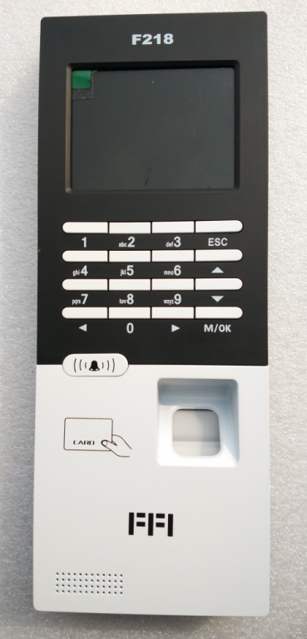

Product Overview
Communication
F218 has U-disk, RS485 and TCP/IP communication interfaces .
Keypad Functions
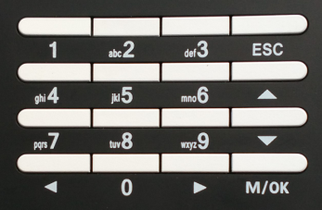
ESC Move one level up from the menu hierarchy
M/OK Get into the system setting menu / Confirm the current setting
▲ Move the cursor up
▼ Move the cursor down
◄ Move the cursor to the left
► Move the cursor to the right
0...9 Numeric keys

User Management
Two user roles are defined: namely manager or normal user .
- Normal users can clock on the device but can NOT access the settings.
- Managers can clock on the device as well as run system management :
1. Register/delete normal users' fingerprints, passwords and RF ID cards (optional).
2. Browse attendance records as well as other system information.
3. Set up system configurations

User Enrollment
Enrollment is the process of creating an ID, assigning a password and scanning a user’s fingers to create the fingerprint templates. All these are stored in the device.

During user verification, the stored fingerprint templates are compared to the current scanned fingerprint to confirm the user’s identity.

Enrollment takes approximately 2 seconds for each user. Up to 9 fingers can be enrolled for the same ID number. Ideally, at least one finger on each hand should be enrolled in case of injures.

Illustration of Correct Fingerprint Pressing
Flatly press fingerprint on U fingerprint scanner
Try to press fingerprint center to the middle or a little upper of U scanner
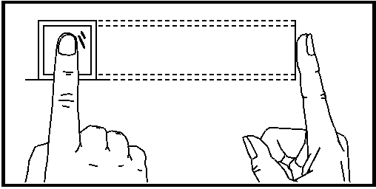

Wrong Pressing Method
Vertical
Too partial
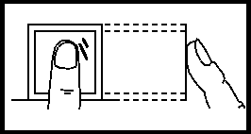
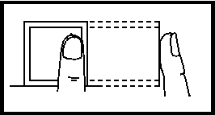

Slant
Too lower
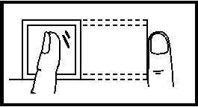
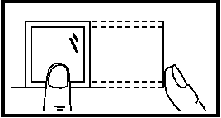

Note: Please adopt correct fingerprint placement method, to ensure the best identification results.

Authentication & verification

There are 3 verification ways to access the unit, either by Fingerprint or by Password or by RF ID card (optional).

Authentication with Fingerprint

Press the finger directly on the scanner and wait until the registered ID number is displayed on the LCD screen. If unsuccessful, press the finger accurately one more time.

Authentication with RF ID card
Swipe the RF ID card to the device (place it over fingerprint sensor position)

Authentication with Password
Enter the enrolled ID No. at the device and press OK to confirm.
“1:1 check P” will display on the screen and then input the correct password and wait until the registered ID number displays on the LCD screen.

If unsuccessful, “Wrong Password” will display and it’s required to input correct password once again.

Delete User
Press menu and select Delete User, press OK and input the enrolled ID number which is to be deleted and then press OK to confirm, then the relevant user is deleted.

Menu Level Structures
The first level menu items show up when MENU key is pressed if there’s no available administrators, administrator affirmation will be done otherwise.
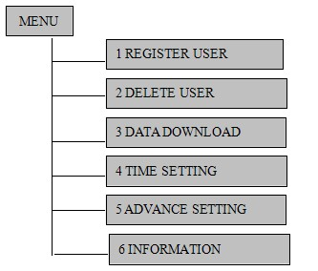

Menu 1:Register User
The Item “Register User” includes 4 Sub Items which are “User”, “Admin”,
“Security level” and “U-disk Upload”
The Sub Items will show up after user select “Register User”, which under the first level menu, and Press “OK”
REGISTER USER

1 USER

3 Security Level

2 Admin
4 U-disk UPLOAD

Menu 1 User / Manager
Select the level of User registration (User/Manager) and Press “OK”. The Third Level Menu Items show up as the figure below. “New Register” is for new user registration. “Backup Register” is for enrolling “Backup Record” of registered user.(PS: Back Record means the 2nd or 3rd Finger Print Template and password) The registration method shows up after “New Register” or “Backup Register” is selected.
Registration of administrator, first needs to register the Super Administrator, then you can register the USB administrator, Enroll Administrator and General Administrator.
Note: Registration card options are optional, with card machines have card options.
Administrator
USB Administrator
Enroll Administrator
General Administrator
Super Administrator
New Register RRTTENJKE LRERRRRegister
Backup

USER
New Register
Backup

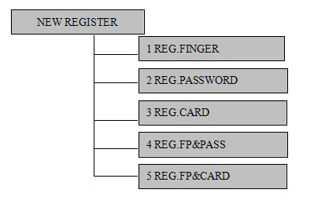

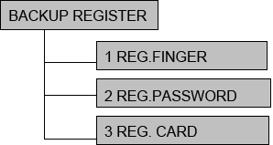

Remark
Register abbreviated to REG
Fingerprints abbreviated to FP
Password abbreviated to PASS
All card operation in this menu is not applicable to F218

There are 3 options under Security Level which are 1:1 Verify, Init.1:1,1:N Identify

1:1 Verify - Compare the user’s fingerprint and the fingerprint template stored in card.(Option Setting depends on the model)
1:N Identify- Compare the user’s fingerprint with the fingerprint template of all registered users stored in machine.

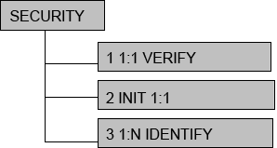

U-disk Upload
The Backup of Menu Setting can be uploaded from U-disk storage device, namely U-disk flash disc to the Fingerprint Machine.

Menu 2 Delete User
The Delete Menu shows up after selecting Delete User under the First Level Menu and pressed OK. Enter the user ID or arrow keys to select the user ID, Press OK to confirm the deletion.
Delete
ID. 00000001
ESC-ESC SET-OK

Menu 3 Data Download
The Sub Items show up after select Data Download of user First Level Menu
DATA Download
1 U-disk Download
2 RS232
3 Ethernet Download

Remark:
Download abbreviate to dwnld.

- U-disk download

“There are five options under the U-disk Download, which are “Glog” and “All Glog” and “Slog” and “All Slog” and “All Enroll Data”
Glog - Download the new record
All Glog - Download all the records
Slog - Download the new management record
All Slog - Download all the records management
All Enroll Data - Download all the registered data

2) Ethernet Dwnld

6 Server IP
7 SerPrtNo 7005
5 Server Req YES
4 Port No 5005
3 Default gateway
2 Subnet mask
1 IP Address
Ethernet Dwnld

Menu 4 Time Setting
The Time Setting Menu shows up after select Time Setting under the First Level Menu and pressed OK
Current Time
2009-9-12
14:22:25
WED

Move the cursor location by direction key. Enter the correct value by number key. (Week is calculated by the software, without input.)

Menu 5 Advance Setting
There are three items under Advance Setting, which are Machine Setting, Record Setting and Door lock out.
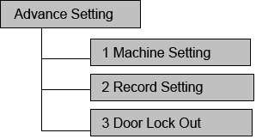
1 Device Setting

Device Setting configures the setting of machine operation.
Record Setting configures the setting of data logging.
Door Lock Out is the setting for Access Control unlock time and purview to the users
already enrolled.

Device Setting
5 Volume 8
10 Default Setting
9 Verify F/P/C
8 RS485 Dwnld Yes
7 Screen Saver NO
6 Auto Off NO
4 Voice Out Yes
3 Language English
2 Admin Qty 5
1 Machine ID 1
Device Setting

Machine ID.: The Unique ID of the machine on the same communication channel.
Admin Qty.: The maximum number of machine administrator.
Language: The language of operation menu. It supports multiple languages.
Voice Out: Enable or disable the function of voice indication.
Volume: Set the prompt voice volume.
Auto Off: The machine will shut down after a certain idle time.
Screen Saver: For the protection of the screen
RS485 Dwnld: Enables or disables RS485 Download
Verify: Choose verification mode.
Default Setting: Restore all setting which under Settings to factory default setting.

Record Setting
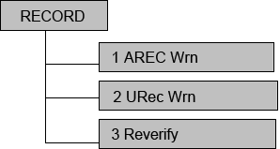

Arec wrn(Slog Wrn): To set the limit of remaining system log memory. If the number of remaining system log memory reach the limit. Warning occurs.(All administrators’ operation is record as system log.)
Urec wrn(Glog Wrn): To set the limit of remaining attendance record memory. If the number of remaining record memory reaches the limit. Warning occurs.(All attendance activity is record as Glog.)
Reverify: The duration of 2 successful attendances which from the same fingerprint . All duplicate attendance record doesn’t be recorded.

Door Lock Out
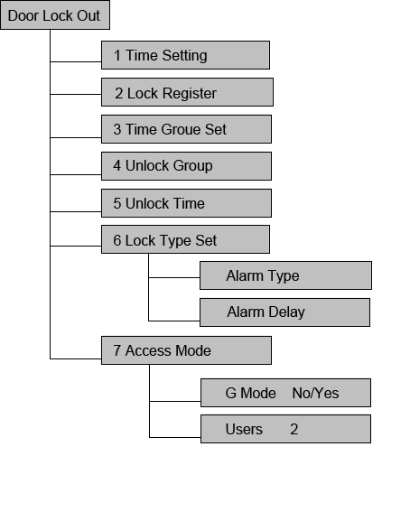
Door Lock Out setting are for setting the access control. All the setting can be set from the ACCESS CONTROL module of software and then uploaded into the device, or can be directly set on the individual device.

Time Setting: Time setting from hardware, which is only for one separate device, and it can also be set from software access control part and then uploaded to 1or multiple devices.
Lock Register: Set lock register of different ID number. It can also be set from software.
Time Group: Time Group setting from hardware, which is only for one separate device, and it can also be set from software access control part and then upload to 1 or multiple devices.
Unlock Group: Unlock setting of time group. It can also be set from software.
Unlock Time: Unlock time delay and it counts by second. It can also be set from software.
Lock Type: A. Alarm type: NG for none, No for Normal Open, NC for Normal Close.
B. Alarm Delay: Alarm time delay and it counts by seconds.
Access Mode: It includes G Mode & Users. G Mode is defaulted as NO, if it’s changed as Yes, and Users qty is 2, it means it need any 2 person who have already registered on site to open the door together.

Menu 6 Information
Information shows the storage detail, records, manufacturer and firmware version.
The sub items are shown below.

Storage Detail: To show the information about of user registration such as the number of registered users, number of registered administrators, number of fingerprint templates, number of registered passwords and number of registered Cards.
Record Detail: To show or operate the Device record such as number of user records, number of administrator records, attendance record of users, system log of administrators, and delete all record.
System Detail: To show hardware information which includes Manufacturer, Device Name, Release Time, Serial Number, Firmware version, Software Version and Upload firmware .

Information
1 Storage Detail
User Reg.
Manager Reg.
Finger
Password
Card
2 Record Detail
View User Rec.
View User Rec.
Delete All Rec.
Device Name
Firmware Version
Software Version
Upload Firmware
3 System Detail
Manufacturer
Release Time
Serial Number

Device Operation for Administrator
How to show the First Level Menu
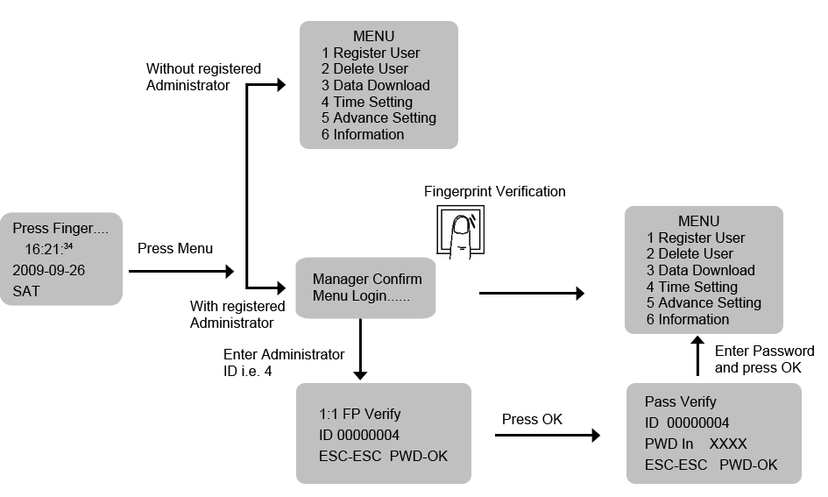
If the manager confirm is requested on the operation and the user didn’t enroll any administrator, please shut down the Device and contact with retailer.
If confirmation is failed, Illegal is shown and request the reconfirmation.
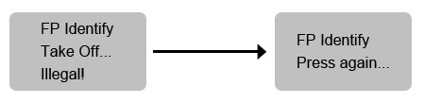

Device Management

New User Registration / New Administrator Registration
Step1 Enter the First Level Menu(Refer to Page 6.)
Step2 Press 1 to choose Register User
Menu
1 register User
2 Delete User
3 Data Download
4 Time Setting
5 Advance Setting
6 Information

Step3 Press 1 to choose User for normal user registration Or Press 2 to choose Administrator registration(The administrator menu has four different levels, first need to register the super administrator.)

Level Selection
1 User
2 Administrator
3 Security Level
4 U-disk Upload

Administrator
1 USB Administrator
2 Enroll Administrator
3 General Administrator
4 Super Administrator

Step 4 Press 1 to choose New Register
Enroll Method
1 New Register
2 Backup Register

Step 5 Press 1 to choose Reg Finger
Enroll Object
1 Reg Finger
2 Reg Password
3 Reg Card

Step 6 Enter the User ID(i.e. )00000001 and Press OK
Reg Finger
ID 00000001
ESC-ESC SET-OK

Step 7 Flatly press fingerprint the first time on U fingerprint collector
Press Finger
First



Step 8 Flatly press fingerprint the second time on U fingerprint collector
Press Finger
Second

Step 9 Flatly press fingerprint the third time on U fingerprint collector
Press Finger
Third

Successful Registration

Step 10 Press ESC to quit the registration process.
Reg Finger

Continue?
NO-ESC YES-OK

Enrolled User Registration (Backup Register)

It allows administrator enroll 2 more fingerprint temple, password and Card for the same user as Backup.

Password Registration

Step 1 Enter the Menu Enroll Object
Step 2 Press 2 to choose Reg Password
Enroll Object
1 Reg Finger
2 Reg Password
3 Reg Card

Step 3 Enter the User ID (i.e) 00000001 and Press OK
Reg Password

ID 00000001
ESC-ESC SET-OK

Step 4 Enter the Password (1-8 digits) and Press Enter.
Reg Password
ID 00000001
PWD In XXXX
ESC-ESC SET-OK

Step 5 Re-enter the password to confirm

Reg Password
ID 00000001
PWD Re Input XXXX
ESC-ESC SET-OK

Successful Registration

Step 6 Press ESC to quit the registration process.

Reg Password

Continue?
NO-ESC YES-OK

Card Registration

Step 1 Enter the Menu Enroll Object
Enroll Object
1 Reg Finger
2 Reg Password
3 Reg Card
4 Reg FP & Pass
5 Reg FP & Card

Step 2 Press 3 to choose Reg Card
Reg Card

ID 00000001
ESC-ESC SET-OK

Step 3 Enter the User ID (i.e) 00000001 and Press OK
In Card No.

Swipe Card!
ESC-ESC SET-OK

Step 4 Please swipe card on the detecting area.

Step 5 Card ID is shown on the screen and Press OK to confirm.

In Card NO.
50741209
ESC-ESC SET-OK

Successful Card Registration

Step 6 Press ESC to quit the registration process.

Delete User

Step 1 Enter the First Level Menu( Refer to Page 6)

Step 2 Press 2 to choose Delete User
Menu
1 Register User
2 Delete User
3 Data Download
4 Time Setting
5 Advance Setting
6 Information

Step 3 Enter the User ID and Press OK
Delete
ID 00000001
ESC-ESC SET-OK

Step 4 Press OK to confirm
Delete
00000001
Sure to Delete?
ESC-ESC SET-OK

Successful Deletion
If any backup record belongs to the deleted User ID. the alert of deletion of backup record will show on the screen.
Delete
00000001-1
Sure Delete?
ESC-ESC SET-OK

The type of record is indicated by the last digit
0 means 1st Fingerprint template
1 means 2nd Fingerprint template
2 means 3rd Fingerprint template
P means Password
C means Card

Attendance Log and System Log Management

Query of Attendance Log
Step 1 Enter the First Level Menu (Refer to Page 6)
Step 2 Press 6 to choose Information
Menu
1 Register User
2 Delete User
3 Data Download
4 Time Setting
5 Advance Setting
6 Information

Step 3 Press 2 to choose Record Detail
Information
1 Storage Detail
2 Record Detail
3 System Detail

Step 4 Press 1 to choose View User Rec
Record Detail
1 View User Rec
2 View Admin Rec
3 Delete All Rec

Step 5 Press OK to query all attendance log(In order by time) Or Enter the User ID to query a certain user’s record. Press OK
View User Rec

ID 00000001
ESC-ESC Continue-OK

Step 6 Press ▲ or ▼ to view the previous or next record
View User Rec
N/C
09/09/26 13:23
00000001
ESC- ESC Con-OK

C: total amount of attendance record (C-00022 means there are 22 records)
N: the sequence of attendance record(n-00001 means it is the first record)
00000001: User ID of the current record
09/09/26 13:23 : attendance time

Query of System Log
Step 1 Enter the Menu Record Detail
Step 2 Press 2 to choose View Admin Rec
Record Detail
1 View User Rec
2 View Admin Rec
3 Delete All Rec

Step 3 Press OK to query all system log.(In order by time)or enter the User ID to query a certain user’s system log. Press OK
View Admin Rec

ID 00000001
ESC-ESC Continue-OK

Step 4 Press ▲ or ▼ to view the previous or next record.
View Admin Rec
N/C
09/09/26 13:23

ESC- ESC Con-OK

C: total amount of attendance record (C-00022 means there are 22 records)
N: the sequence of attendance record(n-00001 means it is the first record)

Delete all Record
Step 1 Enter the Menu Record Detail
Step 2 Press 3 to choose Delete All Rec
Record Detail
1 View User Rec
2 View Admin Rec
3 Delete All Rec

Step 3 Press OK to confirm the deletion
Delete All Log
Sure to delete?
NO-ESC YES-OK

Successful Deletion

Advance Setting
Follow the steps below to access Device Setting Menu.
Step 1 Enter First Level Menu
Step 2 Press 5 to choose Advance Setting
Menu
1 Register User
2 Delete User
3 Data Download
4 Time Setting
5 Advance Setting
6 Information

Step 3 Press 1 to choose Device Setting
Advance Setting
1 Device Setting
2 Record Setting
3 Door Lock Out

Device Setting
The Machine ID of each Device on the same channel should be unique (No matter Using RS485 or TCP/IP protocol)
Step 1 Press 1 to choose Device Setting

Device Setting
1 Machine ID 1
2 Admin Qty 5
3 Language English
4 Voice Out Yes
5 Volume 8

Device Setting
6 Auto off No
7 Screen Saver No
8 RS485 Dwnld Yes
9 Verify F/P/C
10 Default Setting

Step 2 Enter the NEW Number with range between 1-255(i.e. 2) and press OK to confirm.

Device Setting
1 Machine ID 1
2 Admin Qty 5
3 Language English
4 Voice Out Yes
5 Volume 8

Admin Quantity
Step 1 Press 2 to choose Admin Qty
Device Setting
1 Machine ID 1
2 Admin Qty 5
3 Language English
4 Voice Out Yes
5 Volume 8

Step 2 Enter the maximum no of Device administrator(i.e. 6) and press OK to confirm

Device Setting
1 Machine ID 1
2 Admin Qty 5
3 Language English
4 Voice Out Yes
5 Volume 8

Language

Step 1 Press 3 to choose Language
Device Setting
1 Machine ID 1
2 Admin Qty 5
3 Language English
4 Voice Out Yes
5 Volume 8

Step 2 Press ▲ or ▼ to choose Language (English, Espanol, Simplified Chinese and Traditional Chinese) and press OK to confirm.
Device Setting
1 Machine ID 1
2 Admin Qty 5
3 Language English

Voice Out

Step 1 Press 4 to choose Voice Out

Device Setting
1 Machine ID 1
2 Admin Qty 5
3 Language English
4 Voice Out Yes
5 Volume 8

Step 2 Press ▲ or ▼ to enable or disable the function
Yes - Enable
No - Disable
Press OK to confirm
Device Setting
4 Voice Out No
5 Volume 8
6 Auto Off No

Volume

Step 1 Press 5 to choose Volume
Device Setting
1 Machine ID 1
2 Admin Qty 5
3 Language English
4 Voice Out Yes
5 Volume 8

Step 2 Enter and press OK to confirm (1- Minimum ,8- Maximum)

Auto Power Off

Step 1 Press 6 to choose Auto Off
Device Setting
6 Auto off No
7 Screen Saver No
8 RS485 Dwnld Yes
9 Verify F/P/C
10 Default Setting

Step 2 Press ▲ or ▼ to disable the function or set the delay time (1--- 255mins)

Screen Saver

Step1 Press 7 to choose Screen Saver
Device Setting
6 Auto off No
7 Screen Saver No
8 RS485 Dwnld Yes
9 Verify F/P/C
10 Default Setting

Step 2 Press ▲ or ▼ to disable the function or set the delay time (1---- 255s)

RS485 Download

Step1 Press 8 to choose RS485 Dwnld
Device Setting
6 Auto off No
7 Screen Saver No
8 RS485 Dwnld Yes
9 Verify F/P/C
10 Default Setting

Step 2 Press ▲ or ▼ to enable or disable the function
Yes - Enable
No - Disable
Press OK to confirm

Verify

Step1 Press 9 to choose Verify
Device Setting
6 Auto off No
7 Screen Saver No
8 RS485 Dwnld Yes
9 Verify F/P/C
10 Default Setting

Step 2 Press ▲ or ▼ to chose verify mode.

Default Setting
Step 1 Press 10 to choose Default Setting and confirm the restoring.

Device Setting
6 Auto off No
7 Screen Saver No
8 RS485 Dwnld Yes
9 Verify F/P/C
10 Default Setting

All setting under machine setting will be recovered to default factory setting (Except System Log and Attendance Log)

Record Management

Follow the steps below to access Record Setting Menu.
Step 1 Enter First Level Menu
Step 2 Press 5 to choose Advance Setting
Menu
1 Register User
2 Delete User
3 Data Download
4 Time Setting
5 Advance Setting
6 Information

Step 3 Press 2 to choose Record Setting
Advance Setting
1 Machine Setting
2 Record Setting
3 Door Lock Out

Administrator Record (System Log) Warning

Step 1 Press 1 to choose ARec Wrn
Record Setting
1 ARec Wrn 100
2 URec Wrn 1000
3 Reverify No

Step 2 Enter the number of residue system log memory(1-255) before the warning occur,and press OK to confirm.(i.e. 100 means the warning will occur if the residue system log memory reach 100)

User Record (Attendance Log ) Warning

Step 1 Press 2 to choose URec Wrn
Record Setting
1 ARec Wrn 100
2 URec Wrn 1000
3 Reverify No

Step 2 Enter the number of residue attendance record(1-1500) before the warning occur. And press OK to confirm. (i.e. 1000 means the warning will occur if the residue attendance log memory reach 1000)

Reverify

Step 1 Press 3 to choose Reverify
Record Setting
1 ARec Wrn 100
2 URec Wrn 1000
3 Reverify No

Step 2 Press ▲ or ▼ to disable the function or set the duration between 2 successful attendance (1-255mins)

Record Detail
Follow the steps below to access Information Menu.
Step 1 Enter First Level Menu
Step 2 Press 6 to choose Information

Menu
1 Register User
2 Delete User
3 Data Download
4 Time Setting
5 Advance Setting
6 Information

Step 3 Press 2 to choose Record Detail
Information
1 Storage Detail
2 Record Detail
3 System Detail

Step 4 Press OK to view details
Record Detail
1 View User Rec
2 View Admin Rec
3 Delete All Rec

Enroll Information (Storage Detail)

It shows all amount of Enrolled record storage such as the number of enrolled user,the number of enrolled administrator, enrolled fingerprint template, enrolled password and enrolled card.
Step 1 Press 1 to choose Storage Detail
Information
1 Storage Detail
2 Record Detail
3 System Detail

Step 2 Press 1 to choose User Reg
Storage Detail
1 User Reg 4
2 Manager Reg 3
3 Finger 1
4 Password 0
5 Card 0

Maintenance Clean

Sometimes optical lens, keyboard or screen needs to be cleaned. Due to different outside working environment, it’s hard to give an exact cleaning schedule. The below table is a guide that may help:

c
Keyboard & screen | Whenever it’s too dirty and blurry on the surface, it needs cleaning
Optic Lens | Don’t clean too frequently. Lens works better with a little lipid.  Once the lens is shaded or somewhat affects identification of fingerprint, it needs cleaning.

Clean keyboard & LCD Screen
Make sure to turn off the device when it needs to do cleaning on keyboard & liquid screen, Use wet duster cloth or other mild detergent and then dry it.

Clean Optic Lens
Follow below suggestion when cleaning Optic Lens;
- Once it has dust or grit, please blow dust off first
- Use adhesive tape to clean display window. Warning: Don’t use water or other detergent to clean which may do harm to optic lens.
- Wipe with fine cloth without any fluff and be careful not to hurt lens. Once it has fluff on the lens, blow it off after the lens becomes dry.

Quick Setup Guide
Hardware
Power on/off
- Connect the power Adapter to a 240V/110V socket.
- Connect the fingerprint terminal, and then it will automatically power on.

Door hardware connection diagram:
