User Manual

Product Introduction
- Product structure
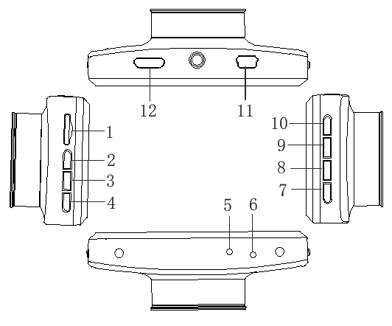

1）TF Slot 2）UP 3）MENU
4）DOWN 5）MIC 6）Reset
7）Power 8）HOLD 9）Mode
10）OK 11）USB 12)HDMI-OUT

Description of Function Keys:
- TF Slot
TF Memory Card Slot
- 2) UP
Standby or short video process click here the key to digital narrow regulation; Down regulate the function key menu options;
- 3) Menu button
Short-Press to bring up the feature set menu;
- 4) Down
Standby or short video process click here button can digital zoom adjust; Down to select the function key menu options;
- 5) MIC
MIC-IN
- 6）RESET
Select to reset
- 7) Power
Long press to turn device on/off. Short press to turn on/off the night vision led lights
- 8) the HOLD button
Press this button, the recording process, the current video file is saved as can not be deleted;
- 9）MODE
Short Press to switch between each other in the camera / camera / playback;
- 10）OK
Video and take pictures to confirm button, the camera mode, short press this key to start recording again press stop recording; camera mode Short Press to take pictures;
- 11) USB
USB data interface, (1) for connecting a PC to transfer data; (2) for connecting an external power supply to charge the battery or supplies power to operate;
- 12）Bracket Mounting Hole
Connect the car bracket mounting screw holes;

Special Function Description：
- G-sensor
When gravity acceleration up to ?g, the machine will automatically save the current video of the accident, not delete the file;

- SOS
Press this button, the current video file is saved as can not be deleted;

- Automatically turn on/off
When connected with car charger, device will turn on when car start, turn off and save the last video when car power off.

REC/photo operation specifications
- Power on/off
Pressthe power button first boot, the blue indicator light lights up at boot time
Again pressthe power button is turned off, the blue light goes out
Note: The recording instrument will be prompted to low battery voltage automatic shutdown when battery is low
- REC mode
Short press key, switch to camera mode, the upper left corner of the screen displays a camera icon;
Short pressbutton to start the camera, the camera icon will appear flashing red dot, indicating the video work
- Photo mode
Short press key, switch to camera mode, the upper-left corner of the screen displays the camera icon;
Short press key camera, take pictures of the screen flashes once said camera to complete.
- Video / photo playback
Short presskey, switch to playback mode, the upper-left corner of the screen to display the playback icon
Short press key up to select the file;
Short presskey down to select the file;
Short press button to play the selected video files;
- Menu setting
Short presskey to enter the video settings state, then the "video icon" field is a yellow background；Again presskey，switch to setting mode, the "Settings icon" field a yellow background,，short presskey, key to exit the setting.
Bring up the settings, short press key，you can set the sub key up and down select switch,，short press key to enter set sub key.
- Short press to quit menu setting.
- Time setting
Short presskey to enter the set state，short press herekey to set up menu，though button to select the date and time options,short presskey enter ，short presskey，Key in Year / Month / Day / minutes / seconds between each other to switch though adjust the required value，pressconfirm the modification

USB mode
Connect DVR with computer by USB Cable, press “power on” button, car DVR will automatically show USB menu ,there are 1 modes available :
USB-Disk : In this mode we can access video files and photo files

Battery instruction
- Battery indication image：
Full battery slightly low battery low battery battery empty

- There are three methods to charge, the red indicator light up when charging, the entire charging time is about 180 minutes, and the red indicator light automatically off when charging completed.
1. Use power adapter to charge
2. Use PC-USB to charge
3. Use vehicle power to charge

Remark: when appear crash because of improper operation, remove battery or press “reset” button to restart.

- Products specifications
Features | HD Camera, HD Video
Program | NT96220
G-sensor | Built-in (car accident case of emergency save, will not be deleted)
LCD screen size | 3.0LTPS (16:9)
Lens | 120 degree A + grade high-resolution ultra-wide-angle lens
Language | Russian, Japanese, English, Chinese (simplified), Chinese (Traditional), Korean, etc…
Files format | AVI
Camera | 3 Mega Pixels
Recording video format | M-JPEG
Color | standard
Continuous loop video | seamless loop recording, don’t leak second
Automatically power on/off | Support auto ignition boot, turn off shutdown
Motion Detection Function | support
Time synchronization | Support (Y/M/D/H/M)
Carrier media | Built-in memory ( total:1024MB)
Photo mode | 5 milliopn
Photo format | JPEG
Memory card | TF (max 32GB)
MIC | Support
Built-in stereo | Support
Infrared night vision | Support
Video format | PAL/NTSC
Current frequency | 50HZ/60HZ
USB function | 1：USB-Disk  2：PC-Camera
Power interface | 5V 1A
Battery | Built-in 200mAh

Trouble shooting:
- For problems in normal operating situation ,please try these methods below:

- Can’t take photo and recording
Check the if the TF card has enough space or locked

- Automatically stop when recording
Use the compatible high-speed TF card with SDHC because of big HD video data, the high-speed TF card have identifying of C4 and C6

- Appear “files error” when replay photo or video
Uncompleted files because of TF card storage error, please use formatting function to format your TF card

- Unclear video
Checks if there are any dirt or fingerprint; and use lens paper to clear the camera len.

- Black image when recording sky or water scene
Scenes with big contrast will influence the automatic exposure function of camera; you can adjust “EV in setting mode to correct.

- Color is not perfect in cloudy day and outdoor light
Set the “white balance” function to automatic

- cross stripe interference in image
Because of wrong “light frequency”, please set it to 50Hz or 60Hz according to the local power supply frequency

- Crash
Restart by pressing shortly on” RESET” button after crash

