User Manual
Thank you for purchasing our 4K extreme definition Wi-Fi video camera; please read this instruction for the sake of playing its performance maximally and lengthening this product’s service life.
Some diagram may be slightly different from the digital video you sued in reality due to technical improvement, software upgrading and production batch, the specific kind prevail.
1. Matters Need Attention
Please read the following safety cautions before using this product and operate the video camera correctly according to specifications; the illegal operation may lead to a damage of internal components:
- Do not drop or hit this product; otherwise, it is easy to cause damage to internal components.
- The increase of machine temperature during using is a normal phenomenon.
- Keep lens clean when using; do not touch the lens for fear of affecting shooting effect.
- Do not attempt to modify or disassemble the machine in any way in case of damaging the video camera.
- Do not put the camera in the place with high temperature, humidity, or direct sunlight in case of damaging the video camera.
- Please select counter authentic brand Micro SD card with more than Class10 card speed; otherwise, the normal storage of image and picture will not be guaranteed.
- Do not place the camera close to the objects and equipment with strong magnetic or the strong radio to prevent from product failure, damaging image or sound, and loss of storage data in Micro SD card.
- If there is overheating, smoking, or a peculiar smell occurred in the process of charging, please immediately unplug the power and stop charging to prevent from fire.
- Please use water shield in the environment with greater humidity and dust in safe of damaging video camera.
- Before using water shield, please check carefully whether there is any damage or foreign matter in the sealing part to avoid affecting the sealing performance.
- For security considerations, keep this product and its accessories away from children or animals to avoid accidents.
- If not used for a long time, take battery out of the machine after fully charged and put it in a cool and dry place.
2. Product Detail and Character
2.1 Product Detail
This camera adopts high-performance chip and is equipped with high-resolution lens, it can record 2.7K extreme definition video and shoot HD pictures. The built-in high-performance wireless Wi-Fi module can be operated in mobile phone and pad by APP software to add speediness to practical effect.
Application areas: outdoor downhill extreme sports such as riding, scuba diving, skiing, surfing, racing, climbing, parachuting, and gliding, outdoor travel and sports events, aerial photography, portable media shooting and other special environments.
2.2 Description of Product Character
- Support 4K/ 2.7K 30fps/ 1080P / 720P / VGA vide recording
- 20 million pixel super HD photograph to present more perfect picture
- Equipped with a 2 inch ultra clear display screen with more clear display and play, and more prominent details
- Support 128G Micro SD storage card
- Support power on video
- Support HDMI high definition output
- Support AV signal output with more splendid aerial photography
- Removable battery, convenient for replacement
- Support video recording while charging; compatible with the function of automobile data recorder
- Support multiple shooting modes, including single shooting, continuous shooting and time-lapse recording
- Support Wi-Fi function with 45 meters maximum distance, which is more convenient when using mobile phone, pad preview, remote and setting
- Equipped with high quality waterproof shell, can shoot underwater exciting pictures and in rainy day
Note: Those did not mentioned in this instruction such as increase or decrease of function and performance improvement caused by product the firmware upgrading without prior notice, the specific kind prevail.
Accessory Assembling Sketch Diagram:
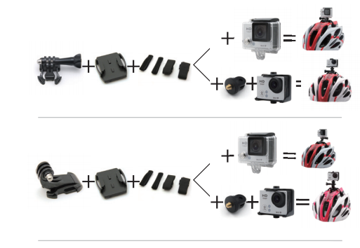
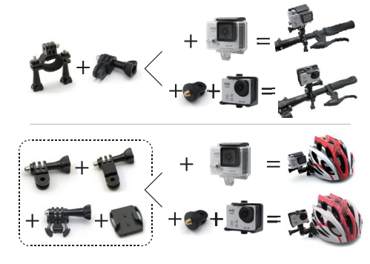

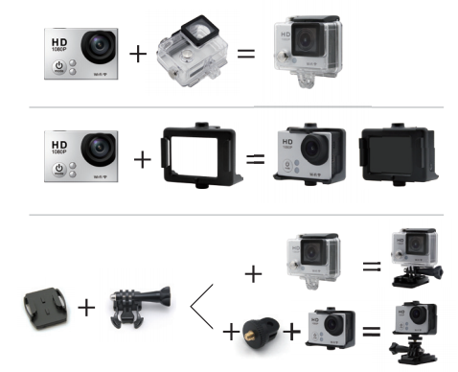

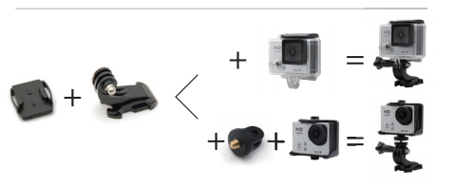

Accessories:
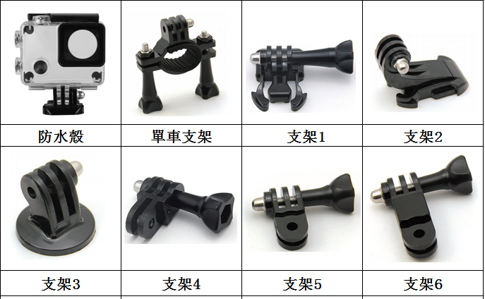

Waterproof Shell
Bicycle Bracket
Bracket 1
Bracket2

Bracket 3
Bracket 4
Bracket 5
Bracket 6
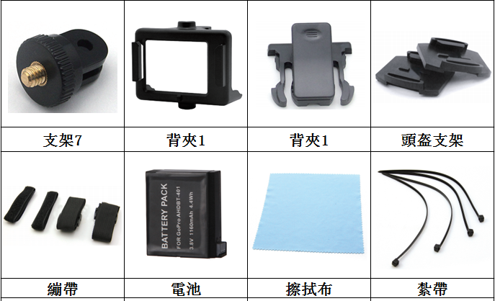

Bracket 7
Back Splint 1
Back Splint 1
Helmet Bracket

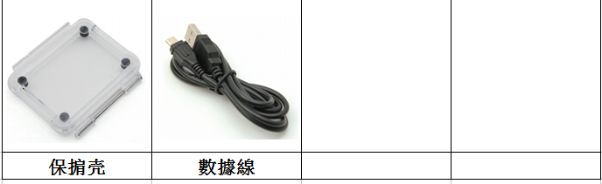
Bandage
Battery
Wiping Cloth
Ribbon

Protection Covering
Data Line

3. Introduction of Appearance Characteristics
3.1 Appearance Introduction and Function Description
3.1.1 Appearance Introduction
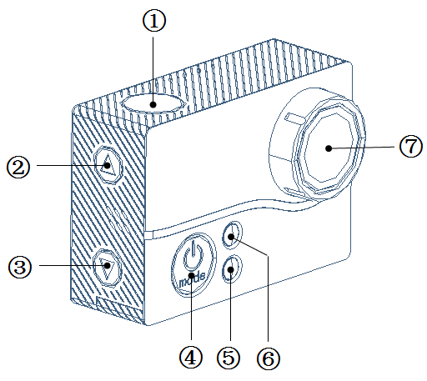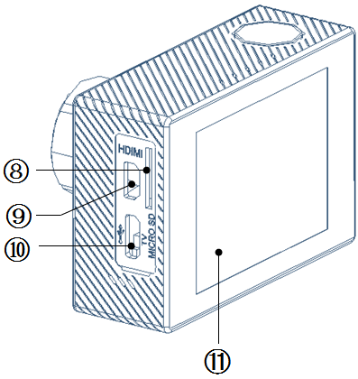

OK Key
Upper Arrow Key
Lower Arrow Key (Enter into menu by long pressing lower arrow key)
Power Resource/Model (Start up by pressing for three seconds)
Charge Lamp (Red)
Work Indicating Lamp
Shot
TF Card Slot
HDMI Interface
USB Interface/AV Output
Display Screen

Video Recording Mode
Press video power button for three seconds and it will enter into video recording mode after starting up

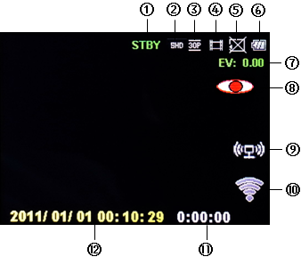
- State Identifier
- Current Video Resolution Ratio
- Current Video Frame Rate
- Video Recording Mode
- SD Card State
- Battery Electric Quantity
- Exposure Value
- Start up Motion Detection
- Data Transmission
- Wi-Fi State
- Video Recording Duration by the Surplus Capacity of SD Card
- Year/Month/Day Time

1. When pressing  in the mode of video recording, the camera starts recording; press again during video recording can save and stop; press MODE button during recording can prevent current file from deletion or formatting.
2. Long press lower arrow button under this mode to enter into menu mode, select by pressing upper and lower arrow buttons after entering into the menu, confirm by pressing ; press MODE button can go back to last interface or exit from current mode
3. Long press upper arrow button under this mode to enter into FPV picture transmitting mode to carry out aerial photography.
4. Snapshot can be achieved by pressing lower arrow button under this mode
5. To launch WIFI by long pressing under this mode; after launching WIFI, ti changed from  to , which means the start up of WIFI is successful.
6. Start up motion detection by pressing upper arrow button under this mode (it is necessary to launch motion detection in advance in the menu before starting up the function of motion detection)
7. Start up time-lapse recording under this mode by press lower arrow button twice in succession (can set take photos every 1S, 5S, 10S, 30S, 60S to form a length of film automatically); press after starting can enter into time-lapse recording; when stop is, press again. If want to close the function of time-lapse recording, press lower arrow button twice in succession.
Photography Mode
To convert to photography mode by pressing MODE button under video recording mode
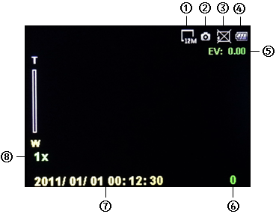
- Current Pixel
- Photography Mode
- SD Card State
- Battery Electric Quantity
- Exposure Value
- Surplus Photographing amounts
- Year/Month/Day Time
- Zoom Ratio

1. Press under this mode to take photos
2. Enlarge pictures by pressing upper arrow button under this mode
3. Reduce pictures by pressing lower arrow button under this mode
4. Start up time-lapse recording under this mode by press lower arrow button twice in succession (can set take photos every 5S, 10S, 30S and 60S); press after starting can enter into time-lapse recording; when stop is, press again. If want to close the function of time-lapse recording, press lower arrow button twice in succession.
5. Long press upper arrow button under this mode to enter into FPV picture transmitting mode to carry out aerial photography.
6. Long press lower arrow button under this mode to enter into menu mode, select by pressing upper and lower arrow buttons after entering into the menu, confirm by pressing ; press MODE button can go back to last interface or exit from current mode

Film Playback Mode
Short press MODE button under photography mode to convert to film playback mode
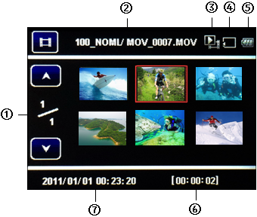
- Current Page/Total Pages
- File name for saving video/file name
- Video playback mode
- SD Card has been inserted
- Battery Remaining Capacity
- Time span of current selected video
- Date and time of current selected video

1. Short press under this mode can play current film
2. Select last or next film by pressing upper and lower arrow button under this mode (it is possible to convert to last or next film during playing by pressing upper and lower arrow buttons)
3. Long press lower arrow button under this mode to enter into menu mode, select by pressing upper and lower arrow buttons after entering into the menu, confirm by pressing ; press MODE button can go back to last interface or exit from current mode

Picture Playback Mode
Short press MODE button under film playback mode to convert to picture playback mode

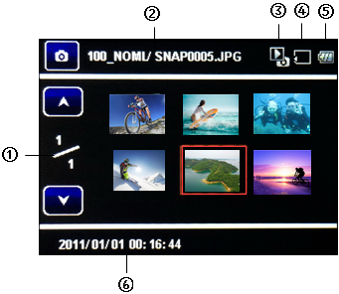
- Current Page/Total Pages
- File name for saving picture/file name
- Picture playback mode
- SD Card has been inserted
- Battery Remaining Capacity
- Date and time of current selected picture

1. To view current pictures by short pressing under this mode
2. Select last or next film by pressing upper and lower arrow button under this mode (it is possible to convert to last or next film during playing by pressing upper and lower arrow buttons)
3. Long press lower arrow button under this mode to enter into menu mode, select by pressing upper and lower arrow buttons after entering into the menu, confirm by pressing ; press MODE button can go back to last interface or exit from current mode

Battery remove and load, insertion and remove of Micro SD
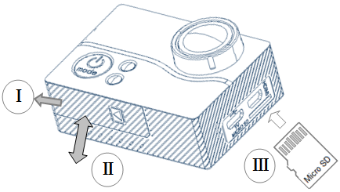
1) As shown in figure, open the battery bin according to the direction shown at I, remove or load battery according to the direction shown at II.
2) As shown in figure, insert Micro SD into machine card slot according to the posture shown at II, when not dropping out the Micro SD indicates correction; press Micro SD again and it will pop up when let go.
Charge
When inserting the equipped adapter into power supply, the USB wire is connected with the machine; the charging indicator light is red during charging while is put out after fully charged. If not used for a long time, take battery out of the machine after fully charged and put it in a cool and dry place.

Note: Please use the charger in 5V/1A
APP Download and Installation


As shown above, the Android system Chinese users scan the first two-dimensional code, non-Chinese users to scan the two-dimensional code with “play goole” words; IOS system scan the two-dimensional code with the word "IOS" and download the APP software to install in the mobile phone. Alternatively, the APP software can also be obtained by searching for AIT WIFI Cam Viewer or Wifi Camera App at gooleplay or Apple Store; or, you can download by scanning the two-dimensional code at camera menu setting
Note: the APP may be unable to run normally when the Android software version is under 4.2
Wi-Fi Connection and Use
1) Long press "confirm" button to start up machine Wi Fi under video recording mode, and then launch the mobile phone or tablet computer WLAN to search and connect hot spot "PRO4WIFI", input password (the default is 1234567890), when the mobile phone displays "connected" it means mobile phone is connected with camera successfully
2) To find the "WiFi camera browser" software in the mobile and start up can control and oprate the machine on the phone
3) Long press "confirm" key again to close and exit Wi-Fi
Use of USB Data Line
Link computer. Access the dedicated Micro USB data lines to the computer according to corresponding interface, select the "mobile disk" to copy or delete data, select the PCAM can use the camera
Charge. To charge the camera by connecting to matched charger through dedicated Micro USB data lines. The camera will start up automatically during charging; for the sake of a fast charge, it is suggested to power off the camera.

Use of High Definition Interface
Use standard Mini HDMI high definition line to connect the display equipment supporting HDMI display; when turn on the camera it will display that the equipment will identify that camera automatically and read the data in camera memory card. Short press to convert between video and picture
Note: 1. This accessory is not included in the package; 2. Some display equipment can start up their high definition functions by setting under HDMI mode, please check whether the display equipment is set correctly.
Use of FPV Line
The camera supports AV signal output, can realize real-time image transmission function. It can be applied to aerial photography, screen display, and other scenes needing AV output. Under video mode, use dedicated FPV line can achieve real-time video transmission by connecting to FPV figure transmission device according to the definition of leading wire, inserting one end of the plug into USB port, and then long pressing upper arrow button.

