GAOSUO Digital Microscope
User Manual
Thank you for Purchasing our GAOSUO Digital
Microscopeit is a slim type tool and can be easily
used in different fields including
Specification
Image CMOS Sensor
Controller High Speed DSP (Driver Free available)
Focus Range 0mm ~ 40mm
Snap Shot Software and Hardware
Video Capture Resolution 0.3M.
Built-in 8 White-light LED and adjustable illumination ensure the
magnified images are clear and bright
Still Image Capture Resolution 640*480
Frame Rate 30 f/s under 600 LUX Brightness
Digital Zoom 5X Sequence Mode
Brightness Control Manual adjustment
Magnification Range 1X ~ 500X (Manually)
Power Supply USB Port ( 5V DC )
USB 2.0 & USB 1.1 Compatible
Operation System Windows XPVistaWin 7 32 bit and 64 bit.
Language: EnglishChinese and other language by selection
System Requirement: Pentium Computer with 700M Hz & above
20M HD Space CD ROM Driver64MB RAMDirect X VGA Card
CD disk Driver and Micro-Measurement Tool
Product dimension 112 mm ( L ) X 33 mm ( R )
Product net weight: 380g
Available color: Matting blackUV black; and other colors.
Notes before use
1. Don’t dissemble the digital Microscope or change the interior partsit can cause damage.
2. Don’t clean the Microscope with alcohol organic solvents
3. Don’t touch the lens with your fingers.
4. Avoid outdoor use if possible.
5. Storage temperature0°C ~ 40°CHumidity:45%RH ~ 85RH%.
6. In case the product gets wetleave PC connection immediately.And do not dissemble or dry by hair dryer. Send to repair center if the digit microscope was effected by liquid or other elements.
7. Measurement Data only for reference.
Product Outlook & Standard parts
1. Digital Microscope (1pcs)
2. USB 2.0 cable
3. Metal fixed Stand (1pcs)
4. CD ROM (DriverMeasurement softwareUser Manual)
Hardware system requirements
Windows 2000、XP、VISTA、WIN7 Pentium 1GCeleronAMD 1G & above128MB Memory150MB Hard Disc memory space16-bit & above VGACD-ROMUSB2.0 or USB1.1.
How to install the Driver
GAOSUO Digital Microscope is a free Driver Product，it can be worked immediately after connected to the computer with operation system above win2000 version.
1. Connect the Portable digital microscope by USB2.0 cable to your computerdouble click ‘my computer’ icon on your computer desktop
below interface will be shown up.
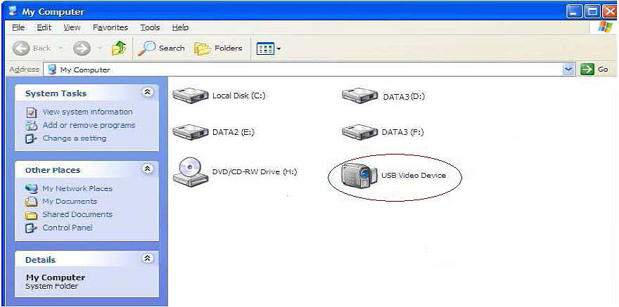

2. Double click the Video device icon as above red marked in your
computer. Now it is ready to use.
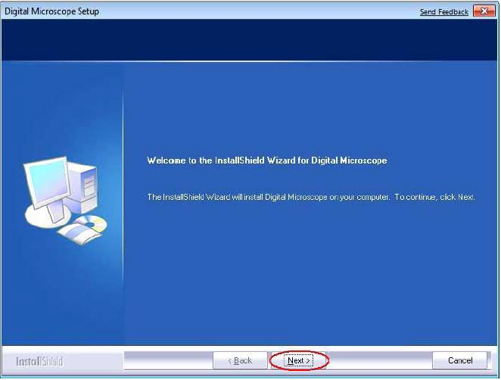
Click“next”to continue，as followings:
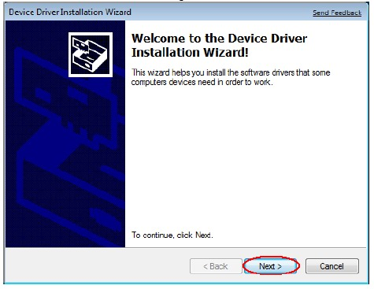
Click“next”to continue，as followings:
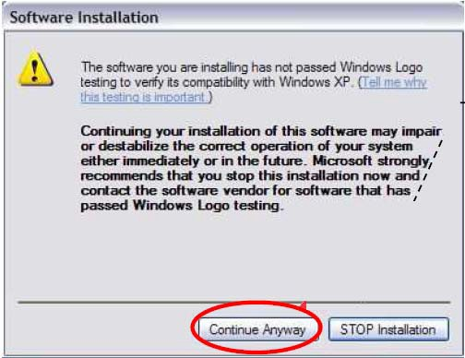
Click “continue Anyway”as followings:
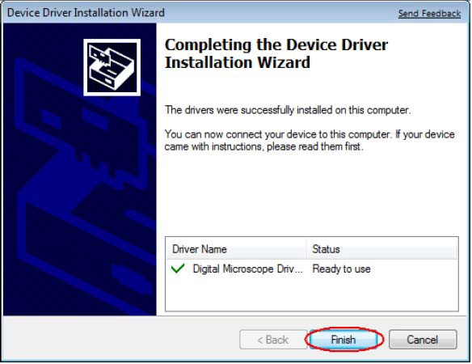
Click“Finish”to continue，as followings
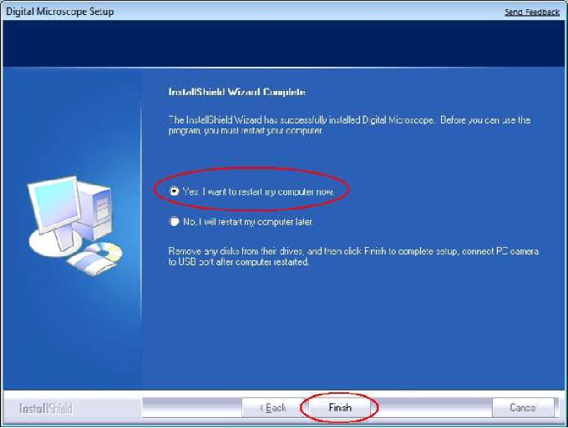

Select ’YesI want to restart my computer now’and click “finish”.
After restart your computerPlug-in the USB port of Digital Microscope into Computer USB port. Following the user guide by steps and complete by click “Next” - “Continue anyway” - “Finish”.

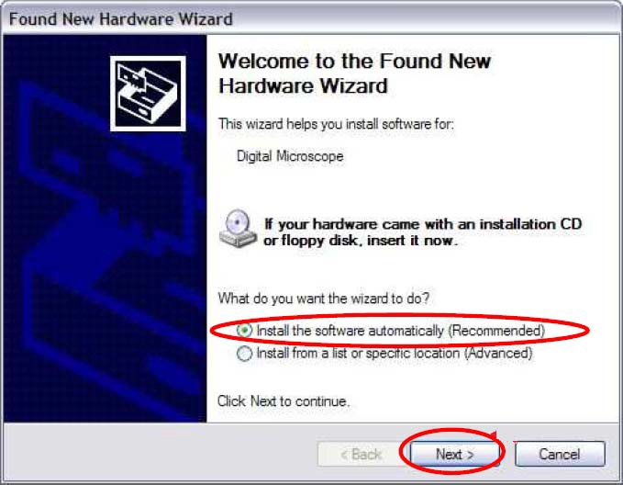
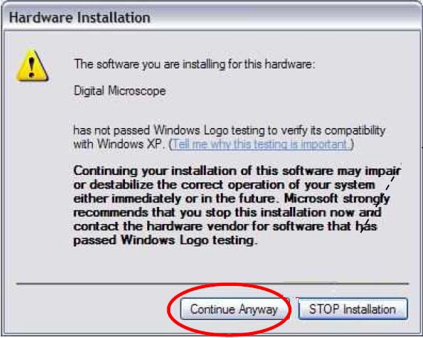
2 Measurement installations:
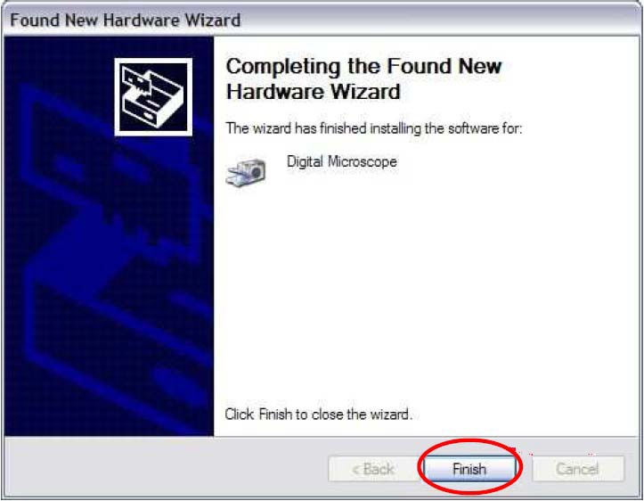
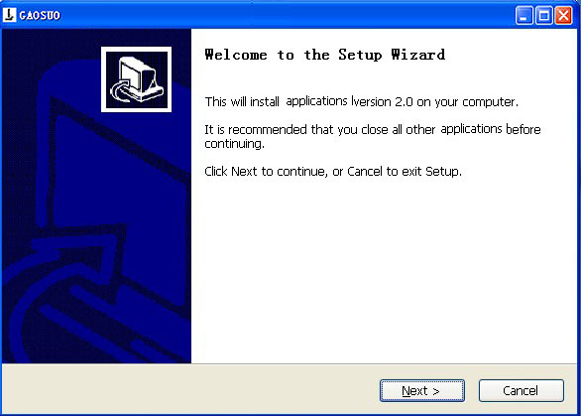2 Click “next” to continueas followings
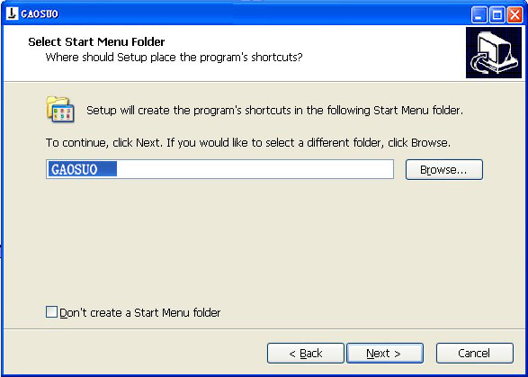
3. Click “next” to continueas followings
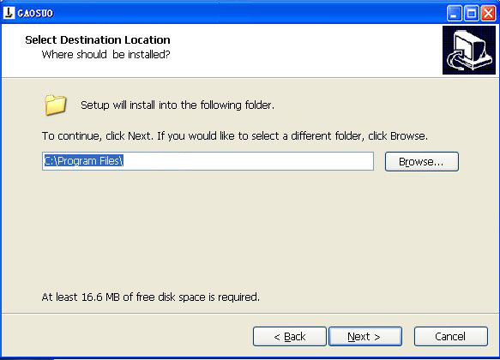
4. Click “next” to continueas followings
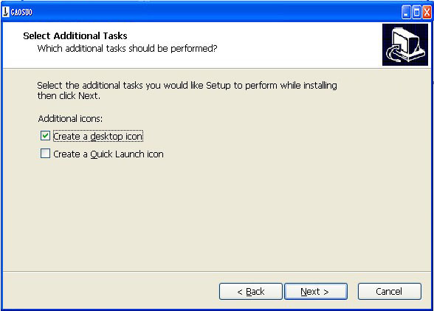
5. Click “next” to continueas followings
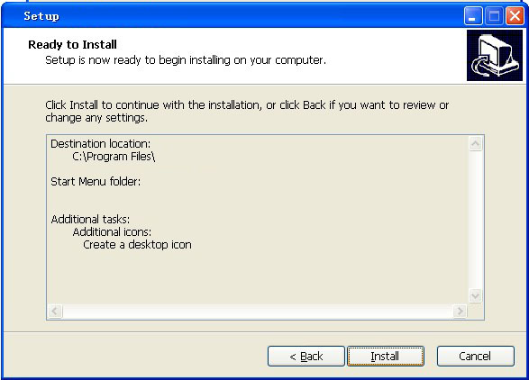
6 Click “Install” to continueas followings
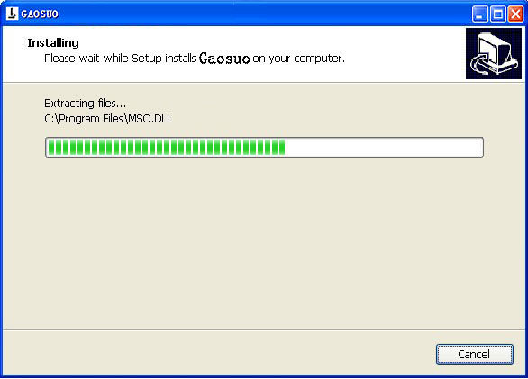
Wait a few seconds while the installation taking place.
7.Click “Finish” and the installation completes.
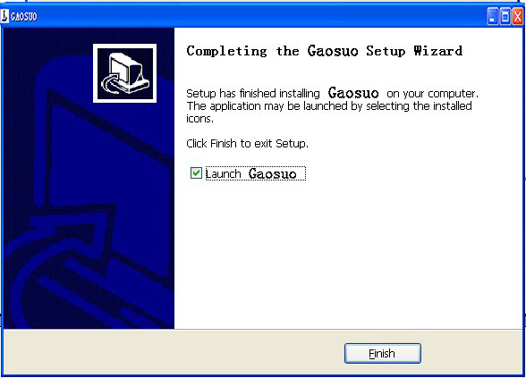

8.After the installation completesdouble click at computer desktop to start using the software.

9 Click open the operation system

Choose the Image resolution from 320*240 to 1600*1200default at VGA Mode640*480

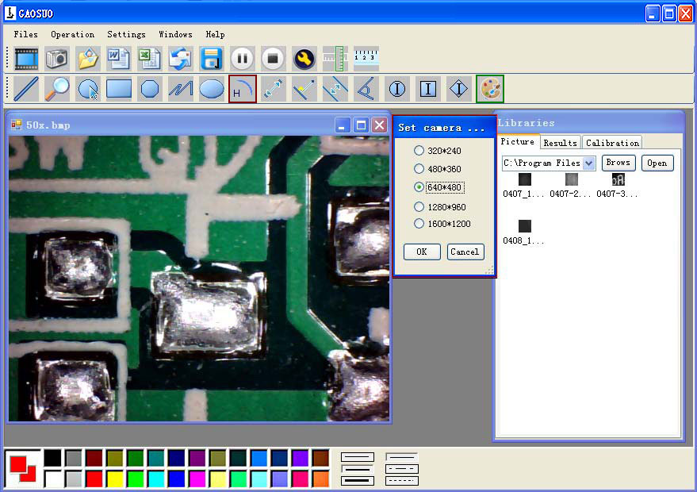
10 Click to use measurement function.
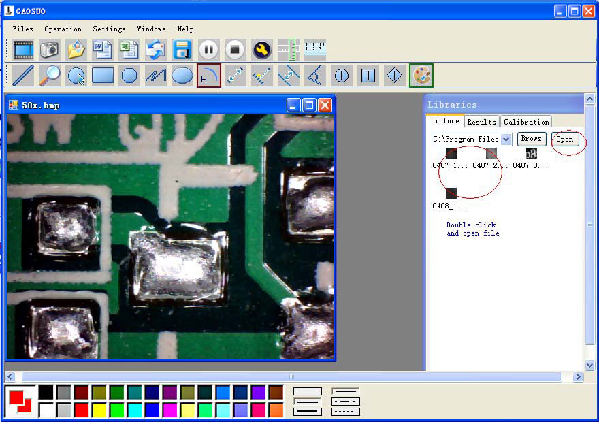
11 Click to open picturesand click to save pictures
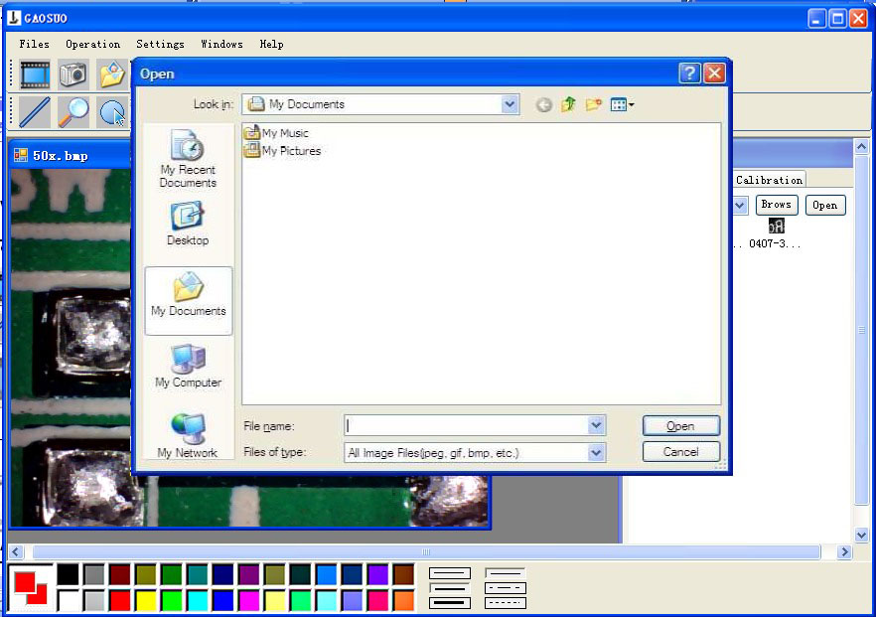

12 Click Video PLAY(Pause)STOP

13Image Parameter including Image setting and special effects
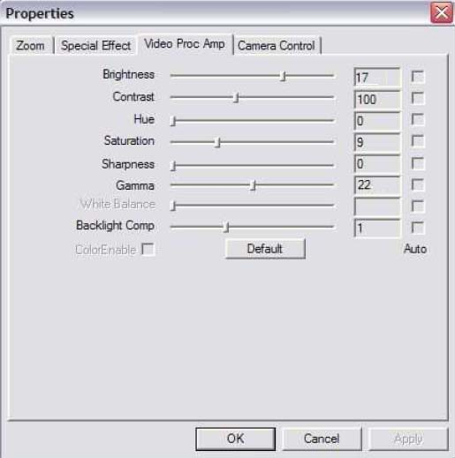

15Magnifier

16 ClickRulleras followings

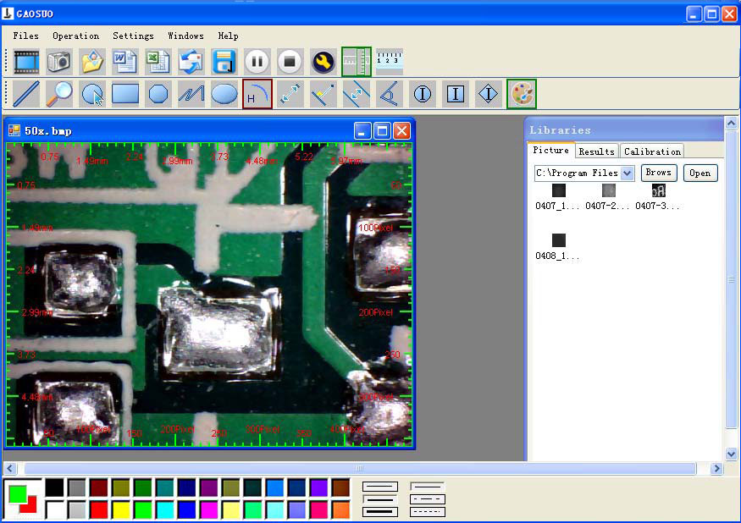
17 Click 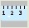 start calibration make sure certain accuracy.
Our experience told us that measurement could be controlled at 99% high precision. Measure tolerance could be caused from human eye distortion and defocus. More practice is helpful to measurements.
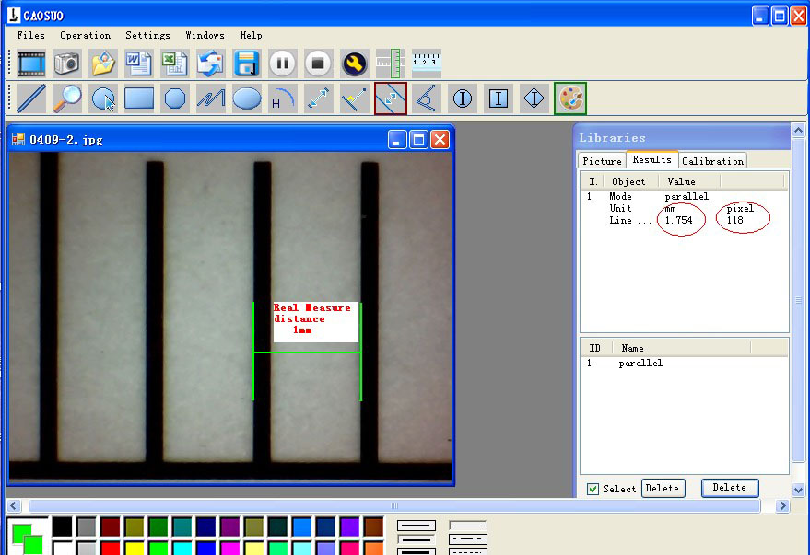
18 Key in the Measure data(Pixel)Unitand Click’ OK’
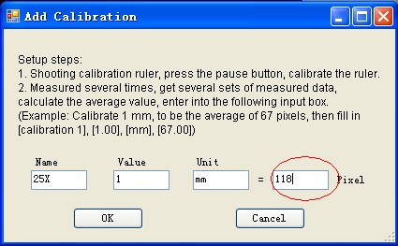
Warning:
Please do calibration again once Magnification Ratio changed.

19 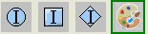Color setting of display character
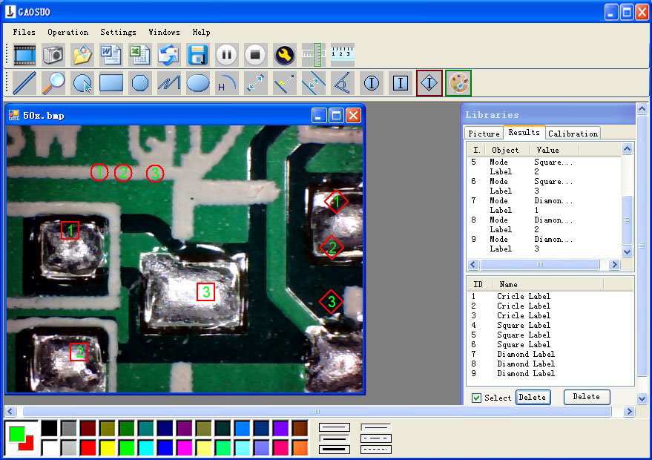

From Left to right:
Line ring Square Polygon Set-line Length
Oval Arc Point to Point distance Point to Line distance
Parallel line Angle
(as below show)

20 Clickto export word or excel format.
Example: Measure data under word file
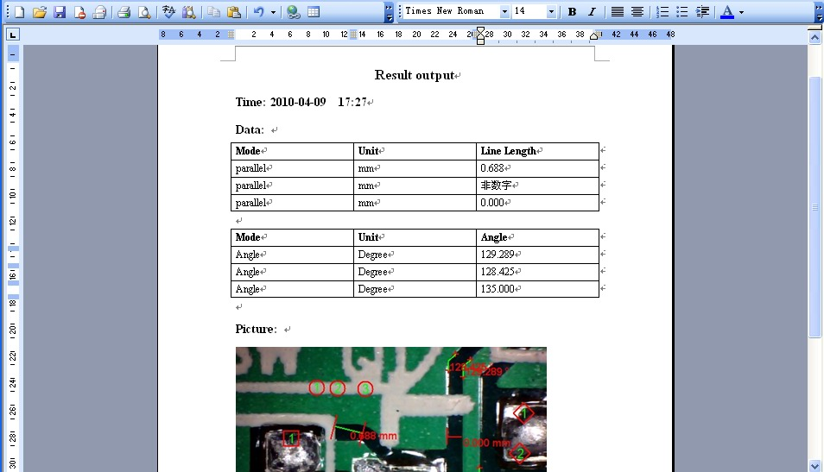

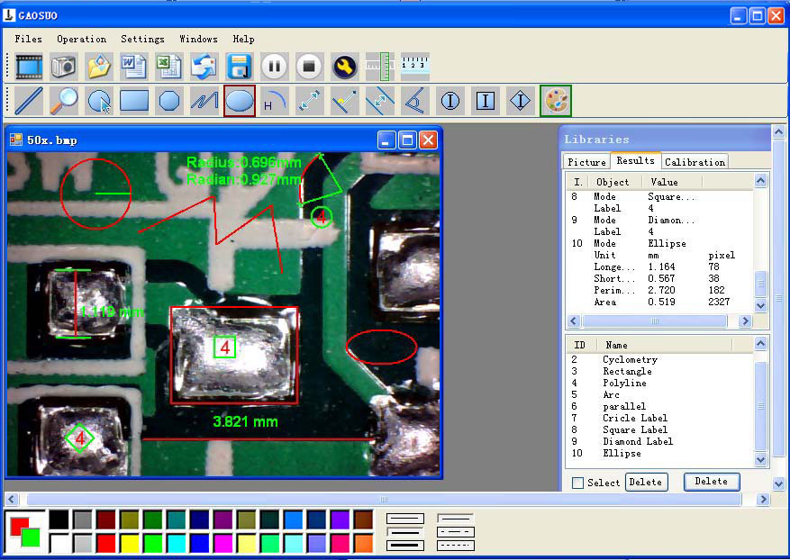
For example 1 Line measurement:
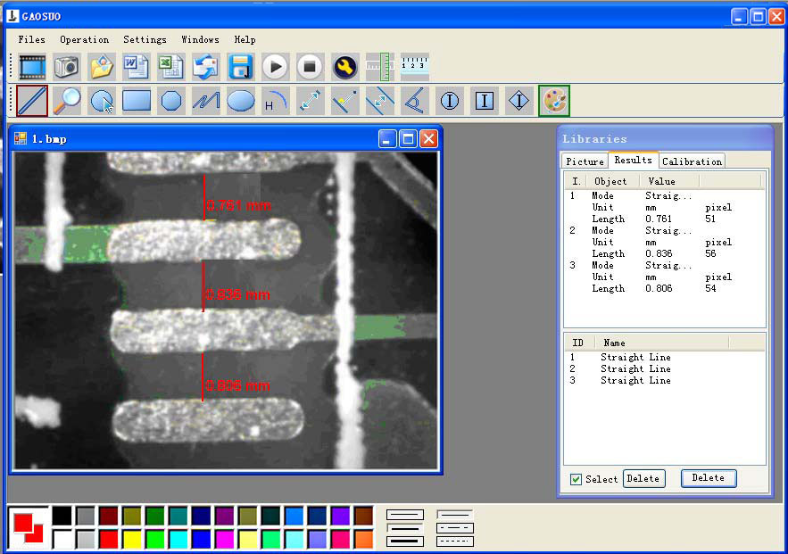
For example 2 Rectangular measurements:
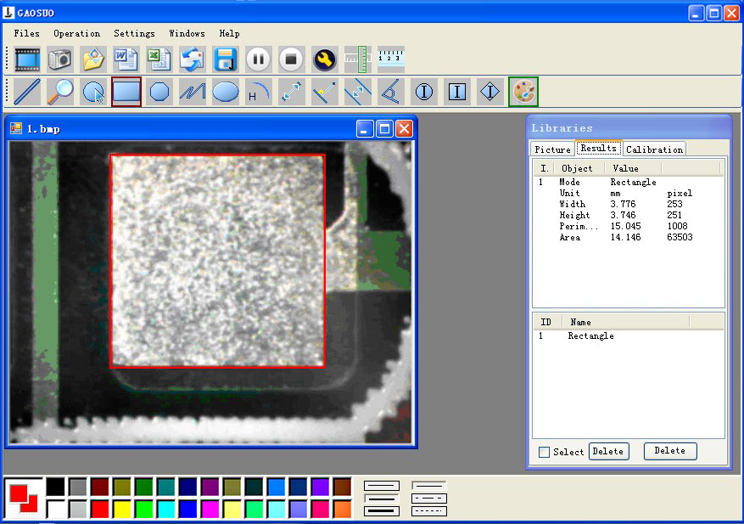
For example3 Ring measurements:
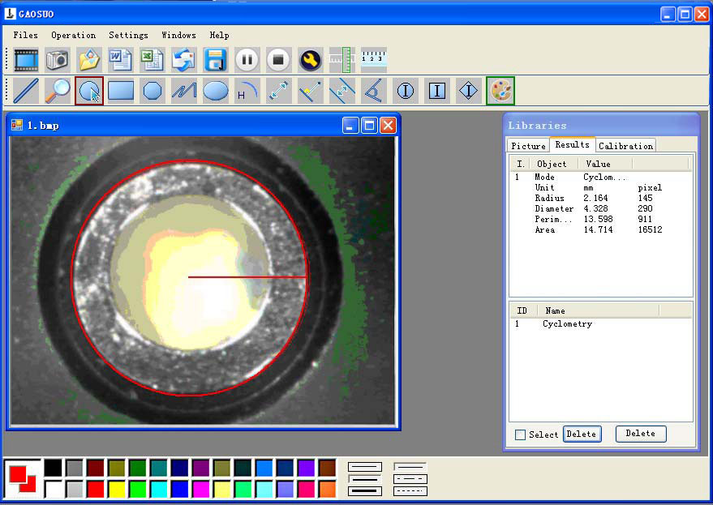
For example 4 Arc measurements:
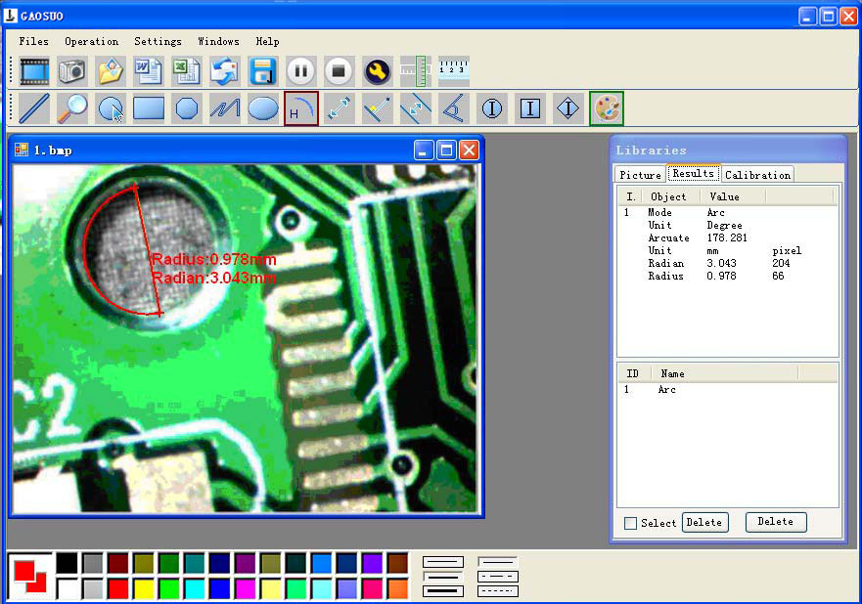
3Please click
to Continue when the NET
Framework2.0 is necessary

