Head Up Display

User Manual

Introduction
Thanks for purchasing our HUD. This HUD is designed to reflect your vehicles computer information onto your windshield offering a safer driving experience day to day as well as more importantly at high speeds and during night driving. As it removes the need for the driver to dip their head to view the instrument cluster. Installing this unit correctly will enable you to more effectively monitor your speed, this is helpful for novice drivers as well as experienced drivers in potentially avoiding speeding infringements.

Our HUD uses the most up to date technology throughout both its hardware and software as well as aesthetical design boasting a unique and elegant shape in its aesthetic final assembly.

To ensure your unit is set up and functioning properly it is crucial you read and
follow this user manual’s set up procedures.

If you encounter any issues please don’t hesitate to contact your nearest reseller.
HUD Main Features:
1. Plug and Play connectivity with any OBDII or EUOBD capable vehicle;
2. 2D visual effect
3. 5.5” screen
4. Multi colour design makes the screen easier to read highlight important details for quick viewing;
5. The use of nanotechnology to eliminate unwanted reflections making the information easier to read;
6. Ability to display a huge range of car statistics including: speed, engine rotational speed, water temperature, battery voltage, instantaneous fuel consumption, average fuel consumption, local time,single driving time,mileage measurement, shift reminder, fatigued driver reminder, low voltage alarm, high temperature alarm, speed alarm, engine fault alarm, fault code elimination, ability to change units e.g. Kilometre/mile
7. Auto power on and off with the vehicle
8. Automatic and manual brightness adjustment mode

HUD Buttons:
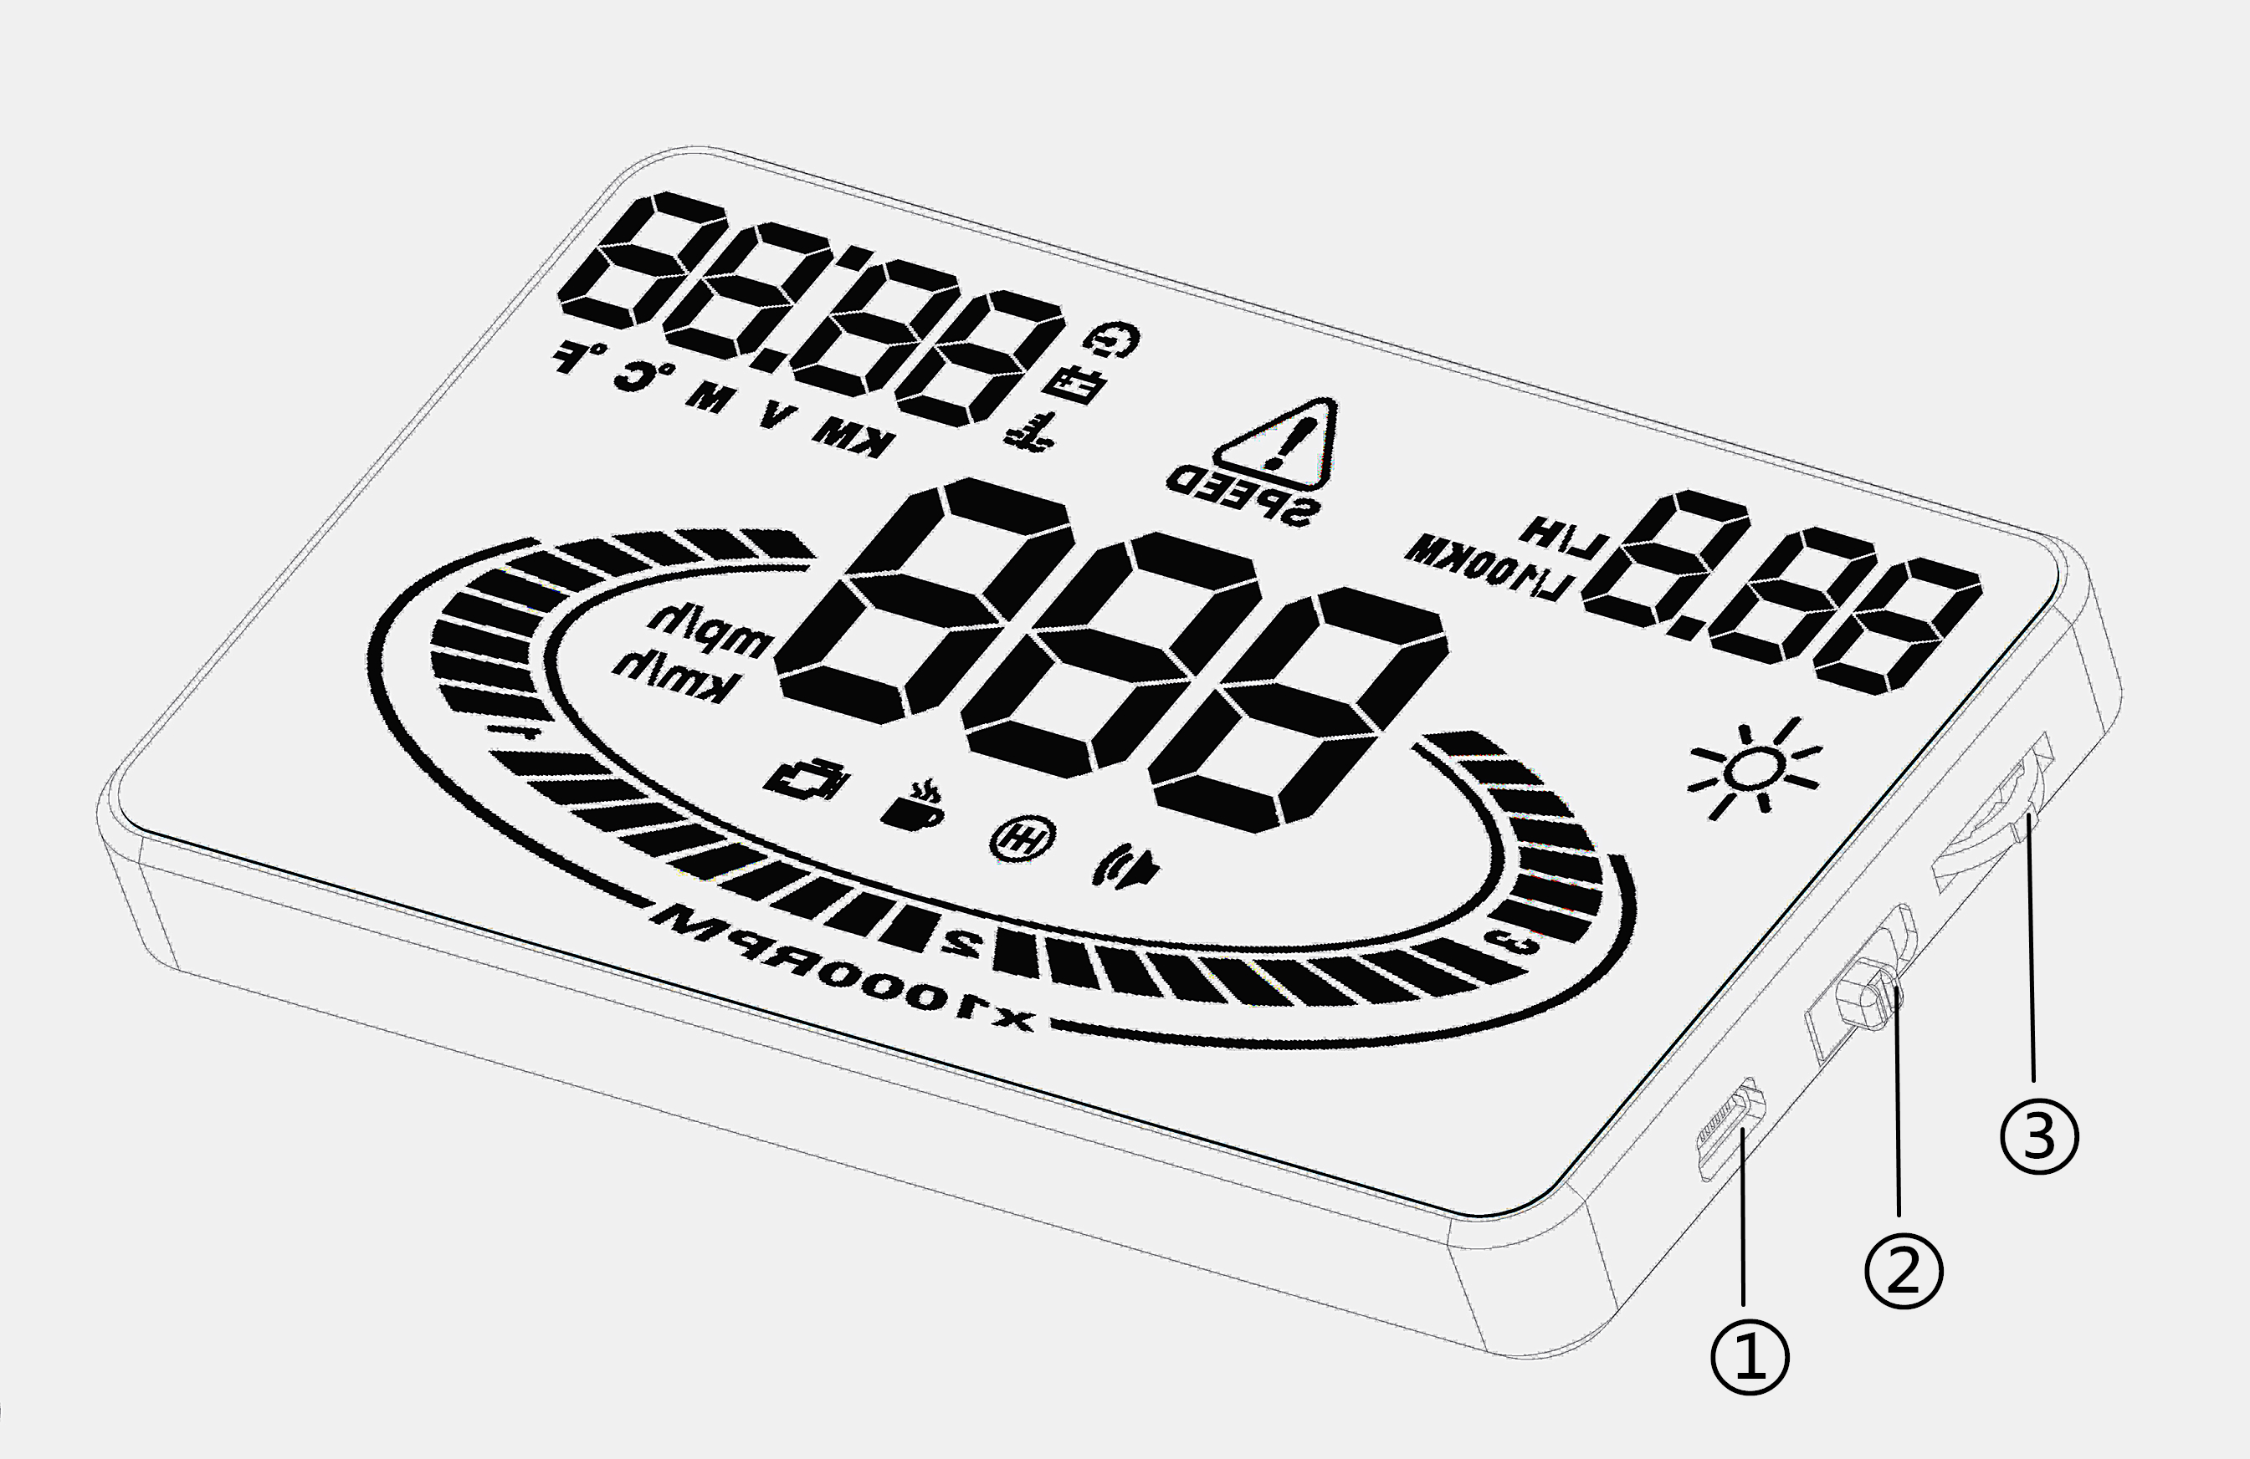
1. OBDII cable input
2. Power button
3. Three way wave button:
a.Up button = up motion
b.Ok button = inward button press
c.Down button = down motion

HUD Display:
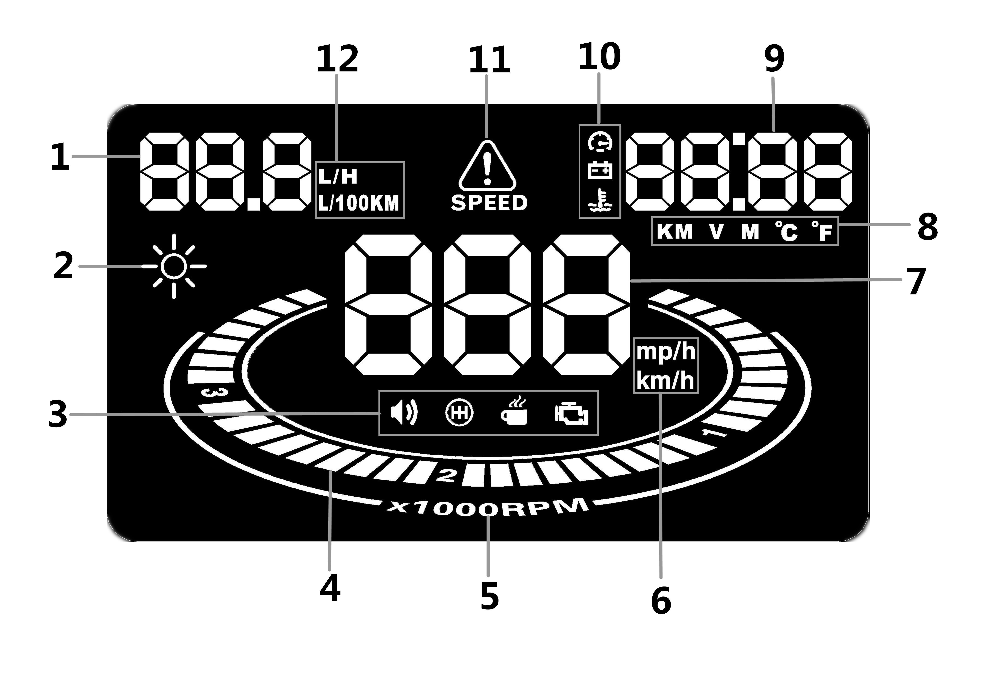
1.Fuel consumption: average fuel consumption per 100km, instant fuel consumption.
2.Brightness sensor: Changes the unit’s display brightness to suit the constantly changing environment whilst driving.
3.Alarm icon panel: From left to right, buzzer, shift reminder, fatigued driver reminder,engine fault.
4.Rotational speed: Indicates the rotational speed of the engine.
5.Rotational speed units: indicating the units of rotational speed.
6.Unit mark of speed:
- KM/H = Kilometres/hour
- MPH = Miles/hour
7.Speed: Live speed
8.Unit mark: From Left to right
- KM = Kilometres
- V = Voltage
- M = Miles
- Degrees (Celsius or Fahrenheit)
9.Multifunction display window: Voltage, Mileage, Water temperature.
10.Secondary Alarm icon panel: From top to buttom,speed alarm, battery voltage alarm, Engine temperature alarm
11.speed alarm icon
12.Fuel consumption unit mark:
- L/100km = Litres/100 kilometres,
- L/H = Litre/hour

HUD installation procedure

1.Ensure your vehicle is OBDII compatible or EUOBD.
a. Check around the area under the steering wheel for an OBD plug
b. Contact your vehicle manufacturer or search online
c. Open the bonnet and look for a OBDII compatible sticker (this is NOT on all OBDII compatible cars, therefore isn’t a deciding factor)

2.Locate the 16 pin diagnostic link (see picture 2). This is usually located in the area under the steering wheel.
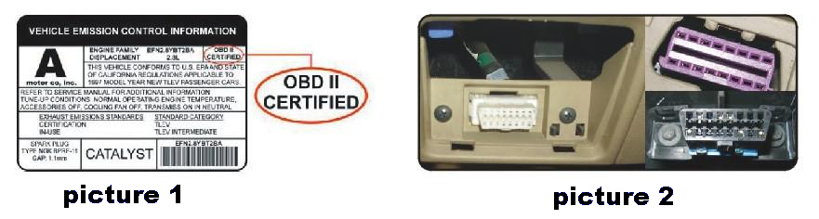

3.Start vehicle’s engine and ensure power switch is in the on position.
4.HUD will power on with engine
a. If the HUD displays vehicle voltage, fuel consumption, speed and rotational speed the unit has installed correctly.
b. Failing the above: Wait up to one minute for software to sync and confirm OBD cable is plugged in properly.

Reflective film installation
Using the unit without the reflective film may result in a double image observed by the user depending on the windshield. If you see a double layer it is due to the windshields dual layer construction and you should install the film by following the instructions below.

1. Place the supplied non-slip mat in the desired position on the dashboard with the HUD on top.
2. Observing where the HUD reflects place the reflective film in position.
a. Ensure the surface is clean and dry before installing the film;
b. Remove the back protective side marked (1) and attach the film to the clean windscreen;
c. Once you’re satisfied with the location use a credit card or similar to remove any bubbles or air pockets that remain;
d. Remove the front side marked (2), if you need to adjust the HUD’s reflection, reposition using the nonslip mat.

The First Use of HUD
Engine starts and HUD powers on accordingly, then it shows current voltage of the vehicle. Later on, it enters to the model of searching vehicle ECU version. Next, the HUD displays fuel consumption, speed, rotation speed to indicate its complete installation. (If it keeps displaying only voltage for a minute, please check whether HUD, OBDII cable and OBDII interface are correctly connected and make sure their tightness. Switch HUD on and scan again.)

1.HUD Setting
A vehicles instrument cluster has an offset value meaning the value displayed on the factory instrument cluster is slightly higher than that computed by the vehicle. This offset value is different for different vehicle manufacturers. As a result we have built in our own offset from a large range of test data. If you find the value on your dashboard is different to the value displayed by the HUD you can change it through the following procedure.

A..Enter the setting mode by holding inward the wave button for 5 seconds.
- Wave button functions
。Press inwards = OK button
。Scroll down = down button
。Scroll up = down button

B. Once in the setting mode press the OK button to advance menu through the screens (see below), and the scroll buttons to adjust the parameters. The screen number you’re in is displayed in the top left hand corner.
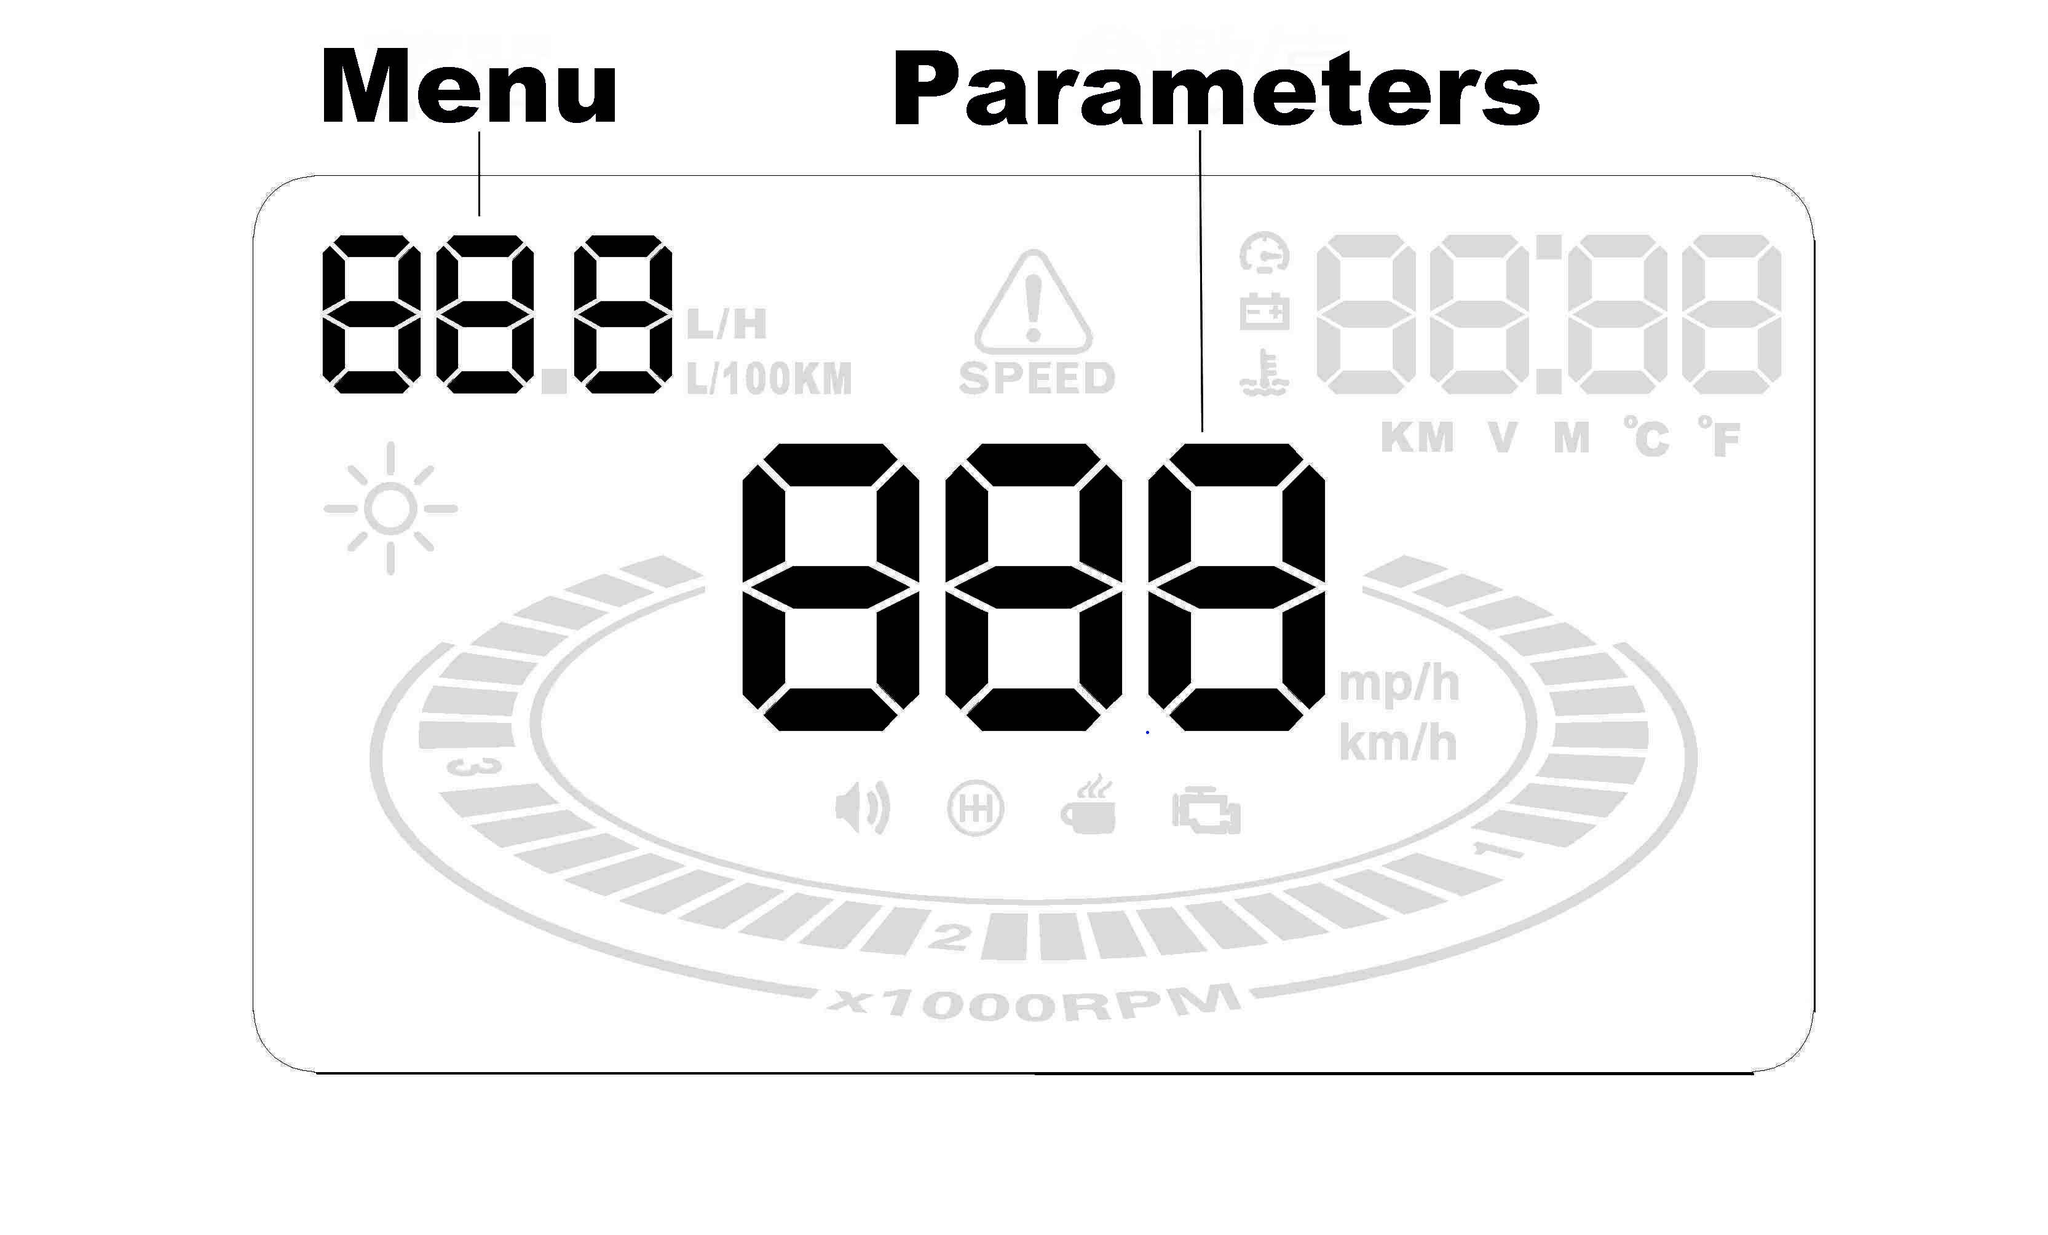

C.Once finished exit out of the setting menu by holding inward the wave button again for 5 seconds.
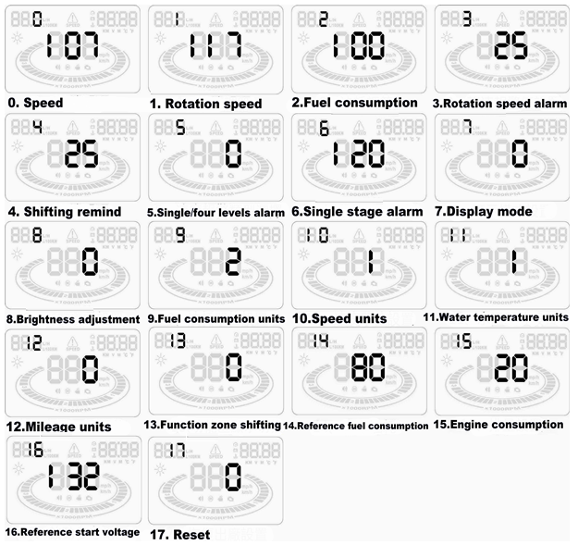

Menu | Parameters | Adjustable range | Explanation | Default
0 | speed | 50-150 | Adjustable range is 50%-150% | 107
1 | Rotation speed | 50-150 | Adjustable range is 50%-150% | 117
2 | Fuel consumption | 50-150 | Adjustable range is 50%-150% | 100
3 | Rotation speed alarm | 10-75 | Adjustable range is 1000-7500r | 30
4 | Shifting remind | 0-75 | Adjustable range is 1000-7500r | 30
5 | Single/four levels alarm | 0-1 | 0 for manual setting, and 1 for four level alarm(60,80,100,120KM/H) | 0
6 | Single stage alarm | 30-250 | Setting range is 30km/h-250km/h | 120
7 | Display mode | 0-2 | 0 refers to automatic mode: when the speed is under 80KM/H, it displays all the data; when the speed exceeds 80KM/H, it turns to high-speed display mode. 1 refers to displaying all the data. 2 refers to high-speed display mode: just displays speed and fuel consumption.) | 0
8 | Brightness adjustment | 0-2 | 0 refers to auto-adjusting brightness, 1 refers to the darkest and 2 for the brightest. | 0
9 | Fuel consumption units | 0-2 | 0 refers to no fuel consumption display, 1 refers to L/H and 2 refers to L/100KM. | 2
10 | Speed units | 0-2 | 0 refers to nothing, 1 refers to KM and 2 refers to MPH. | 1
11 | Water temperature units | 0-2 | 0 is to display water temperature，1 refers to ℃，2 refers to ℉ | 1
12 | Mileage units | 0-1 | （KM/M shift）0 refers to KM, while 1 refers to M. | 0
13 | Multi-function | 0-5 | Local time, mileage, single driving time, engine rotationg speed, voltage, water temperature | 0
14 | Reference fuel consumption | 10-500 | Fuel consumption of factory setting(for fuel consumption calculation) | 80
15 | Air Displacement Setting | 0-100 | 0 represents that the fuel consumption is measured by air flow, and 1 by reference fuel consumption. 2,3,4...100 represents that your fuel consumption is 0.2L, 0.3L, 0.4L...10.0L. | 20
16 | Reference start voltage | 110-150 | It’s automatically power on/off voltage of the HUD, and you needn’t set. | 132
17 | Reset | 0-1 | Set it to 1 and straightly press the wave button for 5s to exit, then reset is done. | 0

2. Short press vertically the wave button,
to switch display contents, including local time, water temperature, voltage, mileage, single driving time, engine rpm,

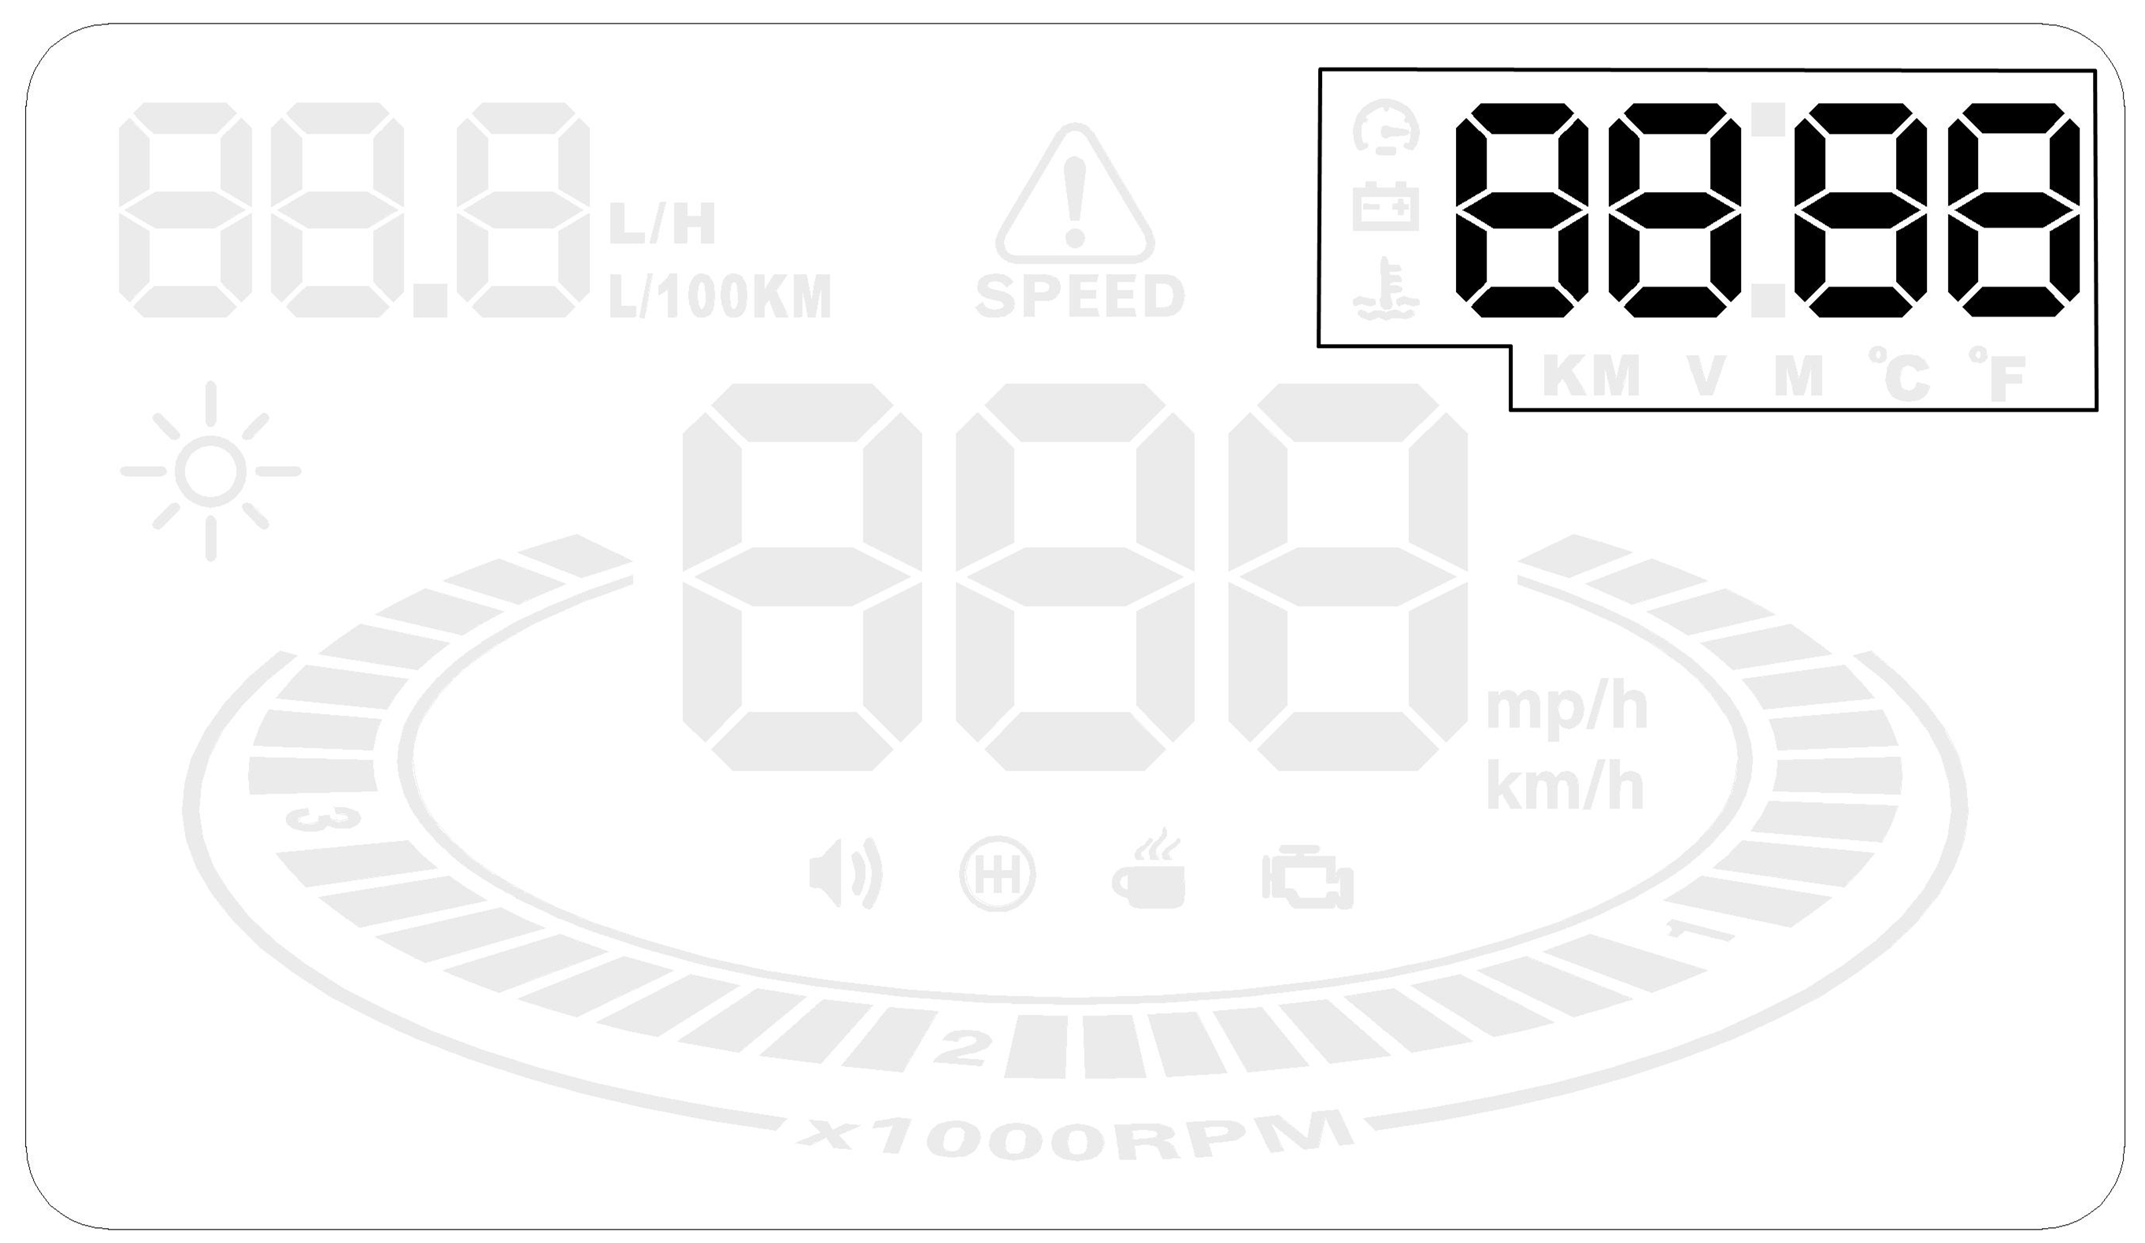
3. Buzzer on/off setting.
Dowturn the wave button for 5 seconds and the alarm buzzer icon will turn off. Upturn the wave button for 5 seconds and the alarm buzzer icon will turn on.

4. Local time adjustment
Power on the HUD and it enters to the display mode. Please short press the wave button until it displays local time on the top right corner. If the HUD display local time is not correct,please press the wave button upside for 5s,the local time icon start to flash, press the wave button upside or downside to adjust the time, long press vertically for 5s to save and exit.

5. Clear fault codes：
Connect this HUD with your car, but do not start the engine. Next, switch the key to “ON” and waiting for the HUD to turn off. Then, please long press the wave button downside for 5s, and you will hear a "tick" sound from HUD, which means the succeed of clearing fault codes.

6. Resore to factory setting
Power on the HUD, and then long press vertically the wave button for 5s to enter the menu setting. Next, shortly press for many times till the menu 17 and move the wave button to the downside till the parameters display 1. Finally, please vertically press the wave /button for 5s to exit and finish.

Technical parameters:
Environment temperature - 40 ⁰C— +80 ⁰C
Barometric press:86-106KPa
Relative humidity:10%-95%
Environment noise:<=60dB
Alarm decibel:>=30dB(A)
Work voltage:9V~16Vdc(12Vdc/400mA)
Product dimensions:12.5*7.5*1.5(cm)
Product weight:110g

Common problems, its causes and solutions
Problem | Possible reason | The way to solve
No speed display | The setting value is too high or the function is closed | Cancel stages of alarm and open the switch of alarm
No rotating speed display | The setting value is too high or the function is closed | Reset the unit and open the switch of alarm
No display after starting | The switch is not opened | Open the switch and check the plug
Inaccurate display of fuel consumption | No air flow sensor | Reset the emissions and then calibrate
No speed or engine speed display | Not compatible with OBDII or EU-OBD port | Contact your vehicle manufacturer
No mileage display | No Settings for fuel and fuel consumption calibration | Switch to manual to input fuel and adjust fuel consumption
Speed is inaccurate | The unit of speed is MPH | Switch the unit of speed to KM/H
Display only shows speed and fuel | Speed exceeds 80KM/H | Enter into settings and switch display mode to 1

