Head Up Display

User Manual

Thank you for purchasing our HUD. This product is for drivers’ safety, especially in high-speed driving at night, HUD can keep driver eyes on the road and can decrease car accident. HUD can project the important information (such as speed) onto the windshield, it can help inexperienced novice to control their speed and to avoid speeding violation in the speed limit road. More importantly, it enables the driver instantly read the number in great vision and always make drivers eyes on the road in clear mind.

Our HUD can display many useful information, and allows you to experience the speed and also to ensure your driving safety and driving pleasure.

Our HUD uses the latest stable integrated circuits, all indexes are in line with the standards. And our HUD has unique and elegant shape, smooth lines, thin body.

Before you using our HUD, please read the instructions in detail.
HUD main features
1. Automatic adaptation car models, and can apply for cars in line with OBD II or EUOBD (onboard automatic diagnostic system).Plug and Play.
2. 3” screen and high-definition display
3. Multi-color design makes the screen more abundant and easier to read
4. The use of nano-technology to eliminate unwanted reflections and can make display information more sharper.
5. Display rich content: speed, engine speed, water temperature, battery voltage, fuel consumption,low voltage alarm, high temperature alarm, speed alarm,free switching between kilometer and mile,free switching between ℃ and ℉.
6. Auto power on and off with vehicle started and shutdown, effective protection of the car battery; while retaining the manual switch mode, and more easy to control HUD.
7. Automatic and manual brightness adjustment mode, driving without glare.

HUD Button function

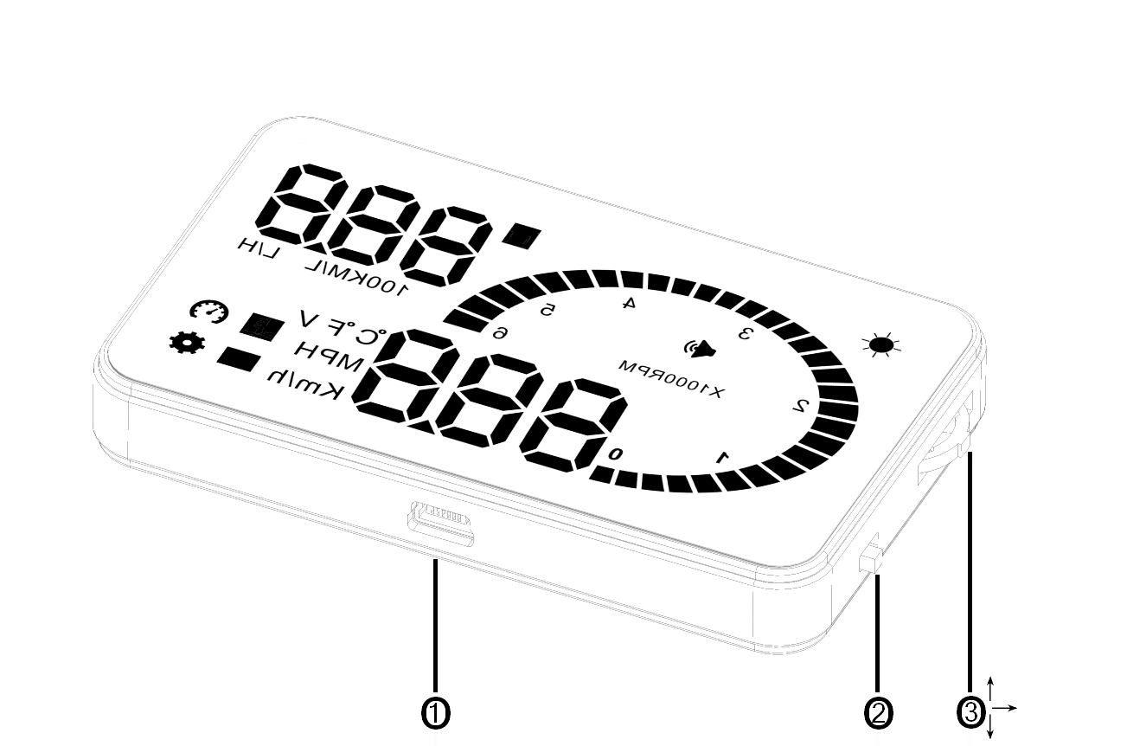
- OBDII interface, to contact the vehicle OBD interface.
2．Button for power on and off
- Wave button: Up button (turning the button to upside),OK button(pressing the button vertically),Down button (turning the button to downside)

HUD display information
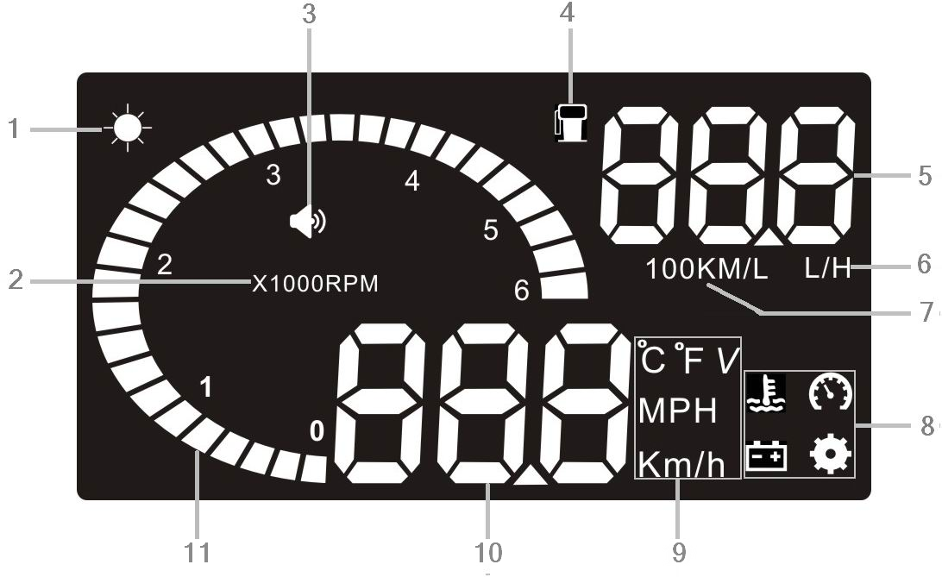

1. Light sensors:brightness can be changed with the change of the outside brightness.
2. Rotation speed: indicates the rotating status of the engine,1 means 1000/min
3. Buzzer mark
- Fuel consumption mark
- Fuel consumption: instantaneous fuel consumption and average fuel consumption
- Fuel consumption unit:L/H
- Fuel consumption unit:L/100km
- Alarm icon：water temperature alarm,battery voltage alarm and over speed alarm.
- Unit mark：℃-degree centigrade, ℉ -Fahrenheit, V -voltage, MPH-Mile per hour, KM/H-kilometer per hour
- Multi-function display：speed,voltage,water temperature.
- Rotation speed: indicates the rotating status of the engine and the scale measured represents the speed reached

HUD installation
1 Know the type of your vehicle. When purchasing HUD, you need to choose the type of vehicle that meets the OBDII standards (or EU OBD) for normal use. Open the engine hood and find the sticker below it (see the below picture 1), if it has words like OBDII CERTIFIED, then it can be installed.
2 Find out the 16 pin diagnostic link (see the below picture 2) of the vehicle and connect it well with OBDII connecting line.
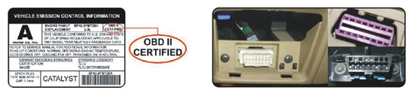
Picture 1 Picturer 2

Reflection film installation
Please Note: HUD project the display information on the car front windscreen , because the windscreen is double, which will make double image on the windscreen when display.The double image of car will be different.If you can see clear the display information, then there is no need to use the reflection film. If there is a double image, then please use the reflection film.

First, please put the supplied non-slip mats in front of the dashboard, and then put the HUD on it.
Second,please stick the reflection film on the windscreen.

The reflecting film should be pasted right above the host machine and it should be able to reflect the whole display screen.

Methods of pasting the film:
1.Spray some water on the place that the film will be pasted on,and then use a dry towel to clean it;
- Tear off the back side（marked 1) of reflection film,then paste it to the right place.
- After you have adjusted the location well, you can use a scratch board or something else flat to slick the film and squeeze the water inside out until there is no bubble or water in it.
- Tear off the front side (marked 2) of the reflection film. If the film cannot display the whole information, please adjust the non-slip mat.

The first use of HUD
Start engine and power on HUD, showing the current vehicle voltage and then enter to search ECU state, if the HUD shows speed, rotating speed, indicating that HUD has been installed successfully. (After 1 minute, or if only display the voltage, please check whether HUD, OBD interface, and OBD data cable are correct connection and plug the OBD cable tightly with vehicle OBD interface and HUD. Open HUD switch, and scan again)

HUD setting
HUD display information is from ECU, because when producing car, there is a difference between vehicle dashboard and ECU , then you can enter the setup mode to fine-tune the HUD display value, in order to achieve exactly the same value as dashboard. We have adjusted HUD according to the general test values at the factory, if you find HUD display information is different from dashboard,then make the following adjustments:
1.Long press the wave button vertically for 5s
Please enter into the setting mode,there are three button for wave button: Up button (turning the button to upside),OK button(pressing the button vertically),Down button (turning the button to downside) , after enter into the setting mode, press the OK button vertically one time, the menu will increase one. Turning the upside button or downside button to increase or decrease the parameter. After finish the adjustment, Long press the wave button vertically for 5s to return to the display interface.
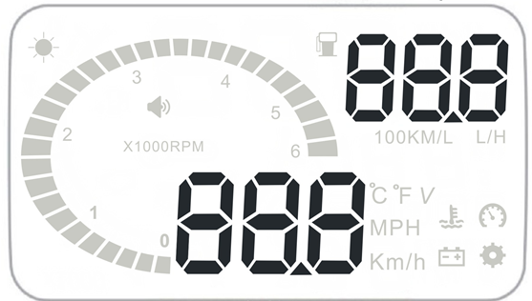

Enter to the setting mode:

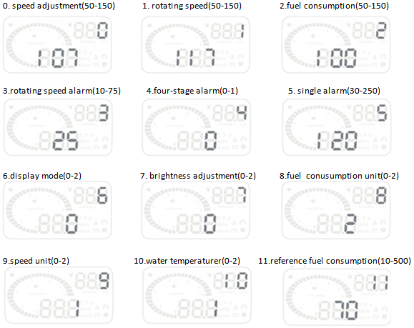
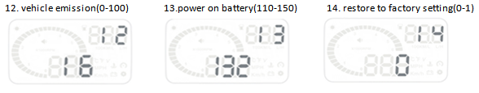

The parameter is as below:
Menu | Parameters | Adjustment range | Explanation | Default
0 | Speed | 50-150 | Adjustment range 50%-150% | 107
1 | Rotating speed | 50-150 | Adjustment range 50%-150% | 117
2 | Fuel consumption | 50-150 | Adjustment range50%-150% | 100
3 | Rotating speed alarm | 10-75 | Adjustment range1000-7500 r | 30
4 | Single/four stage alarm | 0-1 | 0 is a manual mode and 1 is the four-stage alarm value(60,80,100,120KM/H) | 0
5 | Single stage alarm | 30-250 | Setting range is 30km/h-250km/h | 120
6 | Display mode | 0-2 | 0 is an automatic mode: show all with speed under 80KM/H; show high-speed mode with 80KM/H above. | 1
7 | Brightness adjustment | 0-2 | 0 is the automatic adjustment; 1 is the darkest and 2 is the brightest. | 0
8 | Fuel consumption unit | 0-2 | 0 is not display，1 is L/H, 2 is L/100KM | 2
9 | Speed unit | 0-2 | 0 is RPM,1 is KM, 2 is MPH | 1
10 | Water temperature unit | 0-2 | 0 is to display water temperature，1 is ℃，2 is ℉ | 1
11 | Reference fuel consumption | 10-500 | Vehicle fuel consumption | 80
12 | Air displacement setting | 0-100 | 0 means the vehicle has the air flow meter; 1 means the reference fuel consumption.  2,3,…,100 means vehicle emission is 0.2 L,0.3 L ,…,10L respectively. | 16
13 | Start reference voltage | 110-150 | This is the auto power on and off voltage of HUD, and no need to set | 132
14 | Restore to factory setting | 0-1 | Set to 1，vertically press the OK button for 5s, then return to the display interface. | 0

2.Vertically short press the OK button：
Switch the display information,e.g. water temperature, battery voltage, speed

3. Downside turn the wave button for 5s,the alarm buzzer icon will off, and downside turn the wave button for 5s again, the alarm buzzer icon will on.

4. Clear the fault code：
When HUD connected cars, please do not to start the engine, put the key to “ON” gear, and wait HUD to off. Long press the downside key for 5 seconds, then you will hear a "tick" sound from HUD, which means HUD clear the fault code.

Technical parameter:
Environment temperature - 40 ⁰C— +80 ⁰C
Barometric press:86-106KPa
Relative humidity:10%-95%
Environment voice:<=60dB
Alarm of sound level:>=30dB(A)
Work voltage:9V~16Vdc(12Vdc/400mA)
Size of product:9*5.4*1.2(cm)
Weight of product:40g

Common problem, the reason and the solve way
Problem | Possible reason | The way to solve
No speed alarm | The setting value is too high or the function is closed | Canceling stages of alarm and open the switch of alarm
No rotating speed | The setting value is too high or the function is closed | Resetting and opening the switch of alarm
No display after starting | The switch is not opened | Opening the switch and check the plug
Inaccurate display of fuel consumption | No air flow sensor | Resetting the emissions and then calibrating
No speed and engine speed display | Not conform to OBDII or EU-OBD port | Contacting with auto manufacturer
Speed is inaccurate | The unit of speed is MPH | Switching the unit of speed to KM/H
Only display speed and fuel | Speed exceeds 80KM/H | Entering into set and switch display mode to 1

