Head Up Display
User Manual

Introduction
Thank you for purchasing our car HUD Head Up Display. HUD is for drivers’ safety, at high speeds, especially in high-speed driving at night, in order to avoid the driver to look down their head to watch the instrument, and decrease car accident. HUD is in extremely critical moment reflects its delicate care. HUD can project the dashboard information (such as speed) onto the windshield, it can not only to help determine the speed of inexperienced novice to control their speed and avoid many of the speed limit road due to speeding violation. More importantly, it enables the driver instantly read the number in great vision and always make drivers eyes on the road in clear mind.

Our HUD can display many useful information, and allows you to experience the speed and also to ensure your driving safety and driving pleasure.

Our HUD uses the latest stable performance of integrated circuits design, the indexes are in line with the standards, unique and elegant shape, smooth lines, thin body natural beauty, for your car to add a beauty.

Before you use our HUD, please read the instructions in detail, in order to make full use of all the features of the HUD

This HUD built in ELM327 and with bluetooth version function. Not only you can use the HUD to read all the information on windowscreen, but also you can download OBD APP from Android phone to read more information.

The methods are below:
- Download OBD App from phone
- Open bluetooth of phone to scan,when display“HUD bluetooth”，click connect. The password is 1234
- Open OBD App, click setting and adapter to connect
- When finish connection,back to OBD APP interface to read more information.

HUD main features

- Plug and play. HUD can automatically adapt to vehicle type which in line with OBDII or EUOBD(On-Board Diagnostic System).
- Comprehensive display. HUD can display many parameters at the same time as follows, vehicle speed, engine speed, water temperature (voltage, throttle valve position, ignition advance angle, time of 100 km acceleration),fuel consumption, mileage, low fuel tips, engine failure.
- Three display mode. Driver can chose normal display mode, high- speed display mode and automatic display mode.
- Free switch. Km and mile can be switched freely.
- Suitable size. The display area is 5.5 inches which is very clear for driver to read data.
- Automatic power on and off. Starting with the vehicle starting, stopping with the vehicle stopping to protect the vehicle’s battery. Moreover, HUD can also power on and power off by manual, which is more easy to control HUD.
- Flexible alarm mode. HUD can offer single-stage and four-stage overspeed alarm modes to choose to make driving safer.
- Engine speed alarm. It contributes to shift gear in time to save fuel also has significance to new driver.
- Flexible brightness adjustment. The brightness can be adjusted automatically or manually to reach the best state which is in harmony with the environment.

HUD function
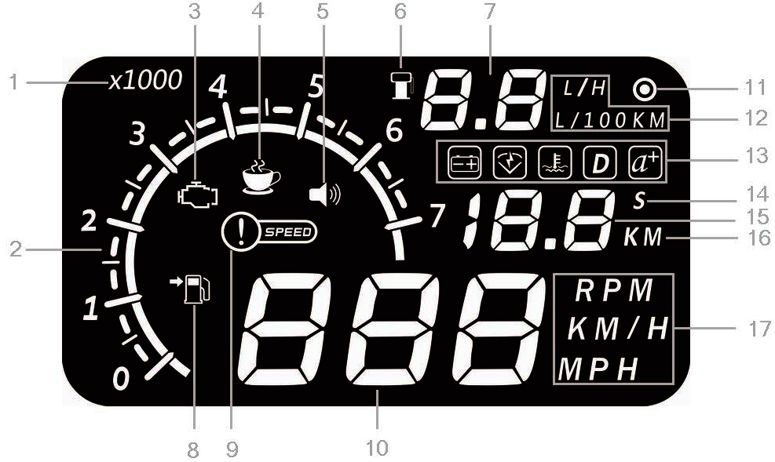

- Rotating speed unit
- Rotate speed: 1 means 1000r/min
- Engine failure
- Fatigue alarm
- Alarm sound switch
- Fuel consumption icon
- Fuel consumption
- Refuel icon
- Speed alarm
- Parameter for RPM,KM/H,MPH
- L/H: Fuel consumption per hour
- L/100KM: Fuel consumption of 100KM
- Voltage,Throttle position,Temperature, Ignition angle, Acceleration
- S: single driving time, the unit is second
- Parameter for driving time and driving distance.
- KM: single driving distance, the unit is KM.
- RPM,KM/H,MPH: Rotating speed per minute,KM per hour,Mile per hour

HUD installation
1 Know the type of your vehicle. When purchasing HUD, you need to choose the type of vehicle that meets the OBDII standards (or EU OBD) for normal use. Open the engine hood and find the sticker below it (see the below picture 1), if it has words like OBDII CERTIFIED, then it can be installed.
2 Find out the 16 pin diagnostic link (see the below picture 2) of the vehicle and connect it well with OBDII connecting line.
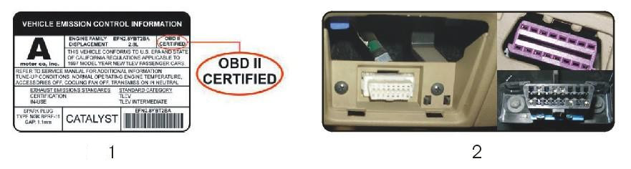
3.Put non-slip mat in flat position in front of the dashboard, you can adjust the angle of the HUD on it.
4.Paste the reflective film above the HUD in order to display the whole information of HUD. (You can ask for the worker in authorized dealer to paste the reflective film)
Some tips to paste:
A.Spray some water on the place that the film will be pasted on,and then use a dry towel to clean it;
B.Tear off the back side（marked 1) of reflection film,then paste it to the right place.
C.After you have adjusted the location well, you can use a scratch board or something else flat to slick the film and squeeze the water inside out until there is no bubble or water in it.
D Tear off the front side (marked 2) of the reflection film. If the film cannot display the whole information, please adjust the non-slip mat.
5.Test the power, you need to turn on the HUD and you will see vehicle’s recent voltage, and then enter into the state of scanning vehicle’s OBD protocol, if the HUD shows fuel consumption, speed, rotating speed, indicating that HUD has been installed successfully.

About the setting of HUD
HUD display information is from ECU, because when producing car, there is a difference between vehicle dashboard and ECU , then you can enter the setup mode to fine-tune the HUD display value, in order to achieve exactly the same value as dashboard. We have adjusted HUD according to the general test values at the factory, if you find HUD display information is different from dashboard,then make the following adjustments:

When HUD and vehicle are connected, please press the wave button for 5 seconds to enter setting mode. Then pressing the button a time the menu adds one. You can plus or minus the parameters by dialing the button left or right. Finally we can back to display screen through pressing the button for 5 seconds or restarting the HUD. (Figure 3)

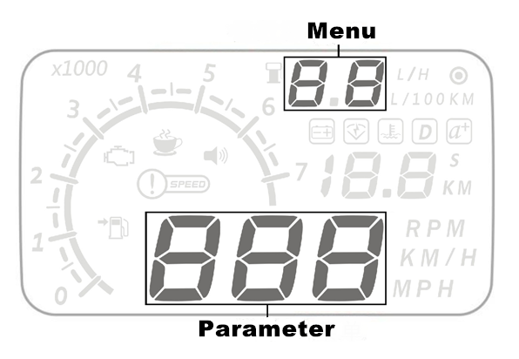

Enter into the adjustment as below
Menu | Parameter | Adjustment range | Explanation | Default value
0 | Vehicle speed | 50-100 | Adjustment range 50%-150% | 107
1 | Rotating speed | 50-100 | Adjustment range 50%-150% | 117
2 | Fuel consumption | 50-100 | Adjustment range50%-150% | 100
3 | Rotating speed alarm | 10-75 | Adjustment range is 1000-7500r | 75
4 | single/four stage alarm | 0-1 | 0 is manual mode,you can adjust to single stage alarm or four stage alarm, 1 is the four stage mode  (60KM/H,80KM/H,100KM/H,120KM/H) | 0
5 | single stage alarm | 30-250 | Adjustment range is 30km/h-250km/h | 120
6 | display mode | 0-2 | 0 is an automatic mode: show all information when speed under 80KM/H; show speed and fuel consumption when speed over 80KM/H. 1 is display all information, 2 is high speed mode: only display speed and fuel consumption when speed over 80KM/H | 0
7 | Brightness adjustment | 0-2 | 0 is the automatic adjustment; 1 is the darkest and 2 is the brightest. | 0
8 | capacity of  fuel tank | 0-150 | Capacity of fuel tank is 0L to 150L. | 50
9 | fuel switch | 0-2 | 0 is the manual; 1 is the vehicle has sensor of fuel level; 2 is closing the function. | 0
10 | input fuel | 0-150 | Fueling 0L to 150L. | 50
11 | Air displacement setting | 0-100 | 0 means the vehicle has the air flow meter; 1 means the reference fuel consumption.  2,3,…,100 means vehicle emission is 0.2 L,0.3 L ,…,10L respectively. | 16
12 | Bluetooth switch | 0-2 | 0 is off the bluetooth function, 1 is bluetooth function is on and the bluetooth icon is on,2 is bluetooth function is on and the bluetooth icon is off. | 0
13 | Start voltage | 110-150 | This is power on and power off reference voltage for HUD,no need to set. When car voltage over 13.2V,HUD will power on and work, when car voltage less than 13.2V, HUD will power off. | 132
14 | Fuel consumption on-off | 0-1 | 0 is off, 1 is on | 1
15 | Reference fuel consumption | 10-500 | Reference fuel consumption of car,no need to set. | 80

* About the 15th fuel consumption explanation:
Setting the reference fuel consumption is based on the Ministry of fuel consumption or car manufacturers released fuel consumption,such as the new Excelle's total fuel consumption is 8.7L/100km, then set in 87 is ok, calculating fuel consumption by reference fuel consumption,and L/H will not display,only display fuel consumption of 100km.
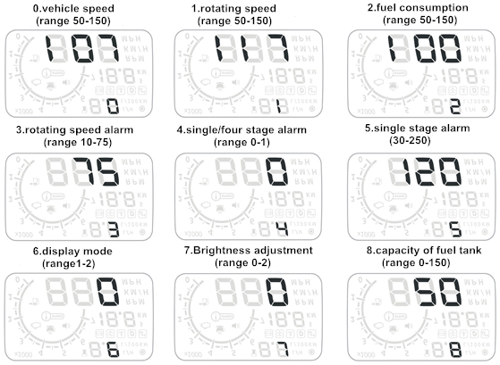
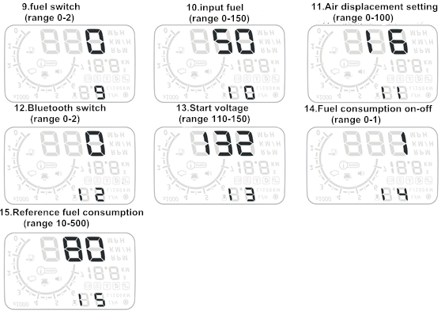

Setting skills:
1.A quick refueling: Start the car,and toggle the dial button right and left to refuel, the unit is L.
2, Generally speaking car produced after 2010 comes with air flow meter,the owner may choose 0 to see whether there is fuel consumption.If there is no fuel consumption,then set emission .
After the adjustment, press the dial switch 5 seconds to return the display interface or restart the HUD.
Restore factory default settings:
When HUD connected cars, please donnot to start the engine, wait HUD finish scanning, then turn off car (or turn off the engine after stopping the car,HUD is off)
Long-press the right key 5 seconds, then you hear a "tick" sound from HUD,which means it restore the factory settings.
Clear fault codes:
When HUD connected car,please donnot start the car, put the key to "ON", waiting for HUD off, long press the left button for 5 seconds, you will hear "beep" sound from HUD, which means clear fault codes completed.

Common operation settings
1. Switch the display information
When the car start and the interface display normally, you can dial the button to right for 5 seconds, and you will see the “functional zone 1” is flashing. Then you can dial left or right to choose what you want to display. To press the button you can enter into the “functional zone 2” by repeating the same steps. Similarly, the “functional zone 3”. Finally you can exit by pressing the button for 5 seconds.
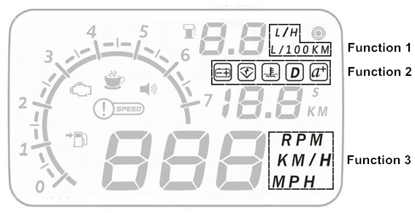

2. Switch of alarm sound
When the car starts and the interface displays normally, you can dial the button to left for 5 seconds, and you will see the icon of voice is closed. Repeating the steps, the icon will be lightened. Just circulate the steps to get what you want state.
3. Fuel quickly
When the car start and the interface display normally, you can dial button
to left or right to decrease or increase fuel consumption. For example, dialing the button until the speed displays 20, that it’s to say you increase 20L oil. (Note: This function is only effective to the fuel switch is 0.)
Function Instructions
1.Parameter value: show the value with the units of kilometers, miles and engine speed.
2. OBDII port: connect the car and HUD.
3.Fuel icon: flash when the fuel is not enough to drive 100km.
4.Engine failure: flash when vehicle’s engine has problems.
5.Engine speed: show the state of engine speed.
6.Engine speed icon: indicate the parameter value of engine with units of 1000r. It will flash when engine speed is alarming.
7.Speed alarm: flash when speed exceeds the preset values.
8.Rest tips: flash when drive continuously for more than 4 hours with HUD starting.
9.Sound switch: light when voice alarm is opened.
10.Fuel consumption icon: show fuel consumption is calculating.
11.Fuel parameter value: show the consumption of fuel in recent driving.
12.Dial button: multi-function switch, you can dial to left or right, you can enter into setting mode by long press. And also has the ability to decrease or increase fuel.
13.Fuel consumption per hour: show oil mass consumption per hour in driving.
14.Light sensor: sense the external light intensity and adjust the HUD’s brightness to adapt to environment automatically.
15.Fuel consumption per 100km: show the fuel consumption per 100km in driving.
16. Voltage, throttle valve, water temperature, ignition advance angle and acceleration per 100km: voltage shows the vehicle’s voltage; throttle valve shows the size of itself; water temperature shows the temperature of vehicle cooling fluid; ignition advance angle shows the angle of twist in firing, it’s also a mark of engine’s efficiency. Acceleration per 100km shows performance of the vehicle’s acceleration per 100km.
17.Seconds: show the unit of acceleration per 100km.
- Parameter value: show parameter value of Voltage, throttle valve, water temperature, ignition advance angle and acceleration per 100km.
- Mileage: light when the fuel only sustains 100km.
- Reel per minute: show the unit of engine speed if you multiply the parameter value with 10.
- Kilometer per hour: show the unit of speed.
- Mile per hour: show the unit of speed.

Common Problems
Problems | Possible reasons | Solutions
No speed alarm | The setting value is too high or the function is closed | Cancelling stages of alarm and open the switch of alarm
No engine speed alarm | The setting value is too high or the function is closed | Resetting and opening the switch of alarm
No display after starting | The switch is not opened | Opening the switch and check the plug
Inaccurate display of oil consumption | No air flow sensor | Resetting the emissions and then calibrating
No speed and engine speed display | Not conform to OBDII or EU-OBD port | Contacting with auto manufacturer
No mileage | No settings of fuel and fuel consumption calibration | Switch to manual to input fuel and adjust fuel consumption
Speed is inaccurate | The unit of speed is MPH | Switching the unit of speed to KM/H
Only display speed and fuel | Speed exceeds 80KM/H | Entering into set and switch display mode to 1

Main Technical Indicators
- Service conditions:
Environment temperature: -40⁰C—+80⁰C
Barometric press: 86—106 KPa
Relative humidity: 10%—95%
Environment voice: <=60 dB(A)
- Alarm of sound level:> =30dB(A)
- Work voltage: 9V~16Vdc(12Vdc/400mA)
- Size of product: 150*85*14 (mm)
- Weight of product: 278g (including the giftbox)

