HDMI 2x1 Multi-Viewer With PIP

User manual
V1.0

Thank you for purchasing this product. For optimum performance and safety, please read these instructions carefully before connecting, operating or adjusting this product. Please keep this manual for future reference.
I. Introduction
This product is a high performance 2 by 1 Multi-Viewer. It supports two High definition input source display on one screen. As a Multi-Viewer, it can display on one screen in 4 modes.
II. Features
- Compliant with HDMI 1.3a,HDCP 1.2；
- Supports multiplexed HDMI 2-input and 1-output and 4 display modes；
- Supports up to 1080p High Definition resolution；
- Support scaler up, scaler down function；
- Support multi output resolution；
- Support digital audio format LPCM/AC3/DTS
III. Package
- HDMI 2x1 Multi-Viewer ------------------------------------------------------------------ 1PCS
- 5V1A DC Power adapter ----------------------------------------------------------------- 1PCS
- Operation Manual ------------------------------------------------------------------------- 1PCS
IV. Specifications
- Video Bandwidth 225MHz[6.75Gbps]
- Input Ports 2 × HDMI (Female type)
- Output Ports 1 × HDMI (Female type),
- Audio output PCM2, 5.1, 7.1CH, Dolby 5.1, DTS5.1
- Input Resolution 480i60Hz,480p60Hz,576i50Hz,576p50Hz,720p50/60Hz,
1080i50/60Hz,1080p24/30/50/60Hz,800x600@60,
1024x768@60,1280x720@60,1920x1080@60;
- Output Resolution 1080p,1080i,720p,1024x768,1360x768
- ESD Protection Human Body model: ±8 kV (air-gap discharge)
±4 kV (contact discharge)
8. Power Supply 5V/1A DC (US/EU standards, CE/FCC/UL certified)
9. Dimensions 70 mm (W)×140mm (D)×25 mm (H)
10. Weight 300 g
11. Chassis Material Metal
12. Silkscreen Color Black
13. Operating Temperature 0 °C~40 °C/ 32 °F~104 °F
14. Storage Temperature −20 °C ~ 60 °C/−4 °F ~140 °F
15. Relative Humidity 20~90 % RH (non-condensing)
16. Power Consumption (Max) 10W

V. Operation controls and Functions
Front Panel
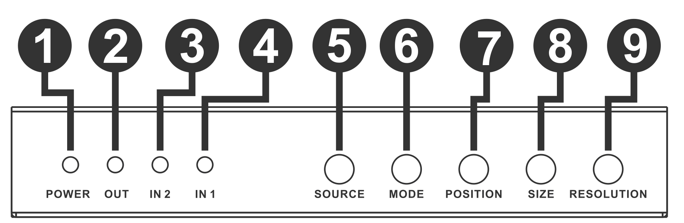
- POWER LED: This red LED illuminates when the device is connected with power supply.
- OUTPUT LED: This red LED illuminates when the TV plug in corresponding HDMI output
Port.
- IN2 LED: This red LED illuminates when the HDMI IN2 is selected as main image.
- IN1 LED: This red LED illuminates when the HDMI IN1 is selected as main image.
- SOURCE: Press the button to select the input source as main image, and the LED will indicate the corresponding input source.
- MODE: Press the button to select display mode. ※ See the description 1.
- POSITION: Press the button to select the position of sub image when in PIP mode.
- SIZE: Press the button to select the size of sub image when in PIP mode.
- RESOLUTION: Press the button to select the output resolution.
NO. | RESOLUTION
1 | 1080P, Main image audio
2 | 1080I, Main image audio
3 | 720P, Main image audio
4 | 1024x768, Main image audio
5 | 1360x768, Main image audio

Rear Panel
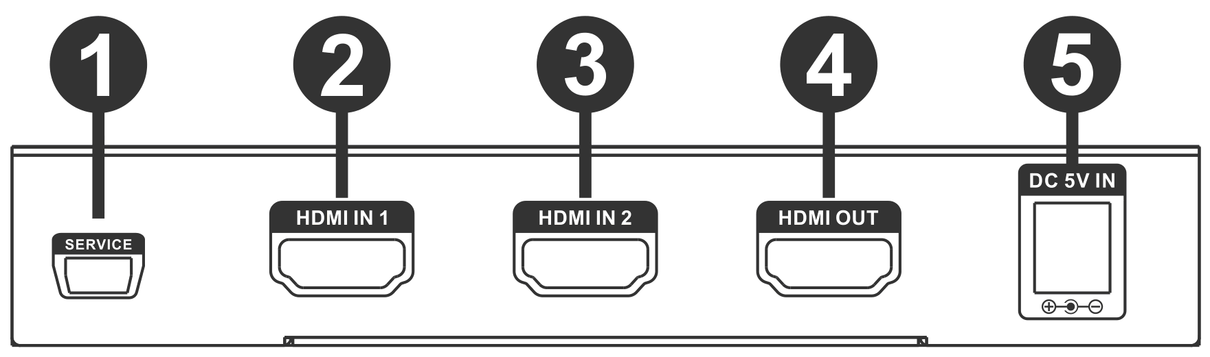
- SERVICE: Connected to computer via RS232 tool, and controlled via host-computer software.
- HDMI IN1: This slot is where you connect the HDMI source output from DVD, PS3.
- HDMI IN2: This slot is where you connect the HDMI source output from DVD, PS3.
- HDMI OUTPUT: This slots is where you connect the HDTV or monitor with HDMI cable.
- DC 5V IN: Plug the 5V DC power supply into the unit and connect the adapter to AC wall outlet.

※ Description 1 Mode Introduction:
1. Mode 1: One-view mode
2. Mode 2: PIP mode
3. Mode3: POP mode A
4. Mode 4: POP mode B

: 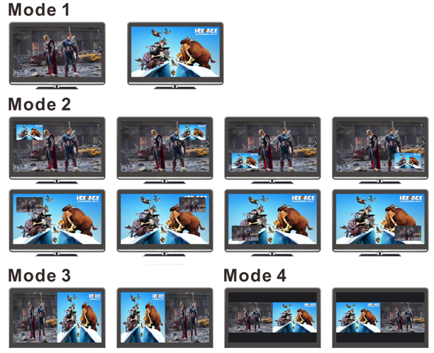
VI. Application Example
