HDMI VIDEO CAPTURE

User Manual

Introduction
The HDMI Video Capture employs HDMI™ technology to receive video and
audio from HDMI input. It can stores the video directly onto a portable USB
hard disk or high speed pen drive. It uses H.264 AVCHD M2TS format, which
guarantees very ef2icient compression and timely delivery. Recorded video
can be played back on any media player, Blu-Ray Disc player or PC/NB that
supports AVCHD M2TS 2ile format.
Package
HDMI VIDEO CAPTURE-------------------------------------------------------1Pcs
5V/2A DC power adaptor----------------------------------------------------1Pcs
Remote Control----------------------------------------------------------------1pcs
User manual--------------------------------------------------------------------1pcs
Feature
It doesn't need to install a driver, and it is truly PnP;
Support recoder video and capture photo to USB storage device;
Support playback video and photo from the usb storage device;
The HDMI Video Caputre formats using the FAT32 2ile system format;
It can automatically detect the input video formats and it will adjust to the
set output size and frame rate automatically;
Fit for recording HDMI videos without computer, its resolution can up to
1080P60;
With HDMI Pass-through function, enables you to play HD games when you
recording it;
With one-button-record button and USB interface, do not need to install any
software;
Portable and Practical, easy and convenient for using, 2it for WiiU Xbox 360
Xbox 1, PS4, ideal for game lovers;
Speci"ication

Host Interface USB2.0 Host;
Input Interface HDMI interface;
HDMI Input Formats: 480i,480p,576i,576p,720p50,720p60
1080i50,1080i60,1080p24/25/30/50/60;
Output Interface HDMI interface;
Output Formats Resolutions: 1080i50,1080i60,1080p50,1080p60;
Encode format: Hardware H.264 encoder
ESD Protection Human-body Model:
± 8kV (Air-gap discharge)
± 4kV (Contact discharge)
Size 135x78x24 (L/W/H, mm)
Weight 120 g
Power consumption 5W
Working Temperature 0-50 deg C
Storage Temperature -20-70 deg C
Storage Humidity 5%-90%
5. Operation Controls and Fuction
5.1 Front Panel
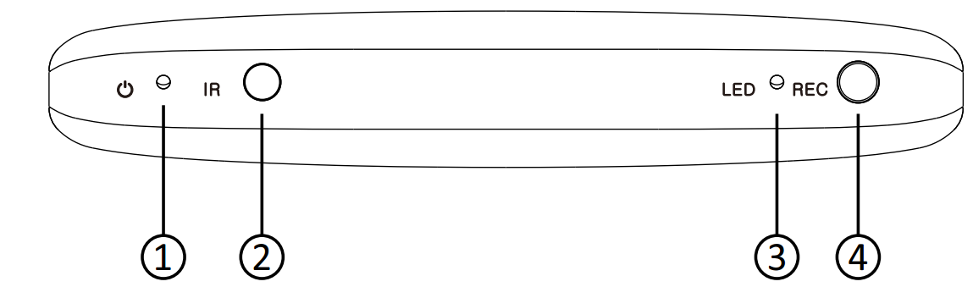
1.POWER LED: This LED illuminate when the device is connected with power supply.
2. IR: Remote control signal receive windows.
3. LED: This LED illuminate when the device detect the Hard-Disc insert,and it
2lash when the system is recoding.
4. REC button: Starts and stops recoding.
5.2 Rear Panel
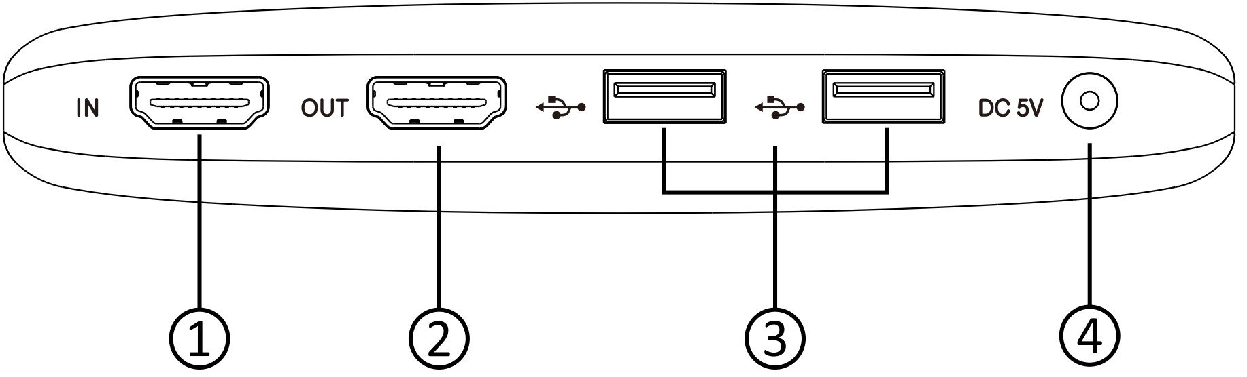
1.HDMI IN: Connect the input port to the HDMI output of your source device
such as a DVD player or set-top box with an HDMI cable.
2. HDMI OUT: Connect the HDMI output to an HDMI display with an HDMI cable.
3. USB Interface: Connects to an external USB storage device, such as a USB
pen drive or USB HDD.
4. DC 5V: Plug the 5V DC power supply into the unit and connected the adaptor
to an AC outlet
5.3 Connect and Operate
Connect the Video Player to the HDMI Video Capture with an HDMI cable.
Connect the HDTV to the HDMI Video Capture with an HDMI cable.
Connect the USB Storage Device to the HDMI Video Capture.
Connect the power cable to the HDMI Video Capture.
Power on HDTV and Video Player.
Power on HDMI Video Capture.
Press the REC button to Recording the video to USB Storage Device.
Press the REC button to stop Recording.
5.4 Remote control

遥控器部份

Connection Diagram
