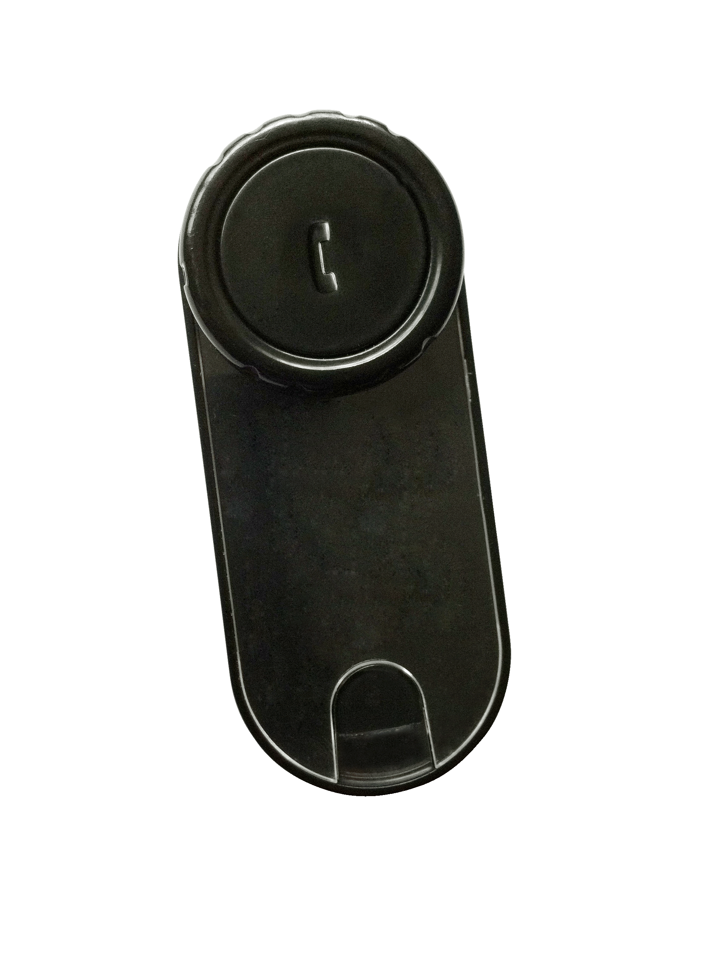
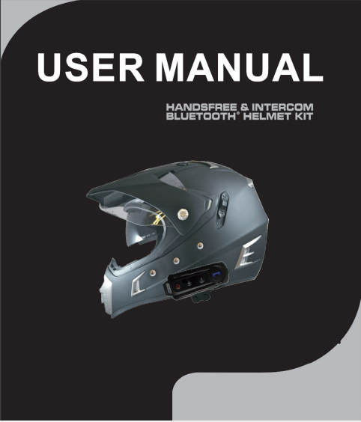 BT-S1 Intercom Features
Automatic answering function
Enjoy the music
Bluetooth Helmet Hands free
All Weather Water Resistant

Index
Package Contents……………………………………………………………………1
Product Descriptions………………………………………………………………...1
Main Features………………………………………………………………………..2
Installing the Clip Mount………………………………………………………..2
Using the Headset Clip Mount with Fastening Clamp………………….2
Mounting the Inter Phone……………………………………………………….3
Quick removal of the Inter Phone…………………………………………...4
Charging the Headset…………………………………………………………….4
Turning the unit on into standby mode ……… ………….. ………………………...5
Turning off the unit……………………………………………..……………….5
To pair to your Bluetooth enabled mobile phone ……………………….5
Phone Controls ………………………………………………………………………..6
Music Controls………………………………………………………………………...6
To Adjust the Volume……………………………………………………...…….6
To Pair 2 devices in intercom mode………………………………………...7
To Pair 3 devices in intercom mode……………………………………..……………7
To Reset the pairing memory……………………………………………..…………..7
To Start FM Radio…………………………………………………………………….8

Package Contents

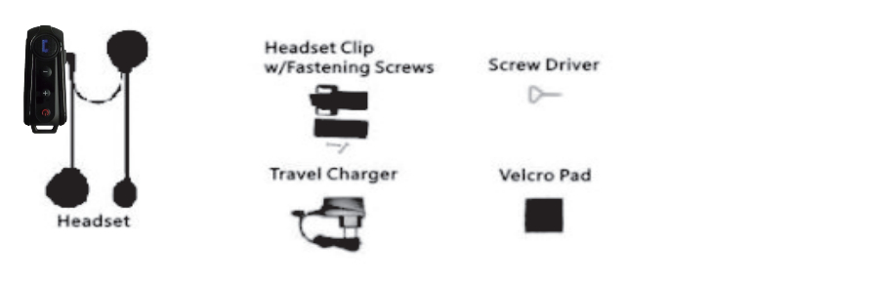
Product Descriptions
The Inter Phone is a Bluetooth Headset designed for the motorcycle rider and passenger who wish to have clear and reliable wireless communications while riding. This headset is compatible with Bluetooth cellular phones and can be suited to any sort of helmet for motorcyclists.

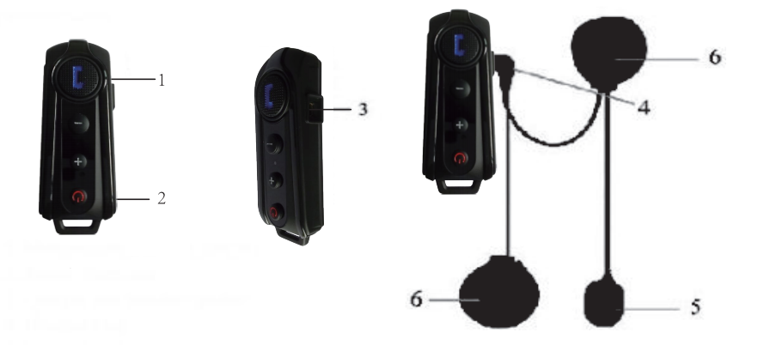
1.Phone Button
2. Power/ intercom Button
3. Charger and Headset Socket
4. Headset Plug
5. Microphone
6. Ear Speaker

1
Main features
(1) Wireless headset for bluetooth enable cell phone at a range of up to 10 meters.
Bike-to-bike intercom for rider& passenger or two separate bikes up to 800-1000 meters.
Up to 10 hours talk time when connected to cell phone.
Up to 6 hours talk time when using the intercom feature.
Up to 300 hours standby
(2) Call out, call answer, call reject, call hang up.
(3) Receive a cell phone call automatically
(4) Support audio transfer.
(5) FM Radio function
(6) Enjoy the cell phone music through A2DP or connect GPS
(7) Control cell phone music through AVRCP: forward, backward, play, pause
(8) Automatic switching among bluetooth cell phone, intercom, stereo music.
(9) With DSP echo cancellation and noise suppression technology, crystal clear voice quality is guaranteed in a high speed.
(10)Button panel is water-proof and sun-proof, while the design is durable.

Using the Headset Clip Mount with Fastening Clamp
1. Using the provided screw driver, loosen the Clips' screws enough to allow the Clip to slide onto either side of the Helmets' shell.
2. Make sure you put the clip under the helmets padding.
3. Adjust the Clip until you find the best location for your helmet
4. Tighten the screws to hold the clip firmly in place.

2
Mounting the Inter Phone
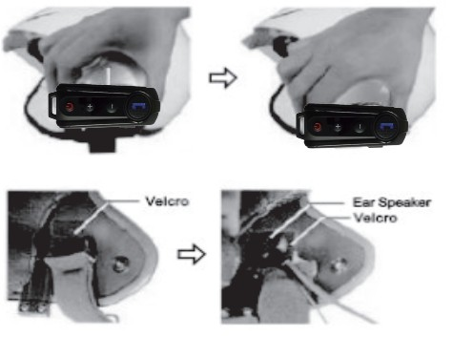
1. Take your Inter Phone Headset and slide it down into the slots in the Headset Clip Mount. Make sure that it's perfectly fitted and locked into place by trying to extract it, pulling upwards.
2. Now you need to attach the speaker and microphone arm to the inside of the helmet. Take the Velcro pad which the speaker will attach to, and test for the best position to fix it. The Velcro Pad should be fixed at the height of your ear in the helmets ear pocket. You will need to put the helmet on a few times to find the optimum position to apply the pad. When the correct positioning is found, remove the protective strip and apply the Velcro Pad.
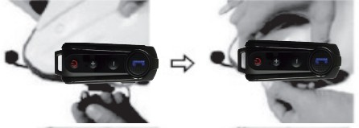
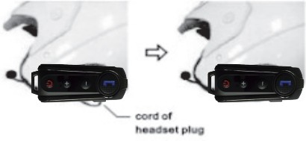
3. Next, take the Ear Speaker and attach it to the Velcro Pad. Run the Microphone Arm down along down to where your mouth will be. As the Microphone Arm is flexible, you can adjust it so it sits in the optimum position in front of your mouth. Some helmets have removable padding; if yours does, it is recommended to run the speaker and microphone under the padding.

4. Taking care to match the pins up, connect the Headset Plug to the Headset Socket. The plug can only be inserted in one position.
5. Secure the cord of the Headset Plug inside the helmet. Tuck any extra wire into the helmet. Ensure that only few centimeters of the cord comes out. You have successfully mounted the Inter Phone
.

3

Quick removal of the Inter Phone
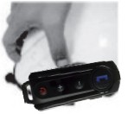
Remove the BT-S1
Inter Phone by pushing down the lock as shown and then take out the Inter Phone Module in an upward motion

Charging the Headset

The AC & USB Charger
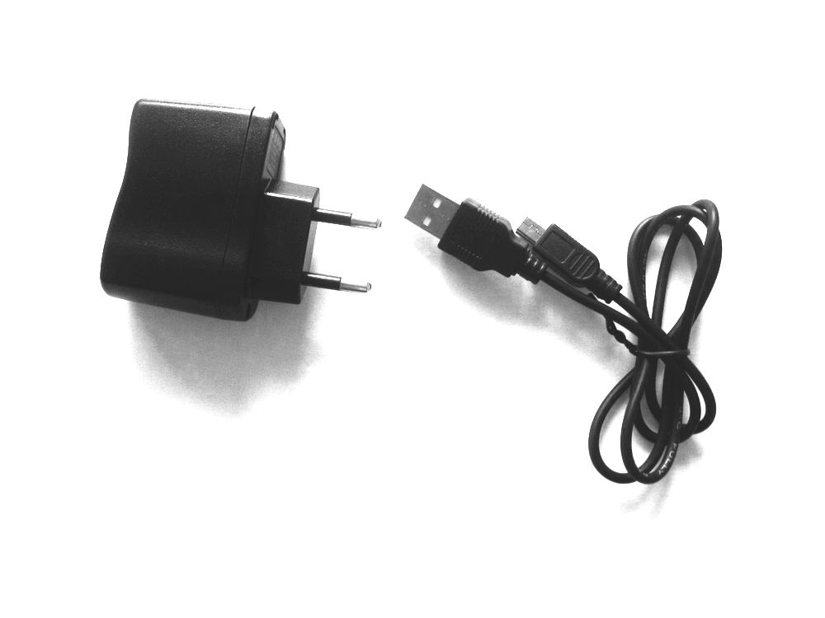
Note: Different country may have different adaptor

Before using this device, Please charge the headset with provided charger. Please ensure that the battery is fully recharged when you first time use it.
We have provided you with the ability to charge the system via the USB port of your computer or if you are away on a trip, you can use the supplied Multi-voltage USB power adapter.

4

The charging cable has a small USB plug for the headset and the large USB plug for the computer or AC adapter; please observe to correct orientation of the USB plug and socket before inserting
- Insert the USB plug of the charging cable, into the USB small jack of the headset; you can either charging by computer or AC adapter.
- While charging, the red LED on the headset module will illuminate, when the charging is finished, the red LED will extinguish. A normal charge from a low battery will take about 4 hours.

Note: if you do not use the headset for a month or more, to protect the Poly-Li battery, please charge the headset at least every month. (The fault damaged by wrong charging will be not guaranteed).

Turning the unit on into standby mode:
Press and hold the power/intercom button at the end of the unit. After 3 sec you will hear a “Di” and the blue LED will begin to flash. Let go of the button and the unit is now in standby mode.

Turning off the unit:
Press the power /intercom button for 5 seconds or until you hear 2 “Di” tones and the lights extinguish.

To pair to your Bluetooth enabled mobile phone:
When the unit is off, press and hold the power/intercom button at the end of the unit. Hold the button until you see a RED AND BLUE light flashing. It normally takes around 5-8 seconds from off. Do not let go when you see the blue light. You will also hear a “DuDu” tone when the unit enters pairing mode. On your phone, search and attempt to pair to the device, when the device is flashing red and blue. If requested the pairing code will be 0000 and you should set the phone to auto pair to the device.

5

Phone Controls:
- To answer a call – Short press the Phone button once
- Auto receive call – Dependant on the phone the unit will automatically answer the call after 8-16 seconds of ringing.
- To reject a call – Press the MFB and hold until you hear a “Du” (around 2 seconds)
- To end a call – Whilst call is active short press the Phone button once
- To go to a phone call during an intercom call – Press and hold the Phone button for 2 seconds until you hear a “Du”

NOTE: Depending on the phone some or all of these functions may not work, or operate differently.

Music Controls:
- Play / Pause – Short press power/intercom once
- Next Track – Turn the “+ “ button and let go
- Previous Track – Turn the “-” button and let go

To Adjust the Volume:
Long press”+”button to increase and long pess”-“ button to decrease. This function is also fit for intercom/music/FM radion function..

NOTE: Depending on the phone some or all of these functions may not work, or operate differently.

6

To Pair 2 devices in intercom mode

- When both devices are turned off, press and hold the power /intercom button on both devices until both units flash red/blue repeatedly. You need to hold the button for more than 6 seconds and dont let go when you see the blue light.
- Short press the power /intercom button on ONE of the two devices and this device will search and auto-pair to the other in intercom mode. A live call will be initiated.(Intercom will start)
- If this fails retry it ensuring both red/blue light sequences are initiated simultaneously and are close together. Also ensure any other Bluetooth devices are turned off.
- When paired, you do not need to go into pairing mode again. In future you only need to go into standby mode (blue light flashing) on both units and press the button on one of the devices.

To Pair 3 devices in intercom mode

- Follow the above procedure for each combination of the three units. (A-B, B-C, A-C).
- Ensure the third unit is switched off when pairing the other two devices.
- Only 1 connection can be live at a time. When successfully paired the connections can be switched by ending any live call and returning to standby.
- From Standby press the power/intercom button 1 time for one of the pairings to be called, or long press(about 2 seconds) for the other pairing to be called.
- The pairing for 1 or 2 presses will depend on the sequence in which you paired the 3 helmets, but once paired the relevant pairings will maintain the number.
- i.e. A will press the power/intercom button 1 time to call B and long press(about 2seconds)to call C. B will press the button 1 time to call C and long press(about 2seconds) to call A. C will press the button 1 time to call A and long pesee(about 2seconds) call C.

To Reset the pairing memory

- If you have problems pairing, then it is best to reset the pairing memory
- Turn on the relevant unit into standby mode. Press the power/intercom button for 3-5 seconds till a “dudu” can be heard.
- Let go of the button when the tone is heard.(The unit will turn off)
- Restart, the memory will be erased. (Repair again)

7
To Start FM radion

After turn the unit on, Long press Phone button about for 1 second (till hear “du” tone), let go of the button, FM radion will start.

Short press:”+” or “-“ button you can adjust the channel.

8

