WP20+Smart Player Quick Start Guide
- Introduction
A．WP20+ uses TI PCM5121 individual DAC and CS8406 optical output, which suits music lover more. This device nearly supports all streaming media formats, and it depends on your mating smart devices and APPs.
B．Main controller uses Ingenic MIPS CPU，1G NAND Flash and 512M DDR memory, which makes it safe, stable and efficient.
C．Individual WiFi chip is used here to prevent overheating, hang up and re-start to compare with SOC, and it supports 802.11b/g/n with 150Mbps transfer rate.
D．AP and STA mode can be used for sending music through WiFi, and supports DLNA and Airplay.
E．The DAC supports 192KHz/24bit.
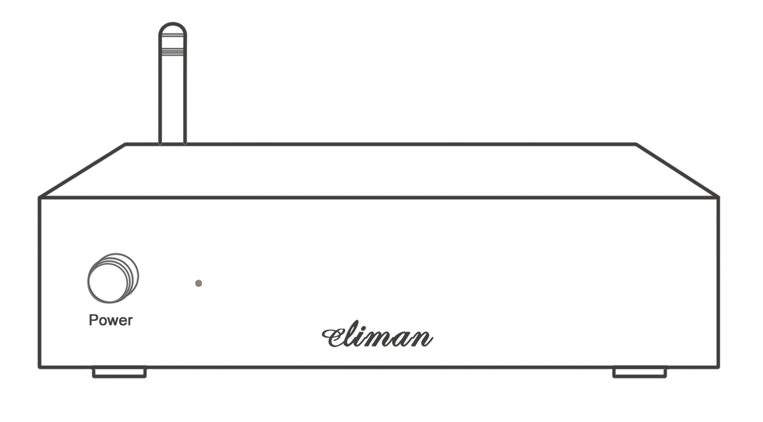

- Antenna mounting
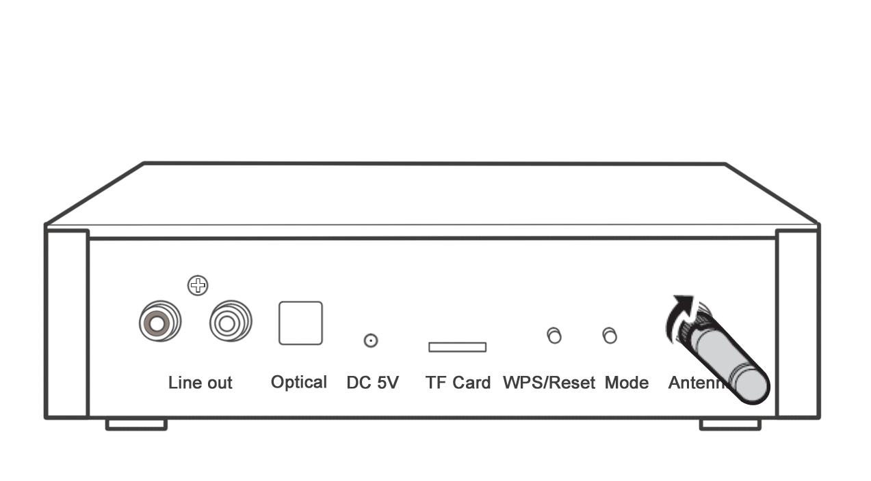
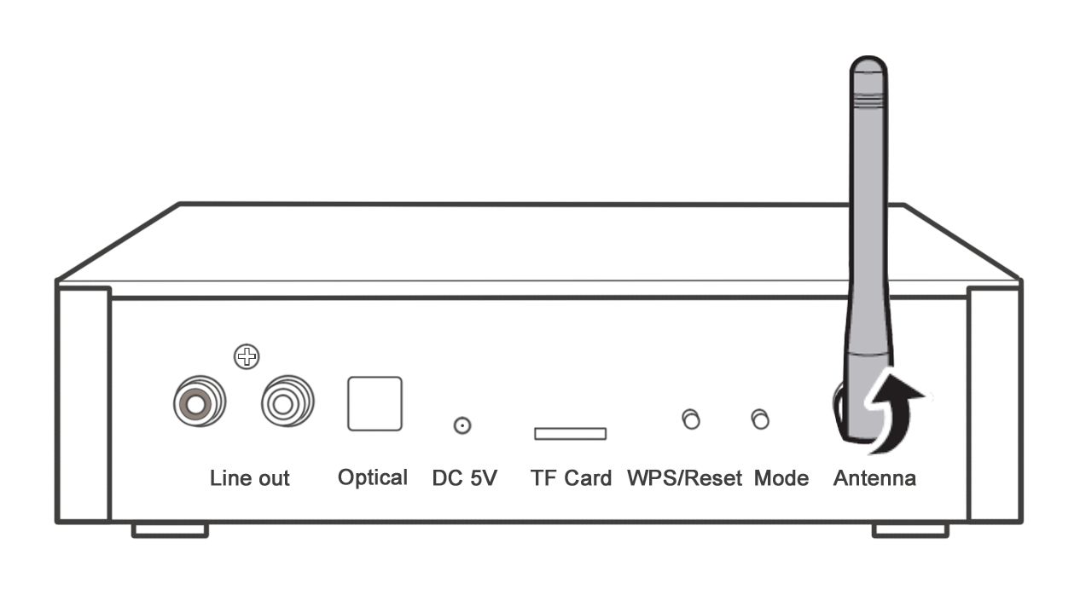
Make sure to mount the antenna properly. Please refer below images.

- Power, Select keys and cables connecting
Make sure to connect DC 5V power adaptor and line out/optical cable to audio devices properly, and then press “Power” key, LED will light up green after a few minutes.
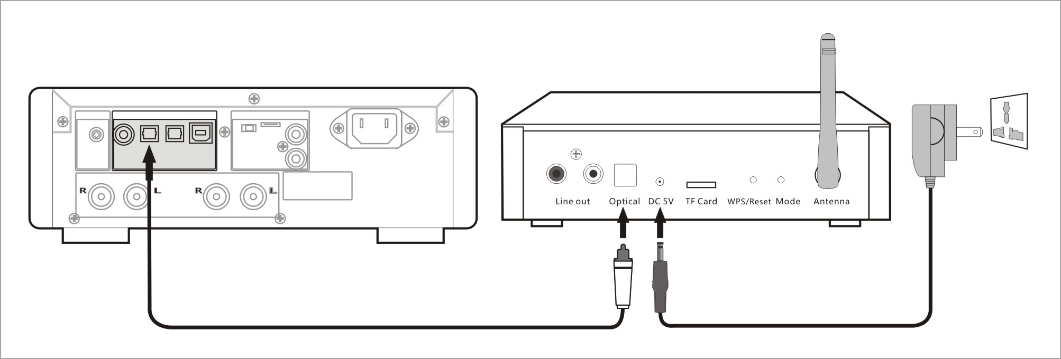

Using optical output
- Using WiFi sending music (Support DLNA and Airplay sending music)
A．OS and Music player
This device can support Android, IOS and Windows operation system. A general stream music player will be needed. For instance: BubbleUPnP, DK UPnP/DLNA, UPnPlay, 8Player, iTunes, Foobar2000UPnP etc...
B．Green LED lights up constantly means works in AP mode (Direct connection mode), and flash in STA mode (Connect to wireless router mode). The mode will be set by the last one you used while power up.
C．Stream music formats
This device can support nearly all stream music formats and depends on your music player settings. Tips: You would be better to chose WAV lossless format as it has great compatibilities to all music players.

D．AP mode (AP means Access point, here specifies using intelligent devices building WIFi direct connection and sending music. You can hear voice prompt “Direct connection mode, we directly connect or configure WiFi”)
- Please enable WLAN from your smart phone, and then select “SmartAudio-XXXXXXXX” to connect. Password does not need while it is in manufacturing condition. Please refer below images.
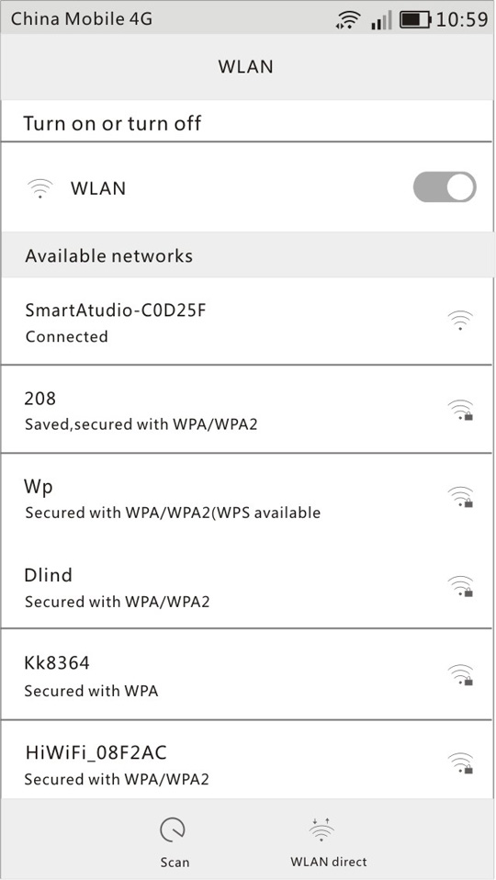
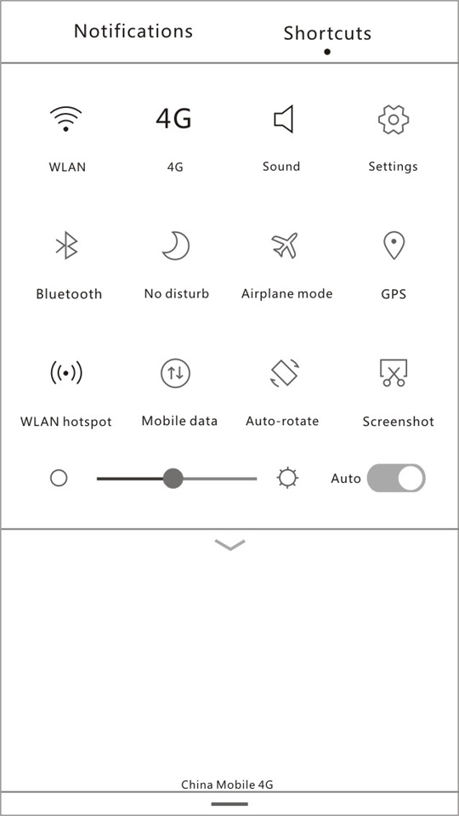

b. If you use BubbleUPnP, please open and select “SmartAudio-XXXXXXXX” as your music output device. This device shows in your renderers list from the device item. Then please click LIBRARY->MUSIC->All TRACKS to chose musics that you want to play. And then you can click “NOW PLAYING” to view the song that is being played. Please refer below images.

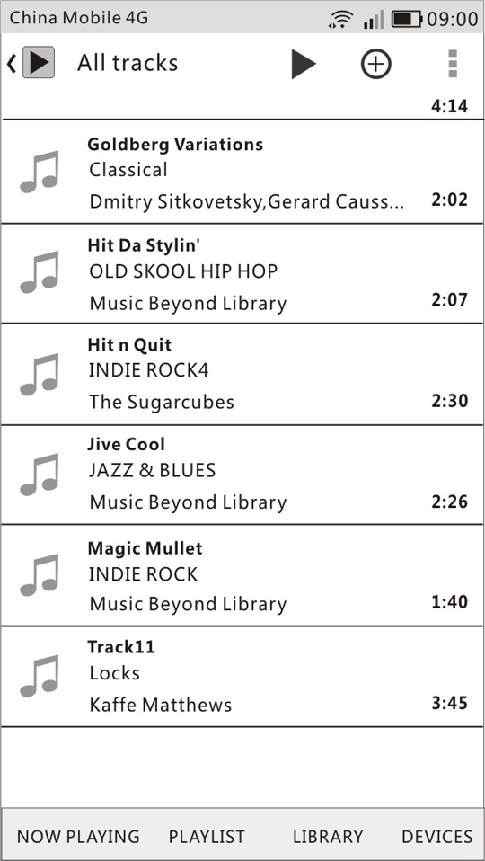
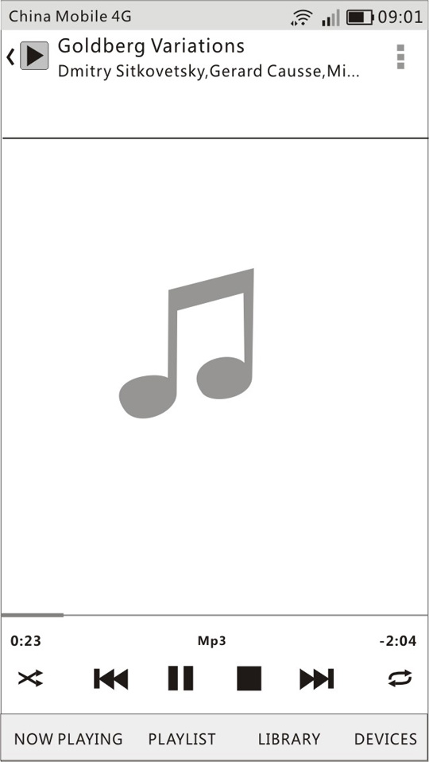
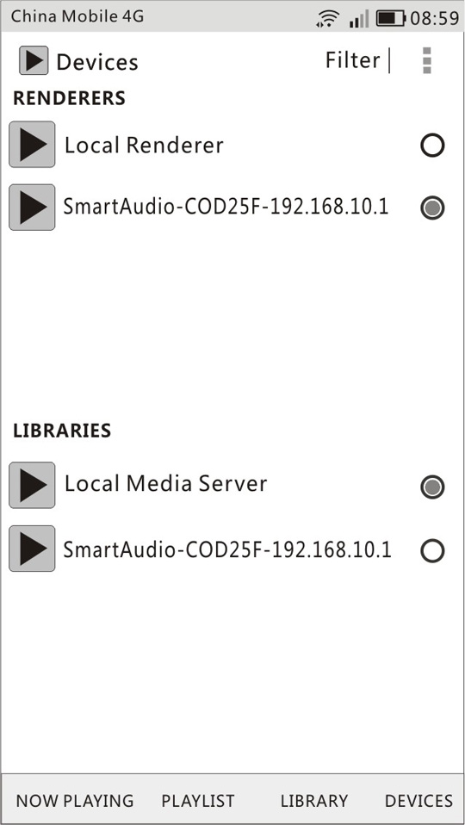

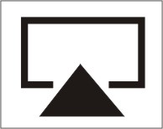
c．If you use iTunes from your laptop, please click and select “SmartAudio-XXXXXXXX” as your music output device. Now you can enjoy music from iTunes cloud or local device (building link is similar to your smart phone). Please refer below image.

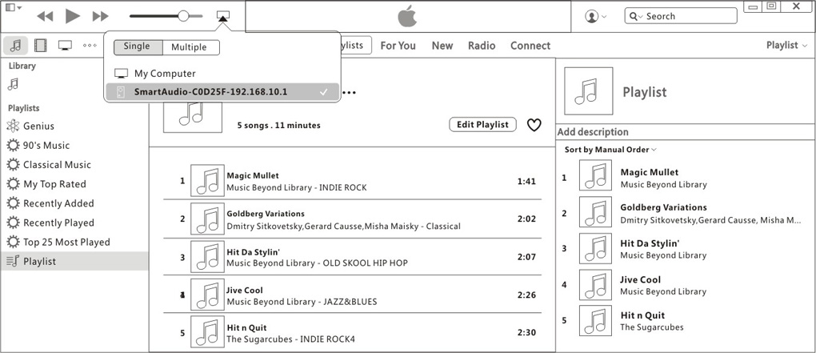

E. STA mode (STA means station, here specifies joining a WIFi network and sharing the device for sending music. You can hear voice prompt “being joined WiFi network, the speaker is ready”.)
a. Firstly please build the connection from your smart phone as AP mode.
b. Then type “192.168.10.1” from your web browser and get in, and then find the router you want to join and click “GO”. This device will join the network after you enter the password, now you can enjoy music from any smart devices linked to the network. The playing procedures are the same as in AP mode.

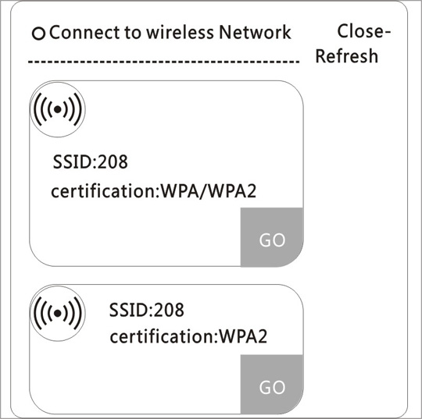

F. Mode key
Press Mode key constantly can circle the mode between AP and STA, and short click this key can circle the mode between Local and AP/STA. In local mode (you can hear voice prompt “local mode”), this device can play stream music from TF Card directly. When the device gets out of local mode, you also can hear voice prompt “Local mode is turned off”.
G. WPS/Reset key
The device can join your network very easy while short click WPS/Reset and WPS key from your router, also the device can reset and clear password if press and hold this key for 3 seconds.
- Caution
This product is working in 2.4GHz ISM band, and complies with CE and FCC requirements. The radiation emission is under the people’s harmful level. We don’t recommend using this device at some special situation such as: when using artificial cardiac pacemaker or other healthy supplementary instruments, or follow doctor’s directions.
- Frequency asked questions
A. There is no audio out from the Line out
a. Checks all cables are connected correctly.
b. Check the connection if it is available.
c. Re-power this device for initialization, if it still does not work please contact the dealer where you purchased the product or after selling service.

B. Active range is shorter than expected
a. Check is there any big obstacle or other powerful microwave devices (Microwave or electromagnetic oven, etc.) working close to this device, if so, please remove this device away from them and keep the antenna up.
b. The active range is connection to environments and your intelligent devices, maybe impacted by some abnormal situations.
- Parameters
Rated voltages: DC 5V
Rated current：300mA
Demension：140mm(L) X 105mm(W) X 40mm(H)
RF section
Output power: +15dBm
Sensitivity: -73dBm
Frequency: 2.4GHz，IEEE 802.11b/g/n
Worldwide radio frequency regulations: ETSI EN 300 328; FCC CFR47 Part 15 (US); ARIB STD-T66 (Japan)
Active range: LOS 50m in AP mode, LOS 100m in STA mode, LOS 10m Bluetooth mode. Please note that this distence depends on your intelligent devices and environment.
Audio section
THD: 0.01%
SNR: 100dB
Frequency response: 20Hz – 20kHz
Max Sampling Rate: 192kHz/24bit (WiFi)
- Content in the package
Receiver: 1
DC 5V adaptor: 1
Antenna: 1
Quick start guide: 1
Package dimension: 250X200X70mm

