ALL to SDI Scaler Converter

Operation Manual

- Introduction
The ALL to SDI Scaler Converter allows you to upscale Composite,VGA,DVI,HDMI signals to high definition video of SDI formats (HD-SDI SMPTE 292M or 3G-SDI 424M/425M), then output to both ports at the same time.
- Features
- Supports HDMI, DVI, VGA and Composite Video input signals;
- Supports two SDI output simultaneously;
- Supports SDI output distance up to 100 meters (3G-SDI), or 200 meters (HD-SDI);
- Scales any input signal to the HD-SDI or 3G-SDI output signals;
- Supports HDMI input timings: VGA@60 ~ SXGA@60 & 480i ~1080p@60 Hz;
- Supports VGA/DVI input timings: VGA@60 ~1920×1080@60 Hz;
- Supports Composite Video input timings NTSC, PAL,SECAM;
- Supports Black screen signal output;

- Package Contents
  - ALL to SDI Scaler Converter 1pcs
  - 12V/2.5A DC power adaptor 1pcs
  - Operation Manual 1pcs

- Specification
SDI Transmission Rates 2.970 Gbps, 1.485 Gbps
Video Bandwidth 165 MHz
Input Ports 1×HDMI (Type A connector),
1×DVI with Audio
1x VGA with Audio
1×Composite with R/L
Output port 2×SDI (HD/3G-SDI),
SDI Cable Distance 3G/HD/up to 100/200 meters with
BELDEN 1694A cable
HDMI Cable Distance Input: 10 m, 8/12-bit
Input HDMI Timing Support VGA@60, SVGA@60, XGA@60, SXGA@60,
WXGA@60,480i@60,576i@50, 480p@60,
576p@50, 720p@50/60, 1080i@50/60,
1080p@24/25/30/50/60;
Input VGA/DVI Timing Support VGA@60, SVGA@60, XGA@60,
SXGA@60, WXGA@60,1280x720@60,
1920×1080@60
Input Composite Support NTSC, PAL,SECAM
Output Timing Support SDI: SMPTE 292M (1.485 Gbit/s) &
SMPTE 424M/425M (2.970 Gbit/s)
ESD Protection Human-body Model:
±8kV (air-gap discharge)
±4kV (contact discharge)
Dimensions 110mm (W)×288mm (D)×32 mm (H)
Weight 750 g
Chassis Material Metal
Operating Temperature 0˚C~40˚C / 32˚F ~ 104˚F
Storage temperature -20˚C~60˚C / -4˚F ~ 140˚F
Relative Humidity 20~90% RH (no condensation)
Power Consumption 5W

- Operation and Fuctions
5.1 Front panel
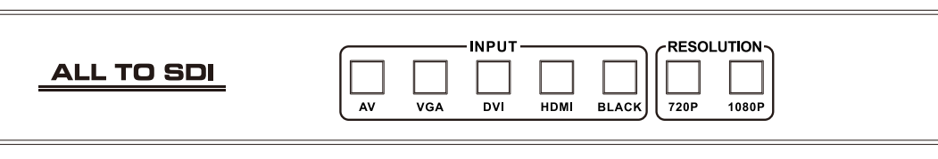
- INPUT BOTTONS: Press these buttons to select the input source.
- RESOLUTION BOTTONS: Press these buttons to select the SDI output resolution.
5.2 Rear panel
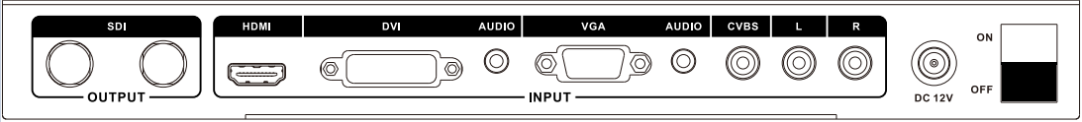
- OUTPUT: The two SDI output is where you connect the SDI monitor with SDI cable for input source display.
- Input: These slot is where you connect the HDMI/DVI/VGA/Composite source output from DVD, PS3,Set-top Box and Note Book.
- DC 12V: Plug the 12V DC power supply into the unit and connect the adaptor to AC wall outlet.
- ON/OFF: Power ON/OFF.

6. Connection Diagram
