Product description
This product is used with the large angle panoramic optics smart phone software APP / APK achieve panoramic camera recording and playback of motion, either use a separate operation, but also can be used with a wealth of accessories to achieve a variety of occasions and photographed image capture. You can record up to 4K 3840*2160 24P,2704*1536 30P,1920x1080 60P,1920*1440 30P,1280*720 120P high-resolution photography, you can shoot 16-megapixel photos, using TF card as the storage device, compact, energy-saving, easy to carry, and compared to conventional cameras, the product to record high-definition video can be recorded more detailed perfect video screen,
Product characteristics
Using 220*360 degree ultra high definition optical lens
HD quality resolution with 4K 3840*2160
The use of advanced photography compression technology
OLED screen display.
30/60 FPS per second
Can choose a variety of accessories, to achieve a variety of scenarios to use.
The design of removable lithium battery.
product structure
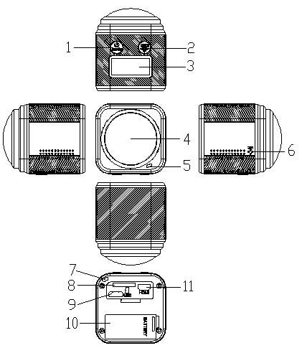

1.POWER  (Shared MODEL) | 2. Recording key  / OK key | 3.OLED screen
4. Lens | 5.Working indicator | 6.microphone hole
7.Charging indicator | 8.TF card slot | 9.USB Interface
10.battery case | 11.HDMI Interface

Getting Started guide
/ Getting Started Charging:
When charging, the camcorder charge indicator (red) will light automatically turns off when charging is complete.
Please use the original data cable with charger and charging in order to avoid damage to the machine.

/ Getting remove a memory card is inserted +
When the card, pay attention to the direction of the slot. Notch upward direction.
* Use the following requirements brand memory card (sold separately): microSD microSDHC or microSDXC
* Class10 UHS-I or grade
* Capacity up to 64GB
Be careful handling the memory card, to avoid liquids, dust and small debris. As a precaution, turn off and remove the memory card before inserting the camera, please refer to the system according to the manufacturer's instructions instructions, use within an acceptable temperature range

/ Getting off the boot +
When you press the power button (button) when about 1 second. The camera automatically turns on. Long press the power button again, the camera turns off automatically.
/ Getting Started video camera +
* Boot mode, press the record button to start recording video.
* Press POWER key to enter the function mode, the mode is selected to the Photo mode to take pictures

Basic Operations
Removable battery
When inserting the battery positive and negative direction not to pay attention to the machine upside, and light to go forward, in order to avoid damage to the machine.
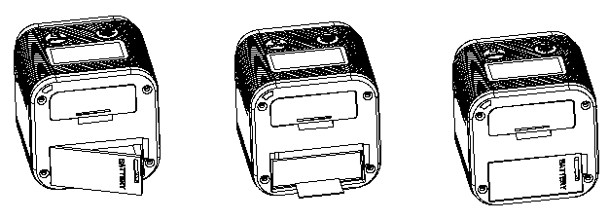

Open the battery cover*Insert the battery in the direction shown*Close the battery cover

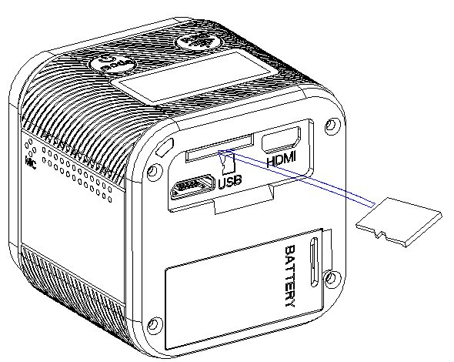
+ Remove the memory card is inserted
When the card, pay attention to the direction of the slot. Notch upward direction
Camera Class 10 or higher-speed memory card

TF card is inserted in the direction shown

Switch:
Press the power button, LCD display, while the buzzer sounds. 2560x1080P 30fps camera to enter standby mode. Press the power button for 1 second automatic shutdown.
If the camera remains in the standby state no operation for three minutes the camera turns off automatically by default.

Mode setting
Mode switch
When the camera is turned on, the default mode is 1920 * 1080 @ 30fps. If the camera is required to switch modes between the different modes,Press the power / mode button to cycle mode in the following order: 1920 * 1080P 60fps → 1280 * 720P 120fps → 1920 * 1440P 30fps → 1080P 30fps REC → 2.7K 30fps → 4K 24fps → PHOTO → return to 1920 * 1080 @ 30fps

1080p 30fps (LOOP) mode
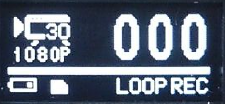

When operating the power / mode button to enter 1920 * 1080 30fps Loop mode. Press the shutter button, the camera will start recording, during recording, the blue LED flashes, press again will stop the recording, the blue LED light will remain on in this mode video (recorded every three minutes a file)

1080p 60fps (LOOP) mode
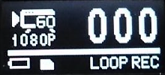

When operating the power / mode button to enter 1920 * 1080 60fps Loop mode, press the shutter button, the camera will start recording, during recording, the blue LED flashes, press again will stop the recording, the blue LED lights It will remain on in this mode video (one file per record 3 minutes)

720p 120fps (LOOP) mode
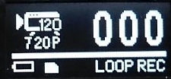

When operating the power / mode button to enter the 1280 * 720 120fps Loop mode, press the shutter button, the camera will start recording, during recording, the blue LED flashes, press again will stop the recording, the blue LED lights It will remain on in this mode video (one file per record 3 minutes)

1440P 30fps (LOOP) mode
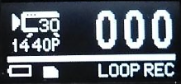

When operating the power / mode button to enter 1920 * 1440 30fps Loop mode, press the shutter button, the camera will start recording, during recording, the blue LED flashes, press again will stop the recording, the blue LED lights It will remain on in this mode video (one file per record 3 minutes)

1080P 30fps (REC) mode
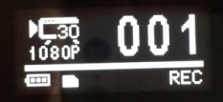

When operating the power / mode button to enter 1920 * 1080 30fps REC mode, press the shutter button, the camera will start recording, during recording, the blue LED flashes, press again will stop the recording, the blue LED lights will remain on in this mode does not support video recording Xun ring

2.7K 30fps (REC) mode
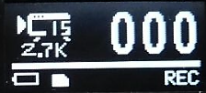

When operating the power / mode button to enter the 2.7K 30fps REC mode, press the shutter button, the camera will start recording, during recording, the blue LED flashes, press again will stop the recording, the blue LED light will remain on in this mode does not support video recording Xun ring

4K 24fps (REC) mode
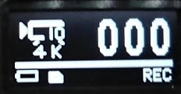

When operating the power / mode button to enter the 4K 24fps REC mode, press the shutter button, the camera will start recording, during recording, the blue LED flashes, press again will stop the recording, the blue LED light will stay Always, this mode does not support video recording Xun ring

Camera mode


When operating the power / mode button to enter the Photo mode, press the shutter button, the camera will start taking pictures, taking pictures during the blue LED will flash once to indicate the completion of photographs

Wifi mode
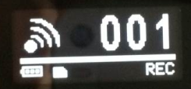

By default, WIFI function is off, to start the WIFI function, simply press the OK button for 3 seconds, you will hear a beep sound, LCD display will show "WIFI icon." At this time it has entered the wifi mode. After WIFI activated, press and hold the record button for 3 seconds to turn it off.
When activated after wifi mode on the camera, follow the steps below to connect the Application Name： Well cam 360
Android smart phone, you can go "google play" download.
Apple's smart phone, you can go to "apple stone" download.

1.After boot, in the case of not recording, hold down the REC button for 3 seconds, LCD displays WIFI icon.
2.Open the Android smart phone WIFI. In WIFI network search apparatus (Action cam _ *****).
3.The first time you connect the need to enter a password. (1234567890）
4.Wait for the phone is properly connected.
5.The connection is completed. And then run the application： Wellcam360.

You can see the camera viewfinder window from the phone screen and control the camera to take pictures, videos, and download photos and video files from the camera's memory card to the phone memory upper-related operations.
Note: The camera and mobile phone connections for 1 to 1 relationship, and when connected to a mobile phone, can not connect to other phones, such as the need to connect the other hand you want to disconnect the machine before connecting that phone, and supports android2. 3 or later and ios phones.

Computer connection
To play back videos and photos on the computer. It must first transfer the file to a computer to transfer files can also free up space on the memory card. For storing new content. The camcorder is connected simple computer operation. After inserting the USB connection to the computer to read, copy data directly after power

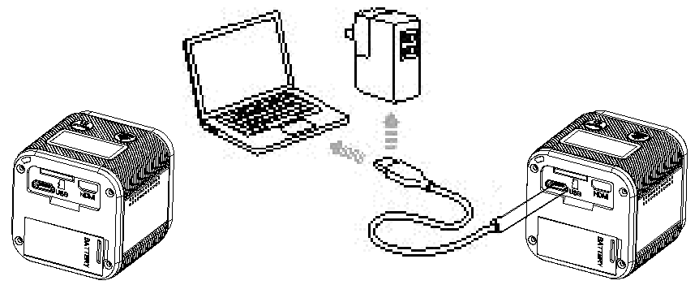

HD connection
* This product uses the HDMI-D high-definition interface, supporting the use of HDMI cable;
* First, the end of the HDMI cable into the HDMI interface of this product, then connect the other end of the HDMI cable to the TV interface with HDMI function;
* Turn on the TV, switch the TV to the corresponding HDMI mode, then turn on the product;
* Via HDMI connection, you can clear preview of this product is currently shooting the picture on the TV.
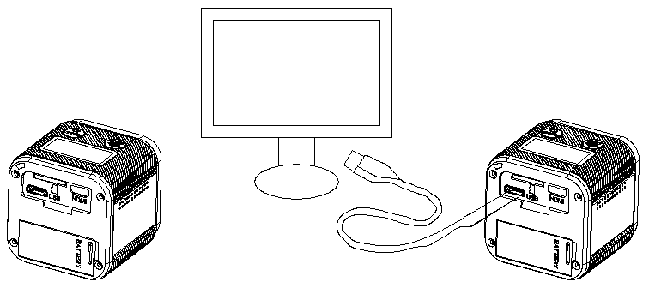

Common Troubleshooting
*Can not boot
Make sure the battery is fully charged, to charge your camcorder, use with original charger and data cable to avoid damage to the machine.
The camera's battery is removable. The battery can be removed and then re-install the boot
* Unable to set the time
This machine is no menu display. The date and time need to synchronize your phone time after connecting WIFI

Warnings and Precautions
1. Check that the device the Micro SD card has been installed correctly, the machine needs 4-64GB card speed CLASS 10 and above
2. Verify that the memory card has enough space
3. You must use the original with charger and data cable to avoid damage to the machine
4. Extremely cold temperatures may reduce battery life or cause the camera to temporarily stop working properly, before using the camera to be placed in a warm place.

Product Specifications：
description | specification
Perspective | 220 *360 degree 8G HD lens
camera function | 1600W JPEG image camera resolution mode
Video Resolution | 1440P 30fps /1080P 60fps /1080P 30fps /720P 120fps  2.7K 30fps /4K 24fps
RecordingFile Format | Recording into MOV (H.264 compression) format video files
File format camera | JPG format picture
Storage media | Micro SD / MMC (maximum support to 64GB SDHC)
USB Interface | USB2.0 (data can be read TF card via USB)
LED | 0.82 inch OLED display
Power | 450mA@3.7V
lithium battery | 620mAh
Recording time | 1 hour
storage temperature | -20–60℃
Working temperature | -10℃—50℃
Humidity | 15~85%RH
Disclaimer
Although every effort to ensure that this guide is accurate and complete, acceptable and does not assume any responsibility for any or omissions. Factory Ltd reserves the right to change the specifications of the hardware and software products at any time without notice.

