Notice:
Before using the camera, please read the following safety precautions;
Please follow the instructions of the manual to operate the camera correctly: such as illegal operation may cause damage of internal components.
Do not fall or hit this product, otherwise easy to cause damage to internal components.
For safety consideration, the product and its accessories as far as possible be away from the kids or animals to avoid accidents.
Do not put the camera for a long time in wet or dusty environment. May cause the leakage or cause fire.
Please do not put the camera for a long time at high temperature condition, such as exposure, may cause the camera casing and damage internal components.
To maximize battery efficacy, we suggest you use this production under -10 to 70 degrees temperature.
Before plug the memory card, please make sure the camera was turned off, avoid cause CARDS or store data is damaged.
Camera is in use for a period of time temperature ,it is normal phenomenon.
When using do not touch the lens, avoid affecting the video results.
Please use a hair dryer (special lens blowing equipment) clean the lens or use special rotating lens wiping cloth to wipe the lens, clean surface fingerprints or dust.

Operating instructions
1.Operation interface
Interface instructions
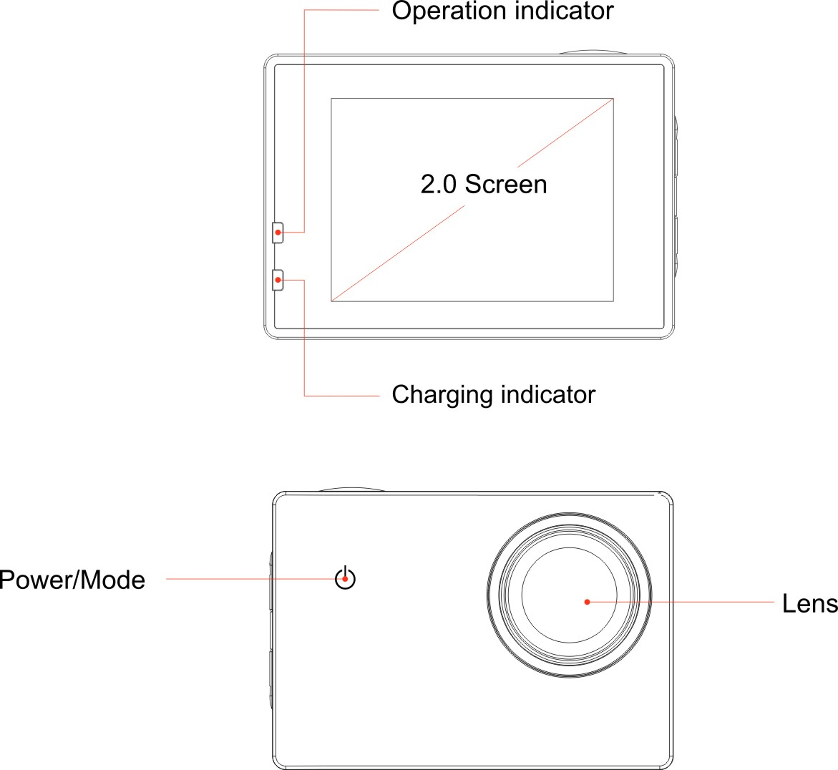

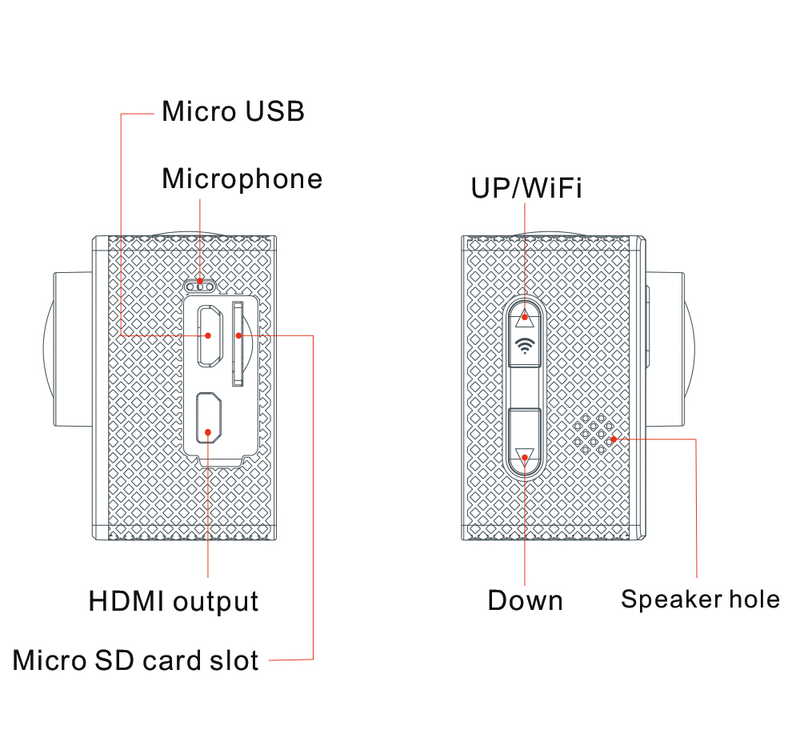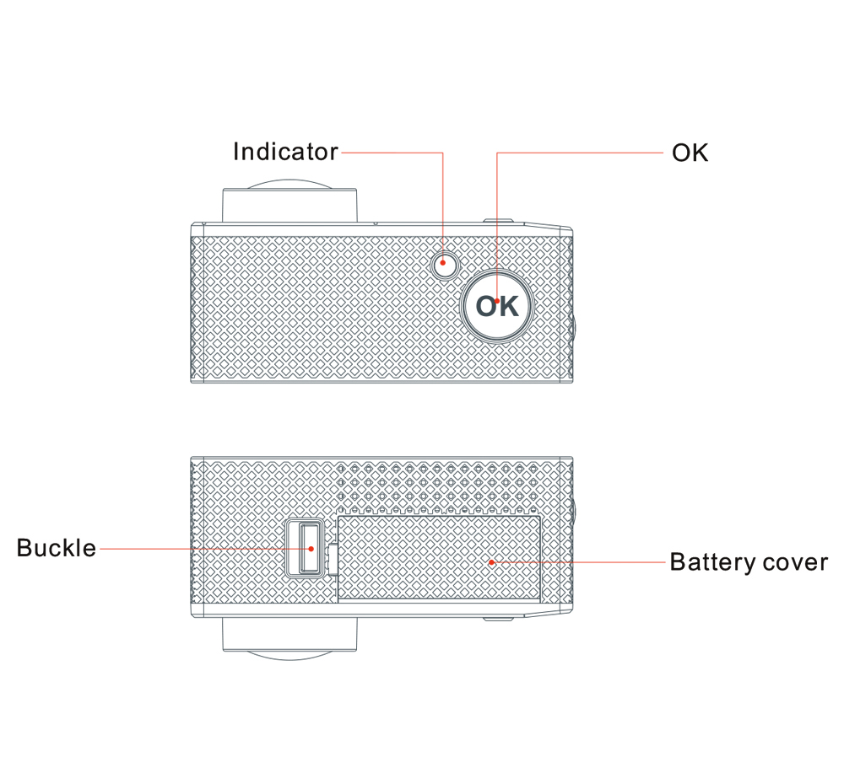

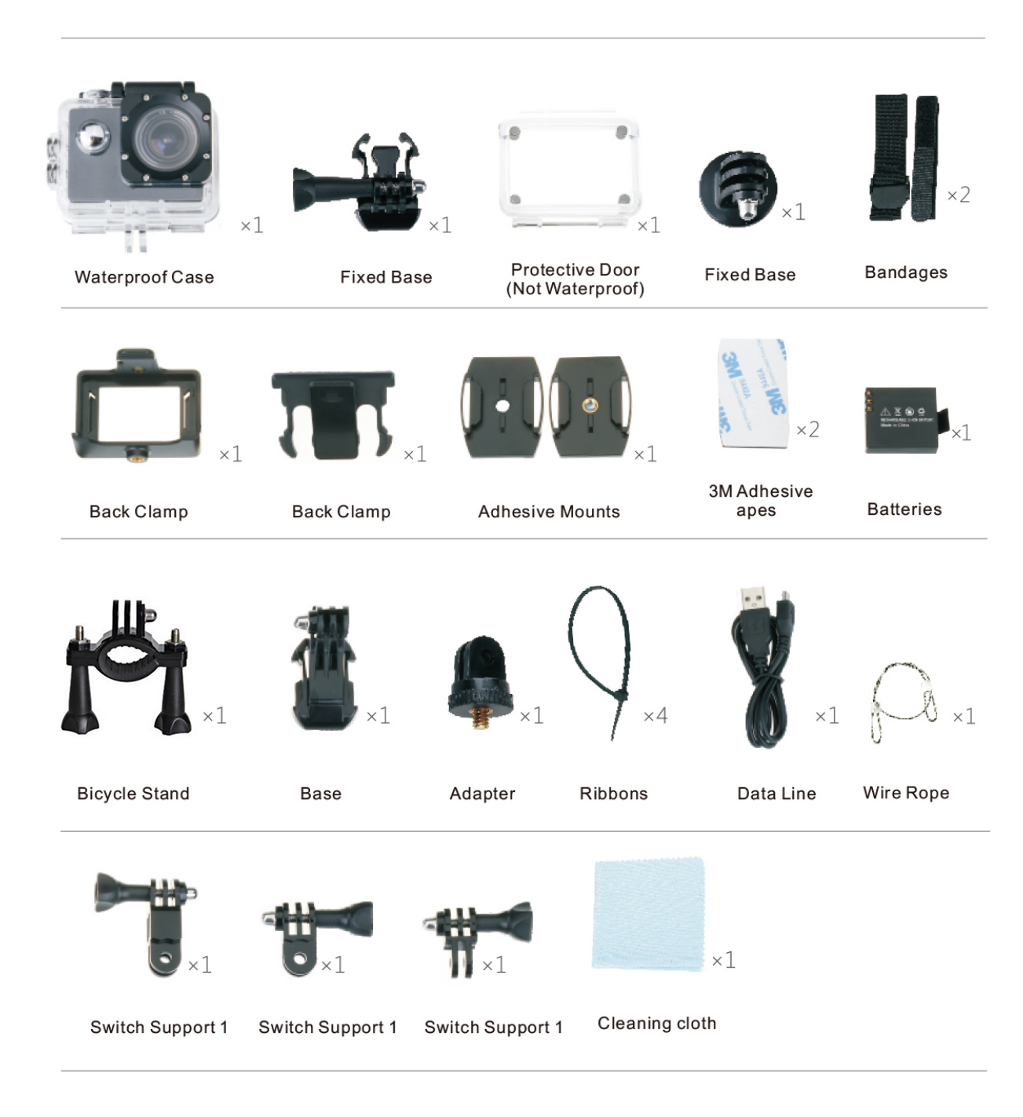
2.Button function introduction

Power key( ):For the camera on or off: when video, click this button to capture images. stop the camera and photography; In the menu mode, click this button to return to the interface of photo or video.

OK Button ( ) For camera, stop the camera and photo; For streaming movies and on TV, in the system Settings to enter /confirm the menu options.
Up Button （ ）In the process of standby or video to enlarge the image; In the menu Settings in the options on a file or a menu. Used for fast rewind play when in playback mode.Also,on standby mode,click this button to open or close WI-FI.
Down Button（ ） In the process of standby or video for narrow image; Under the menu Settings select a file or a menu. Used for fast forward play when in playback mode.
3. Battery Charger
Connect the charger to camera USB interface, and then insert the charger power, when charging the red light bright, full of red light when go out.
Warm tips:
In order to improve the charging efficiency, please charge under the shutdown state.
Please make sure the charger and outlet has electricity.
4. Insert and remove the memory card
1) Insert the memory card: put the card into the card slot , press then fastening.
2) Remove the memory card
5．Open and close the camera
Open the camera
Press and hold the power button for 3 seconds, the machine sends out the sound and the work indicator light, LCD shows the boot screen after the boot (default is the circulation of the state), LCD screen shows photography,exposure compensation, Recording icon, the right shows the remaining time, resolution, card symbols, battery symbols, below the display date / time.
Shutdown
Press and hold the power button for 3 seconds on the state of the switch, hear a sound and display shows the off LOGO, then off.
Video
Loop-Record
Press the power button on the phone or connect the charger will hear a sound, the machine automatically into the video, the green work lights flashing, the LCD screen above the video Icon and Recorded time. When Recording to 3 minutes, the camera will automatically stop Recording and save the file and continue Recording. Press a "OK" button to stop the video and save the video file, and the remaining time of the LCD screen is displayed. When the storage card Recorded in full, the camera will automatically overwrite the first file to continue the video, and so on.
Note: enter the video menu can choose different cycle Recording time, see menu settings.
Normal Record
Into the video menu will be "loop video" set to "off", press the "OK" key machine to start the video, and then press a "OK" button to stop Recording and save video files.
The compressed video
Enter the compressed video menu set time interval for a second. Press the "OK" button to start the video, and then press the OK button to stop shooting. When played back, the Recorded video is playing fast (faster than normal). You can use this feature to capture the progress of the construction project, weather changes, the process of the flower and so on.
To restore to normal Recording, please again, press the “OK” button to pause, the time-lapse video "is set to" off "can be restored to normal video.
Note: enter the compressed video menu can choose different time-lapse Recording time, see the menu settings. This feature is only suitable for long video use, when set to 1 second, the video time can not be less than 1 minutes.
Motion Detection
In the "loop-Record" set to "off" state, and the "motion detection" select "30 seconds" (time optional, see menu settings), confirmed after exit, the interface shows "press OK key for motion detection", press "OK" key to confirm the status of motion detection, the interface shows "motion detection..." , when the machine detects a moving object, the machine will automatically start the camera, when no object is moved automatically after 30 seconds (according to the set time) and continue to monitor, the screen continues to show motion detection..." Go round and begin again. To stop motion detection in the middle of the way, please press the "OK" button to stop, the interface is still displayed "press OK key to motion detection". If you need to continue the investigation, and then press a "OK" button to enter the state of motion detection. If you want to cancel this feature, please enter the menu settings, and the motion detection is set to turn off.
Note: video, video compression, circular motion detection function can only open a three.
Capture
Press the power button on the video capture process can be carried out on a video image process.
Note: in the capture, video continues, can view to capture image browsing.
Take photos
Normal photograph
In standby mode, press the power button to switch to the camera mode, LCD left to display pictures, exposure compensation, white balance, ISO icon, the right side of the picture can take a picture of a number, pixel, image quality, card symbols, battery symbol icon. Press "OK" button to take pictures, and automatically save the photos taken.
Shooting mode
In the menu settings, select the shooting mode, and then select the time to take the time: a single /10 seconds /30 seconds /3 seconds, confirmed after exiting the menu, press the OK button machine will take time to take pictures and automatically save the selected time.
Note: when you want to stop taking pictures, please press the "OK" button again, or "shooting mode" to "single shot" to resume normal camera.
Automatic camera
Select the "automatic camera" (time: 3 seconds, 5 seconds, 10 seconds) after the confirmation of the exit, press the "OK" button machine will automatically take pictures. "Automatic camera" select "off", you can resume normal camera.
Continuous function
Select "burst" and selected (3 continuous or 10 shooting) to confirm after exit, press about the "OK" button, the machine will according to parameter settings; continuous shooting 3 or 10 and photos will be saved automatically. "Shooting" select "off", to restore the normal camera.
Quick Preview
Select "quick preview" and select "2 seconds" (time optional: off /5 seconds /2 seconds) to confirm after exit, each click "OK" button to take a picture of 2 seconds after the preview to return.
6.Zoom
In the camera, video mode of standby state or video , long Press / the image can be enlarged or reduced, the maximum can be enlarged to 4 times.
7. Playback mode
In standby mode, press the twice "mode" button to enter playback mode, press / key to select preview video files and pictures, select the video file to press the "OK" button to start playing; press "OK" button to pause the playback process, to continue to play again "OK" key
In play in the process of click “ ” fast forward playback, maximum 8 times of fast forward, press the "OK" button to stop the fast forward playback; click “ ” into rewind playback, highest can rewind 8 times, press the "OK" button can stop the fast forward playback.
8.Delete and Protect file
1) in playback mode, press "menu" button to enter delete mode, press / key to select "delete" and then press "confirm" button to enter, select "delete current" as delete sheet; select "delete all" to remove all photos; do not need to delete select "Cancel", press "confirm" return menu to set up next.
2) protection file; select "protection", according to "OK" after the confirmation, press
/ key to choose "add lock the current" "unlock the current" "all lock" "all", and then press "OK" to confirm and return to the menu to set up the next.
slide show: select "slide show", press "OK" to confirm, press / key to select "2 seconds" "5 seconds", "8 seconds", then press "OK" to confirm the beginning of slide show, press a button to return to the playback state.
Warm Tips: the first use of the TF card, please first in computer format and format allocation unit selection 32K or 64K format, or in the machine formatted before use.
9.Menu Settings
In standby mode, press the menu key to enter the video settings, press the menu key to enter the system settings, press / key to select the settings option, press the "OK" button to confirm.
Setup
Resolution: UHD 24FPS/QHD 30FPS/FHD 60FPS /FHD 30FPS/HD 120FPS/HD 60FPS/HD 30FPS / WVGA 30FPS /VGA 240FPS
Loop video:3 minutes /5 minutes /10 minutes
RSC:ON/OFF
WDR: on/off
Time-lapse Record:OFF/100ms/200ms/500ms/1sec/5 seconds
Motion detection: ON/OFF
Record Audio: off / on (default is ON)
date Stamp: ON/OFF
FOV:170°/140°/110°/70°
Diving mode:ON/OFF
Night Scene: ON/OFF
Capture Mode:Single/2S Timer/5S Timer/10S Timer
Image Size:20M 5120*3840/16M 4608*3456/12M 4032*3024/10M 3648*2736/8M 3264*2448/5M 2592*1944/3M 2048*1536/VGA 640*480
Burst:ON/OFF
Quality:Fine/Normal/Economy
Sharpness:Strong/Normal/Soft
White Balance:Auto/Daylight/Cloudy/Tungsten/Fluorescent
Color:Color/Black&White/Sepia
ISO:Auto/100/200/400
Exposure:-2----+2
Anti-Shaking:ON/OFF
Delete:Delete Current/Delete All
Protect:Lock Current/Unlock Current/Lock All/Unlock All
WIFI:ON/OFF
WIFI SSID：***********
WIFI PWD：12345678
Date/Time:2015/01/01
10:10:00
YY/MM/DD
Auto Power off:OFF/3min/5min/10min
Beep sound:ON/OFF
CAR ACC：ON/OFF
Language:ENGLISH/FRANÇAIS/ESPAÑOL/Portuguese/DEUTSCH/ITALANO/简体中文/繁體中文/PYCCKЙЙ/日本语/
TV mode： NTSC/PAL
TV output: off / on
Screen Save: OFF/30Sec/1Min /3Min
Frequency: 60 HZ / 50HZ
Format: SD card (cancel/ confirm)
Default settings: cancel / OK
Version: **************
10．WIFI function instruction
Download the APP client and install it to the smart phone.
About the application of APP software, Android mobile phone, please sweep the two-dimensional code using a mobile phone. (not to be used by WeChat)
When Apple phone connect WLAN, searching ZSANYCAM, click install. After the installation of the mobile phone, the interface will appear a APP application icon. Click to enter the APP "ZSANYCAM” interface (see APP for details).
WIFI SSID Password Change
In standby mode, press twice the "menu" button to enter the system settings, press
/ and select the "SSID WIFI" menu，press “OK" menu to change WIFI name (note: changing the name，please Press the "menu" button to move the cursor, press / key to change the letter, press “OK” key to confirm),first move the cursor to “delete”, and then press “OK” key to delete the default name, lastly move the cursor to the “letter”(like A ,a ,0 ),press / key to change the letter, and then press “OK” to confirm. Keep doing this until finish changing, move the cursor “return”, and then press “OK“ to confirm, and then next step.
WIFI password change
The operation method is the same as the "SSID WIFI" name change, password at least 8 characters, modify the completion of the next step. (password default: 12345678)
The open WIFI function
Select the "WIFI" menu, press "OK" button to enter, select "open", the screen will show the WIFI icon, and instantly into the open state after the upper left corner of the screen WIFI icon, SSID:********, PWA2:********, below the left button to return". At this time to open the phone to set the WIFI function, to find a new set of WIFI name of the network, the connection after entering the new WIFI password and confirm the connection, the connection after the success of the LCD on the Connected/ display MAC:************ WIFI, the following is the left button". At this time to open the phone has been installed a good APP client, and search to add the camera ID code, and press the prompt to enter the password again, after the completion of the camera and video operations can be performed. (please refer to the APP operating instructions)

13.The use of television viewing file
1) Connect HD TV
On the state of the machine, the HDMI line of the machine is connected with the high definition TV, and the other end is connected with the output port of the HDMI, the TV is adjusted to the HDMI state, and the operation on the machine can be displayed on TV.
Note: VGA240fps, 720P120fps, HD video, other resolutions can be video.
2) Connected ordinary TV.
On the state of the machine, the TV line of the machine is connected to the ordinary TV, the other end is connected with the USB output port, the TV is adjusted to the TV state, and the "TV output" is set to open. The machine LCD screen is closed and all operation is converted to the TV display and operation. Exit TV mode, the TV screen operation, enter the machine menu settings, the TV output is set to off, this time the machine LCD screen OKovery.
Note: TV line for the matching accessories. Only the output of the image, not with sound output.
14.Use the computer to view the file
After the machine is connected to the computer with the USB line, the LCD screen displays "memory" and "camera" press / key to select "memory" and then press "confirm" key to confirm. On the "my computer" to open the removable disk appear folder CARDV, double click the 2 folders MOVIE and PHOTO, select any folder, open the view of the corresponding file.
15 .Open the camera
After connecting the machine with the USB line, the LCD screen displays "memory" and "camera" press / key to select "camera" and then "OK" key to confirm. On the "my computer" to open ，then is ok.
- Specification:

Specification
Image Sensor | 12 Mega Pixel Sony cqk
LCD | 2.0″ LTPS Screen
Image resolution | 20M 5120*3840/16M 4608*3456/12M 4032*3024/10M 3648*2736/8M 3264*2448/5M 2592*1944/3M 2048*1536/VGA 640*480
Video resolution | 4K @ 24fps, 2K (2560*1440)@ 30FPS
Video resolution | 1080P(1920*1080)@ 60FPS, 720P (1280 x 720) @ 120FPS, VGA @ 240fps
Default resolution | Video:1080P / Picture:4032*3024
Image/Video file format | Video format: MP4 / Image format:JPG
Zoom | 5x digital zoom
Lens | Adjustable wide-angle fish-eye lens Adjust between 170°&70°
Memory | Slot for Micro SD card up to 32 GB *Selected 64gb & 128gb Cards
OSD language | ENGLISH/FRANÇAIS/ESPAÑOL/Portuguese/DEUTSCH/ITALANO/ 简体中文/繁體中文/PYCCKЙЙ/日本语/
Connections | USB 2.0 , HDMI (HDMI Certified)
Battery life | 80 minutes(1080P)
Battery | Battery Detachable 1050mAh
Dimensions | 61×42.4×25 mm
Weight | 58g (without batteries),74g with batteries
Accessories | waterproof case, waterproof case bracket, waterproof case clip,bike bracket，multifunction clip, camera clip, helmet seat, bandages，cleaning cloth, 3M stickers, USB cable,bracket adapter,manual etc.
Applications | Extreme Sports, Outdoor Sport Activities,Bicycle,Car DVR, Diving,Home security etc

注意事项
使用摄像机前，请仔细阅读以下安全注意事项；
请按照说明书指示正确操作摄像机：如非法操作可能会导致内部元件损坏。
请勿摔落或撞击本产品，否则容易导致内部组件损坏。
为了安全考虑，此产品及其附件尽量远离小孩或动物可及之处以避免意外发生。
请勿将本摄像机长时间置于潮湿或多尘的环境中。可能会导致漏电引起火灾。
请勿将本摄像机长时间置于高温状态，如暴晒，可能会导致摄像机外壳和内部元件受损。
为发挥电池最大功效，我们建议你在-10°-70°温度下使用。
插拔内存卡前请确保摄像机处于关机状态，以免导致卡或存储数据被损坏。
摄像机在使用一段时间温度升高，属于正常现象。
在使用时请勿摸镜头，以免影响拍摄效果。
请用吹风机（专门的镜头吹风设备）清洁镜头或使用专门的擦镜布旋转擦拭镜头，清洁表面指印或灰尘。

操作说明
一、操作界面
外观介绍
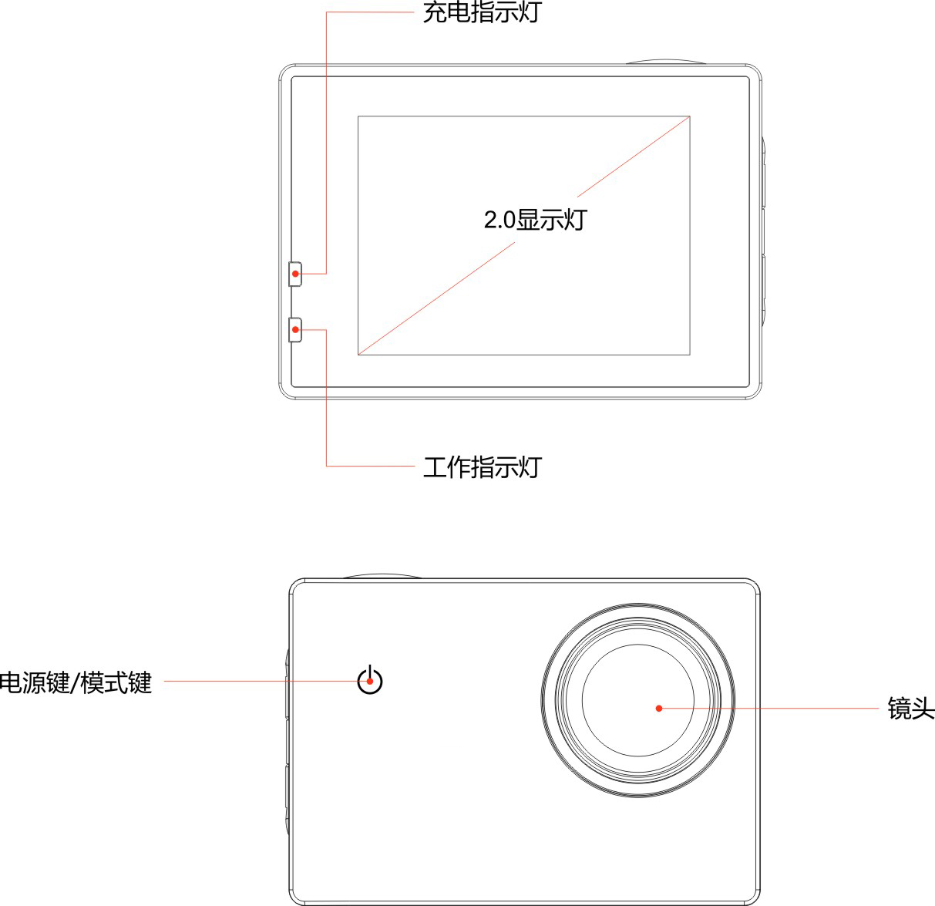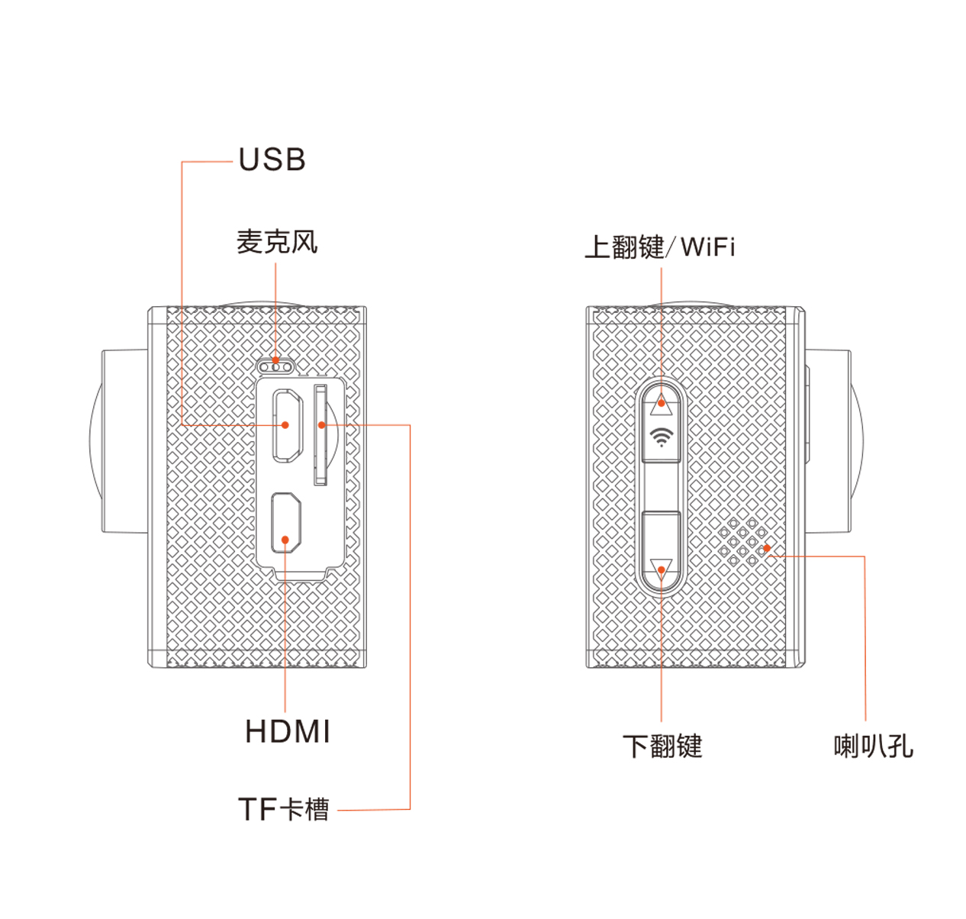

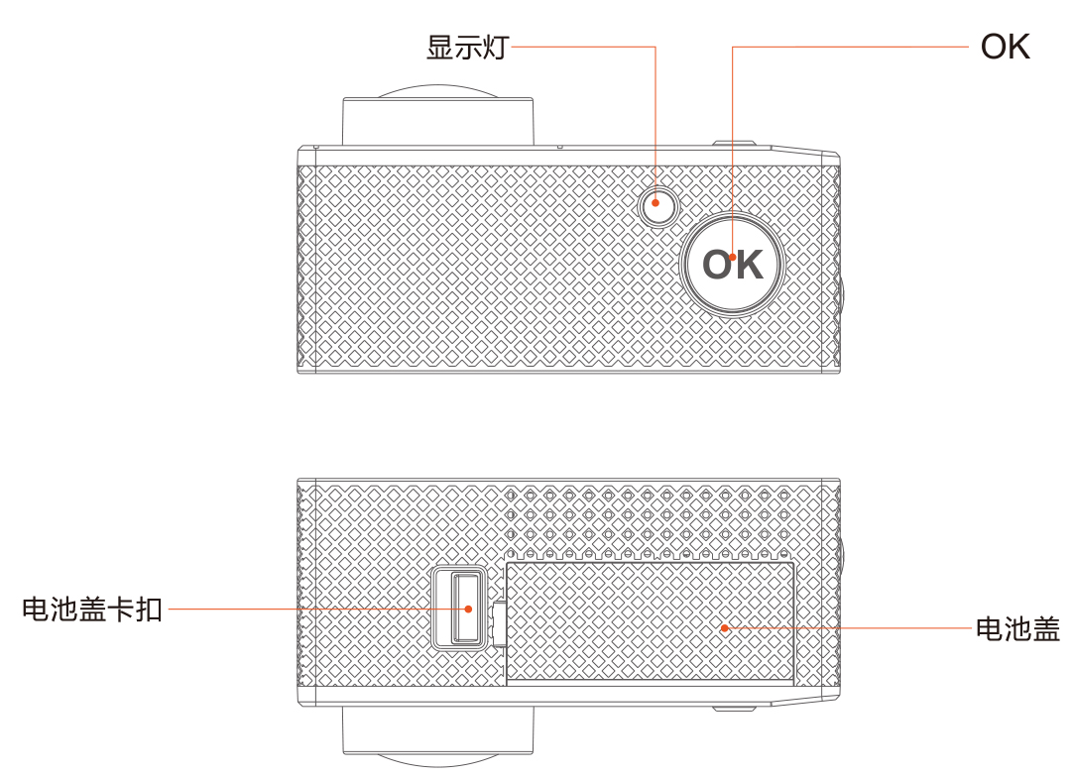

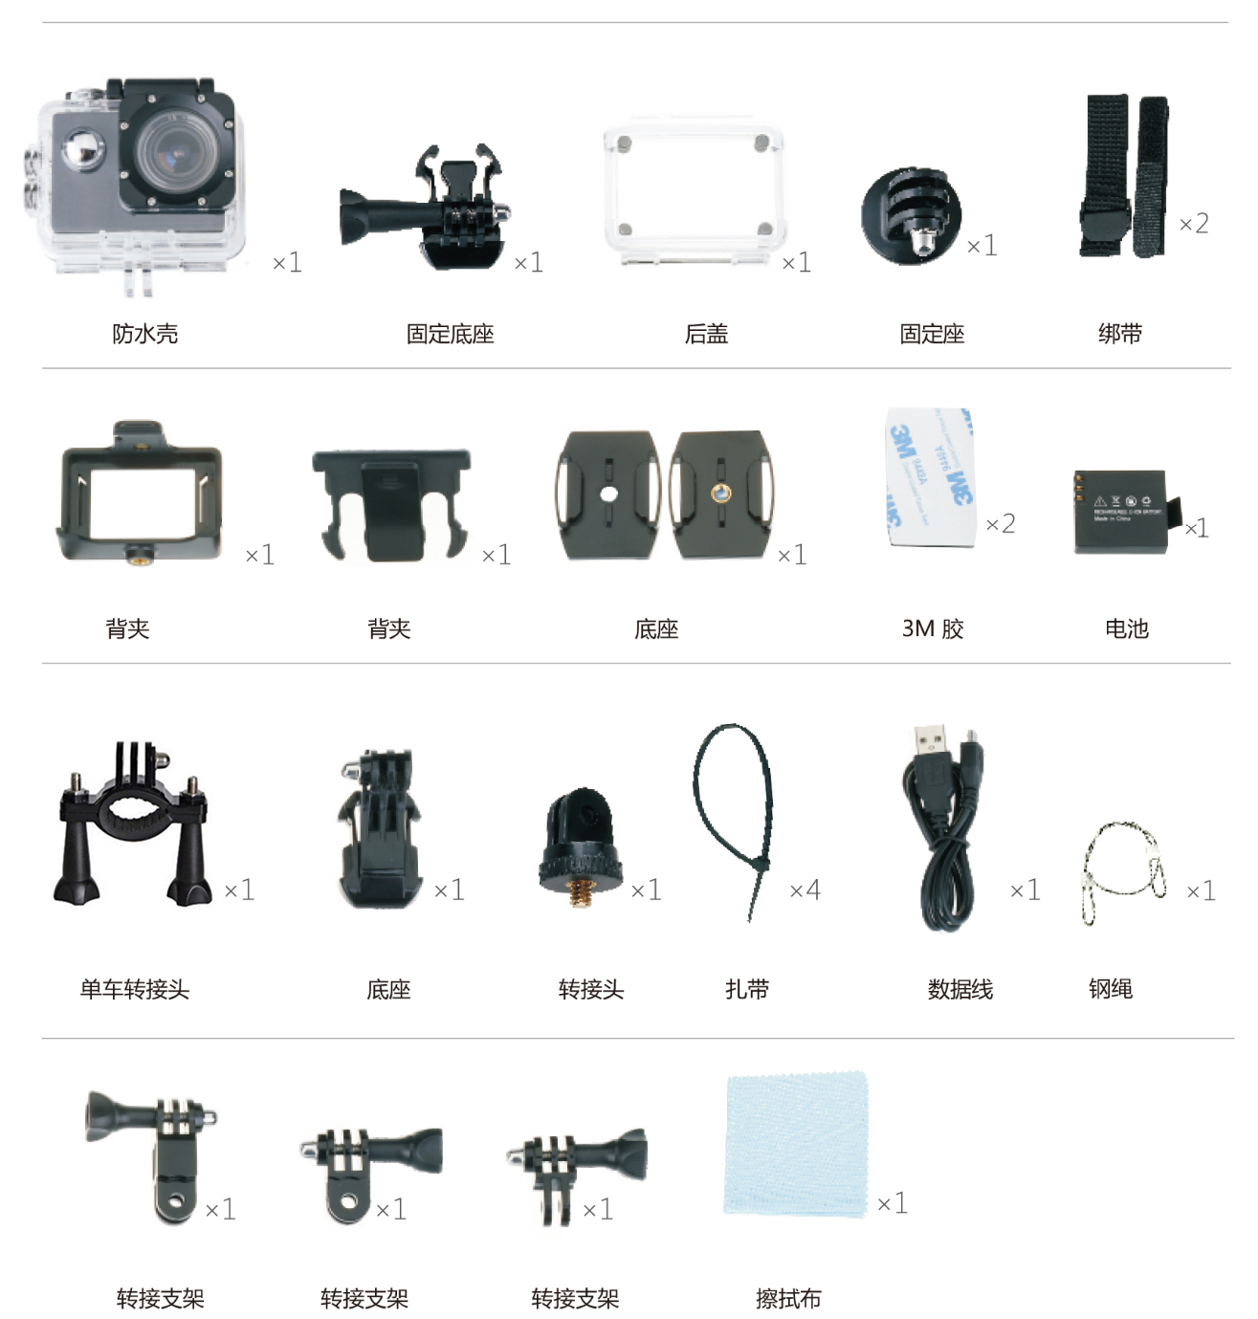

2、按键功能介绍

电源键（ ）：用于开机、关机；在录像时，按此键进行抓拍图片；待机状态下，用于摄像模式、拍照模式、回放模式的转换。

OK键（ ）：用于摄像、 停止摄像及拍照；用于播放电影和暂停播放，在系统设置用于进入/确认菜单选项
上翻键（ ）：待机或录像过程中用于放大图像；在菜单设置中选择上一个文件或菜单；在回放模式时，用于快退播放；待机模式下，用于WIFI的开启或者关闭。
下翻键（ ）：待机或录像过程中用于缩小图像；在菜单设置中选择下一个文件或菜单; 在回放模式时，用于快进播放，录像待机模式下，用于声音的开启或者关闭。
二、电池充电
将充电器连接摄像机的USB接口，再将充电器插入电源，充电时红灯长亮，充满时红灯熄灭。
温馨提示：
①、为了提高充电效率，请在关机状态下进行充电。
②、请确定充电器与电源插座已通电。
四、插入和取出存储卡
1. 插入存储卡：以保证机器能正常存储视频
2.取出存储卡：轻按内存卡，内存卡弹出
温馨提示：
请确定存储卡的插入方向，插入方向不正确可能会损坏摄像机及存储卡。
五、开启、关闭摄像机
1.开启摄像机
按住电源键3秒，机器发出提示音且工作指示灯长亮，LCD显示开机画面后开机（默认为循环录像状态），LCD屏显示摄影、循环录时间、 曝光补偿 、录音图标、剩余摄影时间、分辨率、内存卡符号、电池符号，下方显示日期/时间。
关闭摄像机
开机状态下按住电源键3秒，听到一声提示音并显示关机LOGO后机器关闭。
录像
循环录像
按电源键开机或者连接充电器会听到一声提示音，机器自动进入循环录像，绿色工作指示灯闪烁，此时LCD屏上方显示录像图标和已录制的时间。当录制到已设置的3分钟时，摄像机将自动停止录像并保存文件且继续录像。在录像过程中按一次“OK”键机器停止录像并保存录像文件，LCD屏下方显示剩余录像时间。当储存卡录满时，摄像机会自动覆盖第一段文件继续录像，以此类推。
注：进入录像菜单可选择不同的循环录制时间，详见菜单设置。
正常录像
进入录像菜单将“循环录影”设置为“关”后，按一下“OK”键机器开始录像，再按一次“OK”键停止录像并保存录像文件。

缩时录像
进入缩时录像菜单设置间隔时间为100ms。按一下“OK”键机器开始录像，再按一次OK按钮后，停止拍摄。当回放时，录制的视频快速播放（快于正常播放速度）。您可以使用此功能拍摄建筑项目进展、天气变化、花开过程等的视频。
如需恢复正常录像时，请再次按下OK按键停止，将“缩时录像”设置为“关”即可恢复正常录像。
注：进入缩时录像菜单可选择不同的缩时录制时间，详见菜单设置。另此功能只适用于长时间的录像使用，录像时间不能少于1分钟。
运动侦测
在“循环录像”设置为“关”的状态，且将“运动侦测” 选择”开启”（，确认后退出，界面显示"按OK键进行运动侦测”；此时按“OK”键确认进入运动侦查状态，界面显示“运动侦测中。。。”，当机器检测到有物体移动时，机器将自动开始摄像，当无物体移动10秒后自动停止（且继续监控，屏上继续显示“运动侦测中。。。”，周而复始。中途需停止运动侦测请按一次“OK”键即可停止，界面仍显示“按OK键进行运动侦测”。如需继续运动侦查，再按一次“OK”键进入运动侦查状态。如要取消此功能请进入菜单设置，将“运动侦测”设置为关。
备注：循环录像、缩时录像、运动侦测三个功能只能开启一项。
抓拍
在录像过程中按一下电源键可以对录像过程中的某个图像进行抓拍。
备注：在抓拍时，录像仍然继续，浏览时方可查看到抓拍的图像。
拍照
正常拍照
待机状态下按一次电源键切换到拍照模式， LCD左边显示拍照、曝光补偿、白平衡、ISO 图标，右边显示照片可拍张数、像素、图像质量、卡符号、电池符号图标。按下“OK”按键即可进行拍照，同时自动保存所拍摄的照片。

拍摄方式
在菜单设置中选择“拍摄方式”，再选择延时拍照时间：单张/3秒/10秒/30秒，确认后退出菜单，按一下“OK”键机器将按选定的时间定时拍照且自动保存。
备注：当你想停止定时拍照时，请再次按下“OK”键，或者将“拍摄方式”选择为“单拍”即可恢复到正常拍照。
自动拍照
选择“自动拍照”（时间可选：3秒、5秒、10秒）确认后退出，按一下“OK”键机器将按设定的时间自动拍照。 “自动拍照”选择“关”，即可恢复正常拍照。

连拍功能
选择“连拍”并选定(3连拍或10连拍)确认后退出，按一下“OK”键机器会按设定参数；连续拍照3张或10张且照片会自动保存。“连拍” 选择“关”，即可恢复正常拍照。
六、变焦
在拍照、录像模式的待机状态或者录像过程中，按 / 即可对图像进行放大或缩小。
七、回放模式
在待机状态下，按两次“模式”键进入回放模式，按 / 键选择预览所拍摄的录像文件和图照片，选择拍摄的录像文件时按“OK”键开始播放；在播放过程中按下“OK”键暂停播放，要继续播放再按一次“OK”键。
在播放过程中按一下“ ” 进行快进播放，最高可快进8倍，按“OK”键可停止快进播放；按一下“ ” 进入快退播放，最高可快退8倍，按“OK”键可停止快进播放。
八、删除与保护文件
1.在回放模式，按“菜单”键进入删除模式，按 / 键选择“删除”再按“确认”键进入，选择“删除当前”为删除单张；选择“全部删除”为删除所有照片；不需删除选择“取消”， 按“确认”返回菜单进行下一步设置。
2. 保护文件；选择 “保护”， 按“ OK”确认后，按 / 键选择“加锁当前”“解锁当前”“全部加锁”“全部解锁”，再按“ OK ”确认并返回菜单进行下一步设置。
温馨提示：首次使用TF卡，请先在电脑格式化，格式化时分配单元选择 32K 或64K格式化，或者在本机上格式化后再使用。
九、菜单设置
待机状态下，按一次“菜单“键进入录像设置，按两次“菜单“键进入系统设置，，按 / 键选择设置选项，按“OK” 键确认。
录像设置
录影分辨率: UHD 24FPS/QHD 30FPS/FHD 60FPS /FHD 30FPS/HD 120FPS/HD 60FPS/HD 30FPS / WVGA 30FPS /VGA 240FPS
循环录影:3 minutes /5 minutes /10 minutes
电子防抖陀螺仪:开/关
WDR: 开/关
间隔录像:关/100ms/200ms/500ms/1sec/5sec
运动检测: 开/关
录影音频: 开/关
日期标签: 开/关
影像视角: 170°/140°/110°/70°
潜水模式: 开/关
夜景: 开/关
拍摄方式:单拍/2秒定时/5秒定时/10秒定时
拍照分辨率:20M 5120*3840/16M 4608*3456/12M 4032*3024/10M 3648*2736/8M 3264*2448/5M 2592*1944/3M 2048*1536/VGA 640*480
连拍: 开/关
图像质量:优质/标准/经济
锐度:强烈/标准/柔和
白平衡: 自动/日光/阴天/钨丝灯/荧光
颜色:彩色/黑白/深褐色
ISO:自动/100/200/400
曝光:-2----+2
防手震:开/关
删除:删除当前/删除所有
保护:锁当前/解锁当前/锁定全部/解锁所有
WIFI: 开/关
WIFI SSID:********
WIFI PWD:12345678
日期/时间:2015/01/01
10:10:00
YY/MM/DD
自动关机:关闭/ 3分钟/ 5分钟/ 10分钟
按键声音:开/关
车载ACC：开/关
语言设置:ENGLISH/FRANÇAIS/ESPAÑOL/Portuguese/DEUTSCH/ITALANO/ 简体中文/繁體中文/PYCCKЙЙ/日本语/
TV 模式： NTSC/PAL
TV: 开/关
屏幕保护: 关/30Sec/1分 /3分
光源频率: 60 HZ / 50HZ
格式化: SD card
默认设置: 取消/ 确认
版本: **************
十、WIFI功能说明
Wifi function instruction
下载APP客户端并且安装到智能手机。
关于APP应用软件，安卓手机，请用手机扫一扫下图二维码。（不能使用微信的扫一扫）
苹果手机连上WLAN，直接搜索ZSANYCAM;点击安装。安装后此时手机界面会出现一个APP 应用图标。点击可以进入APP “ZSANYCAM”界面（详细请参考APP操作说明）。
WIFI SSID修改
待机状态，按两次 “菜单”键进入系统设置，按 / 键选择到“WIFI SSID”菜单，按“OK”键进入WIFI名称修改（注：修改名称时，按“菜单”键移动光标，按 / 键修改字母，按“OK”键确认），首先移动光标至“删除”位置，按“OK”键删除默认的名称，然后再将光标移至“字母”位置（如： A a 0 ），按 / 键修改字母，按“OK”键确认，如此类推直到修改完成，将光标移至“返回”位置，按“OK”键确认返回菜单，进行下一步设置。
WIFI密码修改
操作方法同“WIFI SSID”名称修改，密码至少要8个字符，修改完成进行下一步设置。（密码默认：12345678）
开启WIFI功能
选择“WIFI”菜单，按“OK”键进入，选择“开”，屏幕上将显示 WIFI图标，瞬间进入开启状态后屏幕左上角有WIFI图标，左边显示SSID：********、PWA2：********，下方有“按左键返回”。此时打开手机设置的Wlan功能，找到新设置的WIFI名称的网络，连接后输入新的WIFI 密码并确认连接，连接成功后摄像机LCD上显示表示连接成功的提示信息屏幕(WiFi Connected/ MAC:************ ，下方有“按左键断开连接”。) 此时打开手机已安装好的APP客户端，并搜索添加相机ID码，并按提示再次输入密码;完成后可以进行拍照和录影操作。（请参照APP操作说明）
十三、使用电视查看文件
①连接高清电视
开机状态下，用本机配置的HDMI线一端连接高清电视，另一端连接本机HDMI输出端口，将电视调节到HDMI状态，此时机器上的操作均可在电视上显示。
②连接普通电视，
开机状态下，用本机配置的TV线一端连接普通电视，另一端连接本机USB输出端口，将电视调节到TV状态，进入机器菜单设置，将“电视输出”设置为开；此时机器LCD屏关闭，所有操作转换到电视上显示及操作。退出电视模式，则在电视屏幕上操作，进入机器菜单设置，将“电视输出”设置为关，此时机器LCD屏恢复开启。
备注：TV线为选配配件。仅输出图像，不带声音输出。
十四、使用电脑查看文件
将机器用USB线连接电脑后，LCD屏上显示“存储器”与“摄像头” 按 / 键选择“存储器”再按“确认”键确认。在 “我的电脑”上打开可移动磁盘出现文件夹Novatek，双击显示2个文件夹MOVIE与PHOTO，选择任意文件夹，打开查看对应的文件。
十五、打开摄像头
将机器用USB线连接电脑后，LCD屏上显示“存储器”与“摄像头” 按 / 键选择“摄像头”再” OK “键确认。在 “我的电脑”上打开即可。

十六、技术参数
图像传感器 | 12 Mega Pixel Sony cqk
LCD显示屏 | 2.0″ LTPS Screen
图像分辨率 | 20M 5120*3840/16M 4608*3456/12M 4032*3024/10M 3648*2736/8M 3264*2448/5M 2592*1944/3M 2048*1536/VGA 640*480
视频分辨率 | 4K@ 24fps, 2K (2560*1440)@ 30FPS
视频分辨率 | 1080P(1920*1080)@ 60FPS, 720P (1280 x 720) @ 120FPS, VGA @ 240fps
默认分辨率 | Video:1080P / Picture:4032*3024
录像/图片格式 | 录像: MP4 / 图片:JPG
数码变焦 | 5x digital zoom
镜头 | 可调广角鱼眼镜头的镜头调整在170°&70°
内存 | 为微型SD卡插槽MAX 128GB卡
机器语言 | ENGLISH/FRANÇAIS/ESPAÑOL/Portuguese/DEUTSCH/ITALANO/ 简体中文/繁體中文/PYCCKЙЙ/日本语/
接口 | USB 2.0 , HDMI (HDMI Certified)
录像时间 | 80 分钟(1080P)
电池 | 1050mAh 电池
尺寸 | 61×42.4×25 mm
重量 | 58g (不带电池),74g 带电池
配件 | 防水壳, 防水壳底座, ,单车支架，multifunction clip, 相机支架, 头盔底座, 绑带，擦机布, 3M胶, USB 线,胸带转接底座,长支架，短支架，短款转90°支架，说明书，防丢绳.
使用场景 | 极限运动、户外体育活动,自行车,汽车DVR、潜水、家庭安全等

