Product Overview
Portable optical power meter is an accurate and durable handheld meter designed for the installation, operation and maintenance of optical fibre network. It is a compact device with backlight switch and auto power on-off ability. Besides, it provides ultra-wide measurement range, high accuracy, user self-calibration function and universal port. In addition, it displays linear indicators (mW) and non-linear indicators (dBm) in one screen at the same time.
Features
Self calibration by user himself
Rechargeable lithium battery supports continuous work for up to 48 hours.
Linear indicators (mW) and non-linear indicators (dBm) display in one screen
Unique FC/SC/ST universal port (see Figures 1, 2), no complex conversion
Optional auto power-off ability
Backlight ON/OFF

Know the product:
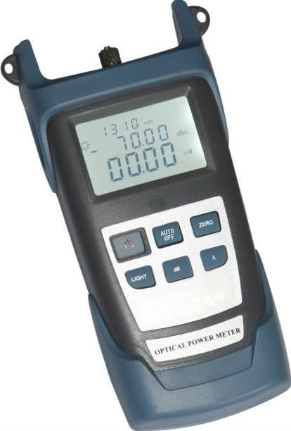 | 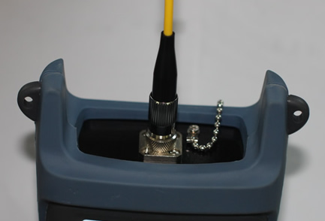  Figure1: connect with FC
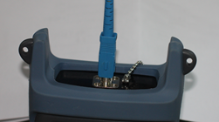

Figure2: connect with SC

Specifications
Model | A | B
Measurement range | -70～+10 | -50～+26
Type of probe | InGaAs
Range of wave length | 800～1700
Uncertainty | ±5%
Standard wave length (nm) | 850、980、1300、1310、1490、1550
Resolution | Linear indication: 0.1% Logarithmic indication: 0.01dBm
Working temperature (℃) | -10～+60
Storage temperature (℃) | -25～+70
Auto power-off time (min) | 10
Continuous working hours | At least 48 hours
Dimensions (mm) | 190×100×48
Power supply | Rechargeable lithium battery
Weight(g) | 310
Notice:
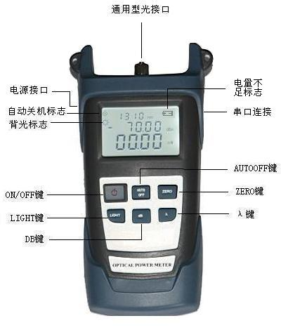
- Range of wave length: a standard working wave length that we specified: λmin – λmax, the optical power meter within this range can work well with all indicators meeting requirements.
- Measurement range: the maximum power that the meter can measure as per required indicators.
- Uncertainty: the error between the test results and standard test results over a popular optical power.

Function descriptions
  - LCD
It displays the optical power measurement results in forms of dB, dBm, mW, uW, nW; the set wave length is 850nm , 980 nm, 1300 nm, 1310 nm, 1490 nm, 1550 nm, etc.
  - ON/OFF
To power on the meter, press and hold ON/OFF till information appears in LCD; while in power-on state, press the key to power off the meter.
  - dB
Measure relative optical power under preset wave length.
  - ZERO
Press this key to zero the optical power meter.
  - λ
Press λ key to select wave length, there are six wave length, i.e.: 850nm , 980 nm, 1300 nm, 1310 nm, 1490 nm, 1550 nm for your choice, their values will appear in LCD respectively.
  - LIGHT
Press this key to turn on/off the back light of LCD.
7、AUTOOFF
Press this key to enable or disable AUTOOFF function of the meter.

Operating Instructions
Power ON/OFF
- Press and hold ON/OFF on the panel till information appears in LCD.
- Press ON/OFF on the panel, information disappears from LCD, the meter is powered off.

Measure absolute optical power
- Power on the optical power meter.
- Set wavelength to be measured, press λ key to select wave length, the default wavelength will be 1310nm.
- Connect in the light to be measured, the values that screen shows are current measurement results, including linear and non-linear power value

Measure relative optical power
- Set wavelength to be measured.
- Connect in the light to be measured while in absolute measurement mode, get current power value.
- Press db key, current optical power value will become current reference value (in unit of dBm).
- Connect in another light to be measured, the absolute optical power value and relative optical power value of current light will appear in the screen.

Special functions
The product provides three modes, i.e.: factory mode, user mode and working mode, it usually enters working mode.
Factory mode
The measurement and calibration are made by the factory.
User mode
Press λ+Light together, the system will enter user mode, and the “nm” at the end of the first line will be absent. Press λ+Light together again, the system will exit user mode and enter working mode, the “nm” at the end of the first line will appear again.

Functions of keys
Functions | Keys
Increase by 0.05 | Light
Decrease by 0.05 | dB
Save | Zero
Change wave length | Λ
Reset default settings | λ+ Zero

Remarks: in the event error occurs when user calibrates or operates the meter himself, he can press λ+ Zero together while in User Mode to reset default settings.

10 minutes’ auto off
Press AUTOOFF to enable AUTO OFF function, the icon “OFF” will appear on the left top of the screen, then the meter will automatically turn off if there are no operations within 10 minutes.

LED backlight ON/OFF
While in working mode, press LIGHT to turn on backlight, the symbol “a little sun” will appear on the left top of the screen indicating backlight is on.

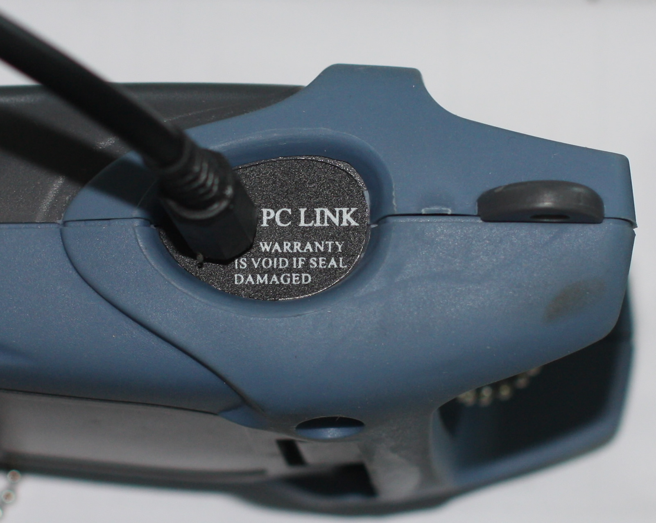
Serial port commissioning
Connect serial port plug to PC’s serial port, you can access data and calibrate the meter (see the Figure on the right) via PC.

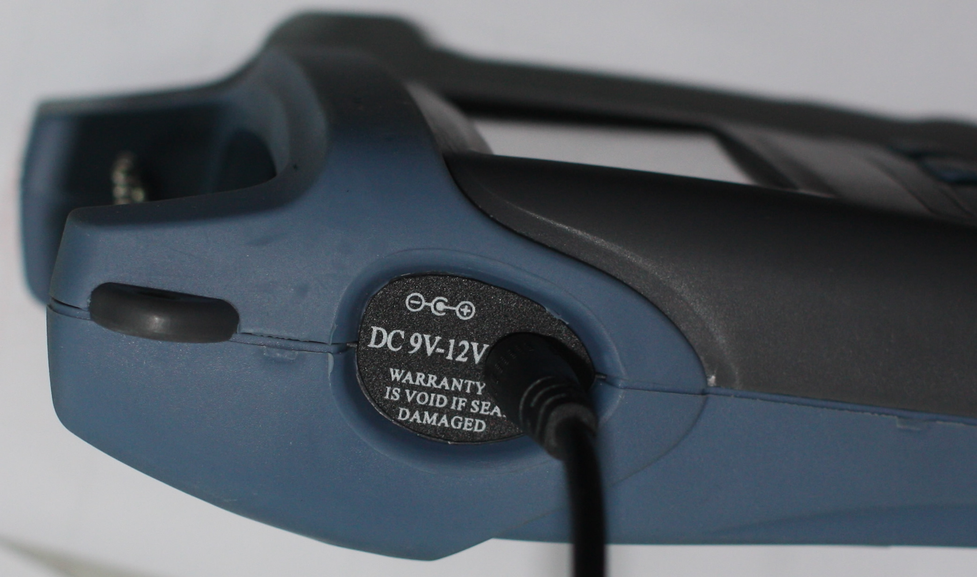
Charging
While in normal working, the power volume indicator will not appear in the screen; however, when the battery is going to run out, the power volume indicator will blink once a second, the meter will automatically power off after the indicator blinks for ten times; if so, you can insert the meter into supplied charger for charging (see the Figure on the right), this way saves a lot of trouble and cost in replacing battery.

Standard configurations
Name
Host
Rechargeable lithium battery
Warranty card
Oxford soft bag
Charger
Data cable (optional)
Pass Certificate

Maintenance
1. Regularly clean the end of sensor, keep it free of grease, dirt. Don’t use dirty, non-standard connector, don’t insert in the end in poor polishing conditions, otherwise the sensor's end may be damaged, otherwise the performance of entire system may degrade.
2. Use only one adapter if possible.
3. If you are not going to use the tester for the time, cover the dust-proof cap immediately to keep the end clean. Long-time exposure in air may gather dust therefore influencing measurement accuracy.
4. Plug and unplug the adapter with care, don’t leave any scratches on the ports.
5. Regularly clean the surface of sensor, when cleaning the sensor, please gently wipe the surface using cotton swab by circling the perimeter.

Troubleshooting
Fault description | Diagnosis | Solution
LCD image is weak | Power is insufficient | Charge the meter
No display after power-on | Power is insufficient / other reason | Restart / charge the meter
No charge or a little charge in LCD readings | Optical adapter’s connector is faulty or contaminated/ display is locked | Check whether the optical adapter’s connector is properly connected, clean the terminal of sensor.
Warranty
No parts of the product can be repaired by user himself.

- Warranty period: 18 months since the date of shipment. If any product defect within the above said period, we will repair or replace the defective product, however, in no events we will bear responsibilities in excess of the product’s sales price.
- If any fault occurs during usage, user can first solve them according to above trouble-shooting instructions, however, if such efforts fail, the user shall not open the cabinet of the product by himself, he should contact our market department or local dealers.
- For any quality problem arising of production defect, the manufacturer will repair or replace the defective product free of charge, however, any damage caused by improper-operation or good product will not be covered by the above warranty.

Notwithstanding the foregoing terms, any problem/fault caused for the following reasons are not included warranty.

- The product has been repaired or modified without the authorization of the manufacturer
- The problem or fault arising of improper use, negligence or incidence.

The product is accompanied by a Warranty Registration Card, please complete it and send it back to us together with a photocopy of the invoice, they will be used as the voucher for any maintenance, technical update or calibration that we may make in the future.

Appendix: measurement of optical fibre loss

Step 1 Set reference value
Power on optical power meter, press λ key to select a proper working wave length.
Turn on light source (emitter), select a proper wave length and keep it steady (it may take 1-2 minutes).
Select a optical fibre jumper to connect light source, we call it emitter jumper, clean the connector of emitter jumper. Note the optical fibre that the emitter jumper uses must be identical the optical fibre that the optical link to be tested uses.
Connect light source (emitter) with the optical power meter using emitter jumper.
Current optical power value is measured.
Notice: the power value that we get now should be approximate to the preset value of the light source (emitter), if the bias is too great, please carefully clean all connection terminals or replace the emitter jumper.
Press dB key, the moment dB reading is 0.00, and set the power measurement result as reference value.
Notice: after you zero the meter, the number of digits after the decimal point may change a little, this is not an indicator of fault.

Step 2 Measure loss of optical fibre link
Make the emitter jumper and light source (emitter) continuously connected.
Connect the light source (emitter) with the optical fibre link to be measured.
Notice: clean all connection terminals including necessary optical fibre adapter.
The reading appearing in the screen now is the loss of the measured optical fibre link, its unit is dB (current absolute power value is displayed in dBm form at the same time).

