Overview
The portable stabilized light source can provide stable output of 1-4 wavelength depending on user’s requirements. It can not only provide 650nm visible red light, but also provide 1310nm and 1550nm double-wavelength laser output for single-mode optical fibre measurement, or provide laser output of four wavelength, i.e.: 850/1300/1310/1550nm, it is an ideal tester designed for optical fibre works..

Features
High-stability multi-wavelength single (multiple) mode laser output, optional CW or modulation mode
Large LCD display of working wavelength
Supports continuous work for up to 48 hours.
Ability to switch working wavelength by pressing one key, easy to operate
AUTO POWER OFF

Specifications
Model | General configurations | Special configurations for PON light source | Others
Working wavelength (nm) | 1310/1550 | 1310/1490/1550 | D: 850/1310/1550  E: 1310/1490/1550  F: 1310/1550/1625
Light-emitting device | FP-LD
Optical output power (dBm) | -7/-7 | -7/-7/-7 | 0DB-7DB
Modulation | CW/270/1K/2K
Type of optical fibre | SM，MM
Connector | FC/PC
Working temperature (℃) | -10～+60
Storage temperature (℃) | -25～+70
Auto power-off time (min) | 10
Continuous working hours (h) | 45
Dimensions (mm) | 190×100×48
Power supply | Rechargeable lithium battery
Weight (g) | 400

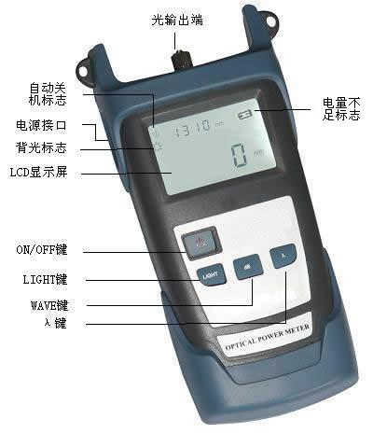
Function Description
- Optical output
Connect FC optical fibre connector to the signal receiver of the device to be measured.

- LCD
LCD displays the length of optical wave.
- ON/OFF
While in power-off state, press it to power on the device.
While in power-on state, short press it (for less than 3 seconds) to enable or disable AUTOOFF function. If the icon “AUTOOFF” appears in the screen, the device will automatically turn off if there are no operations within 10 minutes. If the icon “AUTOOFF” doesn’t appear in the screen, it indicates that the “AUTOOFF” function has been disabled.
While in power-on state, long press ON/OFF key (for at least 3 seconds) to turn off the light source.
- WAVE
Press the key to select output wavelength, the value will appear in LCD.
- MODE
Switch the modulation frequency of light source between CW, 270Hz, 1000Hz and 2000Hz.
- LIGHT
Press this key to turn on/off the backlight.

Operating Instructions
- Connect the optical fibre connector to output port.
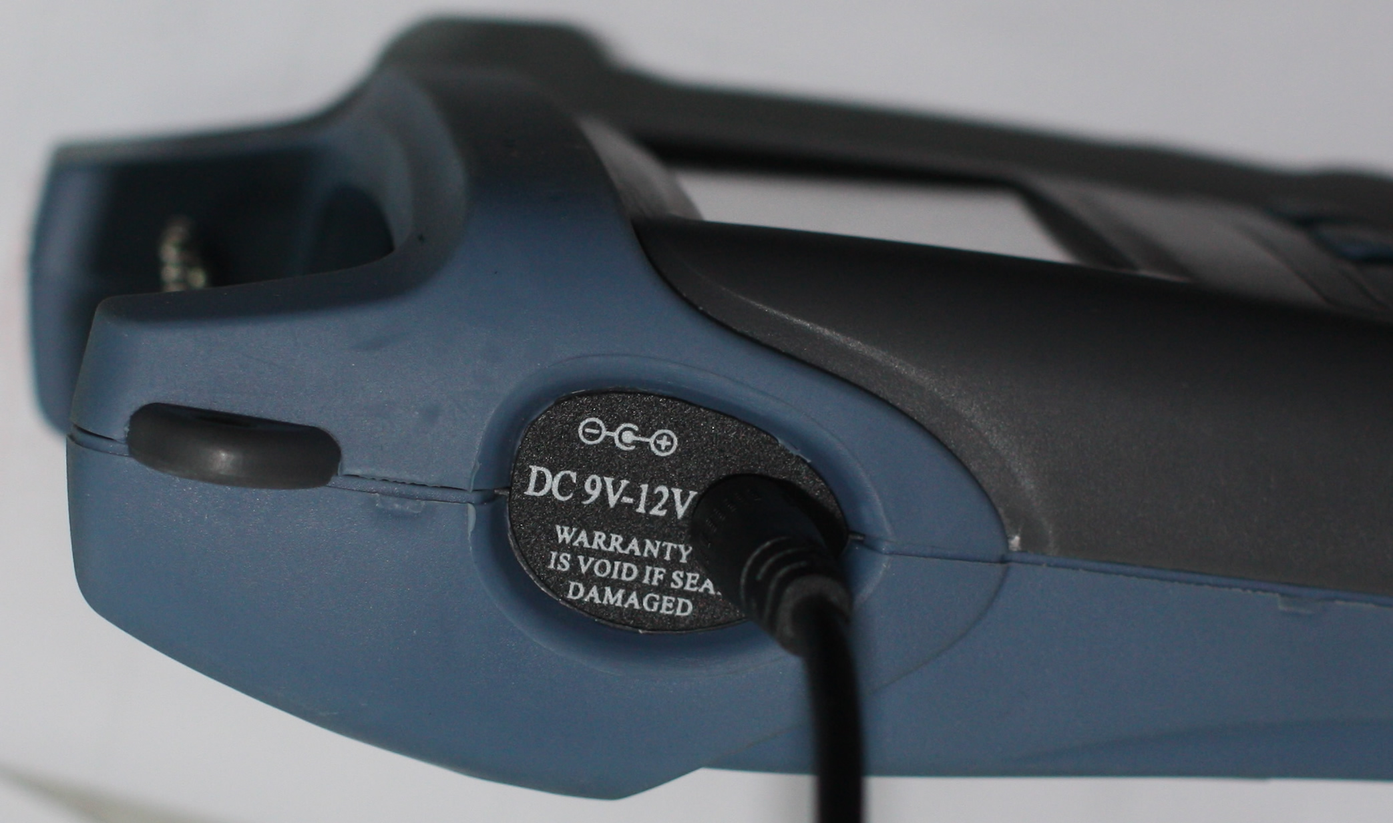
- Press ON/OFF, the working indicator turns on.
- Press WAVE key to adjust modulation frequency of light source.
- Press MODE key to adjust modulation frequency of light source.
- All status indicators of portable stabilized light source will appear in LCD. when the battery is going to run out, the power volume indicator will blink once a second, the device will automatically power off after the indicator blinks for ten times; if so, you can insert the device into supplied charger for charging (see the Figure on the right).
- Power Off: Press ON/OFF on the panel, the indicator turns in dark, information disappears from LCD, the device is powered off.

Standard configurations
Name
Host
Rechargeable lithium battery (in the battery cartridge)
Warranty card
Oxford soft bag
Charger
Pass Certificate

Maintenance
Precautions
1. Don’t watch the output port with eyes while it is running, the laser will hurt your eyes.
2. If you are not going to use the tester for long time, cover the dust-proof cap immediately to keep the end clean, don’t expose it in air for long time, otherwise dust may gather polluting the output end.
3. After the stabilized light source works for a time, dirt or dust may gather at output end reducing output optical power, if so, user can gently wipe the surface using cotton swab dipped with alcohol, then remove the contaminants with dry cotton swab. If end still look dirty after doing so, please contact us.
4. If you are not going to use the tester for long time, please take out the battery, so as to prolong life of battery.
5. For any other fault, please immediately contact our technician, don’t open the cabinet of the device to repair it by yourself, otherwise more serious problems may occur. We will not repair any product that have been disassembled by user himself.

Troubleshooting
SN | Diagnosis | Solution
1 | Output light is found unsteady | Please replace the battery
2 | The terminal of adapter is dirty | Clean it gently with alcohol
3 | The output optical power is unsteady after startup. | Pre-warm the device for 15 minutes before using it.

Warranty
No parts of the product can be repaired by user himself.

- Warranty period: 18 months since the date of shipment. If any product defect within the above said period, we will repair or replace the defective product, however, in no events we will bear responsibilities in excess of the product’s sales price.
- If any fault occurs during usage, user can first solve them according to above trouble-shooting instructions, however, if such efforts fail, the user shall not open the cabinet of the product by himself, he should contact our market department or local dealers.
- For any quality problem arising of production defect, the manufacturer will repair or replace the defective product free of charge, however, any damage caused by improper-operation or good product will not be covered by the above warranty.

Notwithstanding the foregoing terms, any problem/fault caused for the following reasons are not included warranty.

- The product has been repaired or modified without the authorization of the manufacturer
- The problem or fault arising of improper use, negligence or incidence.

The product is accompanied by a Warranty Registration Card, please complete it and send it back to us together with a photocopy of the invoice, they will be used as the voucher for any maintenance, technical update or calibration that we may make in the future.

