BBenchtop Instrument

80000 Counts(4 7/8)
Bench Digital Multimeter
Operation Manual

1. GENERAL
This meter is an intelligent and multi-functional device for various measurement. It features high quality, high accuracy, high reliability, special high frequency measurement and low cost. The meter is in compliance with IEC 6010 CAT II 1000V and CAT III 600V high voltage standards. Other features of this instrument are listed below:
- Multi-display: primary 80000 counts, secondary 80000 counts, bar graph 23 segments
- 50 measuring functions, with basic DCV, ACV, DCA, ACA, Ω, CAP, Hz, TEMP, diode and Continuity measuring function, etc.
- 18 types of frequency, frequency up to 80MHz, 1800 waveform outputs, 0.1%~99% duty cycle.
- Simultaneous measure (AC+DC), (AC+Hz), (DC+dBm), (dBm+Hz), (Hz+Duty), (℃+℉).
- Auto data update and refresh, auto data hold, auto peak hold.
- 36-hour dynamic record: MAG, MIN, AVG, MAX-MIN (REL△), (REL%), setting upper & lower limit, timing measurement
- AC measuring adopts highly accurate true RMS measurement, with testing frequency bandwidth and AC+DC measuring, capable of accurate true RMS measuring of any waveforms in AC range
- RS-232 interface

SAFETY INSTRUCTIONS

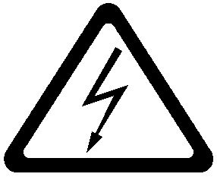 High voltage 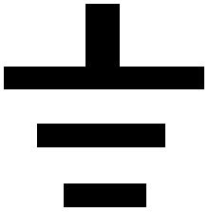 GND  Dual insulation  Refer to manual.
WARNING! To avoid the electric shock and physical injury, and to avoid possible damage to the meter and the tested equipments, read this operation manual carefully before using this meter, and follow the following safety guidelines:
- Before use, check and make sure that the instrument’s plastic chassis, the test leads and the insulation layer are intact.
- User the meter only as specified in this manual. Otherwise, the protection provided by the meter may be expired.
- Never measure voltage while the test leads are inserted into the current input terminals.
- Do not use the meter if it looks damaged
- Inspect the leads for damaged insulation or exposed metal, check test lead continuity. Replace damaged leads.
- Disconnect the power and discharge all high-voltage capacitors before testing in resistance, continuity and diode function.
- Be cautious when working at voltage above DC60V or AC42V. Such voltages may cause a shock hazard.
- When undertaking measurement, keep your fingers behind the guard’s plant on the test leads or probes.
- Select the proper function and range for measurement to avoid damage to the meter.
- Disconnect the test leads from the test points before changing to another function.

The specifications are subject to change without notice.
The content of this manual is regarded as correct. If any error or omits is found, please contact with the manufacturer.
We hereby will not be responsible for the accident and damage caused by improper operation.
The function stated for this User Manual cannot be the reason of special usage.
2. PANEL INSTRUCTIONS

Fig.2-1 Front panel

Fig. 2-2 Rear Panel

1. Power switch: turns the meter on or off

2. Auxiliary keys: SELECT, RANGE, SET, MAX/MIN, Timer/RS232/HOLD/2nd VIEW/ REL△
SELECT: Selects measurement mode
RANGE: Selects measurement range. The meter is default at auto range mode.
SET:
- When the SET button is in operation, the RANGE button is used as a moving up button (), the 2nd VIEW button as a moving down button (), the MAX/MIN as a moving left button (), and REL△ as a moving right (). In this case, the RANGE, 2nd VIEW, MAX/MIN and REL△ buttons’ original functions are disabled. buttons can be used to enter and adjust the setting values.
- Press SET button for at least 2 seconds to start the backlight. Press this button again to turn off the backlight. The backlight can auto off if this button is not engaged within 30 seconds.

MAX/MIN:
- Presses this button to enter the dynamic record mode, with maximum record period of 36 hours.
- In the dynamic record mode, the meter automatically records the maximum value (MAX), minimum value (MIN), difference value (MAX-MIN) and calculate the average value (AVG) of all readings. Press this button to cycle MAX, MIN, AVG, MAX-MIN on the secondary display.
- Pressing this button for at least 2 seconds, the meter returns to auto range.

Timer/RS232:
TIME:
- TIMER function is enabled only in the REL△ and MAX/MIN measuring mode.
- Press TIMER key to start the secondary display for counting time. Press TIMER key again to turn off the counting time display.
- When the secondary display is display counting time, press key SELECT to enter Beeper setup for setting up a timer for beeper. Then, press key REL△ (), MIX/MIN (), RANGE (), 2nd VIEW () to input the time. Next press key TIMER to validate the new time data. When the counting time exceeds the preset time, the beeper sounds.
- In the above two modes, press key HOLD to stop timer function and turn off secondary display, but the preset time remains unchanged.
- The time is display in the format of 8.88.88 on the secondary display. The max.counting time is 9.59.59

RS232:
- Pressing this button for at least 2 seconds, the RS232 remote control is enabled for PC control and communication with other instruments. The LCD display “RS232’
- Auto power off function is disabled in this RS232 programmable mode.
- Pressing this button for at least 2 seconds again to exits this mode and return to normal mode.

HOLD:
- Pressing this button, the meter enters auto data hold mode and “A-H” is displayed on the LCD.
- The data hold mode allows users to hold the displayed value while the analog bar graph shows the current reading.
- Pressing this button again, the meter enters Peak+ hold mode and a “PH+” appears on the LCD display.
- Pressing this button again, the meter enters Peak- hold mode and a “PH-” appears on the LCD display.
- Pressing this button for at least 2 seconds, the meter exits HOLD mode and return to normal mode.

2nd VIEW: Selects the secondary display function. In various measuring mode, press 2nd VIEW button to cycle the displayed data on secondary display. Se the follow table:

Function key | Measuring mode | Primary display | Secondary display
 | ACV+Hz | ACV
 | AC dBm+Hz | AC dBm | ACV/Hz
 | (ACV+DCV)+Hz | ACV+DCV | ACV/Hz
 | dBm+Hz | dBm | Hz/ACV/DCV/ACV+DCV
 | ACmV+Hz | ACmV
 | dBm+Hz | dBm | Hz/ACmV/DCmV/ACmV+DCmV
Hz/DUTY | Hz | Hz
 |  | Press key 2nd VIEW to change output frequency | Press key SELECT to change duty value

- In square waveform output mode, press 2nd VIEW button to select frequency and trigger the square waveform at the selected frequency: 0.5000Hz/1.0000Hz/2.0000Hz/10.00Hz/50.000Hz/60.240Hz/74.63Hz/100.00Hz/151.50Hz/200.00Hz/303.00Hz/606.10Hz/1.2500kHz/1.6660kHz/2.5000kHz/5.0000kHz.
- Press this key for at least 2 seconds to return to 606.10Hz, 50% duty output state.
- When the SET button is in operation, 2nd VIEW button is using as a moving down button (). Pressing this button moves the setting digit down

REL△:
- Pressing this button, the meter enters relative measuring mode and “REL△” appears on the LCD display. The relative measuring functions measures the difference between the testing value and the reference value. The current readings on the secondary display are used as a relative value. The primary display displays the relative measurement in two modes:
One is: REL△=measuring value – Reference value
The other is: REL%= (REL△/Reference value)x100% (press SELECT button to select REL△ or REL% mode)
- Press REL△ button again, the testing value will be used as reference value and displayed on the secondary display.
- While the SET button is in operation, the REL△ button is used as a moving right button () to move the setting digit to the right.
- Press REL△ for at least 2 seconds to exits reference mode and return to normal mode.
- Set up reference value for measurement:
  - In every reference value, use RANGE button to select a proper range
  - When SET button is in operation, press SELECT button twice to set up reference value for measurement. At the same time, the are enabled.
  - Use buttons to adjust the reference value.
    - Press SET button to validate the new setup.

3. Terminal
COM: Common terminal for all measurements
V Ω Hz: Volts, Ohn, Diode, Freq., Temp, and Cap. Measurement and square wave output terminal
mA: Milli ampere current measurement terminal
20A: Ampere current measurement terminal

4. Function Key

- : ACV
- : DCV
: DC/AC Milli voltage
: Diode & Continuity
Ω : Resistance
DUTY/Hz: Duty/Frequency

5. LCD Display: The following table gives description of the symbols displayed on the LCD.
Fig.2-3 LCD display
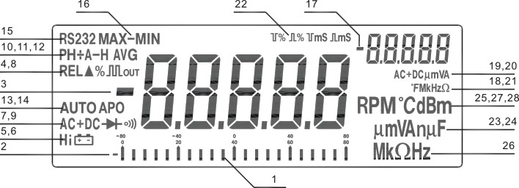

No. | Symbol | Description
1 |  | Analog bar graph
2, 3, 17 |  | Negative sign
4 |  | Square wave output
5 | Hi | Hi frequency or thermocouple indicator
6 |  | Low battery
7 |  | Diode/Audible continuity function
8 | REL△% | Relative measurement
9, 19 | DC, AC, DC+AC | DC, AC, DC+AC voltage or current
10 | PH+ PH- | +Peak Hold, -Peak Hold
11 | A-H | Auto Hold
12 | AVG | Average reading
13 | Auto | Auto mode
14 | APO | Auto power off sign
15 | RS232 | Communication on annunciation
16 | MAX/MIN/MAX-MIN | MAX Rereading/MIN Reading/MAX-MIN Reading
20 | mV/V/mA/A | Voltage and current units on secondary display
21 | Hz/kHz/MHz/Ω/kΩ/MΩ | Frequency and resistance units on secondary display
22 |  | Duty cycle unit and plus width unit
23 | nF/μF | Capacitance unit
24 | mV/V/mA/A | Voltage and current units on primary display
25 | dBm | dBm annunciation
26 | Hz/kHz/MHz/Ω/kΩ/MΩ | Frequency and resistance units on primary display
27, 18 | ℃ ℉ | Temperature units and measurement indicator
28 | RPM | Round/per minute
6. AC110V/220V selector switch
7. Fuse
8. Power plug
9. RS232 interface

3. SPECIAL FUNCTIONS
3.1 Auto Power Off
The meter has two power off function. In normal conditions when the meter is power on, if there is no operation on any of the buttons or function keys within 30 mints, the meter will be automatically powered off. Five mints before auto power off, the audible five beepers give indication that the meter is gong to be power off.

3.2 Setting Upper and Lower Limits for Measurement
The upper and lower measurement limits can be set up in the following steps:
- Set the upper limit: power on the meter select range press SET button press SELECT button to start the upper setting mode (“” appears on secondary display) press buttons to adjust the value press SET button to validate the new input.
- Set the lower limit: power on the meter select range press SET button press SELECT button to start the lower setting mode (“” appears on secondary display) press buttons to adjust the value press SET button to validate the new input.
- After setting up the upper and lower limits, measurement can be carried out and the LCD will have 3 kinds of displays to the results:
  - If the measuring value exceeds the upper limit, the LCD displays the measuring value on the primary display and “” on the secondary display.
  - If the measuring value exceeds the lower limit, the LCD display the measuring value on the primary display and “” on the secondary display.
  - If the measuring value is between and upper and lower limit, the LCD displays the measuring value on the primary display and “” on the secondary display.

3.3 Set up the Time for Measurement
    - Press TIMER button to set enter the setup of time. The secondary display displays “0.00.00”
    - Press SELECT button and the last digit of “0.00.00” on the secondary display glitters, which means this digit can be adjusted. Use the buttons to adjust the digit value. (The first digit from the left is hour, the second and third are minute, the fourth and fifth are second.)
    - Press TIMER button to validate the new setup. By now the measuring time is set.

3.4 Analog Bar Graph
The function of analog bar graph is imitating the analog needle of the meter but without the overshoot. The bar graph refreshes data 40 times per second. Because the graph responds 10 times faster than the digital display, it is widely used in the application of peak value test and zero calibration. It is also commonly used in observing the rapid variation of input signals. The bar graph has 23 segments. The number of lit segments is relative to the full-scale value of the selected range. One unit of the bar graph represents 4000 counts/bar except when in the relative mode. The polarity is indicated at the left of the bar graph.

3.5 Square Wave Output
The square wave output is a very useful function. With adjustable square wave frequency and duty cycle, users can carry out the pulse wave modulation (PWM) output, and adjust the voltage control, timer control and clock syntherization.

3.6 Measurement Range
A measurement range determines the measuring limits. The meter has several measurement ranges.
- Select a proper measurement range:
  - If the selected measurement range is too small (the testing signal exceeds the measurement range), the meter will display “OL” on the LCD.
  - If the selected measurement range is to large, the testing results may have a relatively low resolution.
- Auto range and Manual range
The meter has both auto range and manual range for the measurements.
- In the AUTO measuring mode, the meter will automatically select a most suitable range for the testing signal. In AUTO mode, the meter will display “AUTO” on the LCD.
- In the MANUAL measuring mode, the measuring range is selected manually by pressing RANGE button.
- If there is more than one range in a measuring function, the meter will default in AUTO range. This allows users to override the auto range and lock the meter in a specific range.
- In HOLD or MAX/MIN recording mode, changing the measurement range manually will automatically exit the HOLD or MAX/MIN mode.
- Enter or exit mauran range mode
- Press RANGE button to select manual range mode. Then, every press on the RANGE button, the meter steps to a higher range and will return to the lowest range when the higher range is stepped into.
- Pressing RANGE button for at least two seconds can also return to auto range mode.

4. OPERATION INSTRUCTIONS
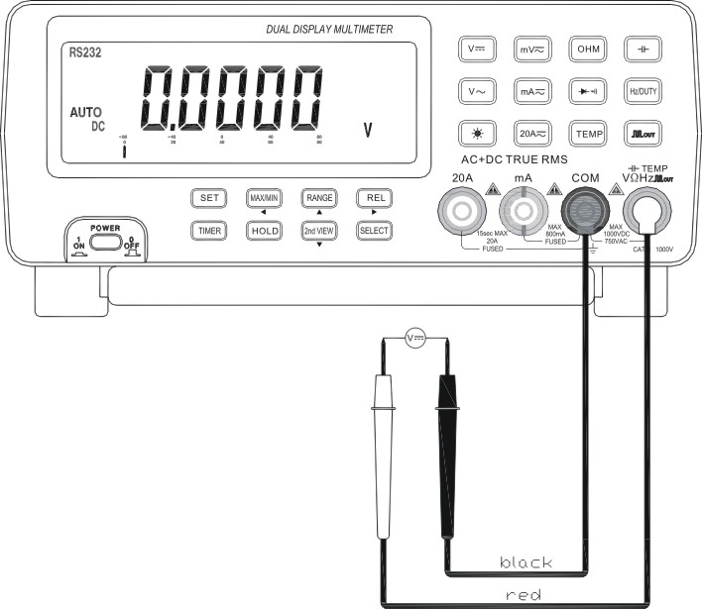
4.1 DC Voltage Measurement (DCV)
The measurement of DC voltage has three modes: DCV, DCV+ACV and dBm.
- Set the function key to “” position.
- Press SELECT button to select measurement mode.
- According to practical demands, press REL△, MAX/MIN and 2nd VIEW buttons to have relative measuring or record.
- Connect the black test lead to “COM” terminal and the read test lead to “V Ω Hz” terminal.
- The meter is in auto range mode and will automatically select a most suitable range. To select a range manually for DCV measurement, press RANGE button to select a proper range. There are four ranges to choose from: 8.0000V/80.000V/800.00V/1000.0V
- Touch the test leads to the test points and read the display on both the primary and secondary display.

Press SELECT | Primary display | Secondary display  Press 2nd VIEW
DCV | DCV
DCV+ACV | DCV
dBm | dBm | Hz/ACV/DCV/DCV+ACV

NOTE:
  - In dBm measurement mode, the decimal point of dBm is fixed between the second and third digits.
  - When in dBm measurement, the impedance is default at 600Ω. To change the impedance, press RANGE button to select a proper impedance. The impedance can be chosen from: 4/8/16/32/50/75/93/110/125/135/150/200/250/300/500/600/800/900/1000/1200Ω.

4.2 AC Voltage Measurement (ACV)
WANRNING: The testing AC voltage must not exceed AC750V!
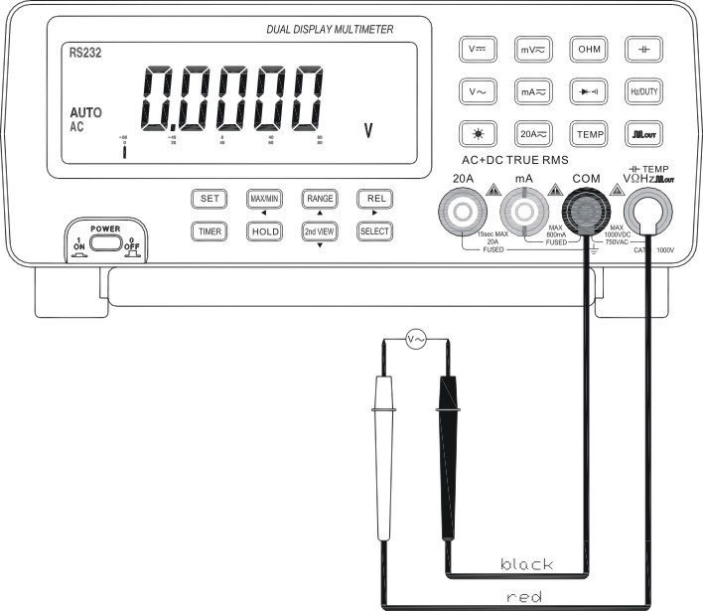
The measurement of AC voltage has three modes: ACV, ACV+Hz and dBm.
- Set the function key to “” position.
- Press SELECT button to select measurement mode.
- According to practical demands, press REL△, MAX/MIN and 2nd VIEW buttons to have relative measuring or record.
- The meter is in auto range mode and will automatically select a most suitable range. To select a range manually for ACV measurement, press RANGE button to select a proper range. There are three ranges to choose from: 8.0000V/80.000V/750.00V
- Connect the black test lead to “COM” terminal and the read test lead to “V Ω Hz” terminal.
- Touch the test leads to the test points and read the display on both the primary and secondary display.

Press SELECT | Primary display | Secondary display  Press 2nd VIEW
ACV | ACV
ACV+Hz | ACV
dBm | dBm | Hz/ACV

NOTE:
  - In dBm measurement mode, the decimal point of dBm is fixed between the second and third digits.
  - When in dBm measurement, the impedance is default at 600Ω. To change the impedance, press RANGE button to select a proper impedance. The impedance can be chosen from: 4/8/16/32/50/75/93/110/125/135/150/200/250/300/500/600/800/900/1000/1200Ω.
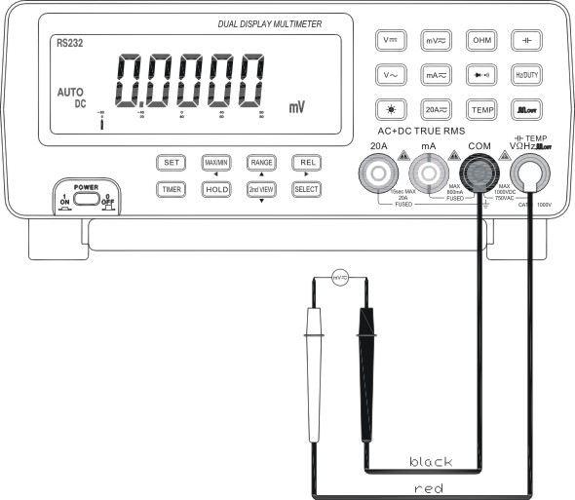
4.3 AC/DC Milli Voltage Measurement (ACmV, DCmV)
The measurement of AC/DC milli voltage have three modes: DCmV, ACmV+Hz and dBm.
- Set the function key to “” position.
- Press SELECT button to select measurement mode.
- According to poetical demands, press REL△, MAX/MIN and 2nd VIEW buttons to have relative measuring or record.
- The meter is in auto range mode and will automatically select a most suitable range. To select a range manually for the measurement, press RANGE button to select a proper range. There are two ranges to choose from: 80.000mV/800.00mV
- Connect the black test lead to “COM” terminal and the read test lead to “V Ω Hz” terminal.
- Touch the test leads to the test points and read the display on both the primary and secondary display.

Press SELECT | Primary display | Secondary display  Press 2nd VIEW
DCmV | DCmV
ACmV+Hz | ACmV
dBm | dBm | Hz/ ACmV/ DCmV/ DCmV+ ACmV

NOTE:
- In dBm measurement mode, the decimal point of dBm is fixed between the second and third digits.
- When in dBm measurement, the impedance is default at 600Ω. To change the impedance, press RANGE button to select a proper impedance. The impedance can be chosen from: 4/8/16/32/50/75/93/110/125/135/150/200/250/300/500/600/800/900/1000/1200Ω.
- In dBm measurement mode, REL△, MAX/MIN, AVG, A-H functions are disabled.
- In milli voltage measurement mode, in order to obtain DC+AC function, the input terminal of ADC does not employ coupling capacitor. Therefore, never apply a voltage over double value of DC or AC voltage of the rated value of this range.

4.4 AC/DC Milli Current Measurement (ACmA, DCmA)
WANRNING:
- To avoid injury and damage to the meter, never attempt an in-circuit current measurement when the fuse is blown, or when the voltage between open circuit and the ground is 1000V.
- To avoid damage to the meter, check the meter’s fuse before proceeding.
- Before current measurement, turn of the circuit power supply, discharge the high voltage capacitance.
- Under no circumstances, do not test the voltage when the test leads are plugged in “mA” or “20A” terminals.
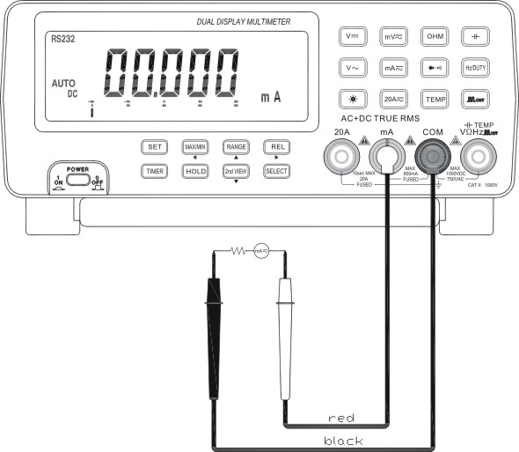
- Do not place the probes in parallel with a circuit or component when the leads are plugged into the current terminals.

The measurement of AC/DC milli current has three modes: DCmA, ACmA, DCmA+ACmA, and ACmA +Hz
- Set the function key to “mA” position.
- Press SELECT button to select measurement mode.
- According to practical demands, press REL△, MAX/MIN and 2nd VIEW buttons to have relative measuring or record.
- The meter is in auto range mode and will automatically select a most suitable range. To select a range manually for the measurement, press RANGE button to select a proper range. There are two ranges to choose from: 80.000mA/800.00mA
- Connect the black test lead to “COM” terminal and the read test lead to “mA” terminal.
- Break the circuit path to be tested. Tough the black test leas to the negative of the break and the red test lead to the positive of the break. Read the display.
- After finishing measurement, disconnect the power supply to the circuit and discharge all high voltage capacitors. Remove the meter and restore the circuit to normal operation. Pull out the test lead from “mA” terminal.

Press SELECT | Primary display | Secondary display  Press 2nd VIEW
DCmA | DCmA
ACmA | ACmA
DCmA+ ACmA | DCmA+ ACmA | ACmA
AcmA+Hz | ACmA | Hz

4.5 AC/DC Current Measurement (ACA, DCA)
The measurement of AC/DC current has four modes: DCA, ACA, DCA+ACA, and ACA +Hz
- Set the function key to “A” position.
- Press SELECT button to select measurement mode.
- According to poetical demands, press REL△, MAX/MIN and 2nd VIEW buttons to have relative measuring or record.
- The meter is in auto range mode and will automatically select a most suitable range. To select a range manually for the measurement, press RANGE button to select a proper range. There are two ranges to choose from: 8.0000A/20.000A
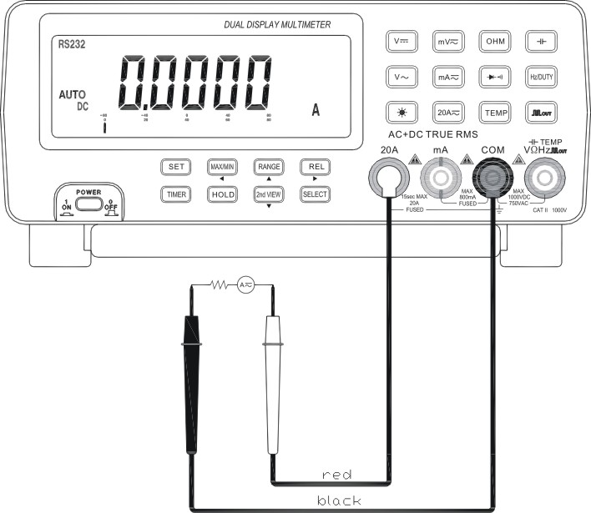
- Connect the black test lead to “COM” terminal and the read test lead to “20A” terminal.
- Other operations apply the same as explained in section 4.4

Press SELECT | Primary display | Secondary display  Press 2nd VIEW
DCA | DCA
ACA | ACA
DCA+ACA | (DC+AC)A | ACA
ACA+Hz | ACA | Hz

4.6 Resistance Measurement (Ω)
WANRNING: To avoid damage to the meter or the testing equipments disconnect circuit power and discharge all high voltage capacitors before measuring resistance. Use the DC function to confirm that the capacitor is discharged.

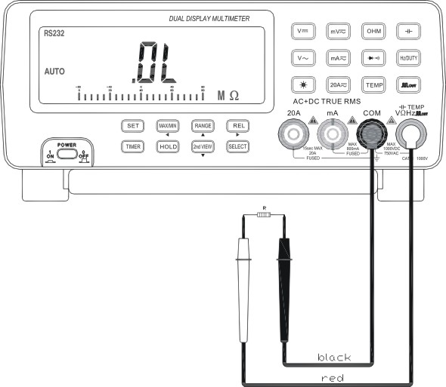
NOTE: In measuring low resistance, the resistance of the test leads may cause an error of 0.1Ω~0.5Ω in the test results. To avoid this error, first short the test leads, next press REL△ button. The primary display will be null and the secondary display displays the resistance of test lead. Measure the to-be tested resistance and the result will be displayed on the primary display.

The measurement of resistance has three modes: normal, continuity and Hi resistance. Press SELECT button to choose from these modes.
Normal mode
- Set the function key to “Ω” position
- According to practical demands, press REL△, MAX/MIN and 2nd VIEW buttons to have relative measuring or record.
- The meter is in auto range mode and will automatically select a most suitable range. To select a range manually for the measurement, press RANGE button to select a proper range. There are six ranges to choose from: 800.00Ω/8.0000kΩ/80.000kΩ/800.00kΩ/8.0000MΩ/80.000MΩ
- Connect the black test lead to “COM” terminal and the read test lead to “VΩ Hz” terminal.
- Touch the probes to the test points and read the display.

Measurement mode | Primary display | Secondary display
Ω | Ω/kΩ/MΩ | MAX/MIN, REL△ parameters

Continuity mode
- Press SELECT button to select “” range.
- If the testing points resistance falls below 50Ω. The beeper will sound.
Hi resistance
- This function is used to measure the resistance above 80MΩ.
- Press SELECT button to select “HiΩ” range. The primary display will display “Hi”.
- A single range is 8000.0MΩ. If the testing points resistance falls below 10MΩ and above 8000.0MΩ, “OL” will appears on the display.

4.7 Capacitance Measurement (CAP)
WANRNING: To avoid damage to the meter or the testing equipments disconnect circuit power and discharge all high voltage capacitors before measuring capacitance. Use the DC function to confirm that the capacitor is discharged.

NOTE:
- Some capacitors have polarities. In measuring polarities capacitors, touch the red test lead to the positive polarity and the black test lead to the negative polarity.
- In measuring low capacitance, the resistance of the test leads may cause an error in the test results. To avoid this error, first short the test leads, next press REL△ button. The primary display will be null and the secondary display displays the resistance of test lead. Measure the to-be tested resistance and the result will be displayed on the primary display.

Capacitor is capable of storing electric charge. When testing capacitance, only the value on a stable display is the correct result.
- Set the function to “” position.
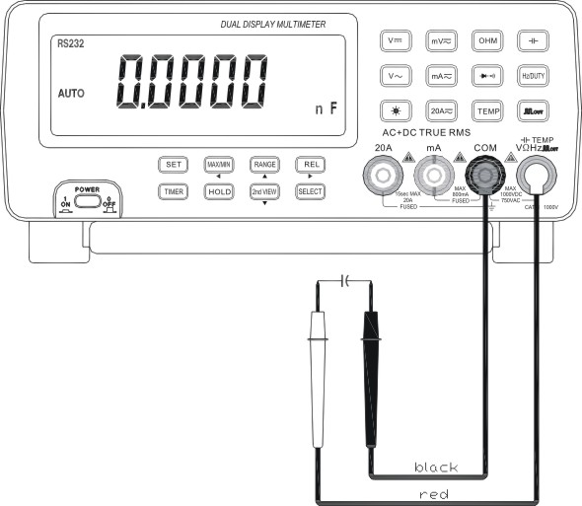
- According to practical demands, press REL△, MAX/MIN and 2nd VIEW buttons to have relative measuring or record.
- The meter is in auto range mode and will automatically select a most suitable range. To select a range manually for the measurement, press RANGE button to select a proper range. There are six ranges to choose from: 1.0000nF/10.000nF/100.00nF/1.0000μF/10.000μF/100.00μF
- Connect the black test lead to “COM” terminal and the red test lead to “VΩ Hz” terminal.
- Touch the probes to the test points and read the display.

Measurement mode | Primary display | Secondary display
CAP | nF/μF | MAX/MIN, REL△ parameters

4.8 Frequency (Hz) and Rotation Speed Measurement (RPM)
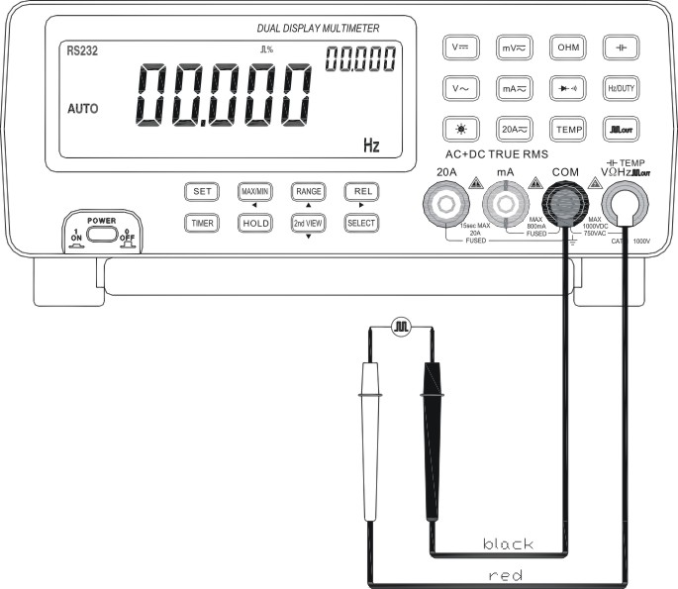
The measurement of frequency and rotation speed measurement have three modes: normal, Hi Hz and RPM.
- Set the function key to “Hz” position.
- Press SELECT button to select measurement mode.
- The meter is in auto range mode.

Normal mode
- In normal mode, the frequency testing range is 0.5Hz~8.0000MHz, divided into six ranges: 999.99Hz/9.9999kHz/9.999kHz/999.99kHz/8.0000MHz.
- The meter is in auto range mode and will automatically select a most suitable range. To select a range manually for the measurement, press RANGE button to select a proper range from the six ranges.
- Touch the probes to the signal source and read the display.

Measurement mode | Primary display | Secondary display  Press 2nd VIEW
Hz | Hz/kHz/MHz

High frequency mode (Hi Hz)
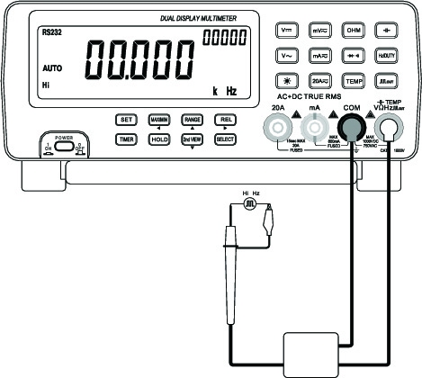
- In Hi Hz mode, the frequency testing range is 8MHz~1000MHz, divided into four ranges: 8.0000MHz/80.000MHz/800.00MHz/1000.0MHz. Use the high frequency accessories to measure frequency above 10MHz.
- The meter is in auto range mode and will automatically select a most suitable range. To select a range manually for the measurement, press RANGE button to select a proper range from the six ranges.
- Touch the probes to the signal source and read the display.

Measurement mode | Primary display | Secondary display
HiHz | 00000 | 00000MHz

NOTE:
    - The primary and secondary displays are using together to form a 10-digit display. The primary display displays the higher 5 digits while the secondary display displays the lower 5 digits.
    - In high frequency measurement, a high frequency tuner is required to facilitate the measurement

RPM Measurement
In RPM mode, the testing range is 0~99999RPM, accuracy ±(0.05% of reading+5). Use the RPM accessory to test the rotation speed and read the display.

Measurement mode | Primary display | Secondary display
RPM | RPM | No display

4.9 Temperature Measurement (TEMP)
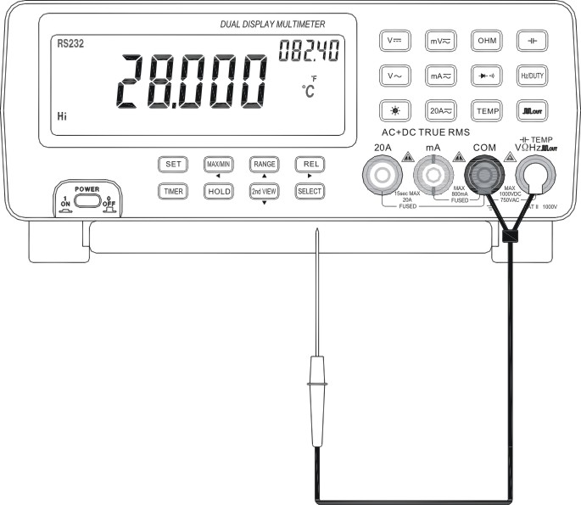
The measurement of temperature has two modes: normal and Hi.
Measuring range: -50℃~1300℃, -58℉~2372℉
Display: Primary ℃, Secondary ℉
Set the function to “TEMP” position.
Press SELECT button to select Hi or normal mode.
In Hi mode, use K type thermocouple to measure temperature. Press SELECT again, “Hi” disappears from the display, and the displayed temperature is internal temperature of the meter.
Connect the black test lead to “COM” terminal and the red test lead to “VΩ Hz” terminal. Read the display.

4.10 Diode and Continuity Check
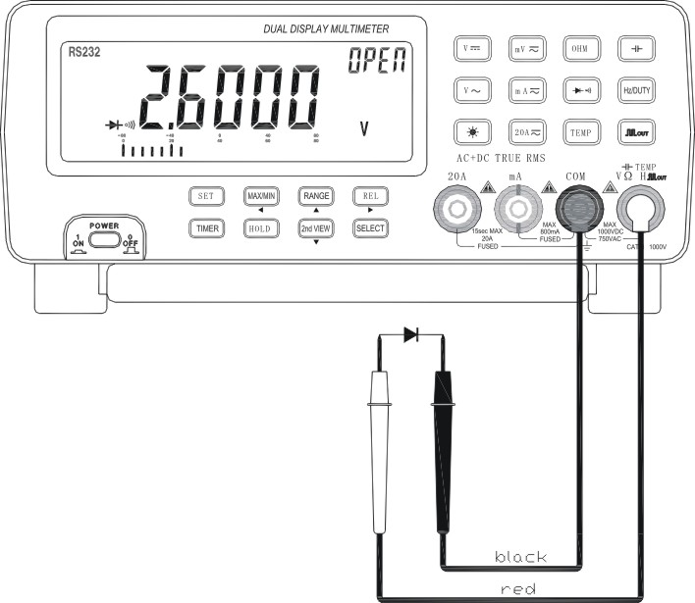
WANRNING: To avoid damage to the meter or the testing equipments disconnect circuit power and discharge all high voltage capacitors before measuring. Use the DC function to confirm that the capacitor is discharged.

- Set the function to “” position.
- Connect the black test lead to “COM” terminal and the red test lead to “VΩ Hz” terminal.
- For diode check, touch the red test lead to the positive polarity of the diode and the black test lead to the negative polarity. Touch the probes to the test points and read the display.
- For continuity check, the beeper sounds if the resistance falls below 60Ω

4.11 Square Wave Output
The meter can be used as a square waveform generator, output the waveform with frequency range of 0.5Hz~5000Hz.
Set the function key to “” position. The square waveform will be output on “COM” and “VΩ Hz” terminals.
The output square waveform is default at 606.1Hz, duty cycle 50%
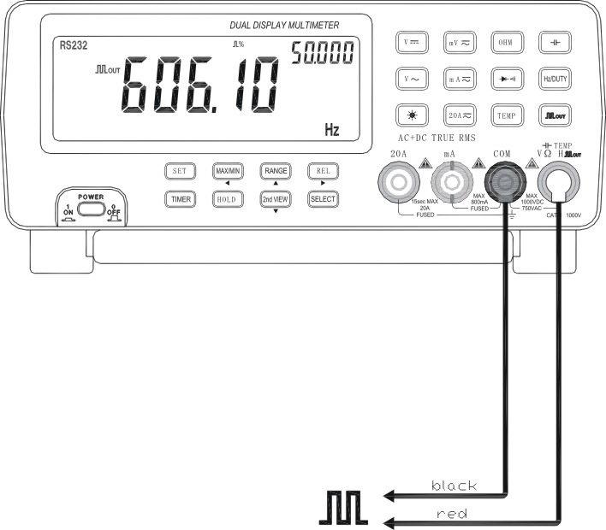
Connect the black test lead to “COM” terminal and the red test lead to “VΩ Hz” terminal.
Press 2nd VIEW button to select the frequency from the following ranges: 0.5000Hz/1.0000Hz/2.0000Hz/10.000Hz/50.000Hz/60.240Hz/74.63Hz/100.00Hz/151.50Hz/200.00Hz/303.00Hz/606.10Hz/1.2500kHz/1.6660kHz/2.5000kHz/5.0000kHz
Press SELECT button to select the duty cycle from 1% to 99%
Press 2nd VIEW button for at least 2 seconds to return to default square wave output.

Function | Primary display  Press 2nd VIEW | Secondary display  Press SELECT
 | Hz

4.12 Backlight Display
Press “’ button to turn on backlight. Press it again to turn it off.

5. PROGRAMMABLE CONTROL

The unit is equipped with RS232 interface and relevant software, which allows easy connections to PC for PC control.
Software operating environment: Windos9x/NT/2000/XP
Software version: V1.0

5.1 Installation
Plug the CD disk into the CD drive. Start up the setup.exe file to install the software. Select a desired installation path.

5.2 RS232 Port Set
RS232 port is used for the data transfer between the multimeter and PC. There are two ports to be chosen from: COM1 and COM2.

5.3 Connect
Click “Connect” to activate the communication between the multimeter and PC. To disconnect the communication, click “Disconnect”.

5.4 Recording Size
User can store up to 8192 files to the multimeter memory。

5.5 Sampling Interval
The sampling interval can be set at any value between 0.1~99 seconds.

5.6 Alarm Setup
This function sets the upper and lower limits for alarm. If the testing results exceed the preset upper or lower limits, the PC will send out alarm with sound.
5.7 Auto Schedule
In this function, user can set up the start and end time of recording.

5.8 Open File
This function opens the stored files (History.txt), which include text file and graph file. The files can be renamed or printed out. Move the mouse to the graph area; click the right key to display details.

5.9 Exit
Exit the current system.

5.10 Digital Display Window
The digital display window displays exactly the same contents as the multimeter LCD display does. However, the digital display window on the PC gives you an easier view.

5.11 Push Button Panel
Basically, the buttons on this panel function the same as the buttons on the multimeter. Double click on the button functions the same as pressing the multimeter button for 2 seconds.

5.12 Analog Display Window
The analog display window displays exactly the same as the analog display area of the multimeter LCD display. The function and range parts display the current communication status, which allows users understand the millimeter’s working state.
When the value is positive, the analog needle turns to green; while the value is negative, the needle turns to blue. When the value is close to zero, the needles changes between yellow and red colors.

5.13 Real-time Graph Window
Before applying this function, user must choose a desired measuring range. The X axis indicates system time, while the Y axis indicates the range of testing data.

5.14 Recorder Control Panel
In this panel function, user can set up the recording time, max.and min. values. The Start, Stop and Reset buttons are used to control the data recorder. Click Start button to start the data recording and Stop button to stop the data recording. In the meanwhile, the data has been stored in the History.txt file.
Click the Reset button to clear the current data in History.txt file, and get ready for the next data recording.

Recorder, Record time and Record in the bottom part of the panel indicate the current status of the data recorder. Battery indicates the power supply status of the multimeter. If power supply is in good status, it will display “Battery: High”. Otherwise, it will display “Battery: Low”.
In the right corner of the bottom displays the system time.

Should you have any questions regarding this software or any suggestions to us, please write down and inform us. We will do the utmost to improve the software.

6. SPECIFICATIONS
6.1 Electrical Specifications
The accuracy is specified for one year after calibration at operating temperature of 18℃ to 28℃, with humidity at 0%~75%.
Accuracy specifications take the form of: ±(a% of reading+number of least significant digits).

Table1. DCV
Range | Resolution | Accuracy | Remarks
80mV | 1μV | ±(3% rdg+10) | Input impedance: 80mV~800mV: >1000MΩ  8V~1000V: 10MΩ
800mV | 10μV | ±(0.05% rdg+5) | Input impedance: 80mV~800mV: >1000MΩ  8V~1000V: 10MΩ
8V | 0.1mV | ±(0.05% rdg+5) | Input impedance: 80mV~800mV: >1000MΩ  8V~1000V: 10MΩ
80V | 1mV | ±(0.05% rdg+5) | Input impedance: 80mV~800mV: >1000MΩ  8V~1000V: 10MΩ
800V | 10mV | ±(0.08% rdg+10) | Input impedance: 80mV~800mV: >1000MΩ  8V~1000V: 10MΩ
1000V | 0.1V | ±(0.08% rdg+10) | Input impedance: 80mV~800mV: >1000MΩ  8V~1000V: 10MΩ
Table 2. ACV (True RMS)
Range | Resolution | Accuracy
80mV | 1μV | <75% Range: 50Hz~20kHz | <75% Range: 20kHz~50kHz | >75% Range: 50Hz~20kHz
800mV | 10μV | ±(0.8% rdg+50) | ±(6.0% rdg+50) | ±(8.0% rdg+50)
8V | 0.1mV | ±(0.8% rdg+50) | ±(6.0% rdg+50) | ±(8.0% rdg+50)
80V | 1mV | <75% Range: 50Hz~10kHz ±(0.8% rdg+50); >75% Range: 50Hz~10kHz
750V | 10mV | 50Hz~1kHz: <90% Range ± (0.8% rdg+50); >90% Range: ± (5.0% rdg+50)
Remarks: Input impedance: 80mV~800mV: >1000MΩ; 8V~1000V: 10MΩ. Parallel capacitance: <100pF

Table 3. DCA
Range | Resolution | Accuracy | Remarks
80mA | 1μA | ±(0.2% rdg+10) | Fuse: F750Ma/250v F13A/250V  Voltage drop: ≤800mV  Max.input current: 20A (up to15 seconds)
800mA | 10μA | ±(0.2% rdg+10)
8A | 0.1mA | ±(0.5% rdg+10)
20A | 1mA | ±(0.5% rdg+10)

Table 4. ACA (True RMS)
Range | Resolution | Accuracy | Remarks
80mA | 1μA | 50Hz~5kHz  ±(0.2% rdg+10) | Fuse: F750Ma/250v F13A/250V  Voltage drop: ≤800mV  Max.input current: 20A (up to15 seconds)
800mA | 10μA | 50Hz~5kHz  ±(0.2% rdg+10)
8A | 0.1mA | 50Hz~200Hz  ±(0.5% rdg+10)
20A | 1mA | 50Hz~200Hz  ±(0.5% rdg+10)

Table 5. dBm
Function | Range | Accuracy | Resolution
dBm | -80.00dBm~+80.00dBm | ±1.0% rdg | 0.01dBm

Table 6. Resistance (Ω)
Range | Resolution | Accuracy | Remarks
800Ω | 0.01Ω | ±(0.3% rdg+10) | Overload protection: 250V RMS
8kΩ | 0.1Ω | ±(0.3% rdg+5) | Overload protection: 250V RMS
80kΩ | 1Ω | ±(0.3% rdg+5) | Overload protection: 250V RMS
800kΩ | 10Ω | ±(0.3% rdg+5) | Overload protection: 250V RMS
8MΩ | 100Ω | ±(0.3% rdg+5) | Overload protection: 250V RMS
60MΩ | 1kΩ | 0Ω~40MΩ: ±(2.5% rdg+10)  40MΩ~80MΩ: ±(3.5% rdg+10) | Overload protection: 250V RMS

Table 7. Frequency (Hz)
Range | Accuracy | Resolution | Remarks
999.99Hz | ±(0.5% rdg+5) | 0.01Hz | Overload protection: 250V RMS  Sensitivity: 0.7V RMS
9.9999kHz | ±(0.5% rdg+5) | 0.1Hz | Overload protection: 250V RMS  Sensitivity: 0.7V RMS
99.999kHz | ±(0.5% rdg+5) | 1Hz | Overload protection: 250V RMS  Sensitivity: 0.7V RMS
999.99kHz | ±(0.5% rdg+5) | 10Hz | Overload protection: 250V RMS  Sensitivity: 0.7V RMS
6.0000MHz | ±(0.5% rdg+5) | 100Hz | Overload protection: 250V RMS  Sensitivity: 0.7V RMS
10.0MHz | ±(0.1% rdg+5) | 1kHz | Plu adapter s
100.0MHz | ±(0.1% rdg+5) | 10kHz | Plu adapter s
1000.0MHz | ±(0.1% rdg+5) | 100kHz | Plu adapter s
Table 8. Capacitance
Range | Resolution | Accuracy | Remarks
1nF | 1pF | ±(5.0% rdg+50) | Overload protection: 250V RMS
10nF | 10pF | ±(2.5% rdg+50) | Overload protection: 250V RMS
100nF | 100pF | ±(2.5% rdg+50) | Overload protection: 250V RMS
1μF | 1nF | ±(2.5% rdg+50) | Overload protection: 250V RMS
10μF | 10nF | ±(2.5% rdg+50) | Overload protection: 250V RMS
100μF | 100nF | ±(2.5% rdg+50) | Overload protection: 250V RMS

Table 9. Diode
Range | Accuracy | Resolution | Remarks
3.0000V | ±(3.0% rdg+5) | 0.0001V | Diode positive voltage drop  Overload protection: 250V RMS

Table 10. Square Wave Output
 | Description
Voltage amplitude | Approx.3V
Frequency | 0.5Hz~5000Hz
Duty cycle | 1%~99%

Table 11. Temperature
Range | Accuracy | Resolution | Remarks
-50℃~1300℃ | ±(1.5% rdg+10) | 0.1℃ | K type thermocouple  Overload protection: 250V RMS
-58℉~2372℉ | ±(1.5% rdg+10) | 0.1℉ | K type thermocouple  Overload protection: 250V RMS

6.2 General Specifications
Max.voltage between terminal and ground: 1000V RMS
Continuity beeper: Approx.3kHz
Display: dual display 80000, update 4 time/Sec.
Bar graph: 23 segments, update 40 time/Sec.
Electromagnetic compatibility:
For all ranges and functions (except capacitance), in a RF field of 1V/m, total accuracy=specified accuracy+5% of range.
In a RF field, the capacitance has no specified range.
or all ranges and functions, in a RF field above 1V/m, there is no specified range.
Safety/Compliance: IEC 61010 CAT II 1000V, and CAT III 600V
Input voltage: AC110V/220V selectable, 50/60Hz
Operating environment: temperature 0℃~50℃, altitude below 2000m
Storage environment: temperature -20℃~60℃, altitude below 5000m
Relative humidity: ≤75%, at 0℃~40℃; ≤45%, at 40℃~50℃
Dimension: 260x220x82mm
Weight: Approx.1.4KG
Accessories:
Manual: 1pcs
Test lead: 1pcs
K type thermocouple: 1pcs
RS232 package: 1set
7. MAINTENACE
The meter is a precise and intelligent instrument. It has been accurately calibrated in the factory before shipment. Readjustment is recommended only if repairs have been made in a circuit affecting adjustment accuracy or if you have a reason to believe the unit is out of adjustment.

The following instructions are for use by qualified personnel only. To avoid electrical shock, do not perform any servicing other than contained in the operating instructions unless you are qualified to do so.

Do not verify the circuit to avoid damaging. Power fuse: 200mA/250V (located in input power socket); Fuse for measuring current: 800mA/250V (located in the current input terminal), 13A/250V (located the main circuit). The fuse must be replaced by qualified personnel.

NOTE:
- Do not connect the voltage higher than DC1000V or AC 1000V rms.
- Do not measure voltage at the Ω range.
- When replacing fuse, please take away the test leads from the measuring point and power off at first.
- Keep the instrument away from water, dust and shock.
- Do not operate the meter in high temperature or strong magnetic place.
- Do not use the abrasives or solvents to clean the meter.

7.1 Fuse replacement
NOTE: Please select fuse of the same specification to replace it.

Power fuse: 200mA/250V (located in input power socket); Fuse for measuring current: 800mA/250V (located in the current input terminal), 13A/250V (located the main circuit).
1. Test fuse replacement:
- Press the function key to Ω range
- Connect a test lead to “VΩHz” terminal, use the pen tip to touch the “mA” or “20A” terminal to test the resistance of the fuse
- If the tested fuse resistance is below 5Ω, it means the fuse is good.
- If the tested result is “OL” (over load), the fuse needed to be replaced.
- If the fuse is tested as good but the multimeter cannot carry measurement, please send the multimeter for repair.
2. Fuse replacement
Disconnect the multimeter from AC power source, and take off all test leads.

2A fuse replacement
Press “mA” input jack by finger; take out the fuse jack after turning 90°angle anti-clockwise
Take off the fuse, and replace an equivalent then turn on the fuse jack.
After press the fuse into the fuse jack, turn 90°angle by an inverse hour direction.

13A fuse replacement (must be replaced by qualified personal.)
Screw off the four screws on the button shell by a screwdriver, take off the upper shell.
Take off the fuse, and replace an equivalent then turn on the fuse jack.
Take on the shell, .Screw on the four screws on the button shell by a screwdriver.

7.2 Troubleshooting
If the meter does not work properly, take actions as described in this manual to check out if the meter is defective or not.
Once defective or malfunctioning is confirmed, please contact your local distributor or the manufacturer for repairing.

E-8145/V1.2

