Instructions for HD video Encoder
Ⅰ Product show

Picture for single Chassis

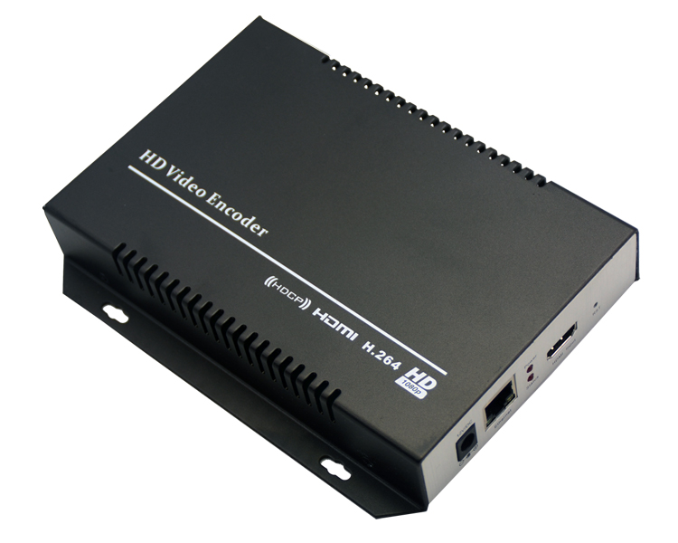

Picture for 3U structure
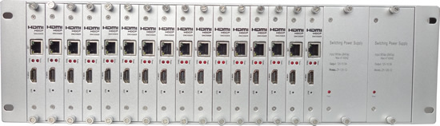
Ⅱ Product introduction

Mine Tech HD video Encoder (HDMI input) is our newest professional HD audio & video encoding device with powerful functionality, which supports H.264 encoding, dual-Streaming data. It is equipped with 1 HDMI channels input supporting MPEG-4 AVC/H.264 High Profile code format & main Profile code format. Its high integration and cost-effective design make this device widely used in variety of digital distribution systems such as CATV digital head-end, satellite and terrestrial digital TV etc, Besides, it supports 3U structure with 16 pieces capture cards in one chassis, and dual power supply make the system more stable. Further more, it full supports VLC decode.

Ⅲ Application

  - IPTV
  - NVR(Net Video Recorder)
  - Digital Signage HD stream server
  - Video Conference system video server
  - internet conference system video capture
  - replace HD video capture card
  - Hotel cable TV system

Ⅳ Main features:

· Support H.264 Baseline Profile /H.264 Main Profile / H.264 High Profile
· Support MJPEG/JPEG Baseline
· Audio coding support MPEG1 Audio Layer2
· CBR/VBR/ABR code rate controlling , 16kbit/s～40Mbit/s
· Support Network interface full-duplex mode 1000M
· Support 1 channel HDMI input, also supports converting HDMI to VGA input
· Support up to 720P, 1080P HD video input
· Support image parameter settings
· Support HDCP protocol and HD blue-ray
· Support HTTP，UTP，RTSP，RTMP，ONVIF protocol
· The WEB operating interface, configuration interface in Chinese and English are optional.
· Authority management for WEB operating interface.
· Support the double stream output
· The main stream and the second stream can be transferred by different networking protocol
· Support the setting for stream resolution.
· Supports MP3 and AAC audio format selection
· Support switching mono and stereo for audio output stream.
· Support GOP frame rate settings
· Support a click to restore the default configuration
· Support decoding the set-top box
· Low-power design
· 3U high-grade chassis, with main power automatic switching function, which ensure the stability of the system.

Input：

video | 1 channel HDMI input (version 1.3a) support HDCP
resolution | 1920×1080_60i/60P、1920×1080_50i、1280×720_60p
resolution | 1280×720_50p etc.
encoding | H.264/AVC High Profile Level 4.0(HD)
code-rate | 0.8Mbps~12Mbps
code-rate control | CBR/VBR
GOP type | adjustable
Video Advanced Pretreatment | De-interlacing, Noise Reduction, Sharpening

Audio

Encoding format | AAC、MP3
Sampling rate | Adaptive and output sampling rate is optional
Bit-rate | 32K，44.1K，48K，64K，96K，128K，160K，192K
Sampling accuracy | 24 bit
Code-rate | 64Kb/s~384Kb/s

System

RJ45 | 1000M
Program stream | HTTP，UTP，RTSP，RTMP，ONVIF protocol
Control interface | WEB
upgrading | Can be upgrated by internet

Miscellaneous

Dimension (W× L× H) | 170*130*30mm
3U standard chassis | 3U structure , A 3 u chassis support 16 channel coding plate
Approx weight | Single :0.5KG 3U: 8KG
Temperature | 0~45℃(work)，-20~80℃(storage)
Power | Single chassis：12V/DC 3U chassis：AC 220V±10%，50/60Hz
Consumption | Signal :5W 3U chassis : 80W

Ⅴ. System settings

When in WEB control interface, the computer’s IP needed be modified as IP 192.168.1.*. the encoder’s default IP is 192.168.1.168.
Reset&Initial: there is a RST on the panel, which can be used for HD video encoder being reseted and initialized. Under condition of power on, keep pressing the RST for 10 seconds ,it will restart, which can make parameters be initialized. Then the IP will be initialized as 192.168.1.168.
1. Set the IP address as 192.168.1.* note：* can be any number among 0-254 except 168
2. Open up IE, input 192.168.1.168 to WEB interface , username: admin password: admin
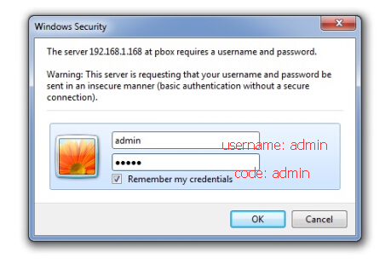
3. HDMI status
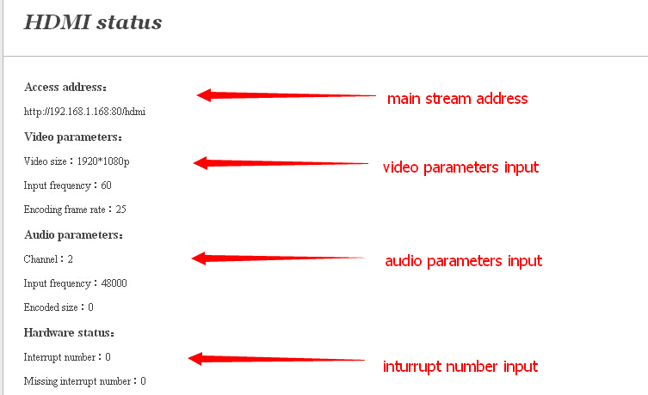

Note:
  - access address: can be directly copied into VCL player to decode.
  - Video parameter: video signal parameter input
  - Audio parameter: audio signal parameter input
  - Hardware status: when the interrupt number rises, it means there is video inputting, when the number is “0”, it means there is no video inputting. Then the input signal need be checked.

4. Network settings
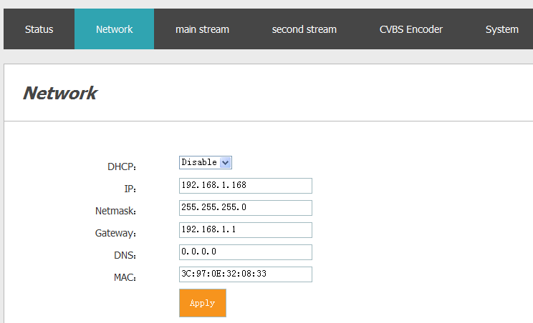

Note: the encoder’s default IP is 192.168.1.168. if you forget the IP address after you modify it, you can keep pressing the RST for 10 seconds ,it will restart, which can make parameters be initialized.

- HDMI coding settings

5.1 : video and audio parameter settings
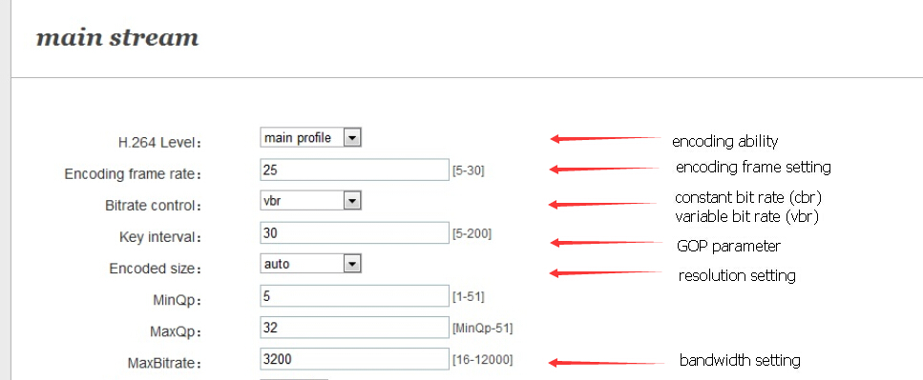
Note: the parameters can be adjusted according to practical application


5.2 : Network transmission protocol Settings
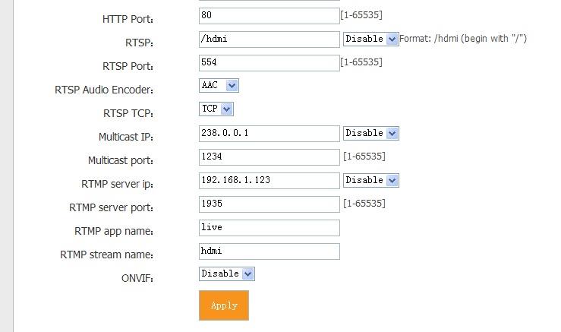

Note: on condition of HTTP protocol, the player can be played without HDMI.

- the second stream settings:
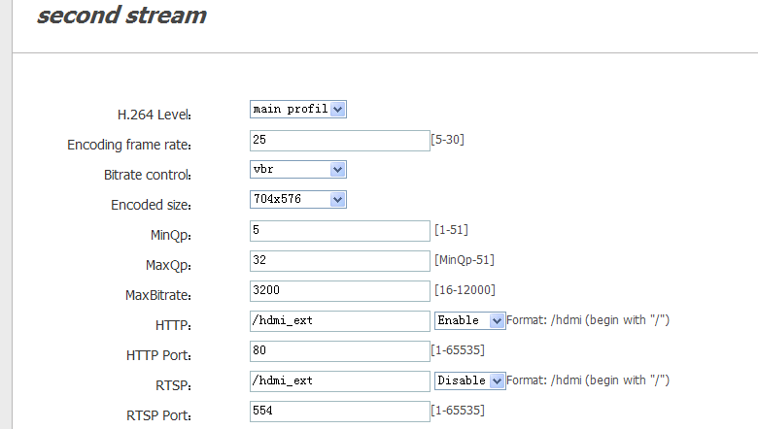

Note: the configuration parameters is same as the main stream

- RTMP protocol settings
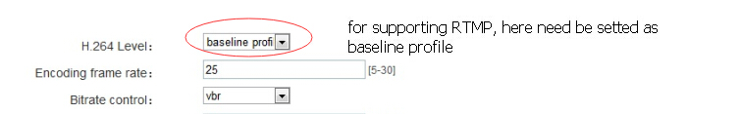
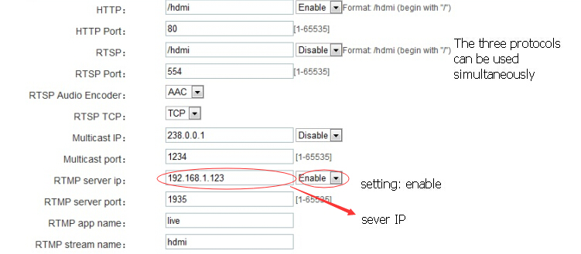

7.1 Set H.264 level : baseline profile
7.2 Set RTMP protocol : Enable
7.3 Set RTMP sever IP
7.4 Set RTMP sever port
7.5 Set RTMP stream name
7.6 Sever test:
7.6.1 Instal software: Flash+Media+Sever3.5 there’s no need for serial number when install, both username and code are “1”.
7.6.2 start background software:
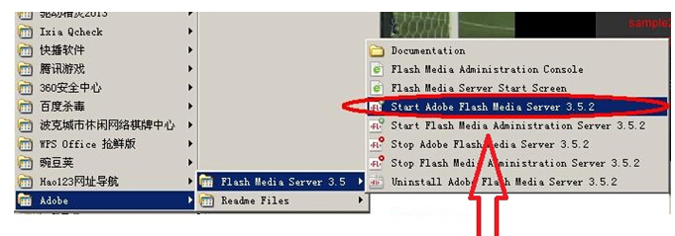
    - Open up the file of FlashPlayer : VideoPlayer.html
    - Type in : rtmp://ip address /rtmp/hdmi ,choose live, then can see the image or type in：rtmp://192.168.1.100:1935/live/hdmi choose：LIVE click：Play stream
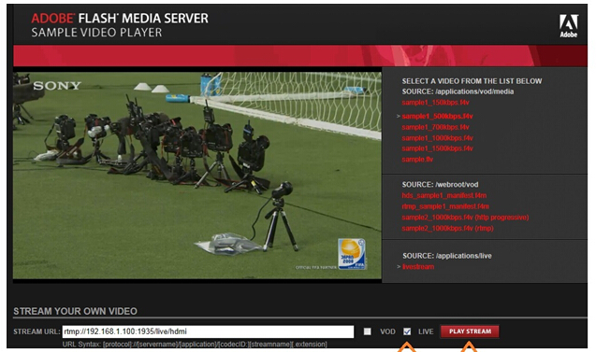

8 . System settings
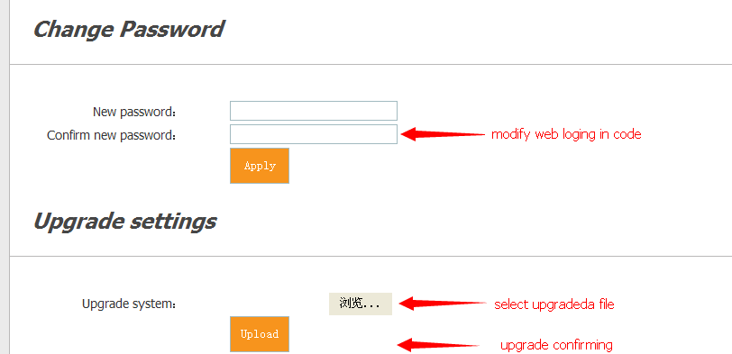

9. Chinese & English switch


10. HDMI OSD settings

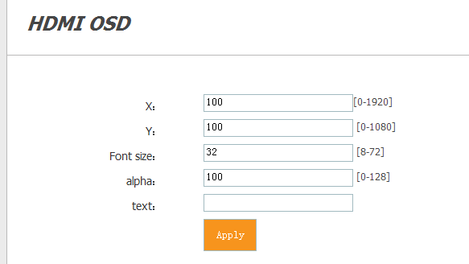
Note: if no need for watermarks, space should be entered in “text”.

Ⅵ VLC decoding configuration

- VLC playing settings
VLC software version NO: 2.0.1

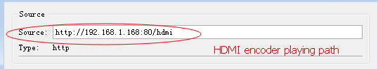
Note：under HDMI protocol condition，the suffix added is not necessary.

- VLC videorecording settings
Click: play



