FY-Economic Series Function/Random Waveform Generator

User’s Manual

Rev1.2
2013-10-14

Thank you for purchasing our products, please carefully read the contents of the use’s manual before use, to ensure the normal use of the instrument.

●Introduction of the instrument
This manual applies to each mode of FY-Economic series Function/Random Waveform Generator.
FY-Economic series adopt direct digital synthesis (DDS) technology and FPGA design. With 14 kinds of frequently-used waveform internal preinstalled, it can also output arbitrary 8-bit 256 dots user-defined waveform. It is easy to use with stable signal and low distortion. It has 1 watt output, broadband frequency measurement and counter functions. The amplitude and DC offset of signal output are adjustable. As a perfect combination of usability, excellent technology indexes and numerous functions, FY-Economic is capable to help the user to accelerate task completion. It’s the ideal instrument for electronic engineering, laboratories, production lines, teaching and scientific research. It can also be used as supporting module for industrial equipment.

● Excellent technical indexes and function features:
◆3 downloadable 256 dots arbitrary waveform memories.
◆14 kinds of frequently-used waveform internal preinstalled. 3 positions are available for user-defined waveform.
◆1 watt signal output.
◆Compact size, multiple functions, easy to carry.
◆High frequency accuracy: ±5×10^{－6}
◆High resolution: 10 mHz
◆All range continuously adjustable, digital directly setting.
◆High waveform accuracy: The output waveform synthesized by function calculation. High accuracy and low distortion.
◆Several different waveforms: Sine wave, Square wave, Triangle wave, Sawtooth wave, user-defined waveform, frequently-used waveform such as pulse, noise, and electrocardiogram etc...
◆Save function: 10 sets of parameters defined by the users can be saved and loaded anytime.
◆Operation mode: Button controlled, LCD1602 display, digital setting, knob adjusted continuously.
◆Highly reliable：Large scale integrated circuit, Surface mounting technology, reliable and durable.
◆Frequency measurement：Frequency of internal / external signal can be measured through built-in 20MHz frequency meter.

●Main technology indexes
- Signal Output
Output waveforms Sine wave, Square wave (Duty cycle adjustable) and Triangle wave, Sawtooth wave, frequently-used waveform such as pulse, noise, and electrocardiogram etc.
Output amplitude 0.5~8Vp-p (no load)
Output impedance 10Ω±10%(signal output)
DC offset ±3V
Frequency range 0.01Hz ~ 50KHz
Resolution 0.01Hz(10mHz)
Frequency accuracy ±5×10^{－6}
Frequency Stability ±2×10^{－6}/3 Hours
Sine wave distortion ≤0.8% (reference frequency is 1kHz)
Triangle linearity ≥98% (0.01Hz~5kHz)
Rise and fall time of square wave ≤3.8us
Square Wave Duty range 1%~99%
- COUNTER function
Counter Range 0-65535
Frequency Meter Range 1Hz~20MHz
Input Voltage Range 0.5Vp-p~20Vp-p
- Others
Display LCD1602 in English
Save and Load Parameter M0-M9(M0: default load)
Size 83mm (Length)×60 mm(Width)×24mm(Height)
Production technology Surface mounting technology, large scale integrated circuit, reliable and durable
Operation feature Button-controlled, Knob-adjusted continuously
Conditions requirement Temp: 0~40℃ Humidity: ﹤80%

●The function introduction of front panel
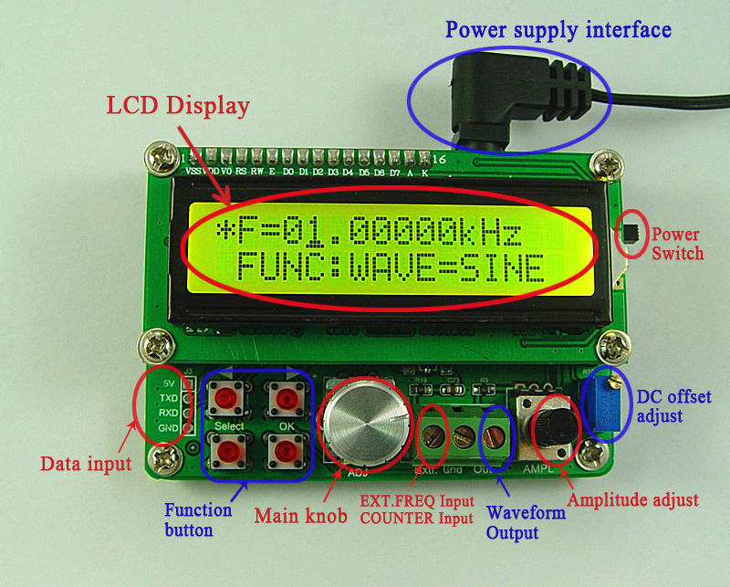

●Operating Guide
- Pressing the “select” button which can switch between frequency adjusting and function adjusting. The detailed condition (frequency adjusting or function adjusting) displayed after “*”.
*F=01.00000KHz
FUNC:WAVE=SINE
F=01.00000KHz
*FUNC:WAVE=SINE

- As frequency adjusting, pressing the button【】and【】can move the cursor position, and the “OK” button can toggle frequency unit(Hz，kHz and MHz) and then adjust the Main knob and the corresponding value of frequency appears.
(Note: The frequency value displayed for random waveform is referenced.
i.e. The actual output frequency=Display value×Cycle of the random waveform)

Step frequency：1kHz
*F=01.00000KHz
FUNC:WAVE=SINE

Step frequency：0.01kHz
*F=00.01000KHz
FUNC:WAVE=SINE

*F=01000.00Hz
FUNC:WAVE=SINE
The frequency unit is Hz.

The frequency unit is KHz.
*F=01.00000KHz
FUNC:WAVE=SINE

- As function adjusting, pressing the button 【】or【】to toggle among “WAVE”，“DUTY”，“COUNTER”，“EXT.FREQ”，“SAVE” and LOAD”
- The “WAVE” shows the current wave state. Press the button 【OK】or rotate the【Main knob】to toggle the current output of waveform. SINE refers to Sine wave. SQUR refers to Square wave. TRGL refers to Triangle wave. ARBI1、ARBI2 and ARBI3 are user-defined arbitrary waveforms. PREC1、PREC2、PREC3、PREC4、PREC5 are waveforms internal preinstalled.
Main output of waveform is SINE.
*F=01.00000KHz
FUNC:WAVE=SINE

Main output of waveform if SQUR.
*F=01.00000KHz
FUNC:WAVE=SQUR

Main output of waveform is TRGL.
*F=01.00000KHz
FUNC:WAVE=TRGL

Main output of waveform is ARBI1.
*F=01.00000KHz
FUNC:WAVE=ARBI1
（Default：Lorentz Pulses）

Main output of waveform is ARBI2.
*F=01.00000KHz
FUNC:WAVE=ARBI2
（Default：Multitone）

Main output of waveform is ARBI3.
*F=01.00000KHz
FUNC:WAVE=ARBI3
（Default: Random Noise）

Main output of waveform is electrocardiogram.
*F=01.00000KHz
FUNC:WAVE=PREC1

Main output of waveform is trapezoidal pulse.
*F=01.00000KHz
FUNC:WAVE=PREC2

Main output of waveform is Sinc pulse
*F=01.00000KHz
FUNC:WAVE=PREC3

*F=01.00000KHz
FUNC:WAVE=PREC4
Main output of waveform is narrow pulse.

*F=01.00000KHz
FUNC:WAVE=PREC5
Main output of waveform is white Gaussian noise.

*F=01.00000KHz
FUNC:WAVE=PREC6
Main output of waveform is amplitude modulated wave.

Main output of waveform is frequency-modulated wave.
*F=01.00000KHz
FUNC:WAVE=PREC7

- The “DUTY” means duty cycle. It can be adjusted by rotating the【Main knob】. SQUR adjustable from 1% to 99%, while TRGL adjustable among 50% (standard TRGL), above 50% and below 50% (both are different sawtooth waves). SINE is disabled in this case.
: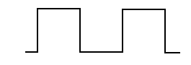(WAVE=SQUR)
F=01.00000KHz
*FUNC:DUTY=50%
: (WAVE=SQUR)
F=01.00000KHz
*FUNC:DUTY=80%
: (WAVE=TRGL)
F=01.00000KHz
*FUNC:DUTY=50%
: (WAVE=TRGL)
F=01.00000KHz
*FUNC:DUTY=51%
: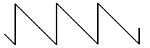 (WAVE=TRGL)
F=01.00000KHz
*FUNC:DUTY=49%
- COUNTER is counter function, and the counter values displayed on the screen, pulse inputted from Ext. Input. Reset it to “0” as pressing 【OK】to count again.
CNTR=1201
*FUNC:COUNTER

- EXT.FREQ is exterior frequency measuring function, which can measure the frequency of input signal.
CNTR=10.00KHz
*FUNC:EXT.FREQ

- Press the button【Save】to save the value of current frequency, waveform and duty cycle into internal memory for loading next time. There are 10 storage positions from M0 to M9, which can be chosen by rotating the【Main knob】. Then press the button 【OK】to save. When “OK” appears on the right corner of the screen, storage is finished. If the current value is saved to “M0”position, the changed value will be loaded when restarted.
F=16.07326KHz
*FUNC:SAVE=0

（Choose storage position）

F=16.07326KHz
*FUNC:SAVE=0 OK

(Save to “0 position” is OK)

- The “LOAD” is function of loading the parameters of memory. Operation is similar to SAVE.
- The【AMPL】knob adjusts the amplitude of output signal.
11. The【DC Offset Adjust】adjusts the DC offset of output signal.

●Safety Notes
1、Before using this instrument, please check if the power supply is normal, to ensure the normal use and personal safety.
2、This instrument must be used in the technical index range.
3、Please do not change the instrument circuit arbitrarily, so as to avoid damaging equipment or endangering the safety.
●Warning and personal injury
Do not apply the product in the safety protection device or emergency stop device, or any other applications that the product failure could result in personal injury, unless there is special purpose or use authorization. Before the installation and use, each parameter of the technical indexes in this manual should be referred to. If this suggestion is not obeyed, death or serious personal injury could be caused. In this condition the company will not be responsible for any compensation of personal injury or death, and all the company managers and employees and auxiliary agents, distributors, other personnel concerned will be released from any claim (including all the costs, expenses, attorney fees etc.) that may result in.

Appendix
Complete set of instrument and auxiliary
FY-Economic Function/Random Waveform Generator ----------------1
DC 5V Power Supply------------------------------------------------------1
User’s manual---------------------------------------------------------------1 (PDF format)

Tel:0086 371 68997005
Web:www.feeltech.net

