FM audio speaker R20 user manual
[1]. Remote controller
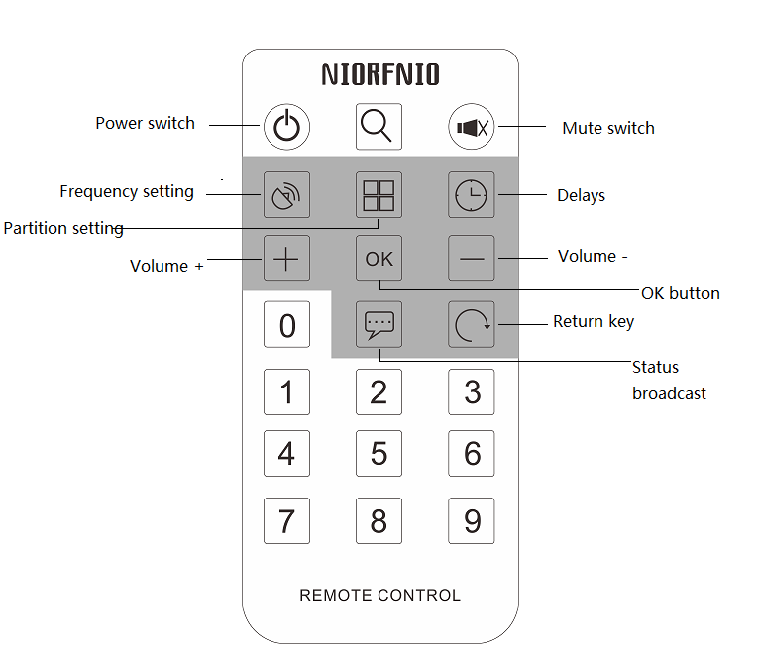
[2]. Audio speaker instructions:
1. Speaker switch
Point remote controller to the speaker, press the power key, the speaker power on or off .
2. Speaker mute
Point the remote control to the speaker, press the mute button, mute on or off

3. Speaker volume + -
Point the remote control to the speaker, press the volume key to turn up or down the speaker.

4. Speaker frequency settings
Point the remote control to the speaker, press the remote control frequency setting key, and then enter the number of receiving frequency, then press "OK" button.

5. Speaker status broadcast
When turning on the speaker , press the status broadcast button, the speaker will broadcast the current reception frequency, volume, delay time.

6. Delay time setting
Point the remote control to the speaker, press the delays key, and then enter the number of delay time to set the value (delay time range 1~10S), and then press the "OK" key.

Note: The delay time means that , after the audio speaker receives the setting frequency and frequency signal keeps stable, then the speaker will be in normal working condition to filter unstable signal or interference signals. The longer the delays , the better filtration.

[3]. Techniccal parameters

N.o | Item | Parameters
1 | Working voltage | 220V
2 | Working current | ﹤0.5A
3 | FM receiving range | 76~108MHz
4 | Frequency stability | ±10PPM
5 | Frequency step | 100KHz
6 | Working temperature | -10℃~45℃
7 | Output impedance | 4Ω/8Ω
8 | Output power | R20：≧20W
8 | Output power | R40：≧40W
8 | Output power | R60：≧60W
9 | Sensitivity | ≧3μv
10 | Audio distortion | 0.3%
11 | Frequency response | 50Hz~15000Hz

