Operation Manual of the Equipement MicroRemage

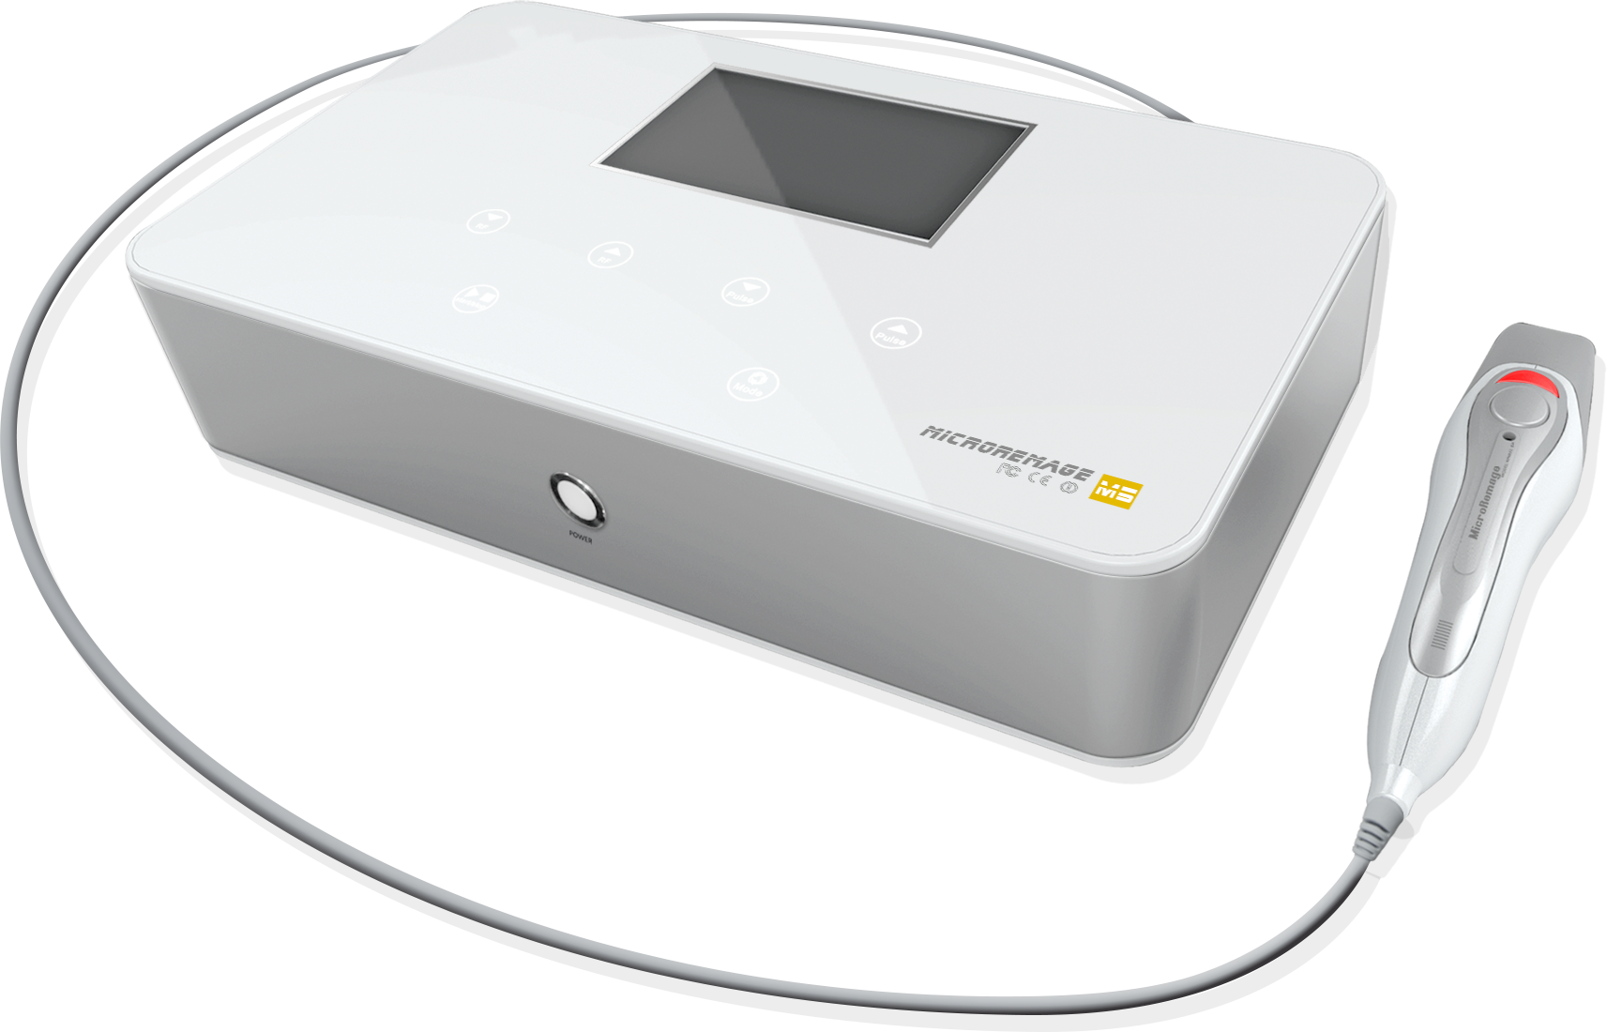

Preface

Distinguished users:

Thank you for your favor for Meno Beauty’s newly launched product—MicroRemage. It is a international and professional beauty equipment, and as a safe and non-invasive beauty equipment, it is specialized in skin refirming, wrinkle removal, shaping and lifting. It affects the skin in the form of lattice and matrix, and by control of high technology it could solve the problem of skin age more accurately, more comfortably and deeply. The equipment -- MicroRemage, should be operated by staff after professional training, improper use may cause undesirable effects to the human body. So, it is hoped that the operator could read the Manual thoroughly before operating the equipment, and strictly follow the guidance in the Manual.

We believe that Meno Beauty’s quality products will bring you good effects and results, and our impeccable after-sales service will present worry-free feelings to you.

Thank you!

Contents

Introduction 1. Overview of the equipment .....................................
2.Principle of the equipment........................................
3.Treatment results of the equipment.......................
4.Technological advantage of the equipment...........
5．Technical parameters of the equipment..............

Use and Operation 1.Name of each parts of the equipment............................
2.Installation of the equipment .........................................
3.Introduction of the interfaces of the equipment.........
4.Operation steps of the equipment.................................
5.Precautions and maintenance .......................................
6. Taboo for users ...........................................................
7. Packaging and unpacking................................................
8. Common failure and problems.....................................
9. Maintenance of the equipment.........................................

Equipment Introduction

1. Overview of the equipment
MicoRemage takes the advantages of the previous RF Equipment,starting from the concept of non-invasive, painless and comfort, it can tender and tighten the skin more closely, rejuvenation and keep youth for you forever.
- Applying multi-groups of parallel matrix on the treatment head with patent design to the epidermis to form aperture in micro, then the grids make the sectional RF energy be distributed balancedly, RF energy shall be delivered to deeper skin through these aperture and pores, and it will cause contraction effect of collagen and activate the renewal and reconstruction. MircroRemage can achieve the effects of comprehensive improvement for different skin problems with long-term effect of skin lifting and tightening.
- When the RF electric takes effect on the skin tissue, the fat tissue will be softened, shrinked and decomposed after absorbing energy, thus the effect of dissolving fat and shaping could be achieved.
- The energy can be divided into grades from 1 to 20, treatment is conducted with different specifications of needleless probes to achieve optimum results. In addition, small probe is configured and customized for the consideration of the sensitive, delicate and fragile skin around eyes. The probe will not cause harm to the eye, and it can plays the best treatment results more safely.
2. Principle of the equipment
Lattice RF Technology
Patent designed lattice RF non-invasive beauty treatment delivers RF energy to the epidermis through micron aperture in form of lattice, and it can heat deeper skin in large area, rapidly activate the renewal and reconstruction of collagens. Thus it achieves the effect of recovering reticular structure of the skin, promoting the metabolism of the skin, as well as wrinkle removal, tightening the skin and rejuvenation.
3.Treatment results of the equipment.
⑴ Rejuvenation, tightening the skin, restore skin elasticity,dispel pseudo wrinkles and repair authentci wrinkles.
⑵Improve the dull and lusterless symptom, enhance dry skin and sallow complexions
⑶Improve metabolism, activate the cell tissues, and rapidly initiate the new generacy of collagens.
⑷Effectively promote facial lympha circulation and blood circulation, and solve the problem of edema.
⑸Effectively improve the flabby facial skin, delicate facial sculpture, better and more ideal effects will be created when cooperate with other home care products.
4.Technological advantage of the equipment
1) The only non-invasive, skin adjusting, balancing and repairing technology in the world, compared with the traditional technology, it can more effectively promote the increase and generation of collagens, and can achieve similar results as surgery without a surgery.
2) One treatment of this equipment can achieve results of several treatments of other equipments, and it has no side effects, and no need to worry about “bounce back”.
3) Specially designed operation handle,different treatment for different parts with more accurate, more obvious, durable, and comfortable effect.
4) The treatment peorid is very short, and no requirement for recovery time, you can leave immediately after the treatment, so it will not affect daily life and work, truly it is the most advanced beauty equipment in the world.

5. Technical parameters of the equipment
Working voltage: AC110～220V Operating frequency: 50Hz/60Hz Maximum power:120w
Size of the equipment: 320mm x 180mm x 100mm (LxWxH)
Fuse: 3A
Net weight: 3KG

Operation and Use of the Equipment

1.Name of each parts of the equipment 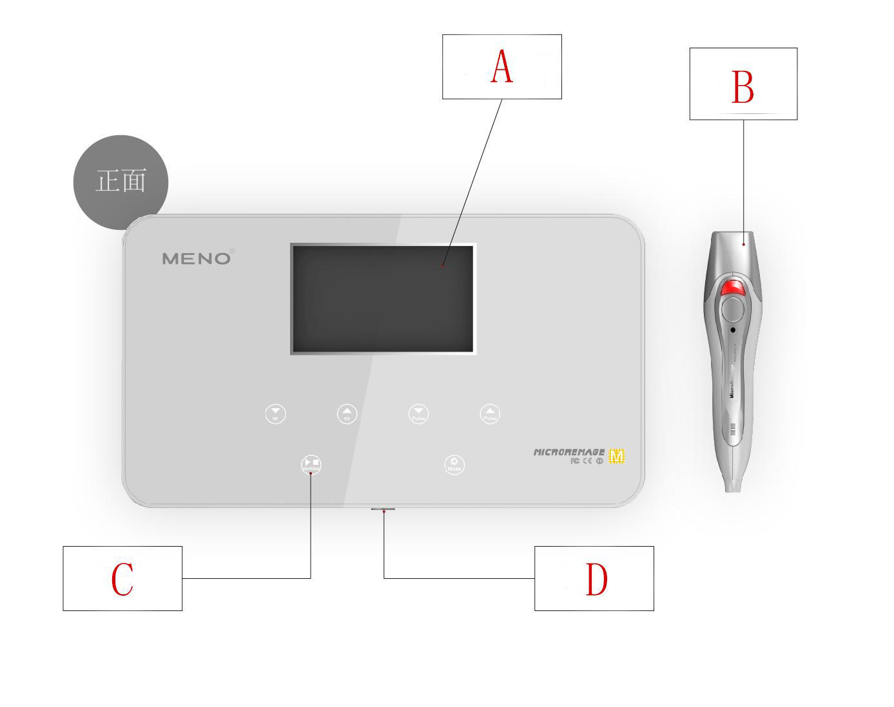
（A） Display
（B） functioning handle
（C）Buttons: [Note:the buttons willdisplay after switch on the power]
（D）Power switch

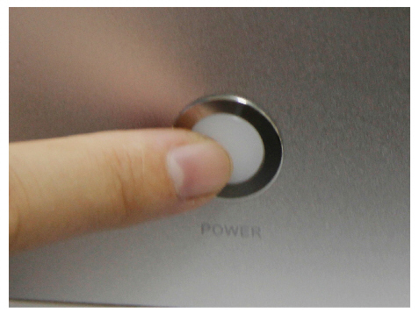
Power switch

Functioning handle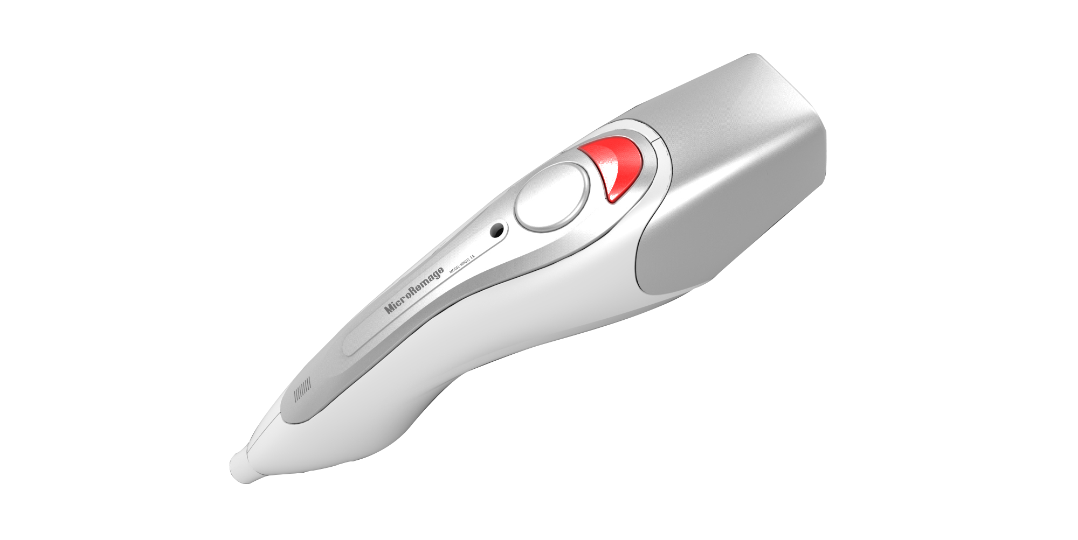

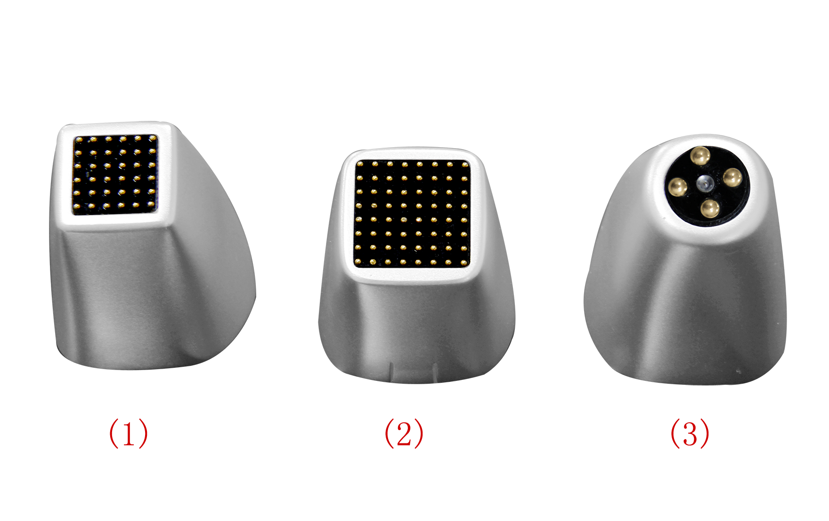
No.1, No.2 and No.3 treatment head from left to right

- Installation of the equipment

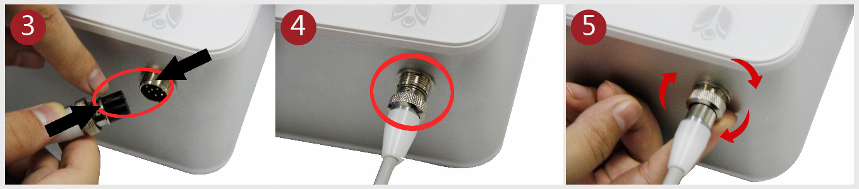
Step 2: Push the plug of functioning handle into the socket on the host like Picture 3, plug the notches into the protruding position, well plugged in, like Picture 4.
Step 3: Like Picture 5, tightening the lock wire ring on the plug
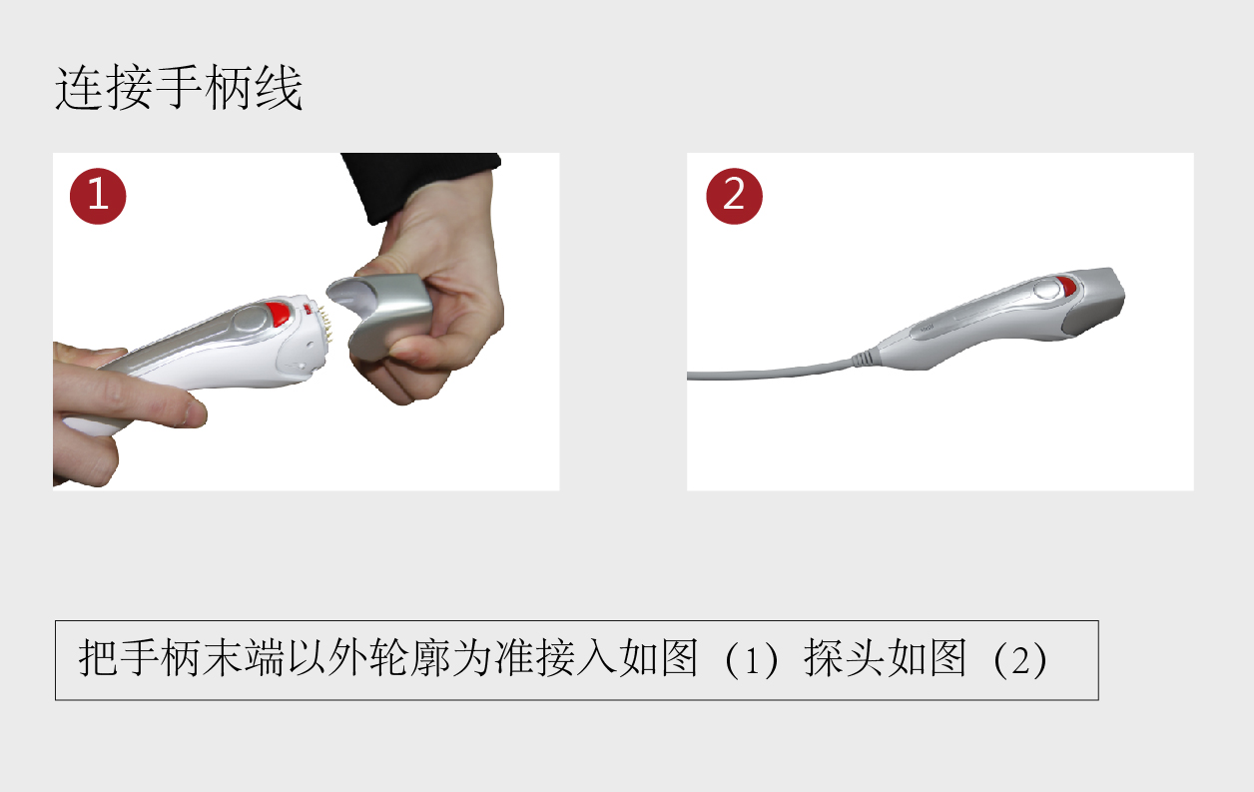
Step 4: as showing on Picture 1 – plug the needed treatment head in the functioning handle. Note: put the sink mark to the red mark on the button.

3. Introduction of the interfaces
（1）Start
When switch on the power supply, and check that the equipment is well connected, then push the button and start the equipment, select operation procedure according to the requirement, there are two optional modes, like Picture 1: CTN mode; like Picture 2: PLUS mode
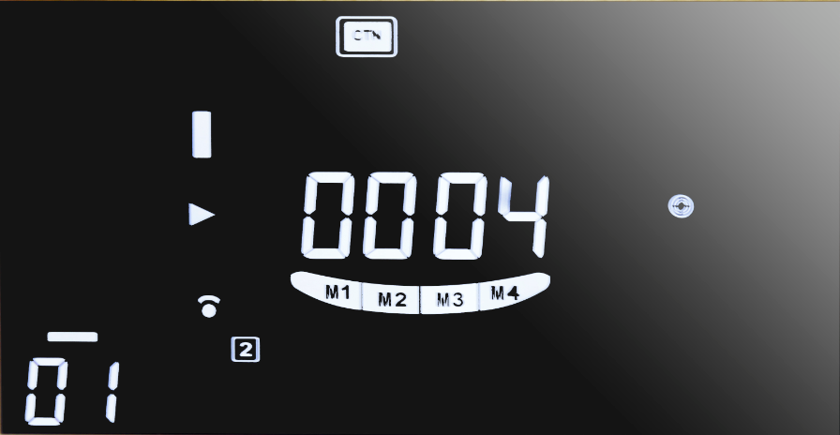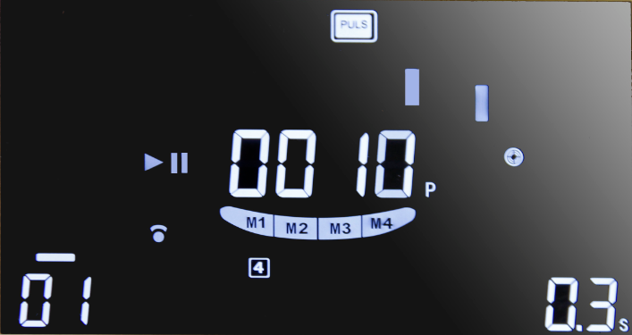
图 一 Picture 1 图 二 Picture 2
- Basic functions of buttons of the interface
Adjust parameters of functionning interface according to treatment requirement at any time by clicking on the options, and choose different opertion handle according to different treatment needs. Introduction of buttons as on Picture 3.
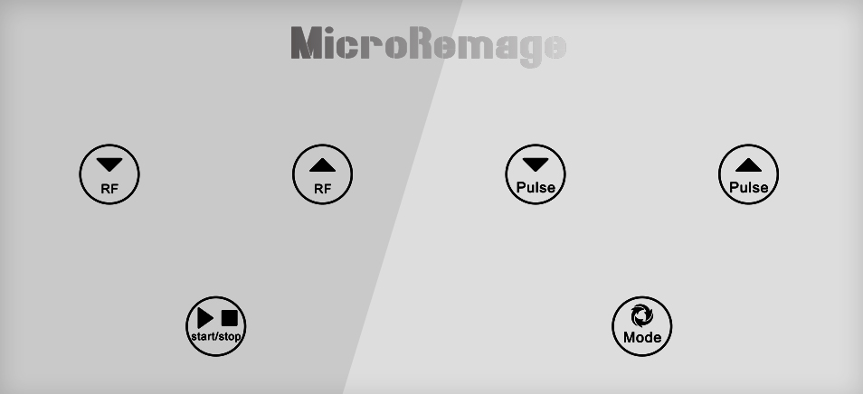
图 三 Picture 3
- 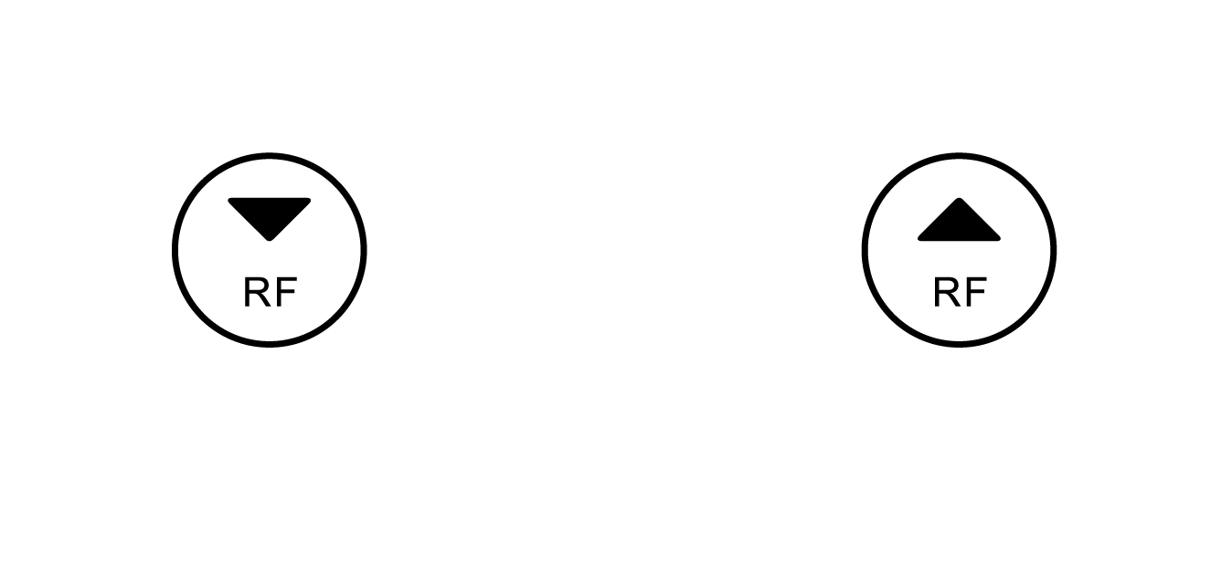
These two buttons are adjustment buttons of RF intensity, push the two buttons can progressively increase or decrease the RF energy, minimum--level 1, maximum -- level 20.
B、 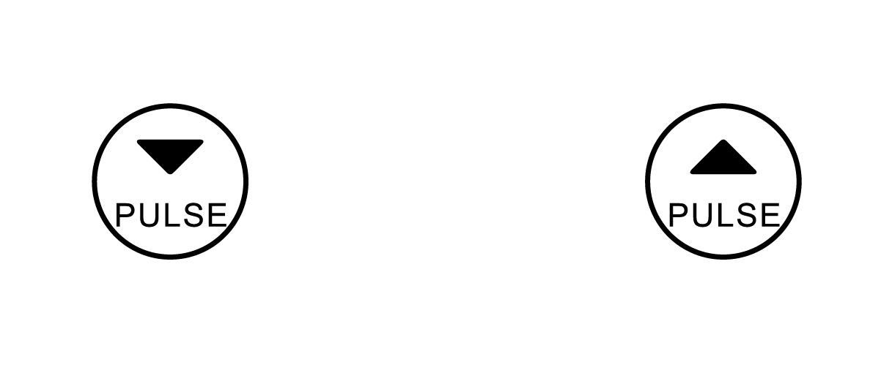These two are time adjustment buttons, during treatment under CTN mode, can extend or shorten the pre-set treatment time by push the two buttons, minimum -- 1 minute, maximum up to 60 minutes.

C、 This button is mode switch button, switch between CTN mode and PULS mode by each click. Under CTN mode, when press the button on the functioning handle then RF energy will be delivered, and when release the button the output of energy shall be stopped. Under PULS mode, when press the button on the functioning handle, then it will deliver RF energy according to the set time.

（三）、Option of function Modes
1、Setting CTN mode, as following Picture 4.
A、The current display shows manual time control of CTN mode, No.1 functioning handle is selected, RF energy level is level 01, at this time, the energy has output for 1 second, the contact of functioning head and the skin is under good condition.
B、Picture 4 – No.1 functioning head is selected, Picture 5 – No.2 functioning head is selected, Picture 6 – No.4 functioning head is selected.
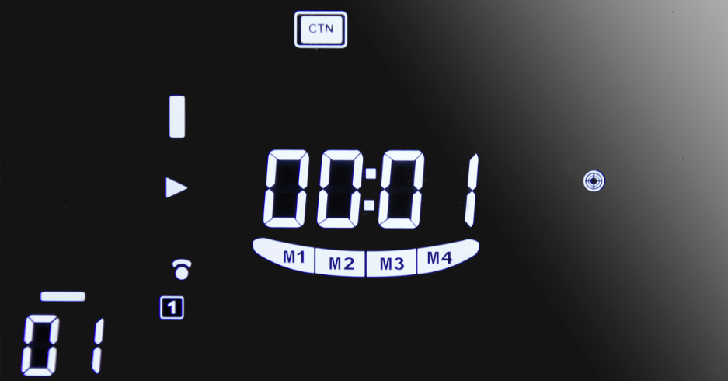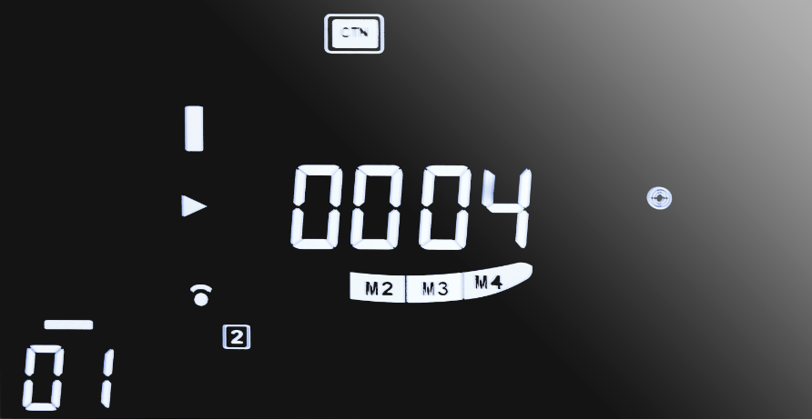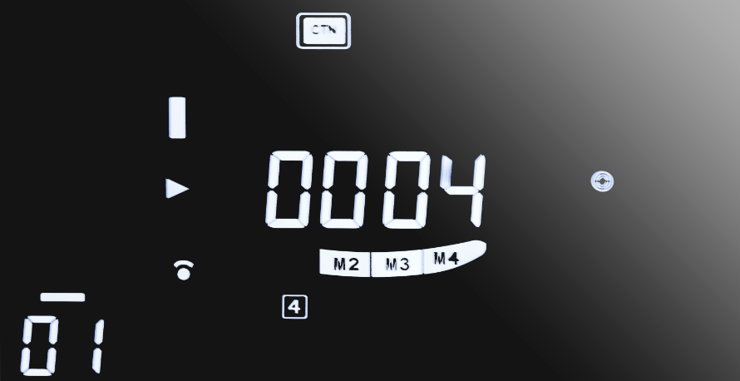
Picture 4 Picture 5 Picture 6
C、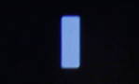 Indicates schedule of operating time.

D、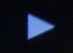 Indicates the equipment is in treament operation.

E、 Indicates the status of normal start-up and output of the RF function.

F、 Indicates the button on the functioning handle is pressed down.

G、 The contact of functioning head and the skin is under good condition.
 The contact of functioning head and the skin is under bad condition.

2、 the following is setting of PULS mode, as Picture 7

- The currently displayed is PULS mode, No.4 functioning handle is selected, RF energy level is level 01, the pulse energy output for 0.3 second.
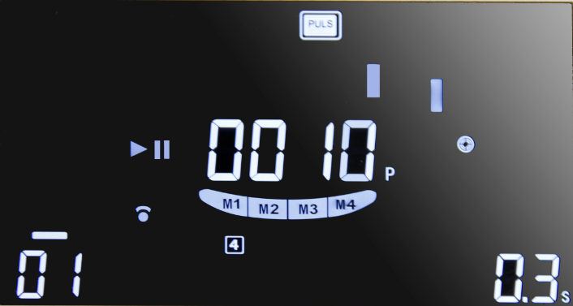
Picture 7
B、 Indicates schedule of pulse.

C、 Start/stop

D、 Indicates the status of normal start-up and output of the RF function.

E、 Indicates the button on the functioning handle is pressed down.

F、 Number of outputted pulses.

G、 The contact of functioning head and the skin is under good condition.
The functioning head and the skin is in bad contact.

4. Operation steps of the equipment
(1) Before useing, clean the parts which will be used.
(2) Apply products(products with good electrical conductivity, such as recovery gel) evenly to the operation parts, and keep the parts be with enough moisture to ensure good conductivity.
(3) Before operating the equipment, please select the corresponding operation probe according to the position that will take the treatment, set the operating parameters, and it’s better to adjust the energy gradually from low to high degree till it satisfies the range the customer could endure.
(4) During the operation process, adjust the energy output and ask the customer about the comfort degree from time to time to ensure the customer could enjoy it with pleasure.
(5) Each operation should be performed within the stipulated time, longer time shall not make the effect better, but will cause fatigue to cells.

5. Precautions and maintenance
1.Each time after use, please wash it with clean water and preserved properly.
2.Before use, applying plug with grouding pins, and make sure the power supply socket of the equipment is actually grounded
3.Ensure that the voltage for the equipment is adapted, if the local power supply voltage is not stable, we recommend users to add stable power supply of matching power between utility power and the equipment.
4.To achieve the treatment effects and guarantee the normal service life, please use accessories supplied by the riginal manufacturers or those designated accessories recommended by them.
5.Do not put the equipment in humid environment or on place near the water source, also do not directly expose the equipment in sunlight.
6.Do not put the equipment near intense heat source, as it may affect the service life and normal performance of the equipment.
7.Before the treatment, please take off all the metal objects, lest any unpreditable situation which may affect the treatment effects.
8.Do not apply it to the parts such as: eyes, thyroid, para-thyroids, testicular, belly of pregnant wowen, and parts around generator of atrial pulse ect.
9.Only get the permission of the doctor should the patients use the equipment, and be with more prudence.
10.When the equipment is not in use, please switch off the power, and make sure the general power is turned off, and make sure the safety of the electricity products.
11.Use the equipment or training the operators strictly comply with instructions in the Manual.

6. Taboos for users
If have the following symptoms or situations, then the users should be more prudent when use the equipment, and should consult a doctor or consult the professional for advice, details as following:
1) Pregnant or breastfeeding wowen
2) Heart disease or equipped with heart pacemakers
3) There’s stuffing inside the skin
4) Large area of skin is allergic or patients with a large area of acnes
5) Patients who has surgical wounds haven’t healed
6) Epilepsy patients, and patients with serious hyperthyroidism and diabetes
7) Patients with malignant tumor, serious bleeding or hemophilia patients
8) Use with cautions in case of skin disease and infectious diseases
9) Serious Telangiectasis (treatment could be applied to other parts)
10) Patients with hyperthyroidism, asthma patients, and hypertensive patients.

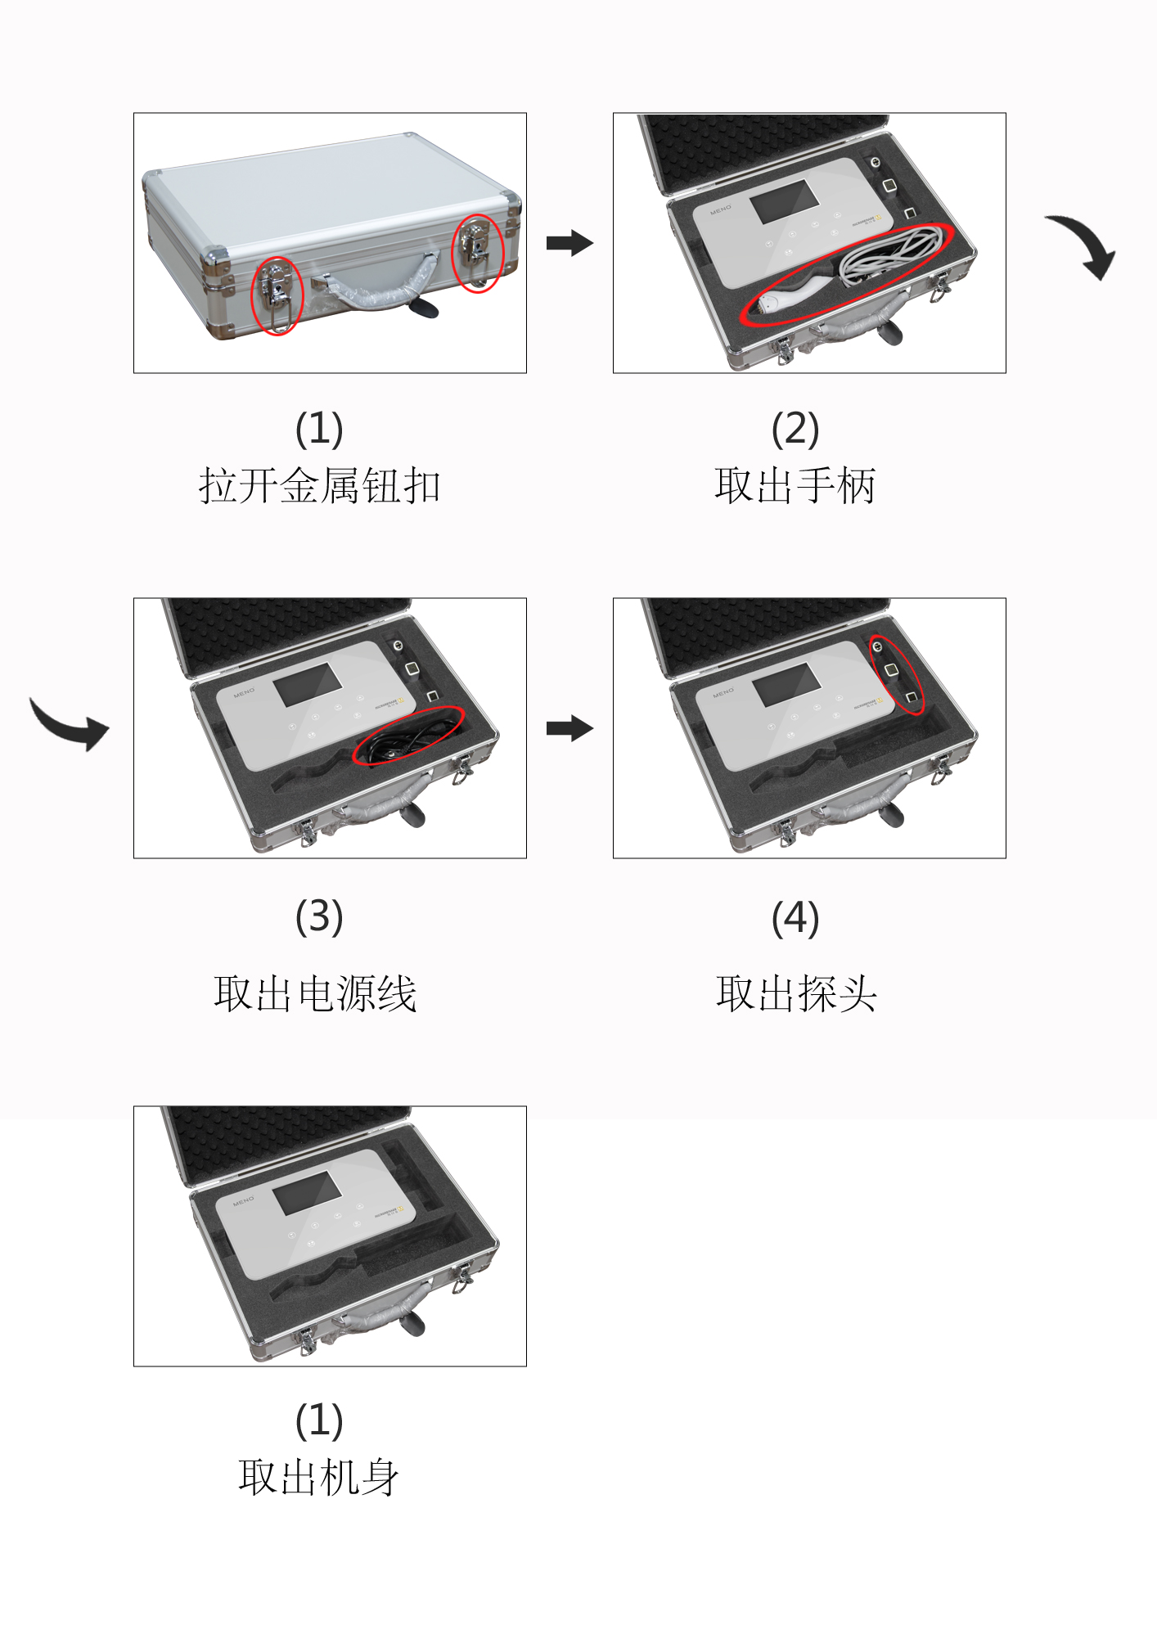
Open the packing box, take the machine body and the accessories carefully.
7. Introduction of package and unpacking
(1) Snap the metal button
（2） Take out the handle
（3） Take out the power cord
（4） Take out the probe
（1） Take the machine body

8.Common failure and problems
1). If there’s no output of energy, check whether the connection between the probe and the machine is loose.
2). If the equipment is normal, but the keys/buttons are out of order, please check whether the power is in bad contact.
3). No signs displayed on the interface, please check whether the the power plug is well connected, or whether the it is switched on.
4). If there’s tingling sensation on the contact position, it may due to breakage on the parts of the probe which contacts the skin, the customer’s skin is too dry to be conductive, or poor contact of the assessories with the skin, to avoid these, please apply matched products to the customer’s skin and keep the skin moist and keep away from abraded skin.

9. Repairing and maintenance of the equipment.
- Moisture-proof
Keep off moist environment or places with direct sunlight or flammable and explosive items, to prevent accidents.
2)Cleaning
Keep the surface of the equipment clean, put a piece of flannelette or gauze on it to prevent dust. For the probe, clean it once used, disposable products should not be reused. Use dry cloth or twisted we cloth to wipe the equipment when cleaning, and then disinfect it with alcohol. Always keep in mind that the operation handle should be dry.
3) Corrosion prevention
Combined and corresponding products must be used in accordance with the relevant requirement, in order to prevent the power fuse broken, all wire accessories are not allowed to be pulled or twisted, and prevent water get into the equipment, and it’s forbidden to open the fittings freely.

