MAIN TECH PARAMETER CARE AND MAINTENANCE

MAIN TECH PARAMETER  - Emitting Frequency  6.99KHz  - Signal Frequency  437KHz  - Weight  2.875KG  - Power Supply  8pcs 1.5V Batteries  Attach external battery box and bag.  - Max Detection  Small coil: 1.5meters  Big coil: 3-5meters  This conclusioin is elicited by testing an aluminum sheet (60cm*60cm*1cm) buried in dry soil  - Sensitivity  Small coil: 30-35cm (test 25 US cent)  Big coil: 40-45cm (test 25 US cent) |  | - If the detector doesn’t work properly, it is possible that the batteries haven’t enough power, replace batteries to try ;  - Place batteries matching the polarity symbols (+ and －) If you won’t use it for a long time, take out the batteries to avoid putridness;  - The search coil’s plug should be not affected with damp, or the detector will loss detection ability; the plug can be used only after drying in such condition;  - The detector is prohibited to work in rainy day and in burning sun;  - The search coil should be far away from furnace and other high temperature circumstance;  - Each detector is attached a piece of guarantee and it is free to be repaired during the length of warrantee unless he circuit is changed by user himself. |  |  | OWENER’S MANUAL MD-5008  Please read before using this equipment  Metal Detector  5008

FEATURES

With your MD-5008 Metal Detector, you can hunt for coins, relics, jewelry, gold, and silver, etc, just about anywhere. The metal detector is versatile and easy to use.  The detector’s features include:  Headphone Jack – lets you connect headphone (not supplied) to the detector.  Viewmeter and Pointer – shows the probable type of metal being detected.  Volume Indicating – gives off tune of fixed frequency while finding metal.  Waterproof Search Coil – lets you use the detector’s length for comfortable use.  Note: The search coil is waterproof, but the control housing is not waterproof..  Adjustable Stem – lets you adjust the detector’s length for comfortable use.  Note: your metal detector requires 8 pieces of 1.5 V batteries. |  | TREASURE HUNTER’S CODE OF ETHICS  All treasure hunters might be judged by the example you set. Here are a few  basic rules you should follow while using your detector.  - Always get permission before  searching any site.  - Respect the rights and property of  others.  - Observe all national, state, and  local laws while treasure hunting.  - Never destroy historical or  archaeological treasures. If you  are not sure about an object you  have found, contact a museum or  historical society in your area.  - Leave the land and vegetation as it  was. Fill in any hole you dig.  - Use your detector only in safe  areas.  - Dispose of any junk you find, only  in approved areas. Do not leave it  for the next treasure hunter to  find. |  |  | Notes:  - The search coil will not detect without motion. You must move the object since you are not sweeping with the detector at this time.  - If you are using a coin, the detector detects it more easily if you hold it so a flat side (not the edge ) is parallel with the flat side of the search coil.  OUTDOOR TESTING AND USE  - Find an area on the ground outside where there is no metal.  - Place a sample of the material you want the detector to find (such as a gold ring or a coin ) on the ground. (If you are using valuable metal such as gold to test the detector, mark the area where you placed the item, to help you find it later. Do not place it in tall grass or weeds.) |  | - While holding the search coil level and about 8 inches above the ground, slowly move the search coil over the area where you placed the sample, sweeping the search coil in a side to side motion.  - Try finding other metal in the area. When you find a metal item, wait a few seconds after the tone stops before continuing, to allow the detector time to reset (or, press the Zeroing Button to return the pointer to “0” position).

DETECTION NOTES |  |  | CONTENTS

- Eliminate unneeded target:  If detect indoor or search very trashy ground, there are a lot of metal trash, they are usual no use and can be eliminated during the detection.  For example, in an area full of iron nails, the iron nail’s signals can interfere the detection, to solve such problem, you can firstly put a iron nail on the ground and let the search coil sweep over it, if the sound increase, press the button and rotate the “DISCRIMINATION” clock-wise a little, relieve the button and try again; adjust repeatedly until the sound doesn’t change when the detector sweeps over the iron nail.  After adjusting, the detector doesn’t respond to iron nails and ferrous metals whose size are smaller than iron nail buried in the ground, but it can respond to all non-ferrous metals and ferrous metals whose size are bigger than iron nail. |  | INDOOR TESTING AND USE  - Remove any watches, ring, or other metal jewelry you are wearing, then place the detector on a wooden or plastic table.  - Adjust the search coil’s angle so the flat part faces the ceiling.  Note:  Never test the detector on a floor inside building.  Most buildings have metal of some kind in the floor, which might interfere with the objects you are testing or mask the signal completely.  Move a sample of the material you want the detector to find (such as a gold ring or a coin ) about 2cm above the searchcoil. |  |  | Preparation...............................................................................................3  Assembling the Detector…………………………………………………3  Installing Batteries……………………………………………………….4  Testing the Batteries………………………………………….......5  Adjusting the Meter………………………………………………5  Using Headphones………………………………………………………..5  Listening Safely…………………………………………………..6  Traffic Safety……………………………………………………..6  External Power Jack……………………………………………………6  Introduction of Operating Buttons............................................7  Zeroing Button.........................................................................................7  Tune Turn Button.......................................................................................7  Sensitivity Turn Button..............................................................................8  Ground Balance Turn Button....................................................................8  Discrimination Turn Button......................................................10  Operation Mode Switch ...........................................................................11  Actual Detection Operation..........................................................11  Preparation ..............................................................................................11  Ground Balance Mode ............................................................................12  Discrimination Mode ...............................................................................12  Detection Notes.....................................................................................13  Indoor Testing and Use............................................................................13  Outdoor Testing and Use ........................................................................14  Main Tech Parameter ......................................................................15  Care and Maintenance .....................................................................15
PREPARATION
ASSEMBLING THE DETECTOR  Assembling your detector is easy and requires no special tools. Just follow these steps.  - Turn the stem’s lock nut clockwise until it loosens.  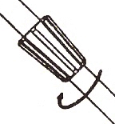  - Lengthen or shorten the stem so when you stand upright with the detector in your hand, the search coil is level with and about 8 inches above the ground with your arm relaxed at your side.  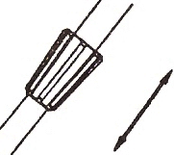  - Turn the stem’s lock nut counterclockwise to lock it in place.  - Unscrew the knob on the search coil and remove the knobs and connector. Insert the stem and align the holes on the search coil |  | bracket and the stem. Push the connector through the holes and tighten the knob  - Wind the search coil cable around the stem. Leave enough slack in the cable to let you adjust the search coil when you are hunting on uneven ground.  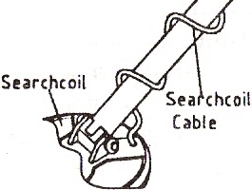  - Insert the search coil’s plug into the search coil jack on the detector’s control housing. Be sure the pins on the plug align with the holes in the jack.  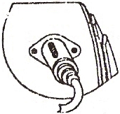  Cautions:  - The search coil’s plug fits into the connector only one way. Do not force the plug or you could damage it. |  |  |  |  |  | Remove any watch, ring, metal button, cigarette box, etc you are wearing, and wear shoes without iron nail.  GROUND BALANCE MODE  This mode can eliminate the “minerlization reaction” and has better penetrability, so this mode is preferentially selected wherever indoor or outdoor search. In this mode, as long as the search coil is moved right over the target, the detector sounds and the viewmeter indicates the change, any type of metal raises the volume.  Follow these steps to set it  - Turn on the switch;  - Set the MODE to “GROUND BALANCE”;  - Stop the search coil 24inch above the ground, press and relieve the “Zeroing Button” for several times to preheat the detector until the pointer returns to the “0”;  Set the “critical sound”; |  |  | - Set “GROUND BALANCE” as mentioned above;  - Sweep the search slowly along the ground and keep 8inch above the ground.  DISCRIMINATION MODE  This mode is used to distinguish ferrous metal and non-ferrous metal, to select bigger metal and to eliminate smaller ones between the same type of metals. This mode hasn’t “GROUND BALANCE” function, so the “minerlization reaction” is heavy, the operator should use it carefully.  Follow these steps to set it:  - Turn on the switch;  - Set “MODE” to “DISCR-IMINATION”;  - Preheat;  - Set the “critical sound”;  - Distinguish the ferrous and non-ferrous metal:  Use the discrimination turn button turn to MIN position. The pointer will rotate to right when you detect the ferrous metal, simultaneously, the detector sound will raise.  If you turn the discrimination turn button to MAX position, the pointer will rotate to right when you detect the non-ferrous metal, simultaneously, the detector sound will raise.

ACTUAL OPERATION
OPERATION MODE SWITCH (MODE)  There are two sections in operation mode switch, one is GROUND BALANCE, and the other is “DISCRIMINATION”.  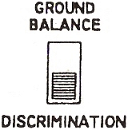  Set MODE to “GROUND BALANCE”, the detector responds to all metals, has no discrimination function, but can eliminate the effect of “minerlization reaction”, has enough penetrability, works steadily, and indicates properly, so, this mode is usually selected at the beginning of detecting some area.  Set MODE to “DISCRIMINATION” the detector can distinguish the type of the metal and select the bigger and valuable metal. |  | PREPARATION:  Place batteries into the battery compartment, turn on the power supply switch, the detector is electrified to work. The pointer is usual not at the center of the viewmeter when detector is just on, but swings to one side. This expresses that the detector is not in a steady mode, you need to press and relieve the “Zeroing Button” a few times until the pointer doesn’t drift any longer. All of these are normal phenomena. The detector needs a short time to preheat, during this period, the search coil should rest over the ground and begin to work only after the pointer return to “0” position. Watch the indictor light when you press the button, if the light is dim or dark, replace the batteries.  In detection, the operator holds the handle and sweeps slowly the search coil above the ground, keeps the search coil 8inch above the ground. When finding metals, the detector responds and the viewmeter indicates change. |  |  |  |  |  | - To disconnect the search coil’s cable from the detector, grasp the plug and pull it out of the connector. Never pull on the cable.  - Loosen the knob at the search coil’s end, then adjust the search coil to the desired angle. (The search coil should be parallel with the ground.) Tighten the knob just enough to keep the search coil from rotating or wobbling.  Caution: Do not overtighten the search coil or use tools such as pliers to tighten it.  INSTALLING BATTERIES  You need 8 pieces of 1.5V batteries to power your detector.  Cautions:  - Use only fresh batteries of the required size and recommended type.  - Do not mix old and new batteries, different types of batteries (standard, alkaline, of rechargeable), or rechargeable batteries of different capacities |  |  | 1. If the detector is ON, turn it to OFF.  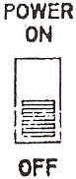  - Press the right battery compartment cover’s tab and slide the cover off in the direction of the arrow.  - Place 4 pieces of 1.5V battery into the battery compartment on top of the ribbon, matching the polarity symbols (+and -).  - Replace the right battery compartment cover.  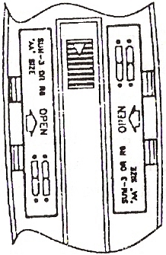
- Press the left battery compartment cover’s tab and slide the cover off in the direction of the arrow.  - Place 4 pieces of 1.5V batteries into the battery compartment on top of the ribbons, matching the polarity symbols (+ and - ) marked.  - Replace the left battery compartment cover.  Cautions:  - Always remove old or weak batteries; batteries can leak chemicals that can destroy electronic parts.  - If you do not plan to use the detector for a week or more, remove the batteries.  - Dispose of old batteries promptly and properly.  You can extend battery lift by using headphones, which require less power than the built-in speakers. |  | TESTING THE BATTERIS  If the indicator light is dim or dark, so the detector does not turn on, has weak volume, will not tune properly, has erratic operation, or drifts. Replace the batteries.  ADJUSTING THE METER  With MODE set to OFF, use a screwdriver to adjust the alignment control until the pointer lines up with 0 on the scale.  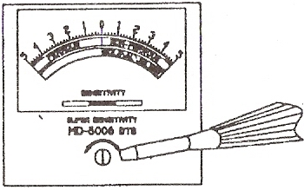  USING HEADPHONES  You can connect a pair of stereo headphones (not supplied) to the detector so you can listen to it privately. Using headphones also save battery power and makes it easier to identify subtle in the sounds you hear, for better detection results. |  |  |  |  |  | The detector eliminates the “mineralization reaction” signal after setting “Ground Balance” as above, the searching coil can sweep the ground freely and only sounds while finding metal.  DISCRIMINATION TURN BUTTON  The discrimination Turn button is used when MODE is set to “DISCRIMINATION”.  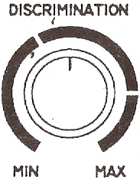 |  |  | When we rotate the “DISCRIMINATION” to different position, we can distinguish between ferrous metal and non-ferrous metal by directioni to which meter pointer swings.  NOTE: Press “Zeroing Button” before adjusting “DISCRIMINATION” and relieve it after adjusting.

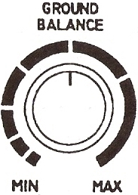  Set MODE to GROUND BALANCE, then tune the ground balance turn button.  Rotate the ground balance turn button to MAX, raise the search coil, then lower it after setting the “critical sound”, the volume rises; Rotate the turn button to MIN, then do as above, the sound falls. This experiment confines that the volume changes while rotating GROUND between two sides of the scale, so there must be a point at which the sound keeps steady, this point is the “ground balance point” we set.  Follow these steps to set “Ground Balance Point”:  - Set MODE to “GROUND BALANCE”;  - Stop the search coil about 24inch above the ground, set the “critical sound”; |  | - Lower the search coil about 8inch above the ground; if the volume rises, raise the search coil (about 24inch) and rotate the turn button counter clockwise to try, if the volume falls, rotate it counter-clockwise a little till the sound gets steady. If the volume falls when we do as above, rotate it clockwise till the sound gets steady.  - No matter you tune the volume, it still rises, witch expresses there are metals in this area, try another area to adjust.  - Press the “Zeroing Button” firstly before raising the search coil to set the “Ground Balance”, lower the search coil after tuning the “Ground Balance” and relieving the “Zeroing Button”. |  |  |  |  | To connect headphones to the detector, insert the headphones’ 1/8 inch plug into the headphone jack on the side of the control housing.  The detector’s internal speaker disconnects when you connect headphones.  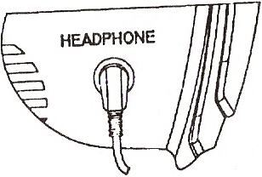  Listening Safely  To protect your hearing, follow these guidelines when you use headphones.  - Set the volume to the lowest setting before you begin listening. After you begin listening, adjust the volume to a comfortable level.  - Do not listen at extremely high volume levels. Extended high volume listening can lead to permanent hearing loss. |  |  | - Once you set the volume, do not increase it. Over time, your ears adapt to the volume level, so a volume level that doesn’t cause discomfort might still damage your hearing.  Traffic Safety  Do not wear headphones while operating your detector near high-traffic areas.  Even though some headphones are designed to let you hear some outside sounds when listening at normal volume levels, they still can present a traffic hazard.  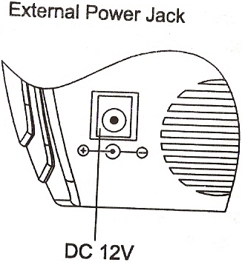

INTRODUCTION OF OPERATION BUTTON

ZEROING BUTTON  Zeroing Button is at the forefinger’s position when holding the detector. Press it, the pointer of the viewmeter returns to “0” position.  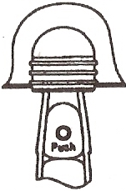  Zeroing Button has memory function, so it can memorize the working circumstance at working time. For example, while holding the search coil over the ground, the ground emits signal to make the pointer leave “ 0”position, you can return it to “0” by pressing the Button again. Then you can begin detecting.  Don’t press the Zeroing Button near metal, or the detector can not detect metal any longer.  What must be pointed out is that you must press the Zeroing Button before adjusting any other turn button, then relieve it after finishing adjusting. |  | During detection , with the changes of environment, the pointer often leaves “0” position. Pressing Zeroing Button to return the pointer to “0”, so you must often press it during the detection process.  The detector need about one minute to preheat after turning on the detector, or the pointer will leave “0” after pressing the Zeroing Button. All will be normal after preheating.  TUNE TURN BUTTON  Adjust the TUNE, the sound rises slowly, the sound which just can be heard is called “critical sound”. The detector has the highest sensitivity when it is at “critical sound”.  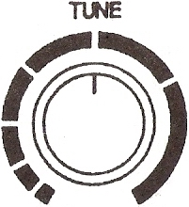 |  |  | Note:  Press the Zeroing Button before adjusting the “critical sound” and set free it after adjusting.  If the “critical sound” rises, falls, or disappears, set it by pressing the Zeroing Button.  SENSITIVITY TURN BUTTON  Sensitivity Turn Button controls the sensitivity of the detector.  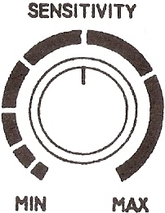  Rotate it counter-clockwise to the end point, the sensitivity is MIN and the detection depth is MIN; rotate it clockwise to the end point, the sensitivity is MAX and the detection depth is MAX.  To set sensitivity depends on the testing circumstance, but not the higher, the better. |  | For example, in those heavy mineralization area, high sensitivity causes false signal, the detector sounds everywhere so that the detector can’t find target correctly. In such condition, lower the sensitivity to reduce the effect caused by complex soil; in those pure area, the higher the sensitivity, the stronger the detection.  Note: Press the Zeroing Button before adjusting the sensitivity and set free it after adjusting.  GROUND BALANCE TURN  BUTTON  Owing to The “mineralization reaction”, the search coil of old-style metal detector emits false signal, and the “critical sound” is affected by the change of the distance between the search coil and the ground, so you can’t distinguish the type of the signal (minerlization signal or metal signal). To solve such problem, Ground Balance Circuit is designed to decrease the “mineralization reaction” to the lowest.

