WVC600 Micro-inverter solar grid system
(Power line communications)

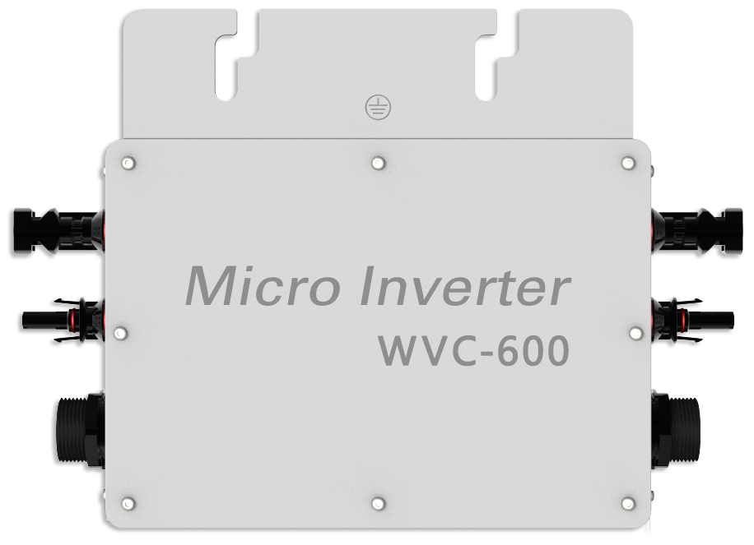

WVC600 Using IP65 waterproof streamline design, Can effectively prevent rainwater on the surface erosion, Built-in high-performance Maximum Power Point Tracking（MPPT）Function，Better able to track changes in the solar luminosity and control different output power, Effectively capture and collect sunlight. AC electric power transmission using the reverse transmission technology, Is one of our patented technology, The inverter output power can provide load priority use, Extra electricity to the grid, Efficient use of the inverter to the power emitted, Electricity transmission rate of up to 99%.
Communication using two modes, Between the inverter and Collector Using power line carrier communication signals, Collector with a PC or other devices to communicate Using RS232 serial port/ WIFI wireless communication. Intelligent monitoring systems, The inverter can collect real-time data, Inverter can be controlled startup / shutdown / power regulation.

Features：
- High performance maximum power point tracking (MPPT)
- Reverse power transmission
- Intelligent monitoring management
- Input /output is fully isolated to protect the electrical safety
- Multiple parallel stacking
- Digital control system
- Simplify maintenance (user serviceable)
- Operation and maintenance costs low
- Flexible installation

WVC600 Parameters
Input Data |  |  | WVC600-120VAC/230VAC
Recommended input power |  |  | 500-600Watt
Recommend the use of PV modules |  |  | 2*300W/Vmp>34V/Voc<50V
Maximum input DC voltage |  |  | 50V
Peak power tracking voltage |  |  | 25-40V
Operating Voltage Range |  |  | 17-50V
Min / Max start voltage |  |  | 22-50V
Maximum DC short current |  |  | 40A
Maximum Input Current |  |  | 25A
Output Data | @120VAC |  |  | @230VAC
Peak power output | 600Watt |  |  | 600Watt
Rated output power | 550Watt |  |  | 550Watt
Rated output current | 4.58A |  |  | 2.3A
Rated voltage range | 80-160VAC |  |  | 180-260VAC
Rated frequency range | 57-62.5Hz |  |  | 47-52.5Hz
Power factor | >96% |  |  | >96%
Maximum units per branch circuit | 6PCS（Single-phase） |  |  | 12PCS（Single-phase）
Output Efficiency | @120VAC |  |  | @230VAC
Static MPPT efficiency | 99.5% |  |  | 99.5%
Maximum output efficiency | 92 % |  |  | 92%
Night time power consumption | <50mW Max |  |  | <70mW Max
THD | <5% |  |  | <5%
Exterior
Ambient temperature |  | -40℃ to +60℃
Operating temperature range (inverter inside) |  | -40℃ to +82℃
Dimensions (WxHxD) |  | 289mm×200mm×38mm
Weight |  | 1.53kg
Waterproof Rating |  | IP65
Cooling |  | Self-cooling
Feature
Communication Mode |  | Power Line
Power transmission mode |  | Reverse transfer, load priority
Monitoring System |  | Lifetime free
Electromagnetic compatibility |  | EN50081.part1 EN50082.part1
Grid disturbance |  | EN61000-3-2 Safety EN62109
Grid detection |  | DIN VDE 1026 UL1741
Certificate |  | CEC,CE National patent technology

* Note: The monitoring software can monitor multiple threads simultaneously 6 PCS power line acquisition
simultaneously monitor 600 inverters.

- Each WVC Power Line Modem monitoring 100 inverters
- Monitoring system simultaneously collect real-time data from 6 WVC power line Modem by 6 threads

PV micro-inverter system components
System Block Diagram

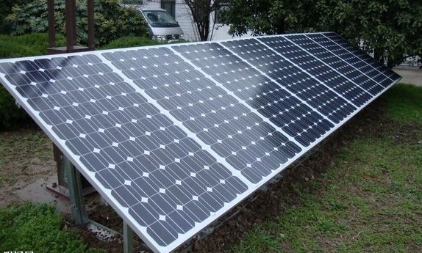
GRID
PV Panel 1-2
PV Panel 1-1

PV Panel n-2
PV Panel n-1
光伏板1

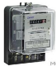
Meter

Inverter 2
Inverter 1
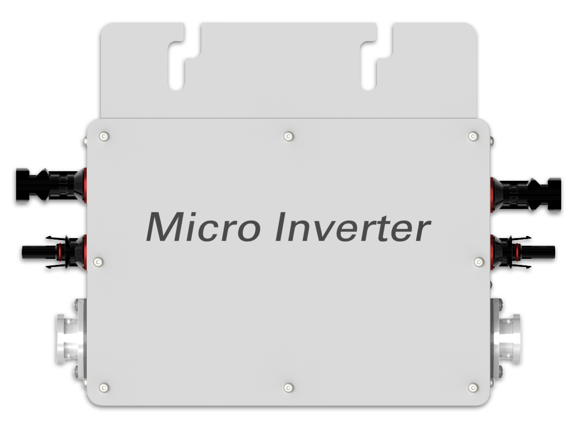
Switch
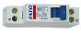
Power line signal filter

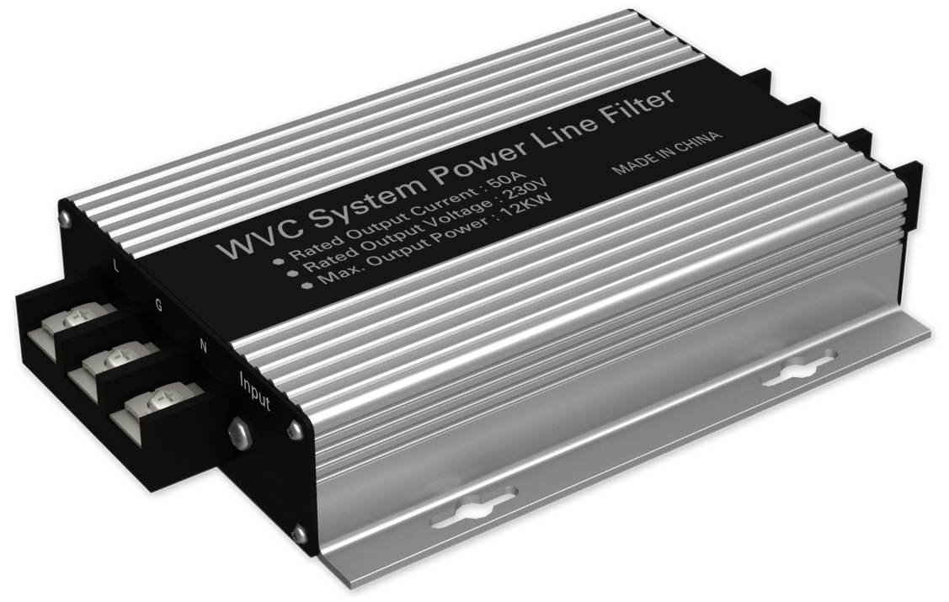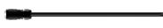

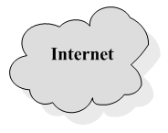
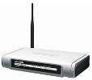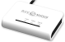


Router

Collector

WIFI

Mobile

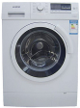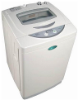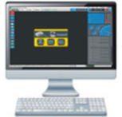


Computer

Household electricity

Industrial version does not have the WIFI function.

System Description
Micro-grid inverter system components

PV panels
Micro-inverters

Components of Micro-inverter system
WVC Data collection
Monitoring System

Power Line Filters

In summary, Micro-inverter system is simpler, more convenient installation.

High performance maximum power point tracking (MPPT)
Powerful MPPT algorithm，Optimize the power from the solar panels to collect，Accurately capture and lock the maximum output power point，A substantial increase in output power greater than 25% or more.
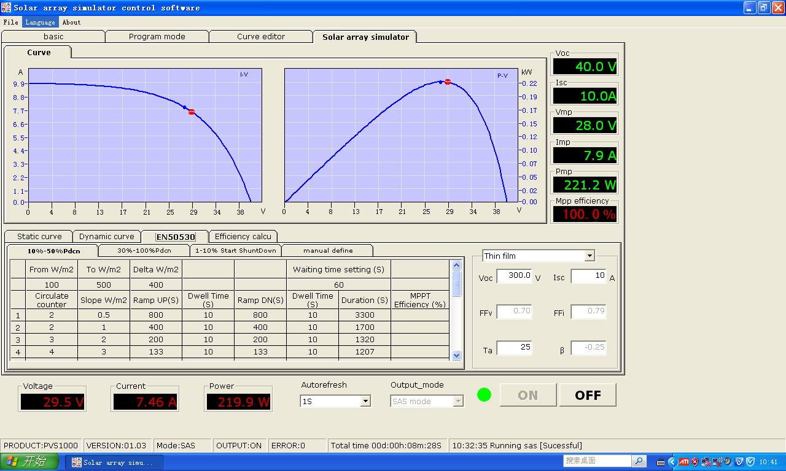
MPPT
Power Output:（Reverse power transmission）
Reverse efficient power transmission technology，Patented technology，The inverter power transmission in the reverse direction，Automatic detection circuit load and using priority，Additional power transmitted to the grid，Power transmission rate up to 99.9%.Higher output efficiency in photovoltaic application system manipulation.
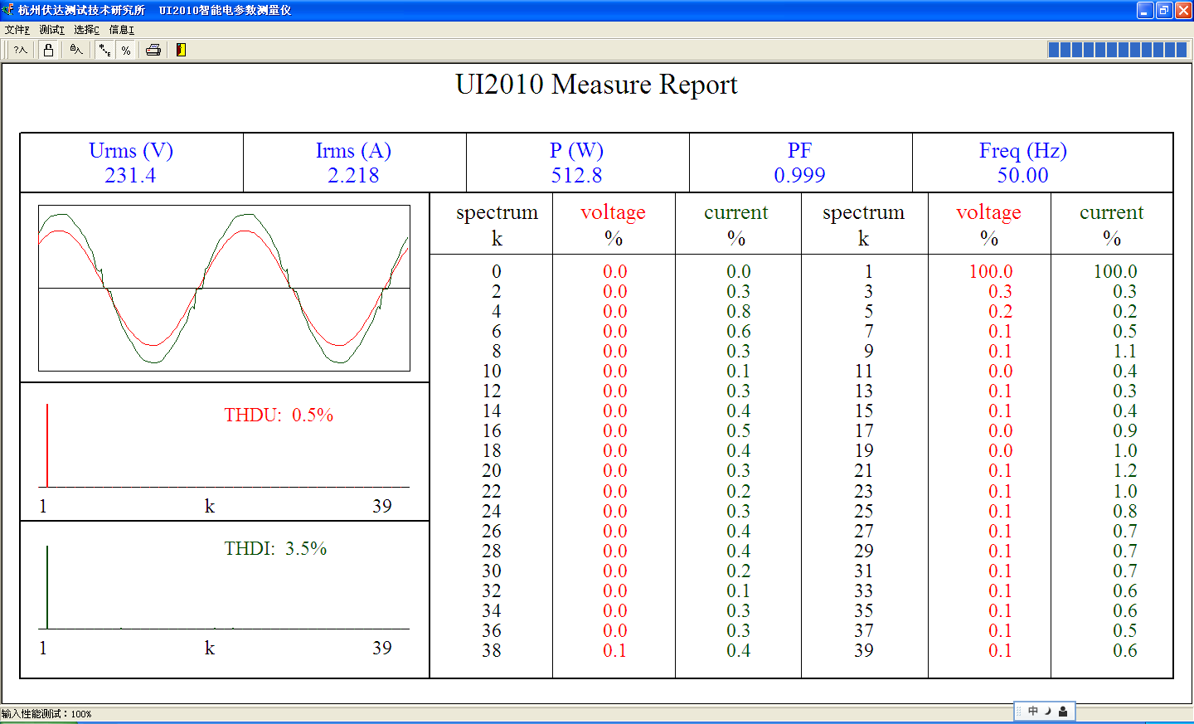
THD
Electrical schematics
Single-phase electrical schematics

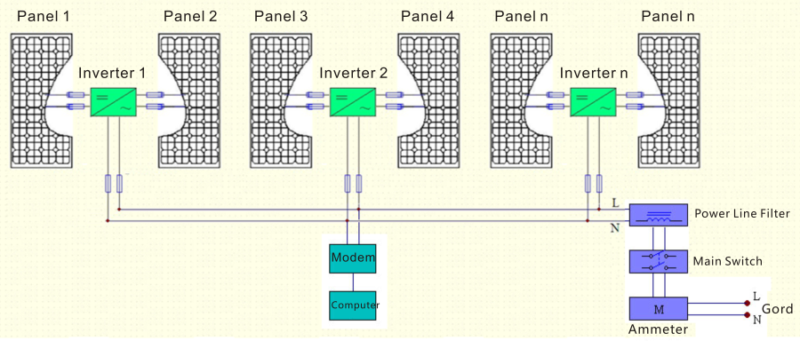

Three-phase electrical schematics
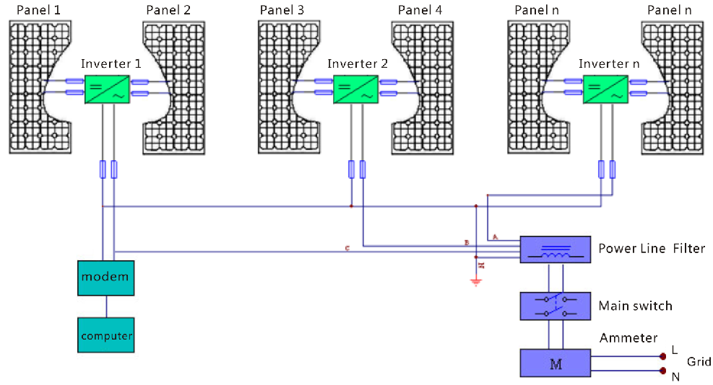

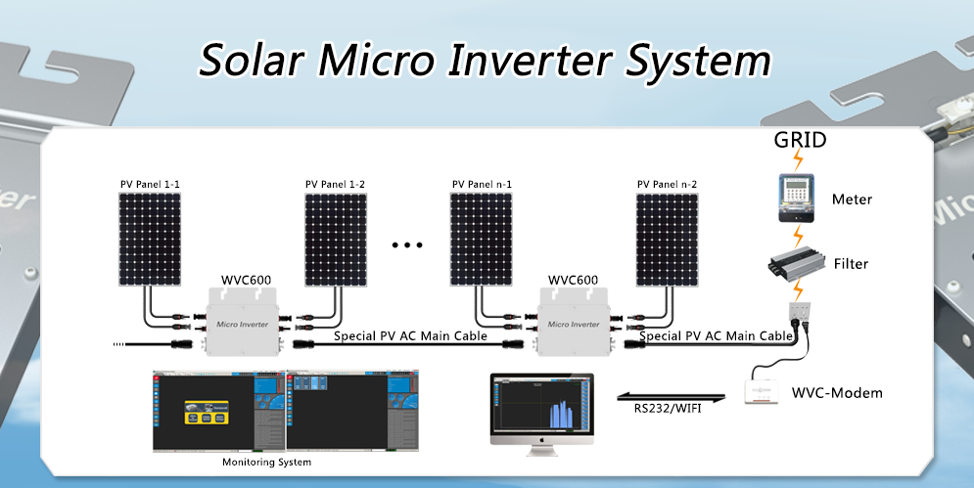
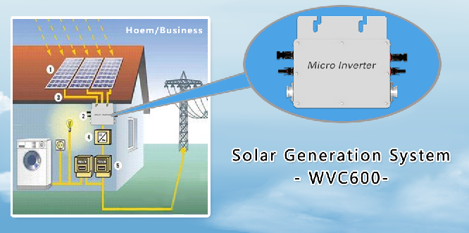
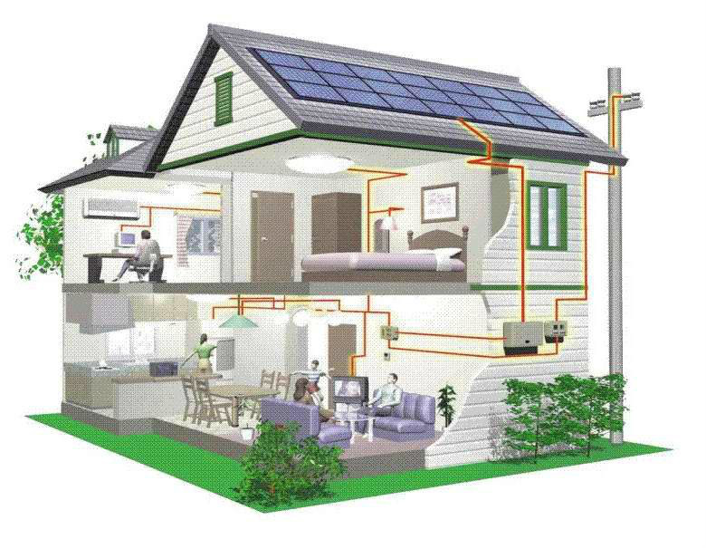

WVC600 Using IP65 waterproof streamline design, Can effectively prevent rainwater on the surface erosion, Built-in high-performance Maximum Power Point Tracking（MPPT）Function，Better able to track changes in the solar luminosity and control different output power, Effectively capture and collect sunlight. AC electric power transmission using the reverse transmission technology, Is one of our patented technology, The inverter output power can provide load priority use, Extra electricity to the grid, Efficient use of the inverter to the power emitted, Electricity transmission rate of up to 99%.

⑤
④
③
②
①

- PV Panel Input 1
- PV Panel Input 2
- AC Input –
- AC Ouput – Connect to the Next
- LED Display

Installation and connection
WVC600 Series Solar Inverter very easy to install, No need for project professionals can also install. Whether installation or maintenance are very simple, No maintenance.

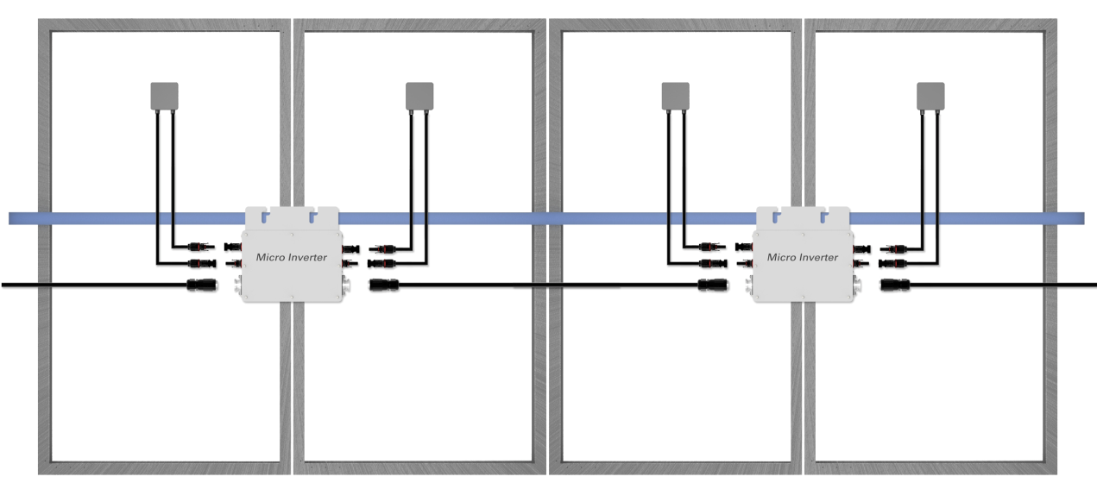

Connect to the Previous
Connect to the Next
WVC600
PV Panel Input 1-1
PV Panel Input 1-2
PV Panel Input n-1
PV Panel Input n-2
AC Output
WVC600
AC Output
AC Input
AC Input

Monitoring System
The Monitoring System KDM is a product designed specifically for WVC.

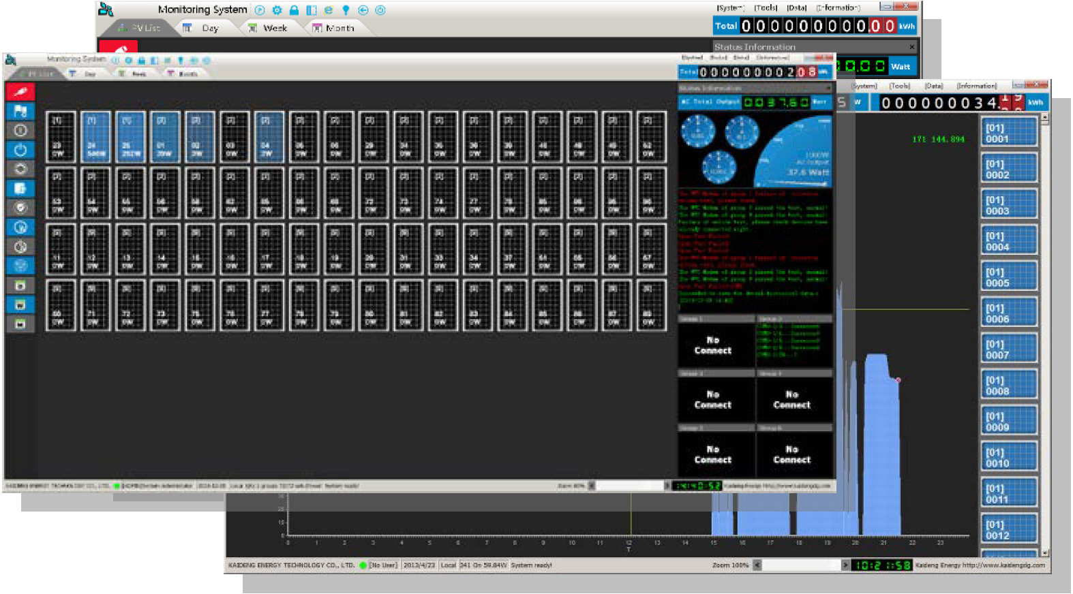

Data collection
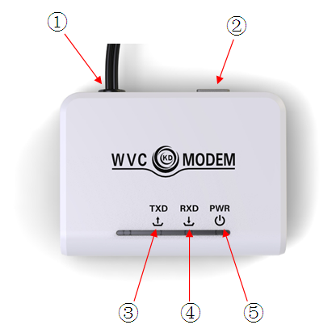

- AC power input, power line signal input
- RS232 serial data port
- Data Send LED Indicator (blue)
- Data Receive LED indicator (blue)
- Power Indicator

Why is the use of micro-inverter？
- The transition from a centralized to a distributed inverter optimizes energy collection.
- The converter module integrated into the solar panels can reduce installation costs.
- By reducing the temperature of the converter and remove the fan, you can enhance system reliability from 5 years to 20 years.
- Soft switch technology to replace hard-switching technology can improve efficiency and reduce heat dissipation.
- From cottage industry to mass production, standardized design (hardware and software) to improve reliability and reduce costs.
- Using a special capacitor (due to the high failure rate). Design requires a higher voltage to reduce the current, we use a special electrolytic capacitors.
- The converter can be connected to the grid to eliminate the need for many battery applications. The high price of batteries, require maintenance, life expectancy is shorter.
- Work required micro-inverter power increasingly smaller (only a few hundred watts), which can reduce the internal temperature and improve reliability.
- Micro-inverter solar inverter system needs to deal with a lot of a particular power level, in order to increase production, thereby reducing costs.

Power line signal filter
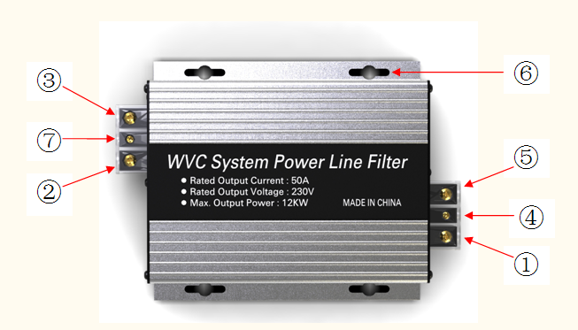

- N-pole AC output
- N-pole AC input
- L-pole AC input
- Output Ground
- L-pole AC output
- Fixed
- Input Ground

Contact Us：

