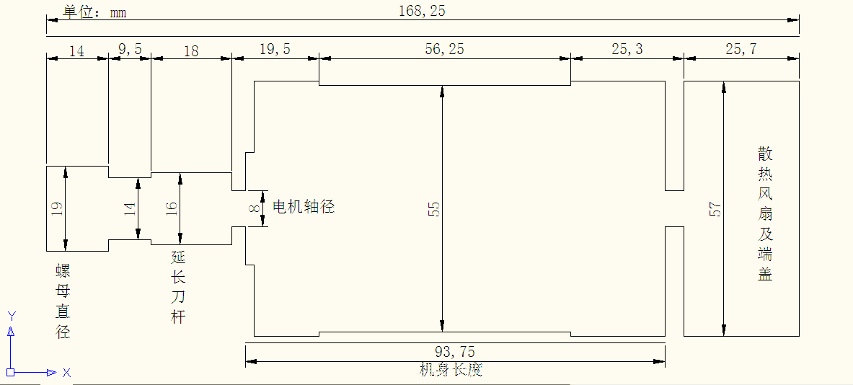
400 w ER11 spindle brushless motor parameters:
Working voltage: 48 VDC need drives, brushless motor to operate
Power: 400 w
Speed: 12000 r/min
Distance: 0.45 (N.m)
Insulation resistance: > 2 ohms
Insulation dielectric strength: 400 v
55 mm diameter:
Spindle net weight: 1.1 KG
The spindle radial runout about 0.01 to 0.03.
Can be used for metal or non-metal materials such as carving. The spindle with forced air cooling, can work long hours.
Brushless main features:
1, brushless, low interference, in addition to the brushless motor brush, the most immediate change is no brush spark generated when the motor running, thus greatly reduce the electric spark interference of remote radio equipment.
2, low noise, smooth operation, brushless motor without brush, less friction force during operation, smooth operation, low noise will be many.
3, long life and low maintenance costs, less brush, brushless motor wear is mainly on the bearing, from the mechanical point of view, brushless motor is almost a free maintenance of the motor
BLDC MOTOR CONTROLLER SPECIFICATION
MODEL：WS55-180/WS55-220
- Overview
WS55-180 and WS55-220 are a high performance，cost-effective 3 phase BLDC motor controller。Voltage range is from 20VDC to 50VDC。The controller can drive the DLDC motor with HALL or without HALL。
The driver is based on advanced technology and be provided with high speed、high torque、low noise、low vibration，over current protection，overload protection，less phase line protection，phase line short protection、alarm output、speed signal output、 positive negative rotation control etc.This controller can be used in small equipment 、Electric Power Tools、bump、exhaust Fan、Jade grinding machine、Vibrating motor etc.
- Electrical Specifications
Parameter | definition
Rated voltage | 20-50VDC
Rated current | WS55-180：8A  WS55-220：10A
Limited current | WS55-180：10A  WS55-220：12A
Maximum speed | Over 20000RPM
Speed control | Two ways：  1.Regulation resistance；  2.External voltage：10VDC；  Note：Two methods cannot be used simultaneously
Speed signal output | PG signal：This port and the ground have a 5V speed pulse output  P(Hz):output frequency  N:motor pole number  F(RPM):Round per minuter  Then F=2*P/N*60
Alarm output | AL signal：This port and the ground have a 5V alarm output output
Forward or reverse rotation | It can change the direction of rotation of MOTOR to Stir the Side switch F/R  Positive inversion
Startup or Shutdown | Two ways：  1.Stir the Side switch EN；  2.Turn on or turn off the external switch  Note：Only one can be used at the same time, one of the switches is turned off, and the other is valid
Speed adjust | Two ways  - Twist external potentiometer or the Side potentiometer。  - Adjust external simulative voltage  Note：Only one can be used at the same time, the other one is Adjusted to zero this time
Locked-rotor protection | The motor will be shutdown When the motor is locked，and Restart after power open again
Power light | Green LED：The led is on once power on
operation condition light | Red LED：The led flash one times continuas When the device is suspended。
Insulation resistance | >100MΩ at normal temperature and pressure
insulation strength | 0.5KV，1 minute at normal temperature and pressure

- Working and storage environment
Parameter | definition
storage temperature | -20℃～ +65℃
Working and storage environment | environment | Avoid direct contact with dust, fumes and corrosive gases
 | temperature | 0-45℃
 | humidity | < 80%，No frost, frost free
 | Vibrating | 5.9m/S² MAX
storage humidity | 0~95%RH
Dimension | 96mm（long）*67mm（wide）*37mm（high)
Weight | Approximate 195g

- Connecting line methods

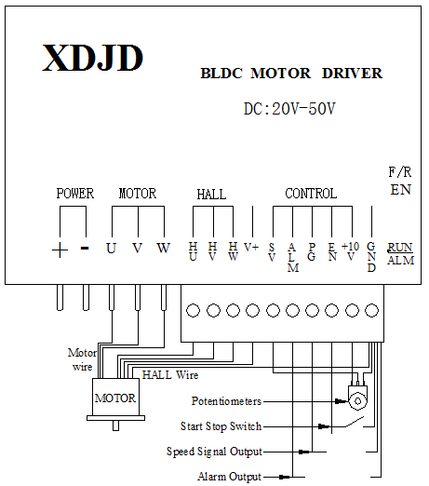
connection mode for adjust speed
with Potentiometers

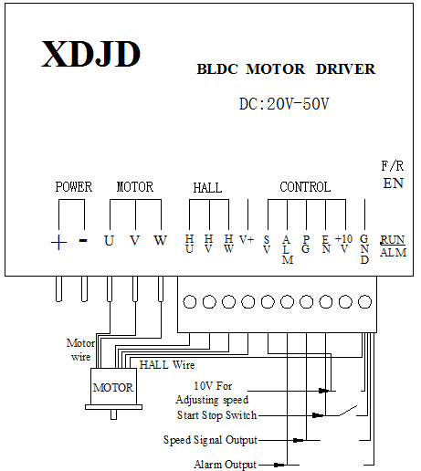
connection mode for adjust speed
with external 10V

- connecting terminal

Parameter | character | definition
Control | SV | - Speed control potentiometer terminal connection position；  - External 10V positive connection position；
 | ALM | Alarm signal interface, the other end connect the GND
 | PG | Speed signal interface， the other end connect the GND
 | EN | Start and stop switch interface ，the other end connect the GND
 | +10V | Provide power for control，the Current is very small
 | GND | GND
 | EN（side） | Stir the switch to turn on or turn off the motor；  Note：Only one “EN”can be used at the same time, one of the switches is turned off, and the other is valid
 | F/R（side） | Stir the switch to control Control motor forward and reverse
HALL | HU、HV、HW、V+ | HALL signal and HALL power；  Note：To correct the corresponding controller and terminal of the motor line is connected correctly, wrong connection will cause the motor to work abnormal, wrong or even damage the power supply controller and motor. V+ can't be used for other purposes.
MOTOR | U、V、W | Connect the Motor
Power | + | Positive power
 | - | GND
indicator lamp | RUN/ALM | 1.Green LED：The led is on once power on  2.Red LED：The led flash two times continuas when the motor is not suspended，and the led flash other different times when there is failure。

六.Dimension

96mm（long）*68mm（wide）*36mm（high）

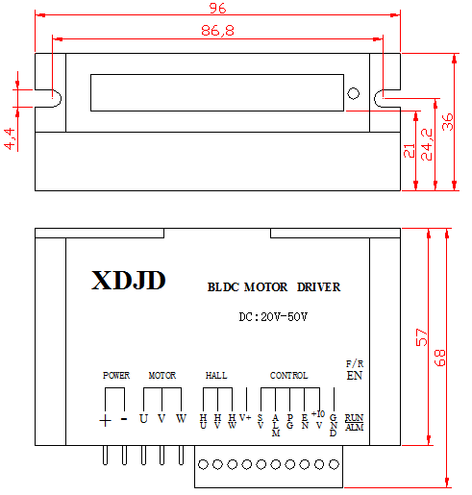

Note：
Try running the motor low speed first,then increase the speed and load gradually after there is no problem；
If the motor fever soon and feel very hot about tens of seconds to one or two minutes，stop the motor，then check the cause of the problem.

