OBDII Break Out Box
User manual
Dear user,
Thank you for purchasing OBDII Break Out Box. This manual contains
introduction, function, usage and after-sale, please read it carefully before
using.
CONTENT
I. Introduction ............................................................................................. 01
1.1 Overview of Test Box ........................................................................ 01
II. Function ................................................................................................. 02
2.1 Features of Test Box ............................................................... 02
2.2 Indicator Light Meaning ..............................................................................
III. Usage.................................................................................................... 04
3.1 Sonata Relay Testing Demonstration ....................................................... 04
FAQ .................................................................................................................. 11
III. After-sale ................................................................................................ 11
- 1 -
I. Introduction
1.1 Overview of Test Box
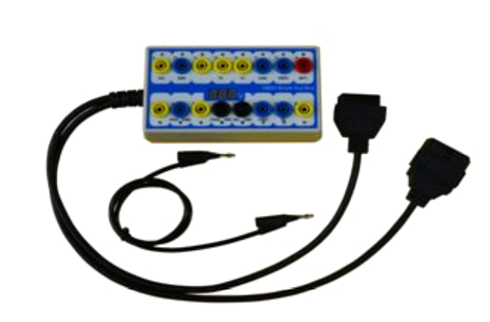
OBDII Protocol Detector & Break Out Box is our latest R & D automotive fault
diagnostic tools. It’s mainly used for changing automotive diagnostic OBD
stitch to signal judgment level transfer. It can connect with any diagnostic
instruments and judge whether car communication is normal. Also it can
supply car power during replacing the battery , in order to prevent the body
electrical equipment locked automatically.
II. Function
2.1 Features of Test Box
1. Test and find out the connection fault of OBD2 interface when using the tool.
2. Monitor OBD interface voltage and ground wire so that it can display low
voltage and fault diagnose stitch.
3. Used for OBD interface signal jumping and quickly test if every diagnostic
stitch communication of OBD diagnostic interface is OK.
4. Save automotive data and prevent automotive data losing and electric
device locking.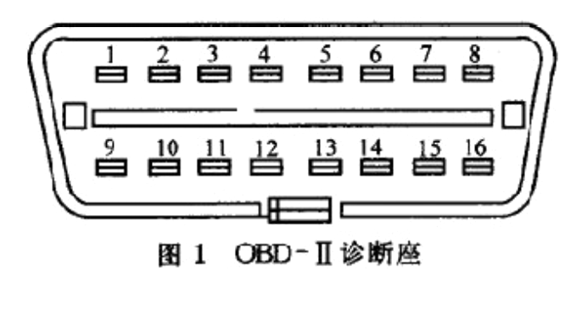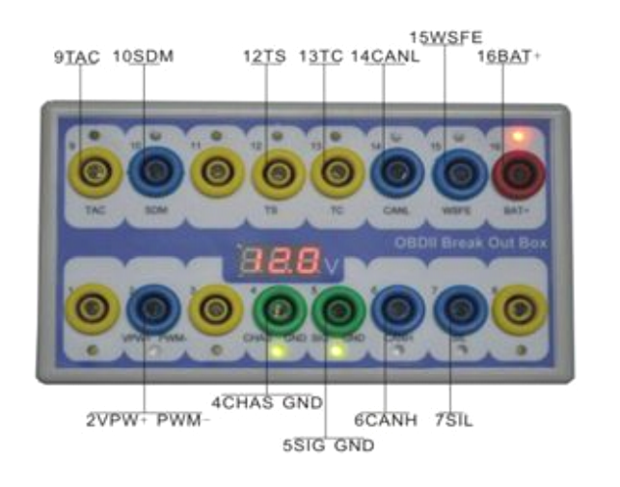
- 2 -
2.2 Indicator Light Meaning
1. Manufactory custom
2. SJE1850 wire<bus+>
3. Manufactory custom
4. Power grounding
5. Signal grounding
6. SAEJ2284《CAN》high
7. ISO9141-2&iso, DIS4230-4K wire
8. Manufactory custom
9. Manufactory custom
10. SJE1850 wire《bus->
11. Manufactory custom
12. Manufactory custom
13. Manufactory custom
14. SAEJ2284《CAN》low
15. ISO9141-2 & ISO/DIS 4230-4L wire
- 3 -
16. Car battery positive
III. Usage
3.1 Actually testing instructions
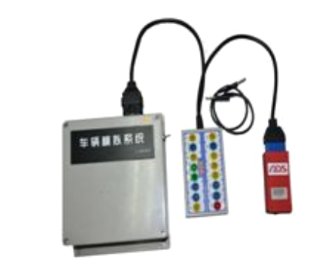
1. In series connect OBD signal adaptor
and car fault diagnostic tester. It supples
power normally if its storage battery
voltage LED displays more than 10V
and NO.16, NO4 or NO.5 LED light.
It’s shortage of storage battery voltage if
less than 10V. None of LED turning light
means that there is something wrong
with the diagnostic holder power
suppling, then check whether abnormal
with the holder and storage battery
voltage.
2. The communication signal LED will
turn light during testing (Egg: NO. 7 wire
signal). The testing of NO.7 pin is
normal when LED flash,it means
communicate normally.
3.The car diagnostic communication is
NO. 15 wire but diagnostic tool is NO. 7
wire, it can’t test car in normal. OBD
adaptor can connect NO.7 wire and
NO.15 wire. When it test, NO.7 and
NO.15 LED will turn light and flash. It can
normally test.
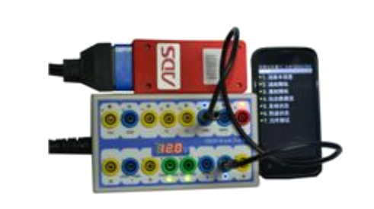
3.2 Replay car storage battery
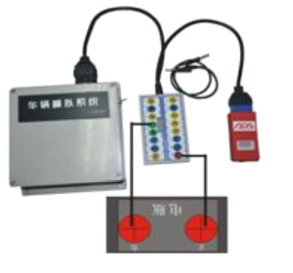
1. Connect the OBD signal adaptor and the car diagnostic holder, NO. 4 and
NO.6 LED light,with 12V.
2. Supplying power to NO.4 negative pin and NO.6 positive pin. Then the OBD
adaptor can supply power to the car through diagnostic holder positive and
negative, to prevent car data losing and audio locking.
3. Remove the car battery.
4. Swift off the power and OBD adaptor in order to finish battery changing.
FAQ and solutions:
1. Make sure the vehicle is parking and has electricity supply.
2. It’s non-waterproof, so don’t touch any more liquid like water and oil.
IV. After-sale
1. Guarantee period: One year warranty.

