

iVolve Nasal Mask

User Manual

0123
Table of Contents
iVolve Nasal Mask 1
Intended Use 1
Before Using the Mask 2
Parts of the iVolve 3
Fitting the iVolve 4
Disassembling the iVolve 6
Cleaning the iVolve in the Home 7
Reprocessing the Mask between Patients 8
Reassembling the iVolve 8
Troubleshooting 10
Technical Specifications 11
Storage 12
Disposal 12
Symbols 12
Limited Warranty 13

iVolve Nasal Mask
Thank you for choosing BMC’s iVolve Nasal Mask.
The Nasal Mask is comfortable, flexible and quiet. It is designed to minimize contact with your face, thus ensuring that you feel comfortable during therapy. This user guide provides you with the information you need for the correct use of your mask.

Intended Use
The iVolve channels airflow noninvasively to a patient from a positive airway pressure device such as a continuous positive airway pressure (CPAP) or Bi-level system.
The iVolve is:
- To be used by adult patients (> 30 kg) for whom positive airway pressure has been prescribed.
- Intended for single-patient re-use in the home environment and multi-patient re-use in the hospital/institutional environment.
CAUTION: Federal law restricts the sale of this device to sale by or on the order of a physician.

Before Using the Mask
WARNINGS
- The vent holes must be kept clear.
- Follow all precautions when using supplemental oxygen.
- Oxygen flow must be turned off when the flow generator is not operating, so that unused oxygen does not accumulate within the flow generator enclosure and create a risk of fire.
- At a fixed flow rate of supplemental oxygen flow, the inhaled oxygen concentration varies, depending on the pressure settings, patient breathing pattern, mask, point of application and leak rate.
- The technical specifications of the mask are provided for your clinician to check if they are compatible with the flow generator. If used outside specification or if used with incompatible devices, the seal and comfort of the mask may not be effective, optimum therapy may not be achieved, and leak, or variation in the rate of leak, may affect the flow generator function.
- Stop using the iVolve if you have ANY adverse reaction to the use of the mask, and consult your physician or sleep therapist.
- Refer to your flow generator manual for details on settings and operational information.

Parts of the iVolve
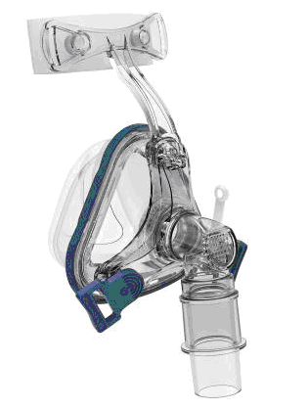

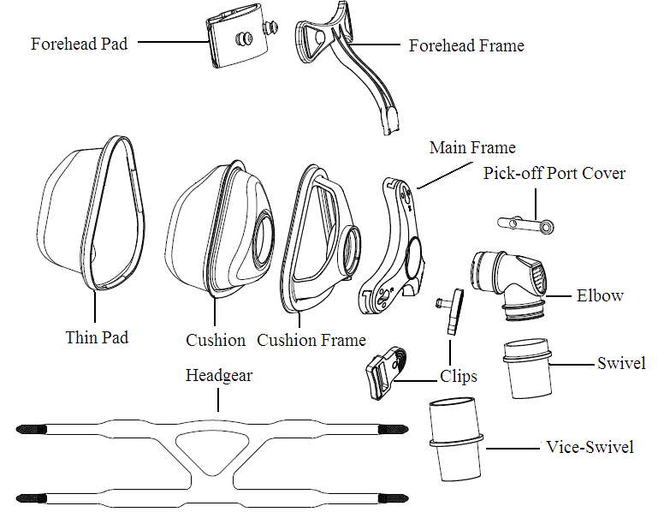
Construction of the iVolve

^{Fitting the iVolve}
1 | 2 | 3
Hold the mask over your nose to find whether the angle of the forehead frame is appropriate to you, slip to step 4 if the answer is yes. | Adjust the forehead pad by pressing or pulling out the bulges on the forehead pad to the other grade. Slip to step 4 if it is OK. | Revolve the main frame. Insert the forehead frame in place. Repeat previous steps. Three levels marked as “1”, “2”, “3” is available.
4 | 5 | 6
Attach the headgear straps by threading them through the gaps of forehead frame and clips. | Hold the mask over your nose and pull the headgear over your head. | Bringing the lower straps below your ears, connect the clips to the main frame.
7 | 8 | 9
Adjust the headgear straps evenly until they are comfortable and firm, and reattach the iVolve. | Connect the main air tubing to the swivel directly or through the optional vice-swivel for the convenience of detachment. Then connect the free end of the air tubing to your flow generator and turn the flow generator on. | Adjust the main frame until the mask is evenly positioned on your face. It should be comfortable, with an effective seal. Adjust the headgear straps if necessary.

Disassembling the iVolve
1 | 2 | 3
Detach the air tubing or the optional vice-swivel. | Unclip the clips and unthread the upper headgear straps. It is not necessary to remove the clips from the headgear. | Note the position on the main frame for the next time you use the mask. Pull the forehead frame out of the main frame.
4 | 5 | 6
Remove the forehead pads from the forehead frame. | Remove the elbow assembly from the mask frame. And the main frame will be apart. | Remove the thin pad and the cushion from the mask frame.

Cleaning the iVolve in the Home
Notes:
- The mask and headgear can only be cleaned by handwashing.
- The headgear may be washed without removing the clips.

CAUTION
- Do not use solutions containing bleach, chlorine, alcohol, aromatics, moisturizers, antibacterial agents, or scented oils to clean any part of the system or air tubing. These solutions may cause damage and reduce the life of the product.
- Exposing any part of the system or tubing to direct sunlight or heat may cause deterioration.
- If any visible deterioration of a component is apparent (cracking, crazing, tears etc), the component should be discarded and replaced.
Daily/After Each Use
To optimize the mask seal, facial oils should be removed from the cushion before use.
Handwash the mask by gently rubbing in warm (30°C) water using mild soap or diluted dishwashing detergent.
If the pick-off port cover requires cleaning use a soft bristle brush.
Rinse all components well with drinking quality water and allow them to air dry out of direct sunlight. Do not soak the mask.
Weekly
Handwash the headgear and all components in warm, (approx. 30°C) and soapy water. Use pure soap. Rinse the components well and allow them to air dry out of direct sunlight.

Reprocessing the Mask between Patients
This mask should be reprocessed when used between patients. Cleaning and disinfection instructions are available from the BMC website, www.bmc-medical.com. If you do not have internet access, please contact your BMC representative.

Reassembling the iVolve
1 | 2 | 3
Insert the cushion into the mask frame. Ensure that the bulge on the cushion embeds into the notch on the cushion frame. | Cover the cushion assembly with the thin pad. Ensure that the directions of thin pad and cushion are aligned. | Align the circle of in the middle of the frame with the one on the cushion frame. Gently push the main frame onto the frame.
4 | 5 | 6
Attach the elbow assembly to the mask assembly. To do this, push the elbow into the seal ring until it clicks into place. | Insert the forehead pad into the main frame to the desirable position. | Revolve the main frame until you reach the setting that gives you a good comfort and seal.
7 | 8 | 9
Insert the forehead frame into the selected position of the main frame. | Attach the headgear straps by threading them through the gaps of forehead frame and clips. | Connect the main air tubing to the swivel directly or through the optional vice-swivel for the convenience of detachment.

Troubleshooting
Problem | Possible reason | Possible solution
Mask won’t seal properly or is uncomfortable. | Mask may have been fitted incorrectly or is incorrectly adjusted. | Carefully follow instructions in “Fitting the iVolve”. Check headgear is not over-tightened. Revolve the main frame to find a suitable position.
 | Mask is wrong size. | Talk to your clinician.
 | Thin pad is misplaced on cushion frame. | Check insertion of thin pad and reinsert correctly according to the instructions in “Reassembling the iVolve”.
 | Mask thin pad is misaligned or creased on face. | Ensure thin pad is properly aligned according to the instructions in “Reassembling the iVolve”. Make sure the thin pad has no creases in it: undo clips, check cushion and thin pad and reposition the mask over your nose.
 | Mask cushion and thin pad may be dirty. | Clean cushion and thin pad according to instructions in “Cleaning the iVolve in the Home”.
Mask is too noisy. | Mask is assembled incorrectly. | Reassemble mask.
 | Vents are blocked or partially blocked. | Clean vents according to  instructions in “Cleaning the  iVolve in the Home”.

Technical Specifications
Pressure Flow Curve | 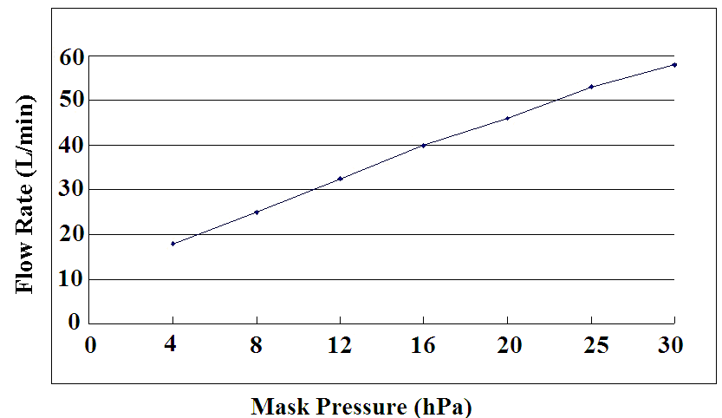
Dead Space Information | Dead space is the empty volume of the mask up to the swivel.  The dead space of the mask varies according to cushion sizes but is less than 145 mL.
Therapy Pressure | 4 to 30 hPa.
Resistance | Drop in Pressure measured (average for 3 sizes)  at 50 L/min: 0.2 hPa  at 100 L/min:0.7 hPa
Sound | DECLARED DUAL-NUMBER NOISE EMISSION VALUES in accordance with ISO 4871. The A-weighted sound power level of the mask is 32 dBA, with uncertainty 3 dBA. The A-weighted sound pressure level of the mask at a distance of 1m is 24 dBA, with uncertainty 3 dBA.
Environmental Conditions | Operating temperature: +5°C to +40°C  Operating humidity: 0% ~ 93% relative humidity non-condensing  Storage and transport: -20°C to +55°C  Storage and transport humidity: 0% ~ 93% relative humidity non-condensing

Storage
Ensure that the mask is thoroughly clean and dry before storing it for any length of time. Store the mask in a dry place out of direct sunlight.

Disposal
The iVolve does not contain any hazardous substances and may be disposed of with your normal household refuse.

Symbols
System and Packaging
Caution, consult accompanying documents.
Indicates a Warning or Caution and alerts you to a possible injury or explains special measures for the safe and effective use of the device.
 | Lot number
 | Not made with natural rubber latex
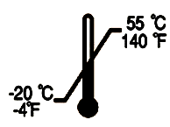 | Temperature limitation
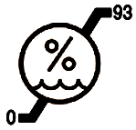 | Humidity limitation

Limited Warranty
It is warranted that iVolve Nasal Mask, including its components, frame, cushion, headgear, tubing and other accessories shall be free from defects in material and workmanship for a period of ninety (90) days from the date of purchase by the initial consumer.
To exercise the rights under this warranty, contact the local, authorized dealers.
The expected service life of iVolve Nasal Mask is one year.

MANUFACTURER:
BMC MEDICAL CO., LTD.
Room 110 Tower A Fengyu Building, No. 115 Fucheng Road, Haidian, 100036 Beijing, PEOPLE’S REPUBLIC OF CHINA

Tel: | +86-10-51663880
Fax: | +86-10-51663880 Ext. 810

EU AUTHORISED REPRESENTATIVE:
Shanghai International Holding Corp. GmbH
Eiffestraβe 80, 20537 Hamburg, Germany

Tel: | 0049-40-2513175
Fax: | 0049-40-255726

Issue date: September 19, 2016

