MACH 3 Interface Manual
V2.0
A. Scope of application
It is used to run the signal processing of the host computer ( LPT port ), with MACH 3 CNC system software, and the peripheral machine dynamic electrical. It is suitable for CNC engraving machine, CNC lathe, CNC plasma cutting machine, laser engraving machine, CNC milling machines, machining centers and other machine tools. With the host computer and the MACH3 series software, it can be the most cost-effective CNC system.
B. Features
1、A special high speed chip is used to process the input and output (I/O) signals. It is capable of making the machine work stably, with the features of correcting and enlarging the signals that removing the unnecessary disturb signals.
2、The computer LPT port supplies the power individually, separating from the power supply of other parts. Therefore, the computer and machine tool isolate effectively. It makes the data more secure, with further insurance of security and stability.
3、There are 5 input signals, communicating with the host computer, which are
isolated by the optical coupling. Among the optical coupling isolation, the P11and P12 are high-speed, which can be used for connecting main shaft encoder, or the same demanding signal as hand wheel A, B. 12V-OUT and 5V-OUT power output interface can be used to pick some necessary power, such as the hall sensor switch and the proximity switch. There are 5 input ports, set to limit, origin, knife, start, stop, spindle speed input, MPG input and any other one of the 5 functions.
4、There are 12 output signal, which is allowed to controlling output, supporting as many as 6 axis linkage. Some of the output port is reusable functinality. Meanwhile, one port only can be used as one function.
5、There are 3 replays, P2, P3 and P4, which can support MACH3 control software programming. The relay's on or off can be controlled through the control of MACH3 software. Each relay has attracted indicating lamp, which is more intuitive and convenient. The 3 relays can be used to control the opening and closing of the liquid coolant, mist coolant, liquid state coolant and so on. They can also be used to control the electromagnetic valve device power switch. P2 port is for the spindle, P3 port is for the cooling liquid, P4 port can be defined.
6、The high speed optical coupling isolation is used to control the rotational speed of spindle. The output port is parallel port P1, which can output the PWM signal within 2.5KHZ. On the interface board ,there is a D/A circuit, with PWM to a 0-10V. The circuit can output 0-10V level to control the inverter which only has analog speed control in the market. Thus it can control the rotational speed of the spindle. It is important that the PWM output and 0-10V output can only choose one in two. They cannot be used at the same time.
7、Interface board can be connected with the cathode or total output to the stepper drive, or servo drive (servo driver must support the digital signal).The output is the 5V level.
8、Wide input voltage power supply: 16-35VDC. The function of preventing reverse connection protection.
2 groups of output voltage: 5V and 12V voltage, 100MA output capacity.
9、Note: There is an enhanced version. Main strengthening function:
① Power supply voltage has a wider range: 15-50VDC
② Increase isolated power module. Do not insert the USB line to the computer's USB port. Just insert a LPT line. It is more convenient and reliable.
③ The current output ability of 5V and 12V voltage output can upgrade to 200MA.
C. Port function
Chart：
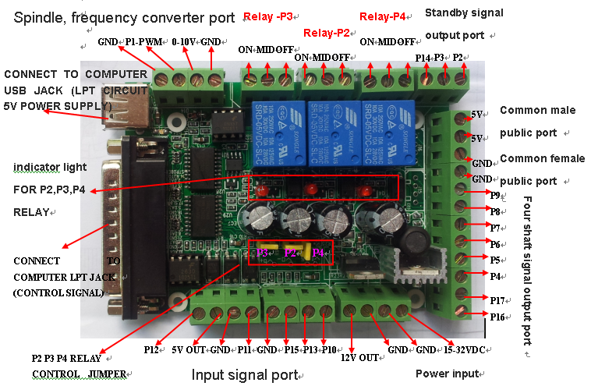

Typical application diagram:
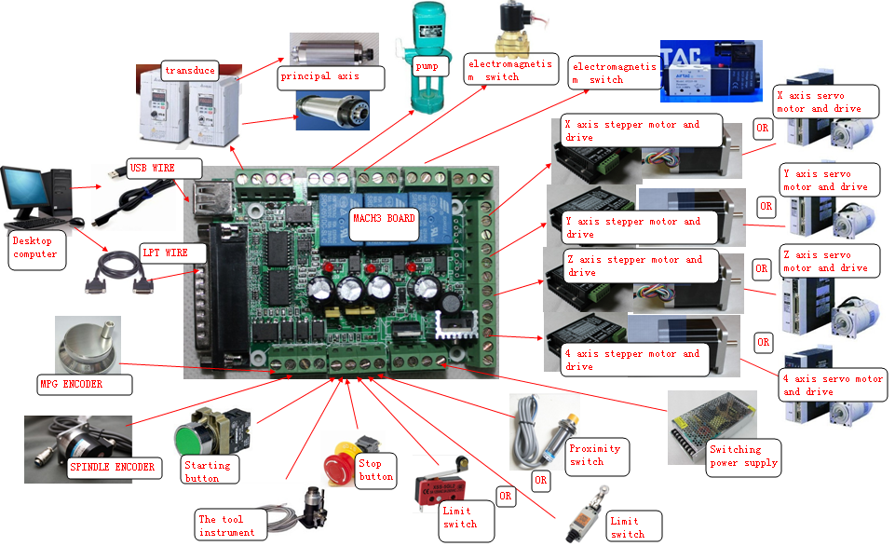

Resource allocation graph:
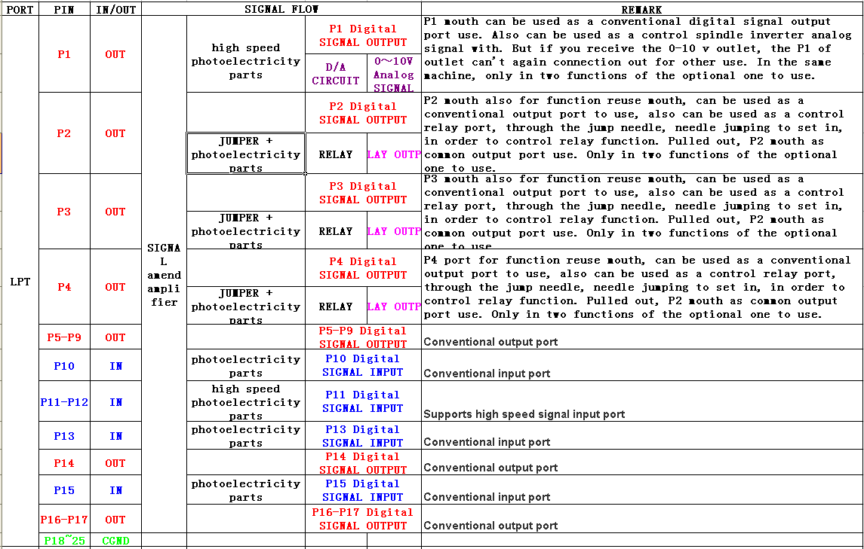

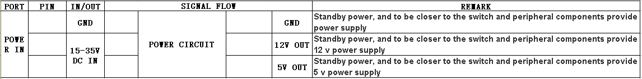
D. The connection of MACH 3 interface board and the periphery
1. The connection to the power input
The interface board must be connected to the power supply.
The requirement of the power is DC15-35VDC. The current should be more than 1A. We recommend that it is better to use the industrial switching power supply. POWER IN connects switching power supply V+, while GND connects V-.
- The connection to the stepper motor driver
The interface board supports the connection of common cathode and common anode. The common anode connection would be taken as an example.
There are two kinds of drivers, the 6 signal port driver with double pulse and double direction and the 4 signal port driver with pulse, direction, enable and public terminal.
For the former. The common anode wiring is to put the PUL+ and DIR+ together firstly, then, connect the C5V port of MACH3 interface board. The PUL- and DIR-, as pulse and direction respectively, are connected to the MACH3 interface board. Next, set the port PUL- and DIR- as pulse and direction port in MACH3 software.
For the latter.The common anode wiring is to connect the public end to the common anode end C5V, connect the pulse with the conventional output port of MACH3 interface board. Then, set the port PUL- and DIR- as pulse and direction port in MACH3 software.
The following is to take the driver of the 6 signal port as example.
EN is for enable end. PUL is for pulse. DIR is for direction. Now, take the controlling of X axis by P4 and P5 for example.
- EN+ and EN- cannot connect wires.
- PUL- of the drive plate connects to the P4 interface board. DIR- of the drive plate connects to interface board of the P5. Meanwhile, PUL+ and DIR+ shall be connected together while connecting to C5V.
- In the "motor output" of the computer software, the pulse of X axis should be set as 4 and the direction should be 5. Choose the setting of the common anode map.
- The settings of the connection are like this:
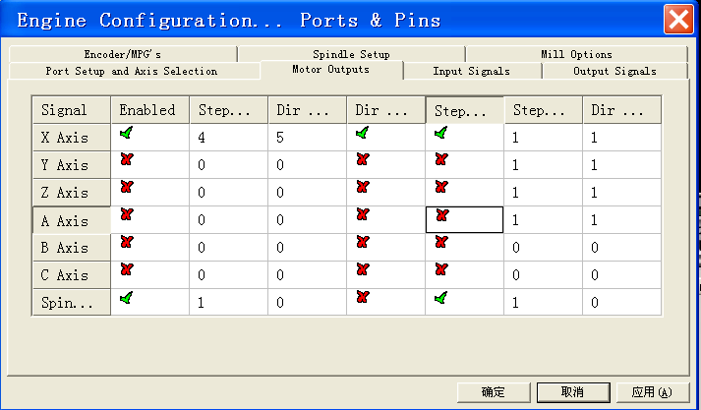
If there must be connected to the EN of the driver, it may take up another output port. That means the driver of X axis shall be controlled by about 3 output ports. Now, it can connect the motor with at most 3 axis. For example, if the EN of the X axis is controlled by P14, the EN- should connect to P14, EN+ should connect to common anode port C5V. The settings of the "motor output "and" output signal "are as follows:

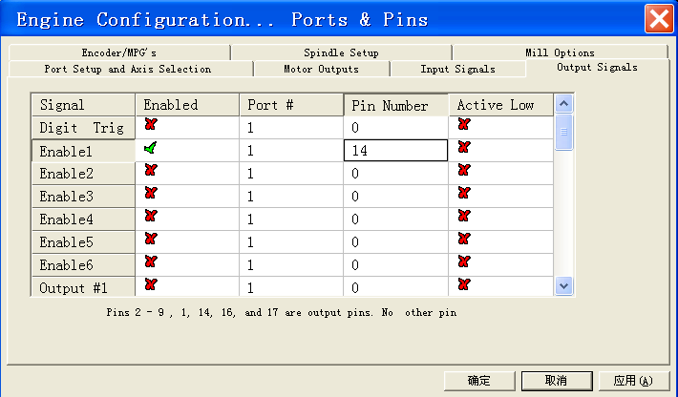
- Note: The USB wire and the parallel line of the MACH3 interface board must connect to your computer together.
- The connection to the inverter
If the inverter is used to connect with the MACH3, it must support the speed control of 0-10V or PWM.
Please confirm that whether the inverter meets the requirements in advance. Then connect it to MACH3 board only with two wires.
1) If it is the speed control of 0-10V, connect GND and 0-10V to the inverter.
2) If it is the speed of PWM , connect GND and P1 to the inverter.
4. The connection to the servo motor driver
Their connection is the same as the connection of MACH3 and stepper motor driver. In the MACH3 board, the axis only can output the control of digital quantity except for the chief axis, which can output the control of analog quantity. Therefore, please make sure that whether the driver supports the control of the digital pulse signal, before you connect MACH3 with the servo driver. If the servo driver is only capable of analog quantity control, it is not suitable for MACH3.
- The connection to the limit switch, tool detection and origin switch
These switches shall be controlled by any one of the 5 input ports of MACH3 interface board. And they can be made by all kinds of the mechanical switches. Otherwise, they can also be made by the capacitive proximity switch, photoelectric switch or Hall switch. Different switch has different positioning accuracy. But they are low level trigger. It is best to use the shielded wire. When routing, it must be separated with various motor wires, high current wires and high voltage wires, especially the output wires besides the motor wires and supply wires of the axis. The GND of the MACH3 board or any other signal wires cannot connect to the metal body of machine.It is easy to cause the switch trigger error.
1) The limit switch can be used by parallelling one port to the 6 or more limit switch, which saving the I/O port. Take P13controlling XYZ as example. Parallel the limit into 2 wires, then connect to the P13 and GND respectively. The setting of "input signal" is as follows：
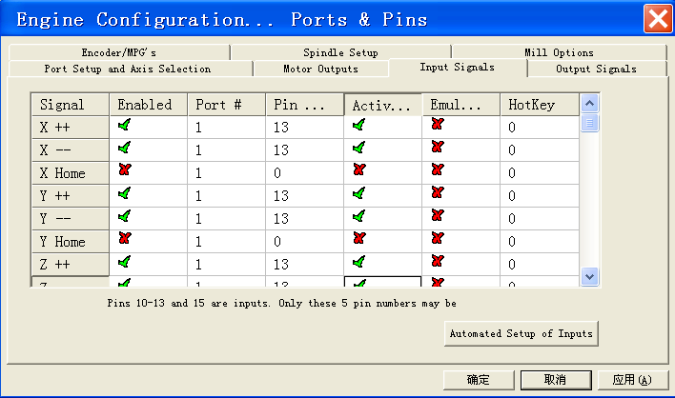
- The tool and origin shall be controlled by input port. The tool works when connecting the tool detection.
- The connection to the relay output.
Our interface board is controlled by 3 relays, which are P2, P3 and P4. P2 is used for spindle. P3 is used for refrigerant. P4 is designed as user-defined. If it needs to use the function, plug all the skipping which controlling the relays. Meanwhile, the 3 output ports cannot be used to the other output port. P4 relay cannot work when you receive it, because the SLI of P4 does not insert in both sides, but one. However, the P2 and P3 can work.
Our product can use 6 axis. But the relay function of P2, P3 and P4 cannot work when using 6 axis. You shall pull the SLI,controlling the relays, out.
P3 is used for refrigerant, supporting G code programming (Parallel P3 port, G code, M8 switch on, M9 switch off). There is a pilot light, which can help you judge whether the power supply is on.
P2 is used for spindle, supporting supporting G code programming (Parallel P2 port, G code, M3 switch on, M5 switch off). There is a pilot light, which can help you judge whether the power supply is on.
Except for the control of P4 port, the relay, of the MACH3 interface board,, can be controlled by the M code number control programming.
The following chart is about the settings of "output signal" and "the chief axis setting", when P2 and P3 are respectively taken as spindle and refrigerant control.
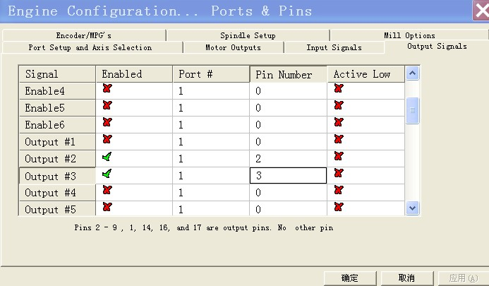
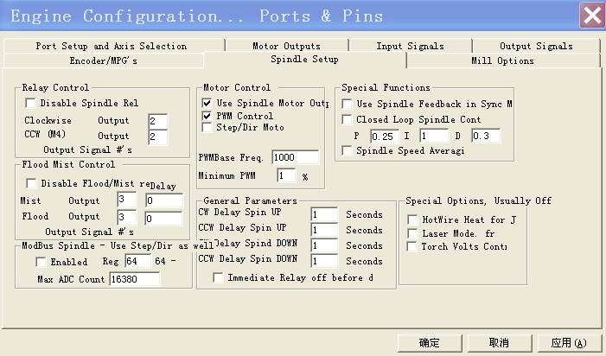
- The connection to the computer and the demands on the computer.
The MACH3 interface board are connected with host computer through the USB port and LPT port.The wire of USB and LPT should not exceed 1.5 meters. At present, many computer host has not LPT output. It needs to buy a PCI parallel port card. PS: You cannot USB parallel port card instead.
Experience shows that AMD and Celeron CPU are not suitable for running MACH3. They would make it working unstabitily.Running the host with MACH3 needs very high real-time. Hence, do not run other software while the MACH3 is working. In addition, you must install as little software as possible on the computer with working MACH3.
You must close the function of the power management and screen saver.You should be careful not to let antivirus software disrupt the system files of MACH3, as some antivirus software may treat it as a virus.
Running the MACH3, the desk-top computer is more stable than the laptop. It barely uses, although the company does not suggest to use laptops. At present, many laptops haven't LPT output. This requires that your computer has a Express Card port. Then you can buy an express parallel card. Generally, the address of these cards are LPT physical, so they work. All the LPT ports, which is software virtual, cannot use, such as USB-LPT port line.
- The connection to the emergency stop and start button.
1) Connecting the starting and stopping button, if you intense to go through the input port of the circuit board. Then connect a GND line and a conventional input port line. It is proposed to use the normally open switch. Then do the following settings on the software. Firstly, active and define the OEM Trigger, in order to control the OEM button. Secondly, set the function codes like this, starting 1000, suspended 1001, stop 1003, F+ 108, F- 109. You can check the other function codes from the MACH3 OEM code. You can do as follows, P11 and GND are connected to a switch, P12 and GND are connected with a switch, P11 is starting, P12 is stopping.
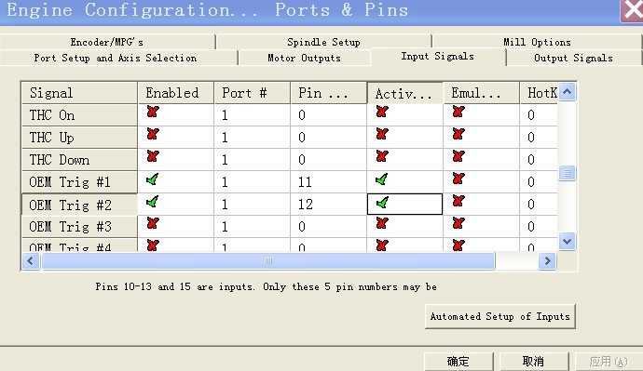
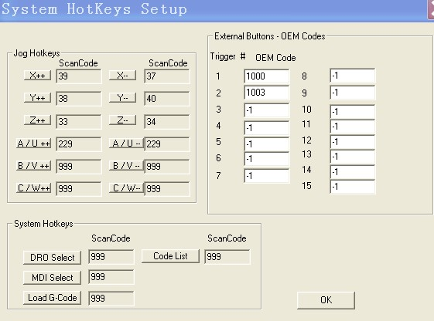
2）When connecting the emergency stop switch, we can lead two wires from it, connecting to the P10 and GND repectively. Then setup in the MACH3.
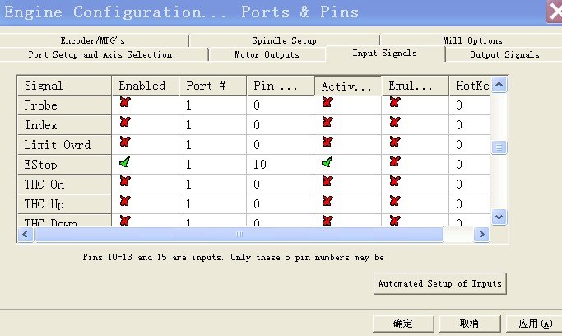

9. The connection to the encoder.
Generally, the encoder shall be connected with 4 wirings and MACH3 board. P11 and P12 ports are respectively connected with the encoder's A, B wires. Then connect 5V/12V of the power output port to the encoder.
E. MACH3 Software Setting
Note: Only in the set of "motor output", the common cathode wiring and common anode wiring are different, when they are in the port settings of MACH3.
Here are settings of two main parameters, "port and pin" and "motor debugging" settings.
(一) "Port and Pin" Settings
- A set of output ports.
There are 12 output ports. They are P1, P2, P3, P4, P5, P6, P7, P8, P9, P14, P16, P17, in which, P2、P3、P4 can be used as relay by skipping.
- Set unit
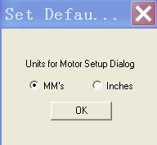
2、Set MACH3 LPT address. The same as the computer host's LPT software address: 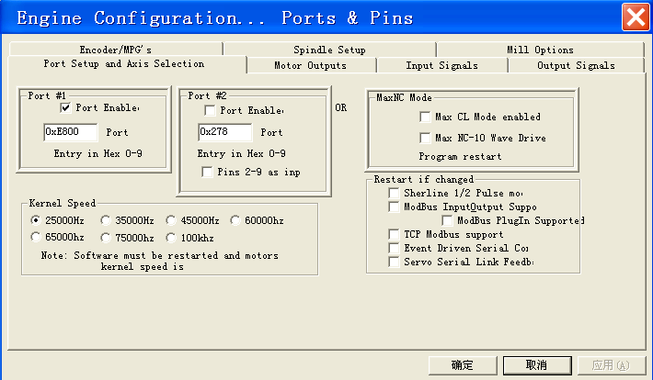
The port, circled by the red, must correspond to your computer's parallel port address. Each computer may not be the same. You can do it according to the following chart.
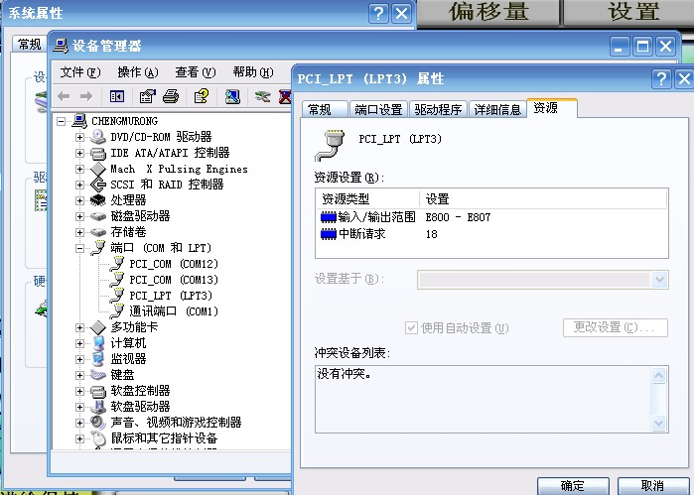
Must correspond to your computer's parallel port address. Each computer may be different.
- Motor output: P4, P5, P6, P7, P8, P9, P16, P17 are used as the port of 4 axis.
Common anode wiring
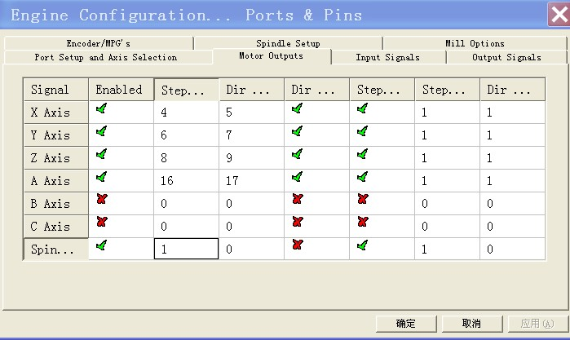
Common cathode wiring
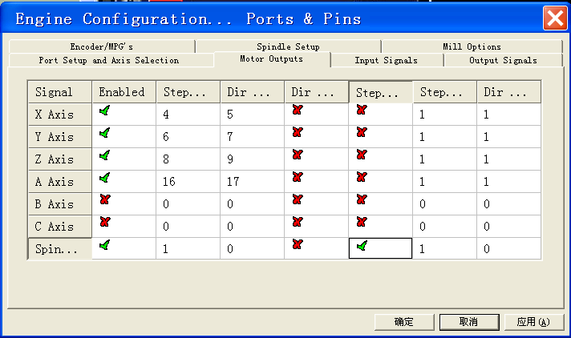
- There are 5 input signals, P10, P11, P12, P13, P15. You can define them by yourself. The chart below is to define P10 as emergency stop, P13 as the XYZ3 axis limit setting, The other ports can be set like this.
5、 Output signal: It can set the output control port of relay. The chart below is the function of the relay of P2 and P3.
6、Encoder and electronic hand wheel. This is the setting without hand wheel.
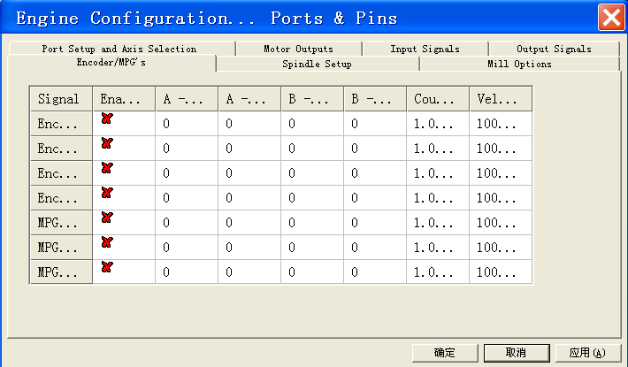

- Chief axis settings. It should be noted that "pulse width modulation base" is based on each PC configuration. The system generate automatically. There are 2 kinds of spindle control, which can use the relay, and the 0-10 port to control.
- It is the setting of the chief axis with the control of the relay. Pay attention to the red circle.

8、Milling machine option, the default values after the computer software installation.
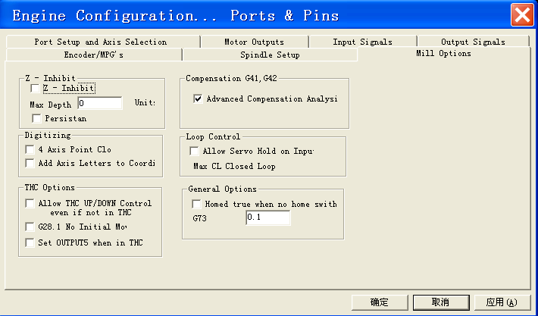
- "Motor Tuning and Setup ". Take the X axis for example
The setting about it is a bit complicated. We can refer to MACH3 software manual. And it shall be kept after a setup.
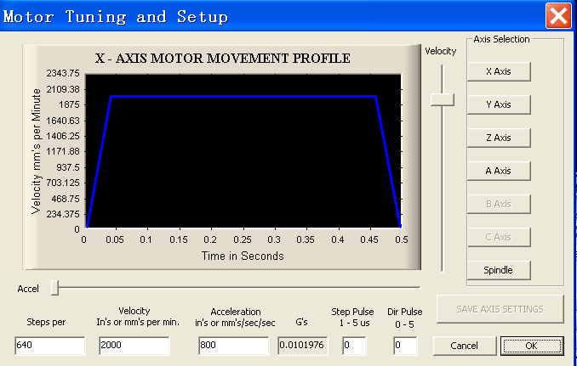
- This must be right. In the case of the stepping motor of 1.8 degree, the numerical=360/1.8*fine fraction/leadscrew pitch.
- 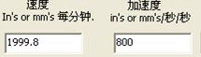They can be filled in according to the actual condition of the machine.
- About the window above, you must click "save axis settings", while finishing a setup each time.
4、Press "Reset"
 Only if the key is not flash, the motor can rotate.
F. Contact us
Thank you very much for your use of our product. If you have any ideas or want to know more about the details of the related products, please login our Taobao shop: http://shop64297629.taobao.com. Thank you.

