The MACH3 Remote instructions
Version：WHB04-V3．0
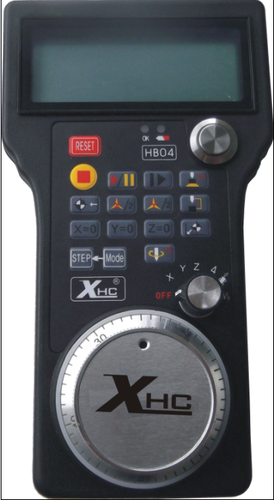
- The RF is Standard with 2.4G ISM ,the Tx power is 0DB and the RX sensitivity is -98DB
- The RF has 64 channels,the channel gap is 1Mhz
- The transmission distance is further than 15 meters with no barrier
- The protocol Designed with high performance； Low power consumption；Automatic learning ID Number
- To jump frequency Adaptively when noised ,which can work with 2.4G wireless Mic ,Wlan and Bluetooth etc. devices.
- 32 sets Wireless Handle work fine at the same time in one room ,with no-interference each other
- has the function of the hand wheel, 100PPR the manual pulse generator output
- display, real-time display of the machine the workpiece coordinates, mechanical coordinates. Coordinates X, Y, and Z three-axis with the screen display
- axis selection function, the band axis selection switch, you can choose the X, Y, and Z axis
- With the function of the hand wheel boot: hand wheel guide, facilitate the adjustment process.

1．ShuttlePro Installation
1. When Mach3 is installed , there will be a folder created named “PlugIns” in the Mach3 folder. This folder is the location to put and Plugin files that you want Mach3 to know about. Place
“ShuttlePro.dll” in the \Mach3\PlugIns folder. Check and make sure it is there.
2．Setup diver for automatically set the knife height function
M930.m1s copy the installation directory to the MACH3
..\Mach3\macros\Mach3Mill

3. Now that the ShuttlePro.dll file is in \Mach3\PlugIns, the next step is to connect the huttlePro. If you are certain that your ShuttlePro is working and your hardware is working then you can simply plug in the ShuttlePro to one of the USB ports.

4. Once the ShuttlePro is connected, start Mach3 and go to the “Config” menu choice and select “ConfigPlugins”. You should see the ShuttlePro choice with a green checkmark in front of it. If it is not checked, you can check it. The checkmark means that Mach3 found the ShuttlePro on tartup. Click the “CONFIG” in yellow and set the buttons as you wish.
5. Once you have the proper button selected in the Mach3 ShuttlePro Plugin CONFIG menu, your Shuttle device should be working properly.

Plug-in configuration instructions：
start Mach3 and go to the “Config” menu choice and select “ConfigPlugins”. You should see the ShuttlePro choice with a green checkmark in front of it. If it is not checked, you can check it. 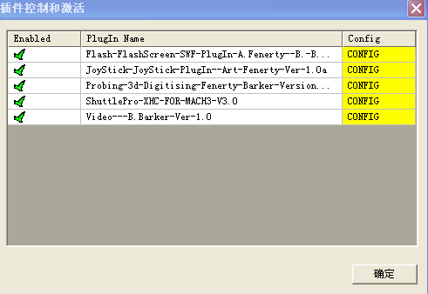

The checkmark means that Mach3 found the ShuttlePro on tartup. Click the “CONFIG” in yellow
and set the buttons as you wish.
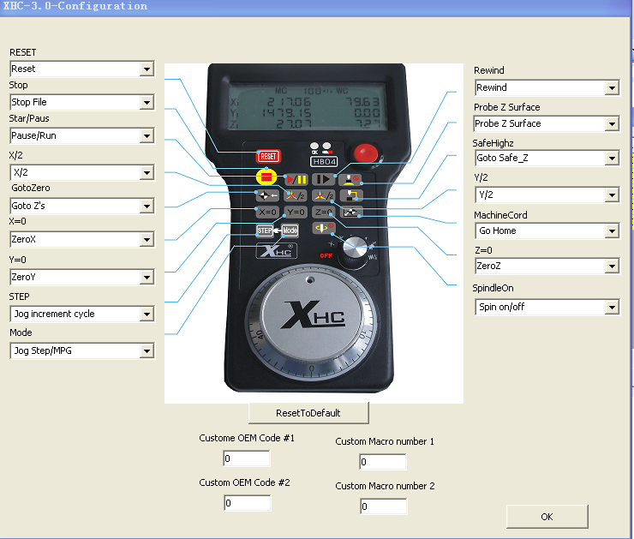

2．The MACH3 handwheel key function
1．Button description

icon | Function | Explain
 | Reset | reset program
 | stop | stop run program
 | Start/pause | start and pause program
 | Rewind | return to the program start
 | automatically set the knife height | automatically set the knife height function
 | Go to zero | go to zero work coordinate
 | x coordinate value/2 | x coordinate value/2
 | Y coordinate value/2 | Y coordinate value/2
 | go to Z safehigh | go to Z safehigh
 | x coordinate clear | x coordinate clear
 | Y coordinate clear | Y coordinate clear
 | Z coordinate clear | z coordinate clear.when band switch to A axis,Z clear will clear A coordinate.
 | Go home | go to home coordinate
 | og Step adjust | When the stepping mode, perform the adjustment will be effective  Adjusted by pressing  the mode button to select the step mode  Adjusted by pressing the mode button to select the step，And LCD display corresponding to the step below.  1*1X ： step 0.001 Unit  10*1X ： step 0.01 Unit  100*1X ： step 0.1 Unit  1000*1X： step 1．000 Unit
 | Jog mode adjust | Jog mode adjust,step/mpg.the lcd will show step number  PG：Jog mpg mode
 | Spindle On/off | Spindle axis on or Spindle axis off
4．Band switch function
Through the stalls of the band switch switch to control the various functions of the hand wheel
icon | Function | Explain
 | Close the hand wheel | Close the hand wheel
 | X-axis manual adjustment | Positioning the band switch to the stall, shaking the hand wheel on the X-axis movement control: the distance traveled according to the magnification
 | Y-axis manual adjustment | Positioning the band switch to the stall, shaking the hand wheel on the Y-axis movement control: the distance traveled according to the magnification
 | Z-axis manual adjustment | Positioning the band switch to the stall, shaking the hand wheel on the Z-axis movement control: the distance traveled according to the magnification
 | A-axis manual adjustment | Positioning the band switch to the stall, shaking the hand wheel on the A-axis movement control: the distance traveled according to the magnification
 | Spindle speed adjustment | The band switch to locate the stall by shaking the hand wheel, spindle speed of adjustment
 | Feed adjustment | The band switch to locate the stall by shaking the hand wheel, Feed adjustment

5．LCD display instructions
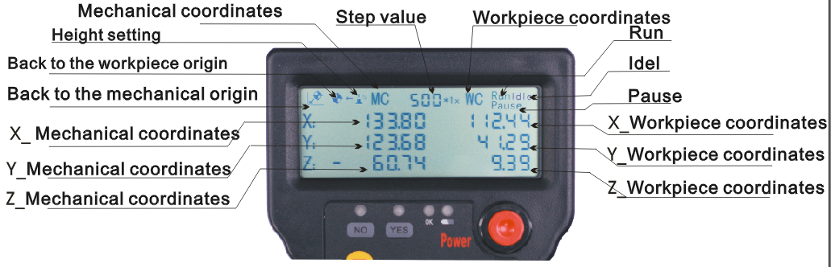

Feed Display
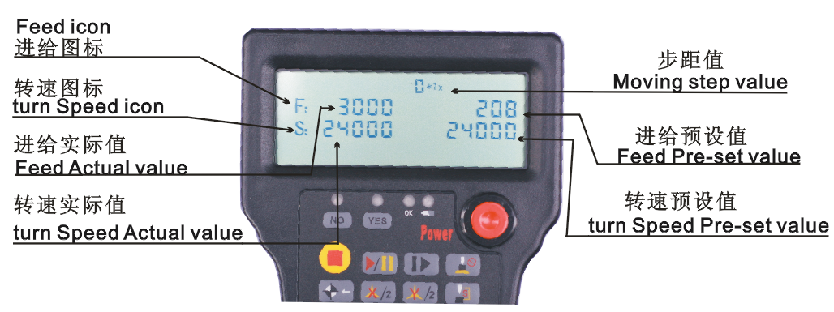

If you have any questions, please visit our website

